Visual Vocabulary
Section 2 – Software

Word | Picture | Sentence | Definition | Synonyms/Examples
Application  Software | 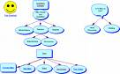
Clip Art
Database
Graphics
GUI | 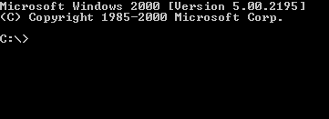  This is a non GUI environment. |  | Graphical User Interface | WYSIWYG
Icon
Operating  System |  |  |  | AKA – OS  Types are Windows, Linux, Unix, Macintosch
Spreadsheet | 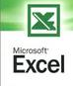
Word Processing | 

