Silver Lakes Elementary – Social and Emotional Learning School Wide Plan
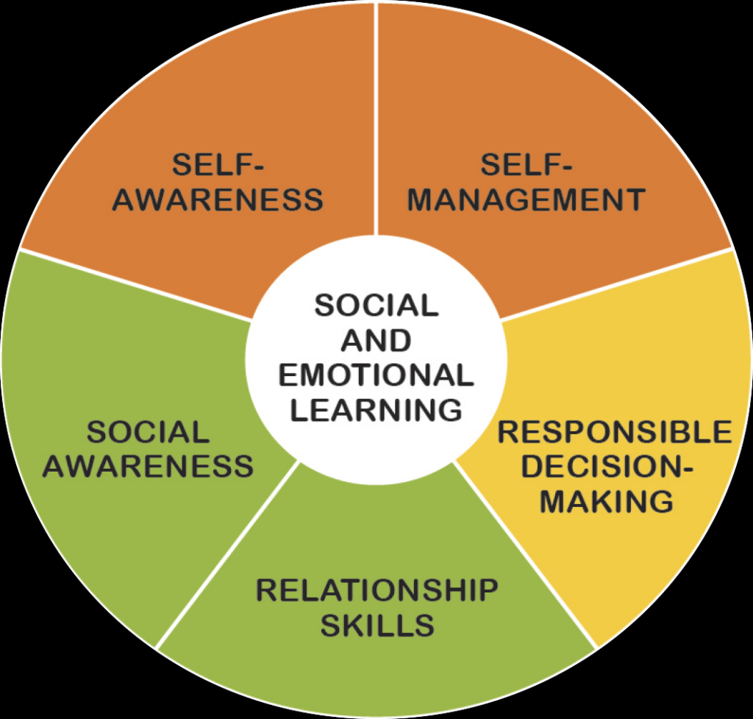

September 17th - 21st – Peace Week
November 5th - 9th – Gratitude Week
December 3rd - 7th – Kindness Week
February 11th - 15th – Friendship Week
March 11th - 15th – Leadership Week (college/career)
May 6th - 10th – It’s Great to be Me Week (Multicultural/Diversity)

- SEL standards will be covered using the following research- based curriculum: Zone of Regulation, Sanford Harmony, Sandy Hook Start with “Hello”.
    - Goal 1: Develop self-awareness and self-management skills to achieve school and life success.
    - Goal 2: Use social-awareness and interpersonal skills to establish and maintain positive relationships.
    - Goal 3: Demonstrate decision-making skills and responsible behaviors in personal, school, and community contexts.
- Giving Back to the Community school wide events will be embedded throughout the year.

