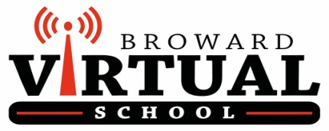

School Advisory Council
AGENDA
May 17, 2019
10 AM

- Welcome Back! Introductions

- Call to Order / Minutes Approval

- Principal’s Updates – C. McGuire

- SIP Goals Update (Tentative Plans for 2019-2020) - N. Lallouz

- Counselor Updates- L. Patino/E. Maldonado

- Senior Alumni- C. Manhas

- Student Activities Updates:

- Business Club, Robotics, Science Labs, NHS, NJHS, and any other info from Club Sponsors, School Counselors, or Admin who are present!

- End of the Year Housekeeping!- C.McGuire

- Next Meeting: June 4, 2019

