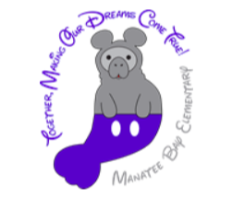
Manatee Bay Elementary School
SAC and SAF Dates

SAC
All meetings at 2:15pm in Media Center
9/11/18, 10/9/18, 11/13/18, 12/11/18, 1/15/19, 2/12/19, 3/12/19, 4/9/19, 5/7/19
SAF
10/3/18 at 6:30pm
11/13/18 (combined with SAC)
January 2019 Exact date TBA- SAF Parent University, Topic: Security
3/12/19 (combined with SAC)
4/3/19 at 6:30pm

