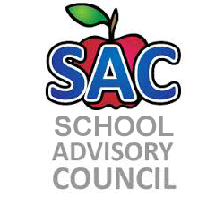
Challenger Elementary – Title 1 School
SAC Meeting Agenda
11/30/2018

- Roll Call to Establish Quorum:
- Approval of Minutes:
- Approval of Accelerated Reader (AR) Program:
- School Improvement Plan: Teaching and Assessing for Learning
- Title One report:
- Equity Liaison- Mrs. Philip
- Principal Remarks
- Adjourn meeting:

2018-2019 Meeting Date:Nov. 30, Dec. 20, Jan. 25, Feb. 22, Mar. 15, Apr. 26, May 17

