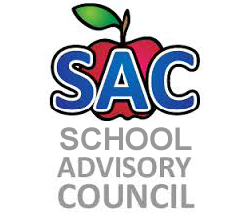
Challenger Elementary – Title 1 School
SAF Meeting Agenda
10/26/2018

- Title One update
- Principal Remarks
- Adjourn meeting:

2018-2019 Meeting Date: Sept. 21, Oct. 26, Nov. 30, Dec. 20, Jan. 25, Feb. 22, Mar. 15, Apr. 26, May 17

