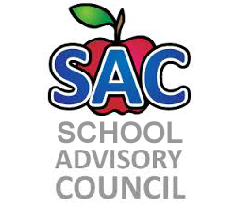
Challenger Elementary – Title 1 School
SAC Meeting Agenda
9/21/2018

- Roll Call to Establish Quorum:
- Approval of Minutes:
- Mission of SAC Committee:
- Election of SAC Members:
- SAC Committee Composition:
- School Improvement Plan results:
- SMART initiative:
- Title One report:
- Principal Remarks
- Adjourn meeting:

2018-2019 Meeting Date: Sept. 21, Oct. 26, Nov. 30, Dec. 20, Jan. 25, Feb. 22, Mar. 15, Apr. 26, May 17

