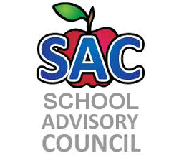
Challenger Elementary – Title 1 School
SAC Meeting Agenda
1/25/19

- Roll Call to Establish Quorum:
- Approval of Minutes:
- School Improvement Plan- Mrs. Cross
- Title One report:
- Principal Remarks:
- Adjourn meeting:

2018-2019 Meeting Date: Feb. 22, Mar. 15, Apr. 26, May 17

