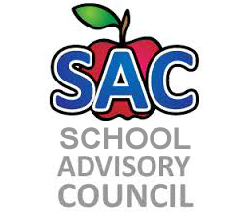
Challenger Elementary – Title 1 School
SAC Meeting Agenda
1/16/19

- Roll Call to Establish Quorum:
- Approval of Minutes:
- School Improvement Plan: Teaching & Assessing for Learning-Mrs. Cross
- Instructional Coaches: Mrs. Barbera, Mr. Briggs
- Media Specialist: Mrs. DeLatorre
- Title One report:
- Principal Remarks:
- Adjourn meeting:

2018-2019 Meeting Date: Jan. 25, Feb. 22, Mar. 15, Apr. 26, May 17

