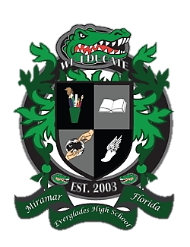
Everglades High School
School Advisory Council Agenda
September 25, 2018……Media Center……3:00pm

- Desired Outcomes
- Welcome
- Approval of minutes for 5/16/17
- Installation of Officers
- New SAC Members
- SAC ByLaws
- Proposed 2018-2019 SAC Calendar
- Subcommittee updates
- SIP Monitoring
- PTSA Updates
- New Issues/Concerns

- Welcome
- Ms. Lisa Alonso, SAC Co-Chair
- Mr. Matthew Cordova, SAC Co-Chair
- Mrs. Maureen Eves, SAC Secretary

- Reading and Approval of Minutes
  - May 15, 2018

- Installation of Officers

- Introduction of SAC Members

- SAC By-Laws

- Proposed 2018-2019 SAC Calendar

- Subcommittee Updates
  - Parent Involvement
  - Student Concerns
  - Discipline
  - Reading and Writing
  - Math
  - Science
  - Social Studies
  - Technology

- SIP Monitoring

- PTSA Update

- New Issues / Concerns

