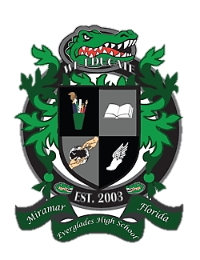
Everglades High School
School Advisory Council Agenda
Feb 26, 2019……Media Center……3:00pm

- Desired Outcomes
- Welcome
- Waiver Results
- SIP Monitoring
- Subcommittee updates
- PTSA Updates
- New Issues/Concerns

- Welcome
- Ms. Lisa Alonso, SAC Co-Chair
- Mr. Matthew Cordova, SAC Co-Chair
- Mrs. Maureen Eves, SAC Secretary

- Waiver Results

- SIP Monitoring

- Subcommittee Updates
  - Parent Involvement
  - Student Concerns
  - Discipline
  - Reading and Writing
  - Math
  - Science
  - Social Studies
  - Technology

- PTSA Update

- New Issues / Concerns

