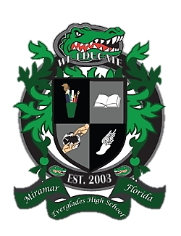
Everglades High School
School Advisory Council Agenda
December 11, 2018……Media Center……3:00pm

- Desired Outcomes
- Welcome
- Approval of minutes for 10/23/18
- Student Success Sessions
- Exam Exemption Application
- SIP Monitoring
- Subcommittee updates
- PTSA Updates
- New Issues/Concerns

- Welcome
- Ms. Lisa Alonso, SAC Co-Chair
- Mr. Matthew Cordova, SAC Co-Chair
- Mrs. Maureen Eves, SAC Secretary

- Reading and Approval of Minutes
  - October 23, 2018

- Student Success Sessions

- Exam Exemption Application

- SIP Monitoring

- Subcommittee Updates
  - Parent Involvement
  - Student Concerns
  - Discipline
  - Reading and Writing
  - Math
  - Science
  - Social Studies
  - Technology

- PTSA Update

- New Issues / Concerns

