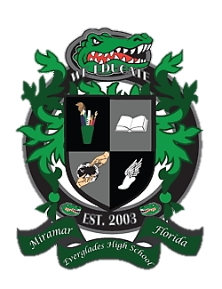
Everglades High School
School Advisory Council Agenda
October23, 2018……Media Center……3:00pm

- Desired Outcomes
- Welcome
- Approval of minutes for September 25, 2018
- New SAC Members
- SMART Bond Update
- BPIE
- School Counseling Plan
- Exam Exemption Application
- Subcommittee updates
- SIP Monitoring
- PTSA Updates
- New Issues/Concerns

- Welcome
- Ms. Lisa Alonso, SAC Co-Chair
- Mr. Matthew Cordova, SAC Co-Chair
- Mrs. Maureen Eves, SAC Secretary

- Reading and Approval of Minutes
  - September 25,2018

- Introduction of New SAC Members

- Smart Bond Update

- BPIE

- School Counseling Plan

- Exam Exemption Application

- Subcommittee Updates
  - Parent Involvement
  - Student Concerns
  - Discipline
  - Reading and Writing
  - Math
  - Science
  - Social Studies
  - Technology

- SIP Monitoring

- PTSA Update

- New Issues / Concerns

