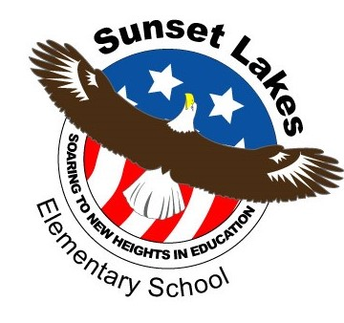

Sunset Lakes Elementary 2018/2019 SAC/SAF Meetings:

September 26th, 2018
October 24th, 2018
November 28th, 2018
January 23rd, 2019
February 27th, 2019
March 27th, 2019
April 24th, 2019
May 22nd, 2019

