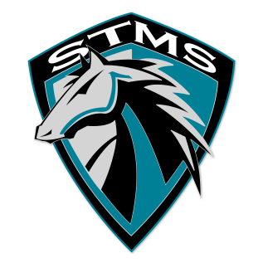
SILVER TRAIL MIDDLE SCHOOL
18299 Sheridan Street, Southwest Ranches, FL 33331
SAF Minutes
October 24, 2018

- Meeting called to order
At 5:25pm

- Approval of Minutes from September 12, 2018 meeting
Motion was made by Jessica Abou and seconded by Suhay Nunez

- Approval of Agenda
Motion was made by Branka Gittens and seconded by Elizabeth Lugo-Martinez

- Chairperson’s Report from South Area District Meeting October 24, 2018
- Lynn Goldman, Community Relations with the Technical Schools & Colleges, on “Different Pathways to the American Dream” — everyone yearns for an education.
- 30% of jobs require a certification and not a 4-year degree
- Broward Community College has been rated top 3 in the United States
- FSFA—everyone is entitled to get some money for help—it is not based on your income—you just need to apply. Every year you must open the account to be eligible for scholarships and merit. It is very easy, and it opens in October.
- If you don’t use it you lose it. $90 million was left on the table.
- Ralph Aiello, Director of School Counseling and BRACE Advisement - how schools are using Naviance—start building the resume when the students get to middle school.
- College Fairs—go to what is offered locally
- SAT scores—register with Khan Academy and a program will be made just for you—FREE, virtual learning.
- BRACE and guidance counselors work together—not enough counselors—ratio is 501students per guidance counselor.
- SMART Bond Update- handout was distributed.
- Ed Talk—coming in December—engaging the community
- Broward Reads for the Record—doesn’t apply to middle schools.
- National School Bus Safety Week— STMS recognizes them with shirts, orange juice and donuts.

- No Sub Committee Reports

- No Public Input

- Meeting adjourned at 5:44 PM

