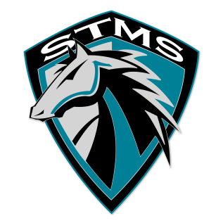
SILVER TRAIL MIDDLE SCHOOL
18299 Sheridan Street, Southwest Ranches, FL 33331

Agenda
October 24, 2018

- Meeting called to order

- Approval of Minutes from September 12, 2018 meeting

- Approval of Agenda

- Chairperson’s Report from South Area District Meeting October 24, 2018
- Lynn Goldman, Community Relations with the Technical Schools & Colleges, on “Different Pathways to the American Dream”.
- Ralph Aiello, Director of School Counseling and BRACE Advisement, on how schools are using Naviance.
- Additional information from District meeting on 10-24-2018
- District 2 General Meeting information 10-24-2016
- SMART Bond Update
- Ed Talk
- Broward Reads for the Record
- National School Bus Safety Week

- Sub Committee Reports

- Public Input – 2 minutes per speaker

- Adjourn

Next Meeting – November 28, 2018 – 4:15 PM in Media

