Virginia Shuman Young
Montessori Elementary School
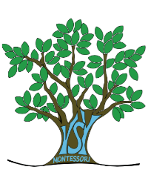
Cyndi Felton, Principal
Luke Balchaitis, Assistant Principal

School Advisory Council Meeting/School Advisory Forum Meeting Schedule
Wednesday Nights
6:00 Media Center

Wednesday, September 12, 2018 SAC/SAF Meeting

Wednesday, October 10, 2018 SAC Meeting

Wednesday, November 14, 2018 SAC Meeting

Wednesday, January 16, 2019 SAC Meeting

Wednesday, February 13, 2019 SAC Meeting

Wednesday, March 13, 2019 SAC Meeting

Wednesday, April 17, 2019 SAC Meeting

Wednesday, May 15, 2019 SAC Meeting

