SAC MINUTES FOR December 13, 2017

The meeting was called to order by Mrs. Beitz at 8:20 AM.
Mrs. Beitz introduced Karla Martinez, the new Office Manager/ Confidential.
The previous meeting (November 08th) minutes were reviewed. A motion to approve the minutes was made by Carol Nissen, it was seconded. It was put to a vote and it passed unanimously.
SIP –
SIP Plan – Ms. Nissen and Ms. Beitz attended the District meeting. We are on track with all documentation requirements. Department Heads will expand on what teachers are doing in the classroom as it relates to the S.I.P.
A+ Funds Allocation Proposal - Ms. Nissen motioned to approve Allocation of A+ funds. It was second, voted on and passed unanimously.
- $192.95 – collection of novels
- $1,908.00 – Laser printers
- $625.00 HDMI cables (computers to T.V.)
Math & ELA Proposal –
Math:
- - An attempt was made to coordinate a math workshop for levels 1 and 2 6th graders but there are not enough teachers available due to many teaching 6 periods.
- – An IReady quote of $3,375.00 was received but only 3 teachers would be utilizing. A minimum of $3000.00 is required for professional development. This will not be paid for only 3 teachers.
Still working on other options.
ELA:
2018 TTMS Literacy Workshop proposal:

Over the course of 10 weeks, from January 31 – April 11, 2018, the Literacy Department would conduct 1 -hour workshop sessions with lessons focusing on practice for the FSA ELA assessments. The FSA Writing assessment is March 6th. FSA ELA begins April 16th. The students selected to attend include 136 students that scored within 1 – 4 points just above the cut score proficiency level (the lowest 3 scores) across all grades.

We would like to extend this learning opportunity to our students again this year with the support of our SAC committee. This in-house workshop will be offered during the day using ELA workshop curriculum provided by Mrs. Manning and literacy teachers. The funds requested from SAC are to pay $25 per hour to the teachers who would be working during their planning or before school 1 day per week. Instruction would be small groups, motivational, and explicit to either writing, reading or both based on students’ 2017 ELA scores.

A total of 10 weeks would break down as follows:
3 teachers teach 10 weeks both reading and writing during planning time or “push-in” $750
2 teachers teach 10 weeks of reading and writing before school 1 day per week $500

Misc. materials $75
TOTAL WORKSHOP COST $1,325

Ms. Manning motioned to approve the proposal and Ms. Beitz second it. It was put to a vote and was agreed upon unanimously.
Departments:
Science – Ms. Swinerton - Cambridge 8th Grade students attended two separate career and college readiness events during the month of December. The first was the Aviation Expo jointly hosted by the City of Miramar and Broward Schools CTACE. Students were exposed to potential career opportunities by organizations such as Broward Sheriff’s Office, Jet Blue, Spirit Airlines, the Latin American Pilots Association, and the Civil Air Patrol. On December 11th Cambridge students attended a presentation by admission representatives from Harvard University.
Science Fair and Invent America projects are being worked on. Projects will be displayed in the Media Center from January 12th through January 17th. The Science Fair Open House is scheduled for January 17th.
All grade levels are progressing through their curriculum as well as completing the next round of performance tasks. All of the science performance tasks include a persuasive writing piece discussing the results of their data. The sixth-grade teachers have partnered with our ELA department to aid them in instructing the students on how to write their persuasive piece as well as give the teachers pointers on how to grade the pieces from a ELA point of view. Seventh grade students are working on their most recent performance task which is a cell brochure. The eighth-grade performance task asks students to display their mastery of density by altering the density of a military diver so they may swim at depths undetectable by enemy ships and sonar.

Electives – Ms. Sikorski - In Peer Counseling – The Harvest Drive was a huge success. I took 40 students to Western High School to “shop” for 150 families in need. It was an amazing experience for my students. I also took 4 students to a Teen Summit where they learned about available prevention programs in Broward County and now they are putting together a plan for TTMS.
The DC/NY field trip was a huge success. We took a group of amazing 8th graders for 5 days to New York City and Washington, D.C. and had a fantastic time.
In Drama – Troupe 88241 participated in Jr. Thespian District 12 Festival last weekend. The troupe presented a one act play, 18 individual pieces which ranged from monologues to small and large group musical. The pieces are judged by local professionals in the theatre community. The students received all Superior rankings on their 14 performance pieces, and Excellent on four technical design pieces. Additionally, the one act play, Conflict, received straight Superior ratings, with special recognition given to Franklin Ferrer for performance and Samantha Monteiro for stage management. Conflict was also selected to represent District 12 at State in February. The small group musical piece, Cookies, and the large group musical piece, 38 Planes, were recognized as Critic’s Choice and performed at the Closing Ceremonies. Just yesterday, they received word that the large group was voted by all the troupes in the district to represent District 12 in the Opening Ceremonies at State, performing to an audience of approximately 3500. Turning our attention to this year’s musical we are very excited to bring you Seussical in May.
Tequesta Trace Pep band recently was the first wind band to perform at a panther game ever!

The Pep band also played at the Weston YMCA veterans day breakfast. They had a chance to meet and be thanked for their performance by Weston Mayor Eric Hersh and congresswomen Debbie Wasserman Schultz as well as many others.

Tequesta Trace Pep band performed a short set of selections at the Eagle Point arts evening Nov 29

Symphonic pep band members Perform for the Indian Trace Field day events December 5th

Symphonic Band and Jazz Band will perform for the Winter Festival of Music at Ft. Lauderdale Hollywood int. Airport from 9am -12 on Dec 11

Choir will Perform for the Winter Festival of Music at Ft. Lauderdale Hollywood int. Airport from 9am -12 on Dec 13

Band Fall Concert set for December 21

Three band students were selected to the All County Band - Clayton Zipperian 7th grade French Horn, Christopher Januario 8th grade Bassoon, and Jeston Curry 8th grade trombone.

Two students made the All-State Ensembles this year. Gareth Gill All State Choir and Jeston Curry State Honors Band.

Several Choir Students have been nominated for All County Choir, but the list has not been sent out yet.

Several 6th Grade band students have been nominated to the Broward Young Musicians Band- no list out yet of who has been selected.

ESE- Mrs. Winter - The SVE classes attended the Special Olympics-Track and Field events last Wednesday (12/6) and it was a fun time for all! They are also planning a trip with the Advanced Drama class to a Drama presentation at Taravella High School at the end of January.
One of our mainstreamed 6th grade students, Michael Albrizio, made the Jr. All County Band, which is a big honor for a 6th grade student. Some of our other mainstreamed students went on the NY/Washington trip last week and several reported back to Ms. Passman and other support personnel that it was a good time in NY and that Washington DC was educational.
The ESE department is working on organizing a training for the staff after the winter break and more information on that will be reported at the January SAC meeting.

Literacy- Mrs. Manning - Some of the events taking place in literacy this month include items from Spanish and Debate. Mrs. Ibarra and Mrs. Felieu’s Spanish classes are getting ready for a District Spanish competition at Rickards Middle on March 17th. In addition, Spanish midterms will be this Thursday and Friday. The students in the Spanish Speakers classes are working on a poem project.

The TTMS Debate team had a strong performance in November, with 21 students competing. Three of our Policy Debate teams won medals for winning both of their rounds! The team will be taking a small group to the December 14th MAST since many of the 8th graders have midterms this week. Mrs. Levine, the debate coach, is always looking for support for our growing Debate team. Email her directly if you are able to help chaperone, judge, or send snacks on Tournament days.

In the ELA classes, teachers are working on writing performance tasks to conclude the second quarter, as well completing presentations on topics such as animal intelligence, pro/con speeches, photo documentaries supporting social causes, and character profiles. We continue to incorporate technology programs in the classrooms such as NoRedInk, Newsela, and Vocabulary.com. These programs have independent literacy practice components that we encourage students to use at home.

On behalf of the Literacy Team, I wish all our TTMS community a safe and healthy Winter Break, enjoying the holidays with your family and friends!

ESOL- Ms. Franco - Ms. Giraldo, Ms. Dillmeier and I are taking 35 ESOL students on a field trip to see a ballet, The Nutcracker. The ESOL students will be treated to lunch as well as each student will receive a copy of the book in either Spanish or English. The field trip was sponsored by a grant from the Immigrant Student Department.
We are continuing with afterschool tutoring. This is a 12-week program. This is the third year for Tequesta Trace to be involved in the program. We currently have 30 students enrolled in tutoring.
In class the students are working in their English Now Books Unit 5 nutrition. They will be having a midterm next week on this information. The students are also practicing some listening activities as part of the new Access 2.0 Test they will have to be able to listen to a story and answer questions.
On behalf of the ESOL students I would just like to take a moment and wish everyone:
Feliz Navidad Meri Kuri Feliz Natal Joyeux Noel

Media-Mrs. Dillmeier – Media aides: decorated “snowpeople” to promote an informational text subject.
Broadcasting: View stream came to adjust our system so we can put our morning announcement online each morning. Possibly the bandwidth is causing issues due to high volume at that time. We are happy to be back up and running.
Research: The Art of Research our collaboration class between Caron Libby and myself to research Styles of Art and present them to the class. 15 students a day from each class work with me and independently on their presentations.
JHS CHILD_NET/ Angel Tree
I the past we have adopted individual teens to purchase their wish gift. This year we have contacted with Child net about our participation. We will collect gift cards to a variety of stores such as Publix, iTunes, Target, Walmart, Dick’s and Starbucks. Collections will be two weeks long.
Cougar Care
Cougar Care wrist bands are closing we sold over 350 bands foe victims of the hurricanes in the Keys, Puerto Rico and Houston. JHS voted to send the monies collected to the Red Cross relief fund.

Social Studies – Mr. Devant - All grade levels … History Fair is coming due this week and by next week at the latest. Students/teacher will pick the best projects from each class to display in media and move on to County (date to be cleared by Mrs. Dilmeier). Check out NHD.org for more information.
6th grade is working on comparing the economic, political, social, and religious institutions of ancient river civilizations. Summarizing the important achievements and key figures of the ancient Greeks and Alexander the Great/Philip of Macedonia.
7th grade is beginning work on examining the structure, functions and processes of the Legislative Branch.
8th grade students are into the North American Colonies and are currently examining the causes, course, and consequences of the American Revolution and individuals and groups that affected political and social motivations during the American Revolution.
Cambridge Global Perspectives has been working on their group projects which are entirely student directed. These contain a group and an individual element. For the group element, each group must produce a collective piece of work that includes: a project plan, evidence of the process and collaboration, and a description of the outcome. Students must also submit an individual evaluation of: the project plan and process, the project outcome, their own contribution to and learning from the project, including cross-cultural collaboration.
Cambridge students are also taking midterms this week and next.

Math-Mrs. Cordoves-
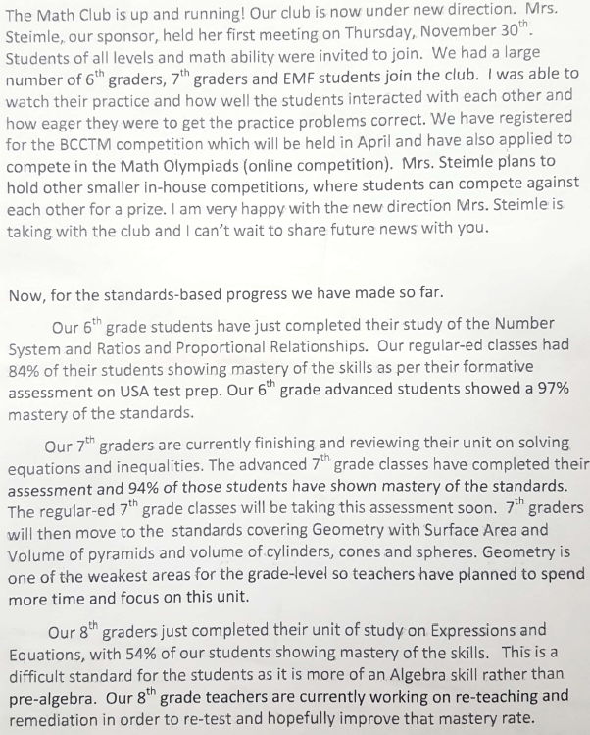

The SAC meeting closed at 8:49 AM.

SAF- Ms. Beitz called SAF meeting was called to order and presented the SAF By-laws. Ms. Baker made a motion to approve the By-laws and Ms. Swinerton second the motion. Motion was approved unanimously.
Ms. Baker reported the November minutes needed to state that Option 1 is the one that went before the Board for the calendar for 2018 – 2019 school year. For teachers there is a start date of August 8th and an end date of June 5th. For students the start date is August 15th and an end date of June 4th. Thanksgiving is from November 21st through November 23rd. Winter break is from December 24th through January 4th. Spring break is from March 25th through the 29th.
The SAF meeting closed at 8:51 AM.

PTA- Cougar Challenge fundraiser is scheduled for February 16th. The Cody memorial garden has been postponed due to Single Point construction. Welcoming Committee for parents of new students discussed. Want to make sure that TTMS website is maintained with current information. Keys for the Keys collected close to $600. Ms. Dillmeier wants to update the Media Center. Mr. Micensky is going to check Smart money. Last year Mr. Schrager asked PTA for help on changing the gym floor depending on results of his fundraiser.
BTU - Mrs. Passman - BTU and the District reached a tentative agreement for the Educational Professionals, Educational Support Professionals and the Technical Support Professionals. The Ratification Vote will take place tomorrow, December 14. BTU is following some of the legislative bills that could potentially affect Public Education. More to come later. BTU partnered with the districts My Learning Plan to offer professional development classes. One of these classes will be offered on ESE Strategies beginning Thursday, Dec. 15 at TTMS to meet the teacher’s requirement for re-certification. The class is being taught by Beth Passman.

Meeting was adjourned.

