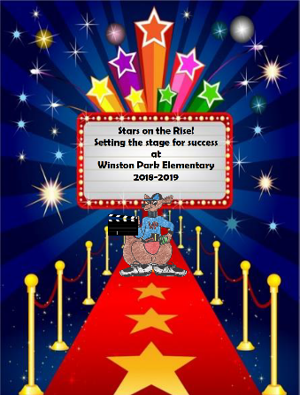
Winston Park Elementary School
A Title I school committed to learning and growing!

School Advisory Council
AGENDA
November 13, 2018

- Welcome/Introductions- Meeting called at 2:31pm by Leslie Jackson, SAC co-chair
- Principal Updates- Ms. Porter
- Exceeding Expectation Conference – recognized for meeting proficiency/learning gains *1 of 4 schools in Broward County
- Smart Bond ($100,000.00) has been allocated- laptop carts are 2:1
- Book Fair/ Literacy Night was a success *A special thank you to PTA for all the support.
- Review of October 2018 Minutes- motion to approve the minutes at 2:38pm
- School Advisory Council
  - School Improvement Plan- reviewed by Mrs. Familia
    - Has been completed, access is available through our school website; copies will be provided upon request.
    - Parents are welcome to give input on the 2018-2019 School Improvement Plan/ Title I Plan
  - Composition- review of all members completed by Ms. Jackson
  - Accountability Funds- In need of one laptop cart ($1,300.00), motion to approve this purchase/ approved at 2:44pm.

- Title One
  - Updates provided by Ms. Courtney
    - Literacy Night
    - Math Night at Publix- December 5th
    - Parent Training- “Breaking Ground with Concrete Math Strategies” (Atlantic West Elementary)- November 15th (7:00pm- 8:30pm)
      - Parent review of most recent parent training- each family received 2 books.
    - Parent Compact Letters- 96% returned
    - School Equity Action Plan- mission/vision/ demographics reviewed
    - Parents are welcome to give input on the 2018-2019 School Equity Action Plan.
- Winston Park Elementary Winter/Holiday Activities
  - Holiday Shop (PTA)
  - Publix Math Night- Dec. 5th 6:30pm – 7:30pm
  - Food Drive
  - Pennies for Patients
  - Anti-Bullying Week (Nov. 13th – 16th)
    - Parent concern about “twin day”, suggestions/ feedback noted for future theme weeks to be inclusive of all students.
- Winston Park Elementary Curriculum Updates
  - Parent informational session for ESOL parents, on Dec. 7th / tentatively scheduled at 9:00am
  - Title III money awarded ($5,000.00) for the purchase of materials for ELL students.
  - I-Zone Meeting at Tradewinds Elementary-review by Mrs. Brooks
    - Question about “safe harbors” on our campus during code red lockdown/ feedback received and noted to be shared with Officer George and safety team.
    - A Honor Roll Assembly – November 20th at 8:30am
- PTA Updates-
  - Purchased baskets for LLI kits
  - Birthday table for students
  - Dairy Queen Night (next Early Release)
- Next SAC Meeting: December 11, 2018 at 2:30 p.m.
- Meeting adjorned 3:05 at pm
- Next SAF Meeting: November 15th, parent representative will be in attendance

