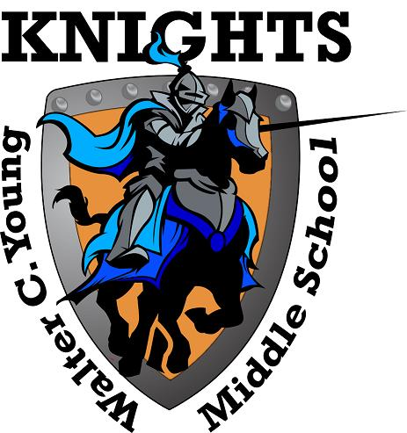
Walter C. Young Middle School
“Home of the Young Knights”
2017-2018

School Advisory Council
Agenda
Tuesday, September 11, 2019

- Welcome
- Roll Call to Establish Quorum
- Approval of May Minutes
- SAC Membership Voting
- WCY School Survey Results

- A+ Recognition Funds Ballot

- Hero Software
- Principal’s Report
- For the Good of the Group
.

SAC Meeting dates for 2018-2019 School year are
9/11, 10/9, 12/11, 1/8, 2/12, 3/12, 4/9, 5/14.

