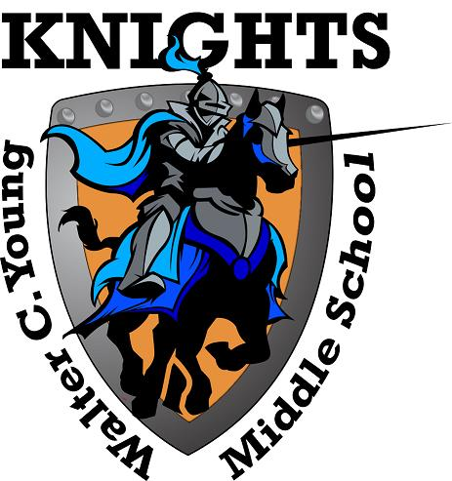
Walter C. Young Middle School
“Home of the Young Knights”
2018-2019

School Advisory Council
Agenda
Tuesday, May 14th, 2019

- Welcome
- Roll Call to Establish Quorum
- Approval of March Minutes
- Microsoft Showcase (Ms. Chanzes)
- Title I: Parent Survey Discussion and SIP Input (Ms. Evans)
  - Parent Input for parental involvement allocation for next school year.
  - Review of PFEP
  - Parent Survey Input Results
- BPIE Assessment Update (Dr. D’Ausilio)
- ESSA (Every Student Succeeds Act) Update: Tiered Support
- SAC Nominating Committee
- Principal’s Report
- For the Good of the Group
.

SEE YOU NEXT YEAR!

