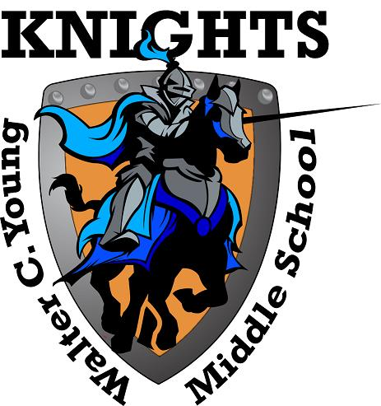
Walter C. Young Middle School
“Home of the Young Knights”
2018-2019

School Advisory Council
Agenda
Tuesday, January 8th, 2019

- Welcome
- Roll Call to Establish Quorum
- Approval of December Minutes
- School Improvement Plan Mid-Year Reflection
- Technology Updates

- Principal’s Report

- For the Good of the Group
.

SAC Meeting dates for 2018-2019 School year are as follows:

2/12, 3/12, 4/9, 5/14.

