School Advisory Council  at  Apollo  Middle  School  When  1st Wednesday of each month at 6pm  Where  Media Center  At Apollo Middle School  Website: www.browardschools1.com/apollo | 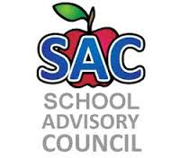  Meeting Dates:  August 29, 2018  SEptember 12, 2018  October 3, 2018  November 7, 2018  January 9, 2019  February 6, 2019  March 6, 2019  April 3, 2019  May 1, 2019

