School Advisory Council (SAC)
Standard Operating Procedural Manual

Broward County Public Schools

Veda Hudge, Director
Donna Boruch, Coordinator/School Improvement
Last Updated 9/17/15

SECTION 1: ROLE OF THE SCHOOL ADVISORY COUNCIL

SAC is part of the process for developing and writing the SIP, but not the sole agent. The SAC is the approving agent at the school level.

- Please note that the membership requirements for SAC (per state statute) are that 51% of the members cannot be employees of the School District.

- The primary role of SAC is to assist in the development of the SIP and to monitor the implementation of the School Improvement Plan. The membership is representative of the school and community and includes the Principal, teachers, community partners and parents. It meets monthly to hear subcommittee reports and make decisions as to whether SIP plan modifications need to be made. If revisions are made to SIP strategies or the SIP budget, they need to be discussed and noted
in the minutes.

Florida Department of Education

School Advisory Councils
Basic Information for SAC Members

Table of Contents

Welcome

What is the School Advisory Council’s Job? Getting Started
Developing the Plan

Florida’s Open Government Laws Your Partners in School Improvement Information Resources

Welcome

As a member of a School Advisory Council (SAC), you are a very important person. You and your fellow council members are entrusted with the improvement of your public school.

Underlying the law that created these councils is a belief that all children can learn, and that the public schools can and will change to better prepare students for today’s and tomorrow’s workplace.

Each public school is unique. It has its own community setting, resources and challenges, and most importantly, a student population unlike any other. The people best suited to decide what will be effective in helping our students learn are the people closest to each school. These are the principal, faculty, parents, students, local business people and community members. These “stakeholders” are represented on your advisory council.

The law that created School Advisory Councils was enacted in 1991 by the Florida Legislature out of concern about the effectiveness of public schools. Today, every public school has a SAC like yours to plan for school improvement and increased student achievement.

You are about to learn a tremendous amount about your school and how it works. Then, together with your fellow council members, you will use that information to come up with a plan that will help your school and its children become more successful.

What Is The School Advisory Council’s Job?

The School Improvement and Education Accountability system, which includes School Advisory Councils, sets up priorities and student performance standards that serve as guiding principles for everything the councils do.

Simply put, each School Advisory Council’s job is to look at aspects of their school as suggested by the priorities and to come up with a written plan for school improvement.

The council must look at what is known about their school and decide which areas need improvement. An analysis of student achievement and school performance data should occur. Then the SAC must decide which needs are most pressing and most important.

Next, the group will develop strategies – the “how-to” for improving the areas most important to their school. Finally, they will decide how to measure the results of what they plan to do.

The end product of this work will be a master plan for improving the school that addresses issues relative to budget, training, instructional materials, technology, staffing, student support services, school safety, discipline strategies, student health and fitness, indoor environmental air quality, and other matters of resource allocation.

Getting Started

All the members of your school advisory council, like you, were elected or chosen to represent a cross-section of the community that has a stake in the success of your school.

The different types of council members---school principal, faculty and staff, parents, students, business people, community members---represent “stakeholders” in the school and in public education. They also must be representative of the ethnic, racial and economic community served by your school.

Each SAC must adopt bylaws on their procedures.

The councils are designed to operate like teams. As the person ultimately responsible for the school, the principal is concerned with all the areas addressed by the goals.

Training is provided by school districts that are eager to help council members learn how to develop consensus, resolve conflicts, develop helpful ways to work together, and make sound decisions that are based on research and data regarding school performance.

The council will need a timeline for completing its work to meet district and state deadlines.

Council meetings should be scheduled at times convenient for most members and must be publicly announced at least 3 working days in advance of the meeting.

Minutes of SAC meetings must be recorded along with a list of members who are absent.

A quorum must be present before a vote can be taken. A majority of the SAC membership constitutes a quorum.

Other individuals, organizations and institutions in the community may be valuable as you develop your school improvement plan.

Developing the Plan

If you are a new council member, you will be part of a process that has been underway for a few years. The goal of this process is to write a School Improvement Plan for your school that follows local school district policies and guidelines.

To develop the plan, your council will:

  - Assess the need for improvement at your school by using district, state and federal goals as a guide and by reviewing student performance data.

  - Put the school’s needs in priority order.

  - Identify problems and barriers that underlie the needed improvements and their causes.

  - Identify and evaluate possible solutions and develop strategies---specific “how- to” steps---to accomplish the needed improvement.

  - Specify what will be done, when who will do it, and what resources are needed.

  - Specify precisely what results (outcomes) you expect to achieve and how they will be measured.

  - Specify which indicators of success will serve as “adequate progress” for strategies in the plan.

  - Decide how you are going to measure success.

This work can be accomplished in various formats ---work groups, subcommittees, and task forces---and may involve people in addition to SAC members from the school or community.

One of the important parts of this process is to not let your thinking be limited by the way things have been done in the past. A primary reason for the School Advisory Council is to encourage innovation. Though some education practices persist because they are effective, many excellent ideas fell by the wayside in the past because they no longer fit existing school system practices.

The intent of the School Improvement and Accountability legislation is to encourage and use strategies that work, even when they are different from what has been done in the past.

Communicate with other SACs to share ideas and support each other. You might especially want to talk with those SACs in your school’s “feeder pattern” (elementary, middle and high schools that share the same student populations).

There is no one “right way” to do your school improvement plan.

Remember that you are charged with working on what will enable your school and your students to be the best they can be.

Once the plan is developed, you need to provide an opportunity, such as a meeting at the school or a community center, to allow the public and the school community an opportunity to review the plan and offer input. Then the plan is submitted to your District School Board for approval.

The plan will be evaluated, updated and revised each year, so your school will have additional opportunities to incorporate new ideas or work on areas that were not a top priority this year.

Each Fall, the school will distribute a report to the public on how well the school did last school year and what progress was made.

Florida’s Open Government Law

Florida government at all levels operates under the principle that the public has the right to know what its government is doing.

Therefore, under the Florida Sunshine Law and the state public records law, work conducted by public officials on behalf of the citizens, and records of that work, must be available for inspection by any interested person.

As a member of a School Advisory Council you are, in effect, doing work for the public, even if you are a volunteer.

This means your SAC’s work, its plan, the information developed and/or used in writing the plan and your meetings all must be open and accessible to anyone who is interested, for whatever reason.

The vast majority of public school records and actions, with few exceptions such as labor negotiations, student records and some personnel matters, have long been public under these laws.

If you have special concerns or a specific question arises, your school principal should consult the school board attorney, who customarily handles these issues.

The Sunshine Law aside, the basic philosophy of school improvement and accountability legislation would have us involve and inform all stakeholders as much as possible in the development of a school improvement plan.

Your Partners in School Improvement

Your School District:

There are many resources to assist you and your SAC team members at the district school office in your county. The local county staff has a great deal of information and expertise

to offer your team. There is also a school improvement contact person in your district. This person can be reached at the main school district office or the Department of Education can provide you with this name and contact information.

Florida Department of Education:

This statewide agency offers technical assistance and resources to help local schools develop and implement their school improvement plans.

Information Resources

In doing your job as a SAC member, you will need information and data. This information is available from many sources, including:
  - Your school principal

  - Your school faculty and non-teaching staff members

  - Surveys of parent, students and faculty at your school

  - Reports about specific characteristics of your school and its students available from your district school board and online websites

  - Budget and program information available from your district school board

  - Students at your school

  - Your School Resource Officer (SRO) or, if you don’t have a SRO program, the law enforcement agencies that protect your school

  - Specialists who work at your school such as school nurses, social workers, guidance counselors, media specialists, technology specialists and others

  - Your school PTA/PSA/PTO and your district PTA council

  - Community groups and agencies that are actively concerned with the welfare of children and youth

  - Florida Department of Education and your district websites

Section 2: School Advisory Council Online Program
  - Go to: http:www.broward.k12.fl.us/ospa

  - Click Initiatives

  - Click School Advisory Councils

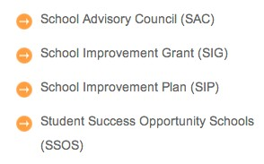

  - Click Online SAC Composition Program

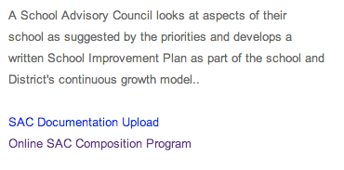
  - Enter username and password into SAC Online Program.
- Username is your school’s location number
- Password is your School’s SIP SBBC Password

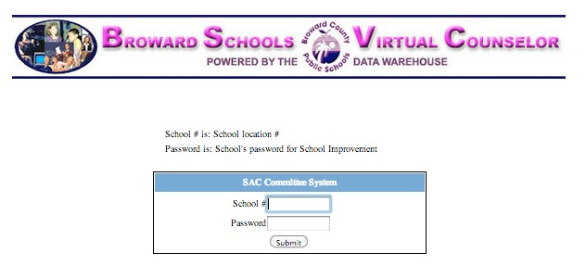
  - Committee Membership Maintenance screen appears.

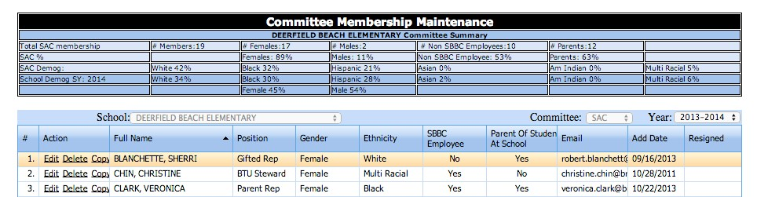

  - To Add a Member, click the ‘Add Member’ button at the bottom of your screen.

  - Document the Last Name, First Name, Position, Gender, Ethnicity, Email, SBBC Employee (yes/no), Parent of Student at School (Yes/No) and Add Date (current date). Click Update in lower right hand corner.
The individual is now added to the SAC Membership screen.

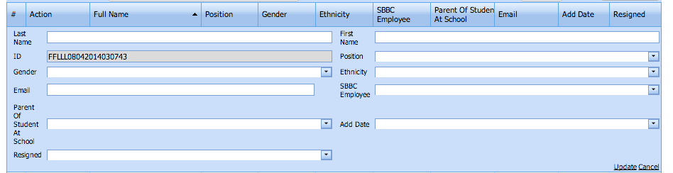

  - Under the Action column you can edit, delete or copy a member.

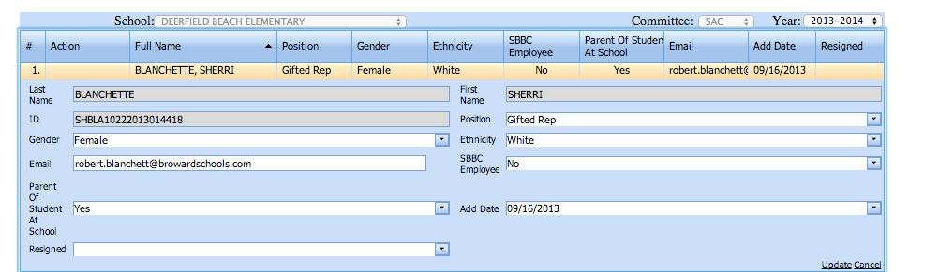
  - Click Edit to change information about an existing member. The online information that can be modified is Gender, Email, Parent of a Student at School, Position, Ethnicity, SBBC (School Board of Broward County) Employee and/or Add Date. Once completed click Update in bottom right hand corner.

      - The only reason to delete a member is if they were input by mistake or added to the membership form too many times. Do not delete a member that has resigned or been resigned from the committee, see directions below about how to resign a member.

• Providing accurate email addresses is important. Emails are often sent to the following individuals from a specialized computer program to email
accounts.
      - SAC Chairs will receive important emails from Office of Service Quality
      - SAC Members will receive surveys regarding their perception of their input into the School Improvement Plans and other SAC processes
- It is important that all email accounts are internet accounts
(Example: @browardschools.com) and accurate.

- If any non-school district employee SAC Members don’t have an email address or do not wish to provide, please input 123@abc.com as the email address. With this, the District will know that the individual member does not have an email address or chooses not to provide. These individuals will not receive emails. There is a full expectation that each SAC member will be asked to provide an email address.
- It is expected that all school district employees include their school district email address.

- Include the date a member resigns if that member voluntarily leaves the committee or misses two consecutive meetings with unexcused absences.

3: SAC COMPOSITION REPORT
The SAC Composition Report provides schools a summary of their membership to assure compliance with School Board Policy and Florida Law.
A SAC Composition Checklist is provided to assist schools and includes all required positions and guidelines (SAC Composition Checklist is provided at the end of this section).
Part I is the SAC Members Employment Status. In alignment with School Board Policy and Florida Law, the SAC Membership must be a minimum of 51% non-School Board employees.
Part II is the required SAC positions. There must be a minimum of 1 representative for each group as described.
Part III is the Race/Ethnicity Percentages Versus School Demographics. The School’s Demographics data is provided to ETS by the Demographics & Student Assignments Department after the 10th day of each school year. ETS then uploads

the data into the Online SAC Composition Program and can be viewed through the Membership Screen (see School Demog SY) or the SAC Composition Report Screen.

Committee Membership Screen:

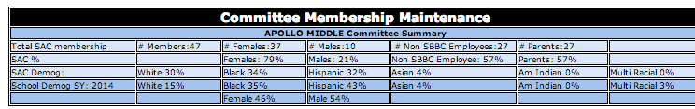
SAC Composition Report Screen:

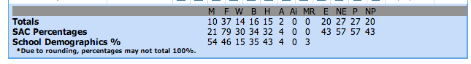

SAC Composition Report Abbreviations:

M | Male |  | B | Black/African American |  | MR | Multi-­‐Racial |  | P | Parent
F | Female |  | H | Hispanic |  | E | District Employee |  | NP | Not Parent
W | White |  | Ai | American Indian |  | NE | Not District Employee

    - The acceptable discrepancy between the SAC Membership and the School Demographics for ethnicity/race, beginning with 2014-2015 is +/-20%.
      - Using the sample data provided above the school has a School Demographic population for Hispanics of 43%. The SAC Membership is required to have a minimum of 23% and a maximum of 63% members that are of the Hispanic ethnicity.

    - The SAC Membership Screen information automatically populates from what is input in the Committee Membership Maintenance screen. Nothing on the SAC Composition Report screen is modifiable by schools; it can only be changed with changes to the Committee Membership Maintenance screen.

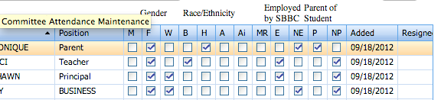

School ___________________________________

SAC Composition Checklist

Part I: Employment Status

SAC Members’ Employment Status

% Employed by District (49% or less)

% Not employed by District (51% or more)

Part II: SAC Positions

Principal (Principal is the only administrator on SAC, AP is not allowed on SAC)

Teachers

BTU Steward (or designee)

Parents

SAC Chair (Can have 2 SAC Co-­‐Chairs, but not SAC Chair and SAC Co-­‐Chair)

Innovation Zone Rep. (Must be a parent)

SAF Chairperson or designee (Must be a parent)

ESOL Rep. (Must be a parent of an ELL student at the school)

ESE Rep. (Must be a parent of an ESE student at the school)

Gifted Rep. (Must be a parent of a Gifted student at the school)

Pre-­‐K (if applicable) (Can be a teacher or parent)

Non-­‐Instructional

Community/Business Reps.

Students (Mandatory for high; optional for middle; N/A for elementary)

Community School Rep. (if applicable)

Part III: Race/Ethnicity Percentages Versus School Demographics

SAC Race/Ethnicity (Each group’s SAC percentage to be +/-­‐ 20 points of school’s demographics percentage)

 | W | B | H | A | Ai | MR
SAC Percentages
School Demographics

4: SAC MEETING SIGN-IN SHEETS

4.1: SAC MEETING SIGN­IN SHEETS FOR SAC MEMBERS
The official School Advisory Council Sign In Sheets for members and guests are to be accessed from the SAC Composition Online Program.
4.1.a. Place your mouse over Sign In Sheets

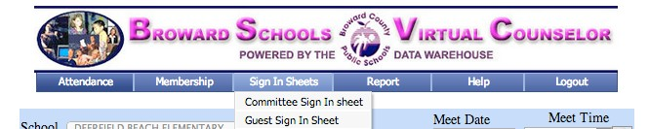

4.1.b Click Committee Sign In Sheet

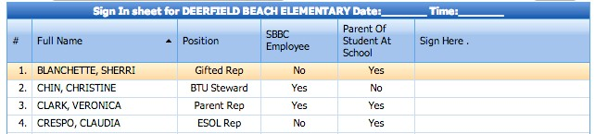
4.1.c Click Print at the center bottom of the page

    - At the SAC Meeting, have members sign this form.

5.2: SAC MEETING SIGN-IN SHEETS FOR GUESTS

4.2.a Place your mouse over Sign In Sheets

4.2.b Click Guest Sign In Sheet

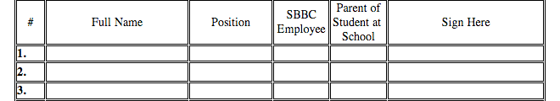

4.2.c Click Print at the center bottom of the page

    - At the SAC Meeting, have members sign this form.

Both the Membership Attendance and Guest Attendance forms are to be scanned and submitted to the District office as one file along with the Agenda and minutes of the meeting. See SAC Agenda/Minutes/Attendance Upload Directions.

4.4: RECORDING MEETING ATTENDANCE
Schools are to record attendance for each meeting in the SAC Composition Online Program. Attendance is to be documented in the SAC Composition Online Program immediately upon the conclusion of the meeting (at the latest).

5.4.a Click Attendance

5.4.b Input the date and time of the meeting

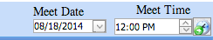

5.4.c Click in the Attended column for those in attendance

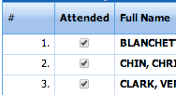
5.4.d Click the Save Button

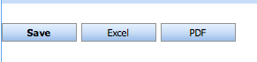

  - If you would like a downloaded version of the attendance form in Excel or PDF format you can click the Excel or PDF button.
  - In the “Attended” column within the .pdf or excel documents, if it indicates ‘False’ that means the member was not in attendance; if it indicates a ‘True’ that means the member was in attendance.

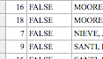

4.5: VIEWING ATTENDANCE REPORTS
The Attendance Reports screen provides a one page/screen summary of the SAC Meeting Dates, Times, registered number of SAC Members, number of SAC Members Present, confirmation that a Quorum was present and the number of parents present.
5.5.a Hover your mouse over Report and click SAC Attendance Report.

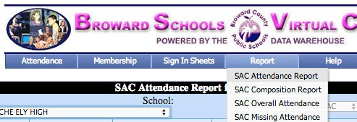

5.5.b A summary of all meetings to date for the academic year is provided.
- Note that the # of SAC Members Present and Quorum Met column are in red if 51% of the committee was not present for a meeting.
- A quorum requirement for a meeting is 51% (one more than half) of the committee being present. The 51% represents the full committee, and not a single membership group (such as parents).

If a quorum is not met a SAC Meeting can still be held for informational and/or presentation purposes, but no voting can be held.

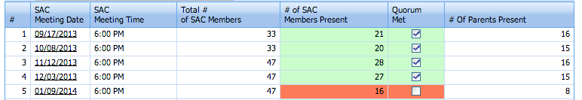

5.6: MISSING SAC ATTENDANCE REPORT
The Missing SAC Attendance Report provides school’s information to see if they are on a list of school’s that have at least one meeting where the Attendance Report is not completed in the SAC Composition Online Program.
If a school is listed in the School Column they should follow the directions for section 5: Recording Meeting Attendance.

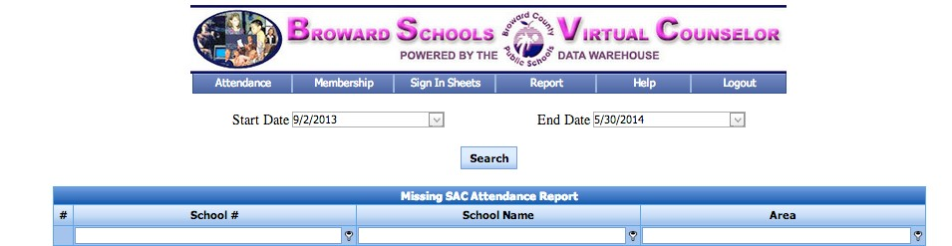

SECTION 5: SAC BYLAWS

Florida State Legislation (1001.452) in 2002 requires all School Advisory Councils to adopt bylaws annually. The following pages include the Directions for Revising School Advisory Council Bylaws and the Bylaws template.

5.1: DIRECTIONS FOR REVISING SCHOOL ADVISORY COUNCIL BYLAWS

School Advisory Councils should review their SAC Bylaws in the beginning of each year and make necessary revisions during the fall.
School Advisory Councils are to review their Bylaws and revise them using the SAC Bylaws Template.
Once the SAC Bylaws have been revised and approved, they are to be submitted through the SAC Documentation Upload Program. Schools are also expected to maintain a copy of their annual SAC Bylaws and should ensure that they are available for anyone who may wish to see them.
The Florida State Legislature enacted legislation that applies to School Advisory Councils (Florida Statute 1001.452: District and School Advisory Councils). This legislation requires that each School Advisory Council adopt bylaws which establish procedures for:
- Requiring a quorum to be present before a vote may be taken
- Requiring at least 3- days advance notice before a vote can be taken
- Scheduling meetings when parents, students, teachers, business persons, and members of the community can attend
- Replacing any member who has two unexcused consecutive absences from SAC meetings
- Recording minutes of meetings

This legislation further states that district school boards may review all proposed bylaws and shall maintain a record of minutes of council meetings.
All School Advisory Councils must adopt bylaws, which reflect all requirements included in the Florida State Statutes as well as Broward

County Public Schools School Board Policy 1403: School Improvement and Accountability.
Broward County Public Schools School Board Policy 1403 established the following criteria for a quorum: A quorum is the minimum number of members who must be present at a meeting for business to be conducted and for voting to take place. To establish a quorum, a majority of the membership of the council (more than half) must be present at the meeting.
To assist schools in complying with these requirements, the Bylaws Template is reviewed annually. All School Advisory Councils will use this template for their bylaws, which needs to be submitted to the SAC Documentation Upload Program. All of the information in the Bylaws Template, which is in a regular font, should be included exactly as it is written.
Information that is presented in italics represents choices/decisions, which individual SACs may make. All councils and committees with bylaws are required to use the District Bylaws Template.
Common misunderstandings in recent years focused on the leadership model of the SAC. Please note that schools have the flexibility to establish one of the following leadership models:
  - Chair (1)
  - Chair (1) and Vice-Chair (1)
  - Co‐Chairs (2)

Please utilize only the model your SAC has chosen and not multiple models. For example, in Article III, membership, please list only one leadership model.
The other common error also occurred in Article III. The SAF leadership choices allow for either a SAF Chair, SAF Co-Chairs, or designee. Please select one and delete the other choices. Please note it will be one person (not 2 Co-Chairs).
Another common question involves the conducting of elections for SAC Members and SAC Officers. Some schools elect members in the spring and then find out that people elected are unable to serve because of work transfers or other obligations. For this reason, schools should consider conducting elections in August/September.
As to the election of officers, this should not occur until the SAC membership is established since they have the responsibility for electing their officers.

5.2 SAC BYLAWS ONLINE TEMPLATE
6.2.a An online template is available at
- http://www.broward.k12.fl.us/ospa
- Click Initiatives
- Click School Advisory Council

6.2.b Enter username and password
Username: School Number
Password: SBBC SIP Password

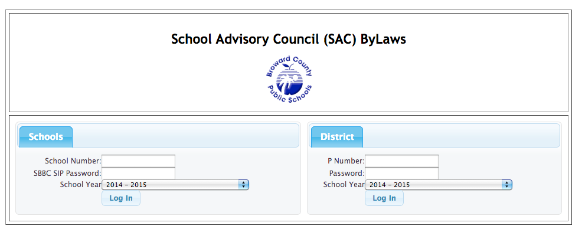
6.2.c Click New SAC Bylaws

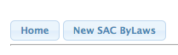

5.2.d Bylaws template opens

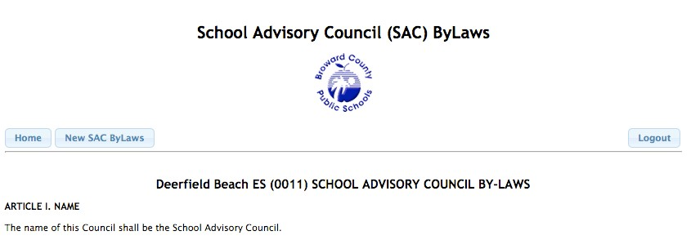

5.2.e There are only 5 required components to review/change.
- Article III Section 3. Choose the number of years for the terms of membership.

- Article IV Section I. Choose the format for Chairperson.

- Article IV Section II. Choose the meeting the officers will be elected at.

- Article IV Section II. Choose the meeting the officers will be installed at.

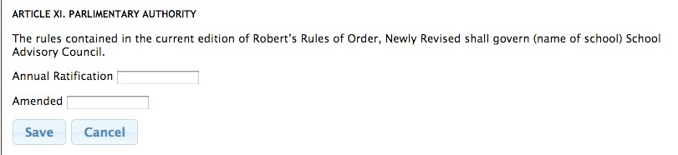
- Article XI. Parliamentary Authority. Select the date that the SAC approved the Bylaws for the school year and click Save.

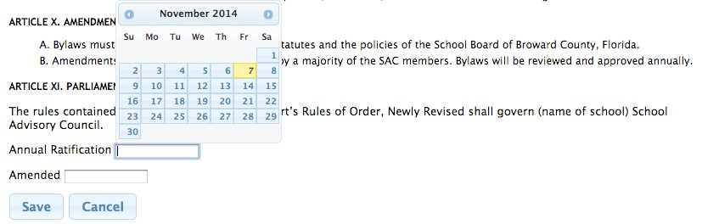

5.2.f Home screen appears. To view or edit Bylaws, click View/Edit.
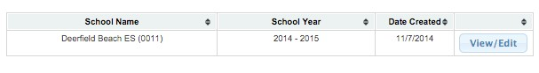

5.2.g If anything in section 6 is changed in the bylaws, go to Article XI, select an Amended date (date SAC approves change) and click Save.

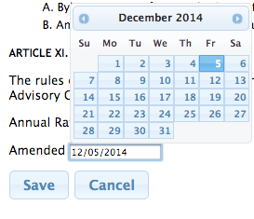

School Advisory Council (SAC) Bylaws

Home Logout

Deerfield Beach ES (0011) SCHOOL ADVISORY COUNCIL BY-LAWS

ARTICLE I. NAME

The name of this Council shall be the Deerfield Beach ES (0011) School Advisory Council.

ARTICLE II. PURPOSE

The primary objectives of the School Advisory Council (SAC) shall be to help identify needs and recommend programs of action. Through a community-wide commitment, the team will foster a positive learning environment, which sets high expectations and meets the diverse needs of the student body.

The School Advisory Council shall be a link between the school and the local community and will serve as a means for participatory management through which the various stakeholders in the school community may assist the school and the school may assist the community. The stakeholders are parents, business people, students, other community representatives, professional educators, and other school staff. The School Advisory Council shall be a resource to the school and school principal. School Advisory Council functions shall include:

A. To facilitate the development of the School Improvement Plan (SIP) B. To monitor implementation of the SIP
C. To evaluate the effectiveness of the SIP
D. To provide assistance in the preparation of the school's annual budget
E. To make recommendations as to the alignment of instructional staffing and instructional materials to support the SIP

The responsibilities and duties of the School Advisory Council will be in accordance with Florida State Statutes 1001.452 and Broward County School Board Policy 1403.

ARTICLE III. MEMBERSHIP

The School Advisory Council shall be representative of the ethnic diversity of the school's student population. In order to satisfy this requirement, the minimum standards for representation shall be as follows:

Principal Teachers
BTU Steward (or designee) Parents
I-Zone Representative (must be a parent) SAF Chair (or designee)
ESOL Parent of a student at the school ESE Parent of a student at the school Gifted Parent of a student at the school
Pre-K (if applicable - parent or certified teacher) Non-Instructional Support Employees Community / Business Representatives
Students (required on high school & adult/technical centers-optional at the middle school) Community School Representative (if applicable)

A majority (more than half) of SAC members must not be employed by the Broward County School District. Required members include the school Principal, BTU Steward, School Advisory Forum (SAF) Chair (Co-Chair) or designee, Community School Representative, ESE, ESOL, and Gifted parent representatives, and students (if applicable). The ESE, ESOL, and Gifted representative must be a parent of a student at the school. One SAC parent member will be elected as an Innovation Zone (IZ) representative.

SAC members will be elected by their respective peer groups (parents elected by parents, teachers by teachers, etc.) Vacancies will be filled by special elections as needed in the same general manner. Changes in the SAC Composition during the school year must be approved by the Office of Service Quality and noted in SAC meeting minutes.

If the elected team is not representative of the school community, as determined by the Principal and/or the Chief School

Performance & Accountability Officer, the district school board shall appoint additional members to achieve proper representation.

All stakeholders are invited to attend SAC meetings as non-voting participants without regard to membership on the SAC.

Section 1. Voting: In accordance with the Sunshine Law, a vote of the membership will be taken. All votes must be conducted orally. All members of the Council shall have one vote each. A voting member must be present (in person, by phone, or Skype/Facetime/Google Hangout, Etc.) to vote. (See Section Article VI, Section 9.)
Section 2. Term of Membership: Members of the SAC should attend SAC meetings on a regular basis. A SAC member will be removed from membership after two (2) unexcused consecutive absences from properly noticed SAC meetings. Vacancies will be filled as described above.
Section 3. Length of Term: Members of the School Advisory Council shall be elected for One-year term(s).
Section 4. Announcement of an election must be made to the various peer groups at least one week in advance. Announcements will be distributed in a manner that ensures the widest dissemination possible within the peer group.
Section 5. Election of the faculty representatives will take place at a scheduled general faculty meeting. Section 6. Election of the parent representatives will take place at a scheduled general meeting of parents.

ARTICLE IV. OFFICERS

Section 1. Officers of this committee will consist of a Chairperson and secretary. Section 2. The officers shall be elected annually at the August meeting.
Section 3: Installation of new officers will be held at the First meeting of the school year.
Section 4: If for any reason, an officer is unable to complete the term of office, a new election will be held at the next meeting. Section 5. Nominations of SAC Officers:
A. There shall be a nominating committee composed of three members who shall be elected by the School Advisory Council at a regular meeting. The committee shall consist of at least one, but not more than two, of current elected officers and the remainder from the general membership.
B. The nominating committee will present a slate of candidates for each office at which time nominations from the floor will be taken.
C. Nominations for officers will be made from the floor at a School Advisory Council meeting.

ARTICLE V: DUTIES OF THE OFFICERS

A. The shall preside at all meetings of the Council and will be an ex-officio member(s) of all committees except the nominating committee. The will prepare an agenda at least 7 days in advance for all meetings. A copy of the agenda shall be provided to anyone who requests it. The or designee shall represent SAC at Area Advisory meetings and as a voting member of the school's School Advisory Forum (SAF). The will represent the SAC at District meetings and/or workshops and may choose a designee to attend as necessary. The SAC will sign the school's annual budget (per District Budget Guidelines) as an indication of SAC participation in both processes.
B. The duties of the Vice-Chair shall be to represent the Chair in his/her assigned duties, and to substitute for the Chair during his/her absence, and to perform such other duties as may be assigned to him/her by the Chair or the School Advisory Council.
C. The Secretary shall be responsible for all correspondence and notices of meetings. The Secretary shall keep the minutes of all meetings and assure that copies of the minutes are distributed in a timely manner to Council members. Minutes will be made available to any stakeholder who requests them. The Secretary will keep an accurate record of attendance at all meetings as well as a current roster of all stakeholders.

ARTICLE VI. MEETINGS

The School Advisory Council shall meet regularly and the schedule of meetings for the year will be determined and published in September for the current school year. The SAC and School Advisory Forum (SAF) will schedule a joint meeting semi-annually. Notification of all regular meeting places will be included in the minutes.

Section 1. Guests: All meetings are open to the public under the Florida Sunshine Law; however, nonmembers / guests may not vote on School Advisory Council issues.
Section 2. Attendance of SAC members will be kept for all meetings. The Secretary or a designee will take attendance. Attendance records will be sent to the Area Superintendent.
Section 3. Minutes of all meetings will be recorded by the Secretary or a designee. Minutes will be sent to the Area Superintendent, kept on file at the school and posted for public view. Minutes of the previous meeting will be approved at the next meeting, with any additions or corrections noted.

Minutes will reflect all motions (including: maker of the motion, person seconding and the results of the vote) and any decisions made.
Section 4. Special meetings may be called by the or by notice of any three (3) members in writing to the .
Section 5. All scheduled meetings, meeting times, and places will be announced at least three days in advance. Any matter that is scheduled to come before the council for a vote requires at least 3 days advance written notice to all SAC members. Members must be advised of a change in the established date, time or location. All special meetings will require notification.
Section 6. SAC meetings will be scheduled at times and locations convenient for all stakeholders (parents, students, teachers, business persons, and members of the community).
Section 7. A quorum is the minimum number of members who must be present at a meeting for business to be conducted and for voting to take place. To establish a quorum, a majority of the membership of the council (more than half the members) must be present at the meeting.
Section 8. SAC meetings will follow the approved agenda. Each item on the agenda will be discussed to the satisfaction of the members present. SAC meeting discussions will be restricted to those topics on the agenda. Other matters will be deferred to another SAC meeting, to the School Advisory Forum, the PTA/PTO, or the principal.
Section 9. Voting will be conducted orally by asking all in favor to say "Yea" and those opposed to say "Nay". If there is any doubt as to whether or not there is a majority for or against the vote, a roll call must be taken. Voting on high-stakes issues such as

Recognition Funds and Waivers shall be conducted by a roll call. All votes will become part of the minutes. Alternates and proxy votes are not permitted (per Florida's Sunshine Law). All votes will be scheduled early in the beginning of the agenda.

ARTICLE VII. COMMITTEES

A. The shall create such committees as may be required to promote the objectives of the School Advisory Council. B. Committees may include other stakeholders not belonging to the SAC.
C. The SAC an ex-officio member(s) of all committees except the nominating committee.
D. All committees shall bring recommendations to the School Advisory Council at the monthly Council meeting.

ARTICLE VIII. UTILIZATION OF SCHOOL IMPROVEMENT FUNDS

A. A portion of the Education Enhancement Trust Fund (lottery money) is distributed to the school (through the District) for the SAC to use for programs and projects to enhance school performance through the implementation of the SIP.
B. Per the General Appropriations Act, Accountability Funds may not be used for capital improvements or for projects or programs with a duration of more than one-year. A principal may not override the selection of the use of the money.
C. School-based decisions concerning the distribution of School Recognition Funds will be the responsibility of the SAC in accordance with procedures established by the District.

ARTICLE IX. SAC TRAINING AND ACTIVITIES

A. SAC members will have opportunities to engage in training activities and workshops to build the team, orient new members, develop skills, assist in the annual budget process, and gain a better understanding as to their roles in the school improvement process.
B. School-based accountability funds may be used to support appropriate training.
C. Members of the SAC will take an active role in the development, implementation and evaluation of the School Improvement Plan. Members will participate in monitoring the progress of the SIP and will assist in completing a needs assessment each year to determine how best to revise the current SIP.
D. The SAC will have access to the necessary data to successfully complete the SIP, including budgets, staffing levels, instructional materials, and test data. School personnel, as directed by the principal, may assist the SAC in gathering and interpreting data.
E. The SAC and its officers will follow all District policies, state rules, and state statutes in conducting its business.

ARTICLE X. AMENDMENTS

A. Bylaws must conform to the State of Florida statutes and the policies of the School Board of Broward County, Florida.
B. Amendments to the bylaws will be approved by a majority of the SAC members. Bylaws will be reviewed and approved annually.

ARTICLE XI. PARLIAMENTARY AUTHORITY

The rules contained in the current edition of Robert's Rules of Order, Newly Revised shall govern (name of school) School Advisory Council.

Annual Ratification

Amended

Save
Cancel

SECTION 6: SAMPLE MONTHLY SAC AGENDAS FOR ELEMENTARY, MIDDLE AND CENTER SCHOOLS

The following pages are sample Monthly SAC Agendas that include items expected to be discussed. In addition to the noted items SAC members are welcome to request additional items be added through the SAC Chair(s).
The monthly SAC Agendas/Minutes/Sign‐In Sheets must be submitted to the SAC Documentation Upload Program.

6A: SAMPLE SAC AGENDA (OPTIONAL MEETING) FOR ELEMENTARY, MIDDLE AND CENTER SCHOOLS
SCHOOL NAME: ___________________________ SCHOOL ADVISORY COUNCIL AGENDA
Date: _______________________________________

  - Roll Call to Establish Quorum
  - SAC Membership Voting
  - Approval of Minutes from Final Meeting in 2013-2014 Academic Year
  - Meeting dates for 2014-2015
  - SMART initiative
  - Innovation Zone Showcase
  - School Improvement Plan results from Monitoring Timeline section of 2013-2014 Plan
  - Review of Accreditation Self-Assessment Results from 2013-2014 School Improvement Plan
  - Accreditation Training Plan (see Accreditation Standard Operating Procedural Manual)
  - Review 2014-2015 School Improvement Plan Template
XI. Additional school business related to improving student achievement can be added beginning here
6B: SAMPLE SAC AGENDA FOR ELEMENTARY, MIDDLE AND CENTER SCHOOLS
SCHOOL NAME: ___________________________ SCHOOL ADVISORY COUNCIL AGENDA
Date: _______________________________________
- Roll Call to Establish Quorum
- Approval of Minutes
- SAC Membership Voting (if not done in optional August meeting)
- Meeting dates for current academic year (if not discussed in optional August meeting)
- SMART initiative
- Innovation Zone Showcase
- School Improvement Plan results from Monitoring Timeline section of expiring SIP (if not finalized in optional August meeting)
- School Improvement Plan Development
- Review of Accreditation Self-Assessment Results for expiring School Improvement Plan (if not reviewed in optional August meeting)
- Accreditation Training Plan (discuss plan for educating community on Accreditation; see Accreditation Standard Operating Procedural Manual)
XII. Additional school business related to improving student achievement can be added beginning here
Once the prior month’s minutes are approved the Agenda from the prior month, minutes and sign­in sheets are to be scanned as one file and submitted to the SAC Documentation Upload Program.

6C: SAMPLE SAC AGENDA FOR ELEMENTARY, MIDDLE AND CENTER SCHOOLS
SCHOOL NAME: ___________________________ SCHOOL ADVISORY COUNCIL AGENDA
Date: _______________________________________

- Roll Call to Establish Quorum
- Approval of Minutes
- SMART initiative
- Innovation Zone Showcase
- School Improvement Plan Approval
- Accreditation Training Plan Implementation (see Accreditation Standard Operating Procedural Manual)
- Waiver Concept Vote of Support (only for SACs and Schools considering applying for a new Waiver)
- SAC Bylaws Proposal/Approval
- Additional school business related to improving student achievement can be added beginning here
Once the prior month’s minutes are approved the Agenda from the
prior month, minutes and sign-­in sheets are to be scanned as one file and submitted to the SAC Documentation Upload Program.
For this month alone, given the SIP was voted/approved and documentation is needed to prepare for School Board approval, scan and submit as one file the Agenda, draft of the Minutes and Sign-In Sheets to the SAC Documentation Upload Program. When the minutes are approved next month you can re-submit the file again.

SECTION 7: SAMPLE MONTHLY SAC AGENDAS FOR HIGH SCHOOLS
The following pages are sample Monthly SAC Agendas that include items expected to be discussed. In addition to the noted items SAC members are welcome to request additional items be added through the SAC Chair(s).
The monthly SAC Agendas/Minutes/Sign-In Sheets must be submitted to the SAC Documents Upload Program.

7A: SAMPLE SAC AGENDA FOR HIGH SCHOOLS
SCHOOL NAME: ___________________________ SCHOOL ADVISORY COUNCIL AGENDA
Date: _______________________________________

- Roll Call to Establish Quorum
- SAC Membership Voting
- Approval of Minutes from Final Meeting in 2013‐2014 Academic Year
- Meeting dates for 2014-2015
- SMART initiative
- Innovation Zone Showcase
- School Improvement Plan Monitoring (discuss some component of the SIP)
- Accreditation Self-Assessment Monitoring (choose 1 of the 5 standards from the Self-Assessment; Discuss the school’s plan for continuous improvement in alignment with the standard)
IX. Additional school business related to improving student achievement can be added beginning here

7B: SAMPLE SAC AGENDA FOR HIGH SCHOOLS
SCHOOL NAME: ___________________________ SCHOOL ADVISORY COUNCIL AGENDA
Date: _______________________________________
- Roll Call to Establish Quorum
- Approval of Minutes
- SAC Membership Voting (if not done in optional August meeting)
- Meeting dates for 2014-2015 (if not discussed in optional August meeting)
- SMART initiative
- Innovation Zone Showcase
- School Improvement Plan Monitoring (discuss some component of the SIP)
- Accreditation Self-Assessment Monitoring (choose 1 of the 5 standards from the Self-Assessment; Discuss the school’s plan for continuous improvement in alignment with the standard)
- Accreditation Training Plan (discuss plan for educating community on Accreditation; see Accreditation Standard Operating Procedural Manual)
- Other school related business can be added beginning here
Once the prior month’s minutes are approved the Agenda from the
prior month, minutes and sign-­in sheets are to be scanned as one file
and submitted to the SAC Documentation Upload Program (see Section 8).

SECTION 8: SAC DOCUMENTATION UPLOAD PROGRAM

This program will be used to upload documentation for:
  - A+ Funds
  - Accreditation
  - SAC Agenda/Minutes/Sign In Sheets
  - Waiver Applications

Each month’s SAC Meeting Agenda, Minutes and Sign‐In Sheets (members and guests) are to be scanned and uploaded into the District’s SAC Documentation Upload Program for archiving purposes.

The monthly file of the SAC Meeting Agenda, Minutes and Sign In Sheets (members and guests) are to be submitted no later than one month after the meeting. This will allow time for the minutes to be approved at the subsequent meeting. The one exception to this is the meeting that the School Improvement Plan is approved. For this meeting the SIP is approved the Agenda, draft Minutes and Sign In Sheets (members and guests) are to be uploaded immediately (this is needed in order to prepare the SIP for presentation to the School Board for approval). At the subsequent meeting that the minutes are approved the same file with the approved minutes can be re‐uploaded to the SAC Documentation Upload Program.

9.1: UPLOADING SAC AGENDA/MINUTES/SIGN IN SHEETS AND BYLAWS

9.1.a Go to: http:www.broward.k12.fl.us/ospa

8.1.b Click Initiatives

8.1.c Click School Advisory Councils

8.1.d Click link next to SAC Documentation Upload

8.1.e Enter username and password
- Username: School Number
- Password: SBBC SIP password (not 06+school location number).
If you have forgotten your SIP password, contact your administration. The Office of Service Quality Instructional Facilitator assigned to your cadre is also available to provide the SBBC SIP password to school administration as needed.

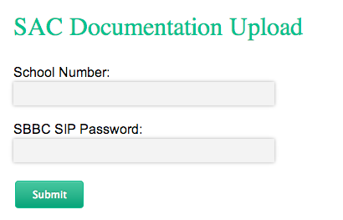

8.1.f Click Upload File

8.1.g Be sure to name the file on your computer as follows:
- For SAC Agendas/Minutes/Sign In Sheets (scan and submit as one file):
SchoolLocationNumber__AgendaMinutesSignIn_Date

Ex. 0011_DeerfieldBeachES_Agenda_091514

- For SAC By-Laws: SchoolLocationNumber_SAC_Bylaws_Date Ex. 0011_DeerfieldBeachES_Bylaws_111314

8.1.h After the mm/dd/yyyy click the down arrow for a calendar to appear in order to select the date that Meeting was held

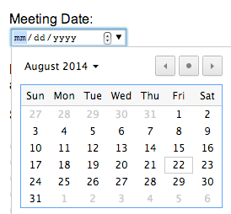

8.1.i Document if the file being submitted is for A+ Funds, SAC ByLaws, SIP/Developed, SIP/Approved, SIP/Monitored or Waiver and click Submit

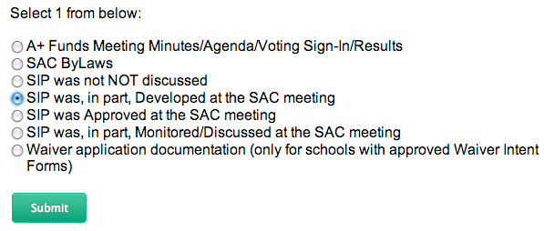

For school’s using the Broward School Improvement Plan Template (schools with Florida Department of Education assigned letter grades of A, B or C) completing this step along with the calendar date will permit your SAC Agenda/Minutes/Sign-In Sheet file to become public record by becoming part of your School Improvement Plan. If you go to your School Improvement Plan Section 1 (upon submission) you will see links with dates in alignment with the date selected. If you click the link it will open your SAC Agenda/Minutes/Sign-In Sheet file.

Schools can copy and paste the website address from the link or file and also use it to post on your school’s website, in effect having the links point to the same files uploaded into the Documentation Upload

Program.

If a Focus or Priority School (schools with Florida Department of Education assigned letter grades of D or F) would like the same links they, too, can go to the Broward School Improvement Plan Template for their school and follow these same directions (although the school will not be completing the Broward SIP Template due to requirements to complete the Florida Department of Education SIP Template). Nevertheless, the links will be available to them on the Broward SIP template made available to them.

8.1.j Click Choose File

8.1.k Select file from your computer and click Upload

8.1.l You will receive a message: File Uploaded

8.2: VIEWING UPLOADED FILES
To view files submitted/archived in the SAC Documentation Upload Program follow the directions below.
8.2.a Click View Files

8.2.b A list of documents submitted the current school year is available for viewing.
  - The archived files can be sorted by School Number, File Name, Meeting Month, Document Type and Upload Date by clicking on the column heading
  - Clicking the links in the File Name column will download the file to your computer.

  - Clicking the link under the Meeting Month or Document Type columns will permit your to revise the Meeting Month and/or Document Type by selecting the correct information through the appropriate pull-down and clicking Save.

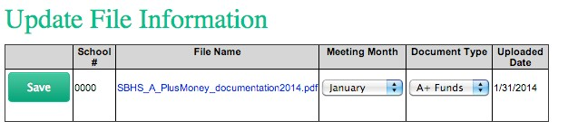

SECTION 9: VOTING ISSUES FOR SCHOOL ADVISORY COUNCILS
Upon advice of School Board General Counsel, the Guidelines for Policy 1403 have been revised to include procedural guidelines for voting by School Advisory Council (SAC) members.

Per Florida State Statute 286.012, School Advisory Council members must vote on all issues brought before the council, unless they have a conflict of interest, and in that case must comply with the conflict of interest requirements set forth in section 112.3143, Florida Statutes.

If a conflict of interest exists, the council member is required to follow the procedures set forth in the conflict of Interest form (Form 8B located in the Broward County Public Schools School Board Policy 1403 –A: School Accountability and Improvement Guidelines) as to the time for disclosure of the conflict of interest and the time for filing Form 8 B. Form 8B (Conflict of Interest Form) must be kept on file with the SAC agenda, be incorporated into the SAC meeting minutes and be read at the next SAC meeting. In addition, a copy of the completed form must be provided immediately to the other members of the council.

Form 8B provides two procedures for appointed officers as stated below.

- If the member makes "any attempt to influence the decision prior to the meeting" - the member has to fill out and file Form 8B and give it to the clerk before making any attempt to influence the decision -- this means before the meeting.

- If the member makes "no attempt to influence the decision except by discussion at the meeting" then the member has to disclose the nature of the conflict before participating in the discussion (before trying to influence anyone) and must complete and file Form 8B within 15 days after the vote.

- Note that even though members are prohibited from having discussions before the meeting (as it would be a violation of the Sunshine Law), they are allowed to disseminate information (handouts, articles, memos) as long as no response (no dialog) takes place outside of the Sunshine.

In response to questions raised regarding voting on School Recognition Program proposals by SAC members who are BCPS employees, School Board General Counsel has advised that no voting conflict exists when staff members vote on the distribution of the school recognition funds if such distribution is based on a uniform criteria or formula, creating no “special private gain” to a particular person. (See memorandum dated 1/10/11 located on the next page).

THE SCHOOL BOARD OF BRO WARD COUNTY , FLORIDA
OFFICE OF TH E SCH OOL BOA R D ATTOR N EY
  - V.'RIGI IT AD!'.ilNISTRATION BUILDING 600 SOUTHEAST THIRD AVENUE. I ITH FLOOR FORT LAUDERDALE. FLORIDA 3330I
Telephone:(754) 32 I-2050 facsimile. (754) 32 1-2705

M E M O R A N D UM

TO: FROM :
James F. Notter, Superintendent of Schools

Robert Paul Vignola, Deputy General Counsel, and Ana l. Segura Assistant General Counsel '·

DATE : January 10, 2011

SUBJECT: Request for Legal Opinion -School Advisory Councils Distribution of School Recognition Financial Awards - Conflict of Interest

This memorandum is in response to the question below raised by Mr. James McDem1ott, principal of Forest Glen Middle School:

Question:

Whether the school staff members who serve on the School Advisory Council (SAC) are required to abstain from voting, pursuant to §ll2.3143(3)(a). Fla. Stat., when the SAC votes on the distribution of recognition award funds pursuant to §1008.36(4), Fla. Stat., if the allocation of said funds results in a personal gain to the staff member.

Answer:

No, provided that there is no "special private gain…to the staff member.

Analysis:

The Florida School Recognition Program (§1008.36) provides financial awards and delineates their distribution as follows:

- All selected schools shall receive financial awards depending on the availability of funds ... Funds must be distributed to the schools fiscal agent and placed in the school's account and must be used for purposes listed in subsection (5) as determined jointly by the school 's staff and school advisory council. If school staff and the school advisory council cannot reach agreement by February 1, the awards must be equally distributed to all classroom teachers currently teaching in the school. . . .
- School recognition awards must be used for the following:

  - Nonrecurring bonuses to the faculty and staff;
  - Nonrecurring expenditures for educational equipment or materials to assist in maintaining and improving student performance; or
  - Temporary personnel for the school to assist in maintaining and improving student performance. (Emphasis added.)

The Florida Commission on Ethics has recently addressed this situation in CEO 10-21 (September 8, 2010) concluding that the voting staff member does not have a voting conflict when voting for a "uniform" distribution of the recognition funds to the school staff because there is no "special" gain to that member. The Commission reasoned that the statutory language shows legislative intent for the school "staff [to] be a part of the membership of SAC and also receive recognition funds." Florida law allows "SAC members to direct public (A plus) moneys to school staff generally ... notwithstanding that a SAC member would, as a member of the school's staff, receive a staff allocation of the moneys." (CEO 10-21) The Commission cautioned that the answer may be different if the distribution of funds were to be for "particular persons or customized amounts."

In other words, a "special private gain" situation may arise, for example, if the SAC were to vote on a proposal to distribute all or a substantial portion of the recognition funds to the school principal. In such a case, the school principal would be required to abstain from voting in compliance with § 112.3143 (complete the Voting Conflict Form (Form 8B) and file it with the clerk of the School Advisory Council within 15 days of the date of the vote.) If any such circumstance arises, please contact our office for further guidance.

In summary, no voting conflict exists when staff members vote on the distribution of the school recognition funds if such distribution is based on a uniform criteria or formula, creating no "special private gain" to a particular person.

RPV:AIS/as

C: Area Superintendents

2

SECTION 10: USE OF ACCOUNTABILITY FUNDS
Florida Statute indicates that Accountability Funds shall be used to “develop and implement” the School Improvement Plan. It is the legislative intent that these funds will enhance rather than supplant dollars and programs already in existence.
The School Advisory Council (SAC) is responsible for determining how these funds will be appropriated. To designate accountability funds, SAC must vote on each item. If changes occur as to how the funds will be utilized, these changes must be indicated in the SAC minutes. The total allocation of Accountability Funds should be utilized annually to promote the school’s written objectives and action steps.
Effective 2008-09, the school will be funded in the amount of $5.00 per un-weighted FTE for Accountability.

“Do’s and Don’ts”
  - Must be tied to programs/activities in the School Improvement Plan

  - Must be used to enhance student performance

  - May be expended only on programs or projects selected by the School Advisory Council (SAC)

  - May be used for student incentives (i.e., certificates/plaques) but not for items unrelated to education.

  - Principals may not override the recommendations of the SAC

  - May not be used for capital improvements

  - May not be used for any project or program that has a duration of more than 1 year (however; a SAC may independently determine that a program or project formerly funded should receive funds in a subsequent year)

  - May not be used to pay a bonus to an individual for performing the duties of chairperson of SAC

  - May not be used for food

  - Always ask: “Will this expenditure improve student achievement and the implementation of the SIP?”

SECTION 11: SAC RECRUITMENT SURVEYS

Broward County Public Schools School Board Policy 1403: School Improvement and Accountability discusses that:
School Advisory Councils (and schools) are to make every effort to encourage parent/community participation on SAC by scheduling meetings at a time that

- School Advisory Councils (and schools) are to make every effort to encourage parent/community participation on SAC by scheduling meetings at a time that accommodates parent/community participation.
- The SAC is to disseminate a survey in the spring to determine the best time of day for conducting SAC meetings. This survey should be sent home to parent, posted on the school’s website and disseminated to all personnel at the school. (A sample survey is provided to facilitate this process.) Highlighted items in the sample survey must be edited by each school to provide correct school-specific information.

Microsoft Word documents of the sample surveys are available online as follows:

English Language SAC Recruitment Sample Survey

Spanish Language SAC Recruitment Sample Survey

Haitian Creole Language SAC Recruitment Sample Survey

Portuguese Language SAC Recruitment Sample Survey

SAMPLE ELEMENTARY SCHOOL

2011-2012 www.samplelementary.com (754) 321-1234
ISSUE I

PARENTS….WE NEED YOU!

Currently, the 2011/2012 School Advisory Council members are working diligently on the New Member Recruitment Drive for the upcoming school year. The mission of Sample Elementary’s Advisory Council is to assist in the development and monitoring of the School Improvement Plan and to advise the administration with decisions in matters that will academically and economically better the school by acting as a liaison between the community and the school. Council members are required to attend monthly meetings (2nd Wednesday) and are expected to represent the best interests of our students and school.

IF YOU WOULD LIKE TO:
- Strive for excellence as a school leader
- Support our school as an advocate for students
- Assist with the annual school budget
- Promote a school, family, and community network to share and discuss pertinent issues concerning our students academic achievement

THEN BECOME A MEMBER OF THE 2012/2013 SCHOOL ADVISORY COUNCIL!

Please complete the SAC interest survey at the bottom of this flyer and return it to your child’s teacher by Friday, May 26, 2012. If you have additional questions, please contact Mrs. McCall, SAC Chair at 754-321-1234.

SAMPLE ELEMENTARY SCHOOL ADVISORY COUNCIL INTEREST SURVEY

I am interested in becoming a 2012/2013 SAC member.

Name of Parent(s): Phone #:

Email address:

Name of Student(s):

What time of day would be best for you to meet for monthly SAC meetings? (Please check one) Early AM (7:00-8:00) After School Evening (5:00 – 7:00)

(Spanish)

SAMPLE ELEMENTARY SCHOOL

2011-2012 www.samplelementary.com (754) 321-1234
ISSUE I

¡PADRES….LOS NECESITAMOS!
Actualmente, los miembros del Consejo de Asesoramiento Escolar (School Advisory Council) de 2011/2012 están trabajando con diligencia en la Campaña de Reclutamiento de Nuevos Miembros para el próximo año escolar. La misión del Consejo de Asesoramiento de (Sample Elementary) es ayudar al desarrollo y la supervisión del Plan de Superación Escolar y aconsejar a la administración sobre temas que mejorarán académica y económicamente a la escuela al actuar como contacto entre la comunidad y la escuela. Se le exige a los miembros del Consejo que asistan a reuniones mensuales (el 2ºmiércoles) y se espera que representen los intereses de nuestros estudiantes y de nuestra escuela.

SI USTED ESTÁ INTERESADO EN:
  - Esforzarse por conseguir la máxima calidad educativa como líder escolar
  - Apoyar a nuestra escuela como intercesor de los estudiantes
  - Ayudar con el presupuesto anual escolar
  - Promover a una escuela, familia y red comunitaria para compartir y discutir temas concernientes al rendimiento académico de nuestros estudiantes.

¡HÁGASE MIEMBRO DEL CONSEJO DE ASESORAMIENTO ESCOLAR DE 2012/2013!

Por favor llene la encuesta sobre su interés en SAC que aparece en la parte inferior de este volante y entréguesela a la maestra de su hijo el viernes, 26 de mayo de 2012 a más tardar. Si tiene preguntas adicionales, por favor contacte a Mrs. McCall, SAC Chair al 754-321-1234.

ENCUESTA SOBRE SU INTERÉS EN EL CONSEJO DE ASESORAMIENTO DE (SAMPLE ELEMENTARY SCHOOL)
Yo estoy interesado/a en ser miembro de SAC en 2012/2013.

Nombre del/de los padre(s): Email: Nombre del/de los of estudiante(s):
# de teléfono:

¿A qué hora del día le convendría más asistir a las reuniones mensuales de SAC? (Por favor marque una)
Temprano por la mañana (7:00-8:00) Después de la escuela Por la noche (5:00 – 7:00)
MEPSD<SP#83/gnm/5/10>
Document translated by Multicultural, ESOL and Program Services Department (5/10)

SAMPLE ELEMENTARY SCHOOL
(Haitian Creole)

2011-2012 www.samplelementary.com (754) 321-1234

FANMI….NOU BEZWEN-OU!
(Parents …. We need you!)
ISSUE I

Kounye-a, manm 2011/2012 School Advisory Council (Komite konsiltatif lekòl) ap travay avèk dilijans sou Kanpay rekritman nouvo manm pou anne eskolè kap vini-an. Misyon Komite konsiltatif lekòl-la se ede nan devlopman Plan Amelyorasyon lekòl (School Improvement Plan) epi veye aplikasyon-li. Komite-a konseye direksyon-an lè gen desizyon ki pou pran nan keksyon akademik ak ekonomik ki ka amelyore lekòl-la. Komite-a ranpli wòl-sa-a lè li aji kòm lyezon ant kominote-a epi lekòl-la. Yo mande tout manm ki nan Komite-a patisipe nan reyinyon kap fèt chak mwa (dezyèm mèkredi) epi yo atann yo chak reprezante meyè enterè elèv-nou-yo ak enterè lekòl-nou.

SI OU TA RENMEN:
- Lite epi patisipe nan efò ekselans kòm yon lidè lekòl
- Sipòte lekòl-nou kòm yon reprezantan anfavè elèv
- Asiste nan preparasyon bidjè anyèl lekòl-la
- Pwomouvwa yon rezo kominikasyon ant lekòl, fanmi, ak kominote pou pataje epi diskite keksyon enpòtan konsènan reyisit akademik elèv-nou-yo.

KIFÈ OU KAPAB VIN YON MANM 2012/2013 KOMITE KONSILTATIF LEKÒL-LA!

Tanpri konplete SAC keksyonnè sou sa ki enterese fanmi. Keksyonnè-a anba fèy-sa-a epi retounen-ni bay pwofesè pitit-ou pa pita pase vandredi, 26 me, 2012. Si ou gen plis keksyon, kontakte Mrs. McCall, SAC Chair (Prezidan) nan nimewo 754-321-1234.

KONSÈY KONSILTATIF LEKÒL KEKSYONNÈ SOU SA KI ENTERESE FANMI
(Sample Elementary School Advisory Council Interest Survey)

Mwen enterese vin yon manm komite 2012/2013 SAC.

Non manman / papa: # telefòn:

imel adrès:

Non elèv-la, elèv-yo:

Ki lè nan jounen-an ki ta pi bon pou ou pou patisipe nan reyinyon SAC chak mwa? (Tcheke youn) Maten bonnè (7:00-8:00) Apre lekòl Aswè (5:00 – 7:00)

MEPSD<HC#175/is/05/10 Document translated by Multicultural, ESOL and Program Services Department (05/100

SAMPLE ELEMENTARY SCHOOL
(Portuguese)

2011-2012 www.samplelementary.com (754) 321-1234

PAIS….PRECISAMOS DE VOCÊS!
ISSUE I

No momento, os membros do Conselho Consultivo Escolar (School Advisory Council) de 2011/2012 estão trabalhando arduamente na Campanha de Recrutamento de Novos Membros para o próximo ano letivo. A missão do Conselho Consultivo da Sample Elementary é de auxiliar no desenvolvimento e acompanhamento do Plano de Melhoramento Escolar e de aconselhar a administração nas decisões referentes a assuntos que irão melhorar a escola tanto academicamente como financeiramente, atuando como um intermediário entre a comunidade e a escola. Requer-se que os membros do Conselho participem das reuniões mensais (2ª quarta do mês) e espera-se que os mesmos representem os interesses de nossos estudantes e da escola.

SE VOCÊ DESEJAR:
- Almejar a excelência como líder escolar
- Dar apoio à nossa escola como representante dos estudantes
- Auxiliar no orçamento escolar anual
- Promover uma rede de comunicação entre a escola, a família e a comunidade para compartilhar e discutir assuntos referentes ao rendimento acadêmico de nossos estudantes

ENTÃO TORNE-SE UM MEMBRO DO CONSELHO CONSULTIVO ESCOLAR DE 2012/2013!

Favor preencher a pesquisa do SAC abaixo e devolver ao professor de sua criança até sexta-feira, 26 de maio de 2012. Se você tiver alguma pergunta, favor entrar em contato com Mrs. McCall, SAC Chair, no número 754-321-1234.

PESQUISA DO CONSELHO CONSULTIVO ESCOLAR DA SAMPLE ELEMENTARY

Estou interessado(a) em ser membro do SAC de 2012/2013.

Nome do(a) Pai/Mãe: Telefone #:

Endereço para email:

Nome do(s) estudante(s):

Qual seria o melhor horário para você poder participar das reuniões mensais do SAC? (Favor escolher um)
Manhã (7:00-8:00) Após a escola Noite (5:00 – 7:00)

MEPSD<Por#171/jl/06/10>
Document translated by Multicultural, ESOL, and Program Services Department (06/10)

School Advisory Councils
Frequently Asked Questions

What is a School Advisory Council (SAC)?
The School Advisory Council is a school-based group intended to represent the school, the community and those persons closest to the students. The group shares responsibility for guiding the school toward continuous improvement. The district school board is responsible, by Florida law, for establishing an advisory council for each school in the district and shall develop procedures for the election and appointment of advisory council members. Each School Advisory Council shall include in its name the words "school advisory council."

What is the role of the School Advisory Council?
The School Advisory Council is responsible for final decision making at the school relating to the implementation of the provisions of the annual School Improvement Plan. Each School Advisory Council assists in the annual preparation and evaluation of the School Improvement Plan (SIP) and in the preparation of the school's annual budget.

Who serves on the School Advisory Council?
Beginning July 1, 2008, a majority of the members of each School Advisory Council had to be persons who were not employed by the school district. Each advisory council should be composed of the principal and an appropriately balanced number of teachers, education support employees, students, parents, and other business and community citizens who are representative of the ethnic, racial, and economic community served by the school. Certain members are elected by their peers, while business and community members are appointed, and the principal automatically serves. Only students in secondary schools serve on a SAC.

How are business and community members selected?
The district school board is responsible for establishing procedures, for use by schools in selecting business and community members, that include a means of ensuring wide notice of vacancies and seeking input on possible members from local businesses, chambers of commerce, community and civic organizations, and the public at large.

How are elections conducted?
Each chairperson is responsible for overseeing the elections. Each SAC must represent teachers, education support employees, parents, and students who are elected by their respective peer groups at the school in a fair and equitable manner as follows:
- Teachers shall be elected by teachers.
- Education support employees shall be elected by education support employees.

- Parents shall be elected by parents.
- Students shall be elected by students.
Voting can occur at meetings or by mail, using written ballots or show of hands. Ballots are counted, recorded, and retained. Ballots and voting records should be kept by a SAC officer, and the results are reflected in the official SAC minutes.

Do elections have to be recorded?
Elections can be by written, signed or computerized ballots as long as the ballots are recorded officially for auditing purposes. Elections must be open and fair.

Does the law require the composition of School Advisory Councils to reflect the racial balance of the student population attending the school?
No. An opinion (AGO 2008-16) from the Florida Attorney General’s Office issued on April 8, 2008, indicates that the composition of the SAC must reflect the ethnic, racial and economic community in the geographic area served by the school (rather than the district at large or the actual student population attending the school). For further information, please see: http://myfloridalegal.com/ago.nsf/Opinions/5634E57A908E25D8852574250071E799

Who serves as Chair of the School Advisory Council?
Any member can be elected to serve as Chair. We recommend that neither a principal (in order to invite greater shareholder involvement) nor a student (due to lack of experience and maturity) fills this role. Some schools elect co-chairs so that a parent/community member and a school-based member can lead jointly.

Are persons serving as a School Advisory Council member required to be screened?
No. If the SAC member is a parent or business volunteer, no screening is required. However, districts are required to check volunteers’ names with the sexual offender/predator database. For further information, please see Section 943.04351, Florida Statutes http://www.flsenate.gov/statutes/index.cfm?mode=View%20Statutes&SubMenu=1&App
_mode=Display_Statute&Search_String=943.04351&URL=CH0943/Sec04351.HTM

What is a quorum?
A majority of the membership of the council (more than half) constitutes a quorum. (Section 1001.453(1)(d)1, Florida Statutes)

Who develops the bylaws?
Each School Advisory Council adopts its own bylaws. The district may require procedures, policies, sample by-laws or a uniform template for all School Advisory Councils in their district. (Section 1001.453(1)(d), Florida Statutes)

How much money is allotted to each SAC?
For the last several years, each SAC has received $10.00 per student. On July 1, 2008, the SAC allocation dropped to $5.00 per unweighted FTE student. The amount for 2009 is up to $5.00 per unweighted student and could be prorated depending on availability of funds. A portion of the funds provided in the annual General Appropriations Act for use by School Advisory Councils must be used for implementing the School Improvement Plan. The money is sent by DOE to each district, which forwards allocations to each local school SAC. Expenditures are reported to the State and are subject to annual audit. (For further information, please see Section 1001.42(18)(f), F.S. and Section 24.121(5)(c), F.S.)

How much notice is given to School Advisory Council members for agenda items?
The law states that each school is required to give at least three business days advance notice in writing to all members of the SAC of any matter that is scheduled to come before the council for a vote. (Section 1001.453(1)(d)2, Florida Statutes) Meeting dates can be posted on school Web sites, marquees or bulletin boards, published in newsletters, announcements or local newspapers, or broadcast on TV.

When are SAC meetings scheduled?
SAC meetings are to be scheduled when parents, students, teachers, businesspersons, and members of the community are able to attend. Location and time of day are important considerations for promoting attendance and participation. (Section 1001.453(1)(d)3, Florida Statutes)

Can members who have been absent be replaced?
Yes. When replacing any member who has two or more consecutive unexcused absences from school advisory council meetings, the SAC follows procedures in its bylaws or in district policies. (Section 1001.453(1)(d)4, Florida Statutes)

Are meeting minutes required?
Yes. Minutes should be written or tape recorded and kept for one to three years. (For further information, please see Section 1001.453(1)(d)5, Florida Statutes, and Florida’s current records retention schedule for local government)

When is the best time to start the school improvement planning process?
Even though the school improvement planning process is ongoing, it is useful to start the evaluation and needs assessment processes in the spring. Districts select planning cycles that accommodate local needs.

Is a charter school required to have a School Advisory Council?
Yes. However, charter schools are sometimes are able to have their governing body serve as their SAC. Refer to agreements in the charter contract on a school- by-school basis.

Does a charter school need to have a School Improvement Plan (SIP)?
Yes. It is a public school; therefore it must have a school improvement plan approved by the district or, if stated in the terms of its contract agreement, it may substitute its charter contract and annual report as the annual SIP.

Are DJJ programs required to have a School Improvement Plan?
Yes. According to HB 991 passed in the 2009 Legislative Session, each DJJ program must have a School Improvement Plan.

Are schools required to include their dropout prevention and academic intervention programs in their School Improvement Plan?
Yes, according to Section 1003.53(2)(b), Florida Statutes, schools must “reflect” those programs in their SIPs. Response to Intervention (RtI) is among the academic interventions which should be reflected in the SIP. For further information, please see: http://leg.state.fl.us/Statutes/index.cfm?App_mode=Display_Statute&Search_String=&U RL=Ch1003/SEC53.HTM&Title=->2008->Ch1003->Section%2053#1003.53

Do SAC meetings fall under the Sunshine Law?
Yes. According to Chapter 286, Florida Statutes, all meetings of any board or commission of any state agency or authority or of any agency or authority of any county, municipal corporation, or political subdivision, except as otherwise provided in the Constitution, at which official acts are to be taken are declared to be public meetings open to the public at all times. No resolution, rule, or formal action shall be considered binding except as taken or made at such meetings. The board or commission must provide reasonable notice of all such meetings. For further information, please see: http://myfloridalegal.com/ago.nsf/Opinions/69EDFFAEB2FE3C8C85256B27005F4371

Are SACs allowed to sponsor fundraisers?
It is generally preferable to have the PTA, PTSO, Education Foundation, or another group conduct school fundraisers in order to keep SAC allocations separate. Consult with your local district office about school board policy.

If SAC funds are left over at the end of the school year, can they be carried over to the following year?
The intent of the Legislature is to have funds used during the school year in which they are awarded. A school board might allow funds to be carried forward, but always check with your District Finance Director first, and consult with your local district office about school board policy.

Can funds be used to pay stipends for members?
No. The Florida Attorney General has written an opinion that funds may not be used to pay a stipend to any member since a School Advisory Council is not a “project” or “program.” For further information, please see: http://www.fldoe.org/ogc/opinions/2000/00-03.asp

Who provides training for new SAC members?
The district office is responsible for training. Some education consortia also provide training. (Section 1001.42(19), Florida Statutes)

What topics are typically covered in SAC training?
- Structure, Purpose and Role
- Parent Involvement
- Way of Work
- Needs Assessments
  - Data collection and analysis
    - Local demographic data
    - School test scores
- School grades: http://schoolgrades.fldoe.org/default.asp
- DOE reports: http://www.fldoe.org/evaluation/
- Graduation Rates
  - School Climate Surveys (optional)
  - Accreditation
  - Waivers
  - A+ Funds
- Developing and Communicating the SIP to shareholders
- Evaluation of the SIP

How can a school obtain a Five Star rating?
The Five Star School Award was created by the Florida Department of Education, Commissioner’s Community Involvement Council and is presented annually to those schools that have shown evidence of exemplary community involvement.

In order to earn Five Star school recognition, a school must show documentation that it has achieved 100% of the established criteria in the categories of:
- Business partnerships,
- Family Involvement,
- Volunteerism,
- Student Community Service, and
- School Advisory Councils.

Obtain guidelines, application forms and information from your District Volunteer Coordinator. Application forms are located at: http://www.fldoe.org/family/fivestar.asp

SECTION 12: SCHOOL ADVISORY COUNCIL LEGISLATION AND SCHOOL BOARD POLICY

The information provided in this School Advisory Council Standard Operating Procedural Manual is in alignment with the Florida Laws and School Board Policies and Guidelines noted below.

Florida State Statute 1001.42(18): Powers and Duties of the School Board

Florida Statute 1001.452: District and School Advisory Councils

Florida Statute 1008.345: Implementation of State System of School Improvement and Education

Broward County Public Schools School Board Policy 1403: School Improvement and Accountability

Broward County Public Schools School Board Policy 1403 – A: School Accountability and Improvement Guidelines

Last Updated 06/03/15
Veda Hudge, Director
Donna Boruch, Coordinator/School Improvement

