10/8/2018 Committee Membership
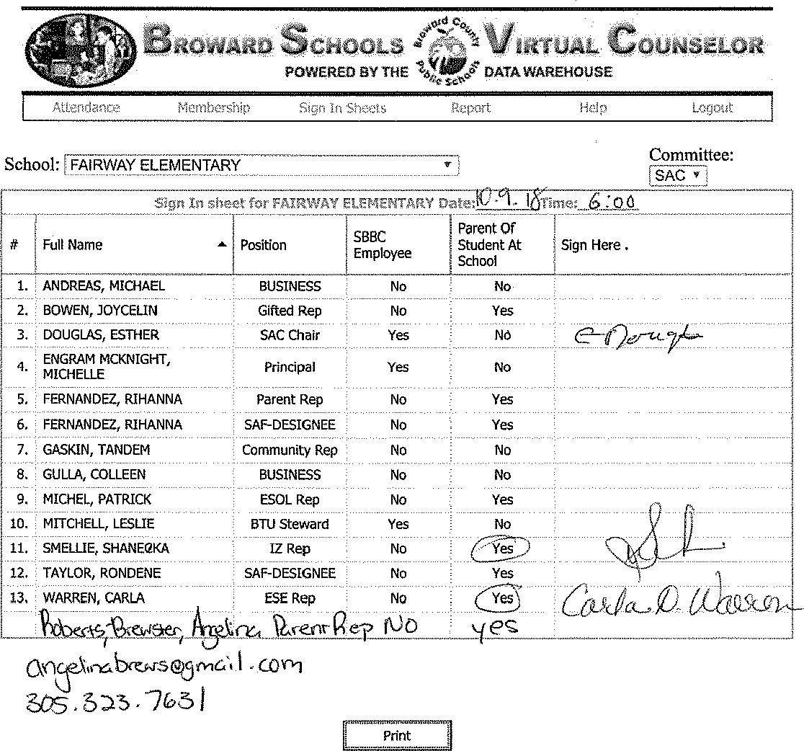
https:Mwebappe.browardschoo!s.comIsip/SignInSheet.aspx?SchoolYear=2008
10/8/2018 Virtual Counslar
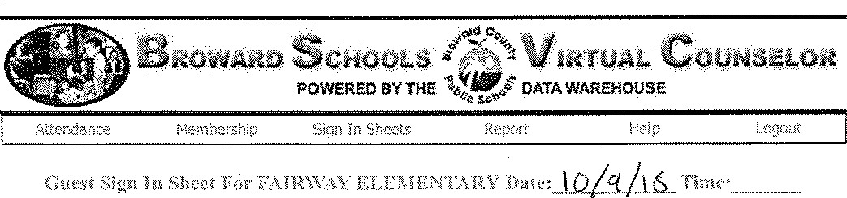
 | Full Name |  | Position | SBBC  Employee | Parent of  Student at School | Sign Here
5. | u..ee
6.
8.
11.
https•J/webappe.browardschoots.c0EWsip}SignlnSheetGuests.aspx
Fairway Elementary School
7850 Fairway Blvd Miramar, FL 33023
School Advisory Council Meeting

Minutes
Title of meeting:
Attendance:
List members and attendees.
(Attach sign in sheet)

Cali to order
A meeti go the Fairway Elementary School Advisory Council was held in the ce.a-zKcalled the meeting to order to order will record minutes for this meeting.
Minutes:

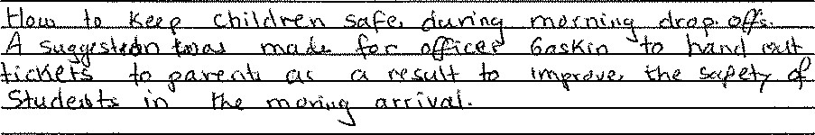

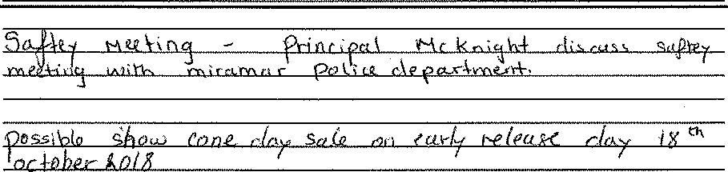
{D16

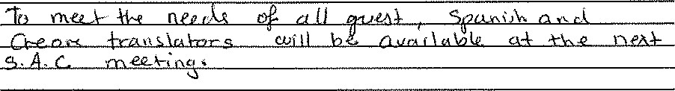

Next meeting date & time:

Meeting adjournment:

Fairway Elementary School
School Advisory Council Meeting
October 9, 2018 - 6.00 p.m.

Agenda

- Roll call to establish quorum

- Policy – Roberts Rules of Order

- Principal’s Report
- School Advisory Update (SAC) Update
- Vote in new parents members
- Approve By-Laws
- Set times/dates for future meetings
- 2018-2019 school improvement plan (content and parent input)
- School Advisory Forum (SAF) Update
- Community Update
- Old business
- New business
- Next Steps / Miscellaneous
- Adjournment

