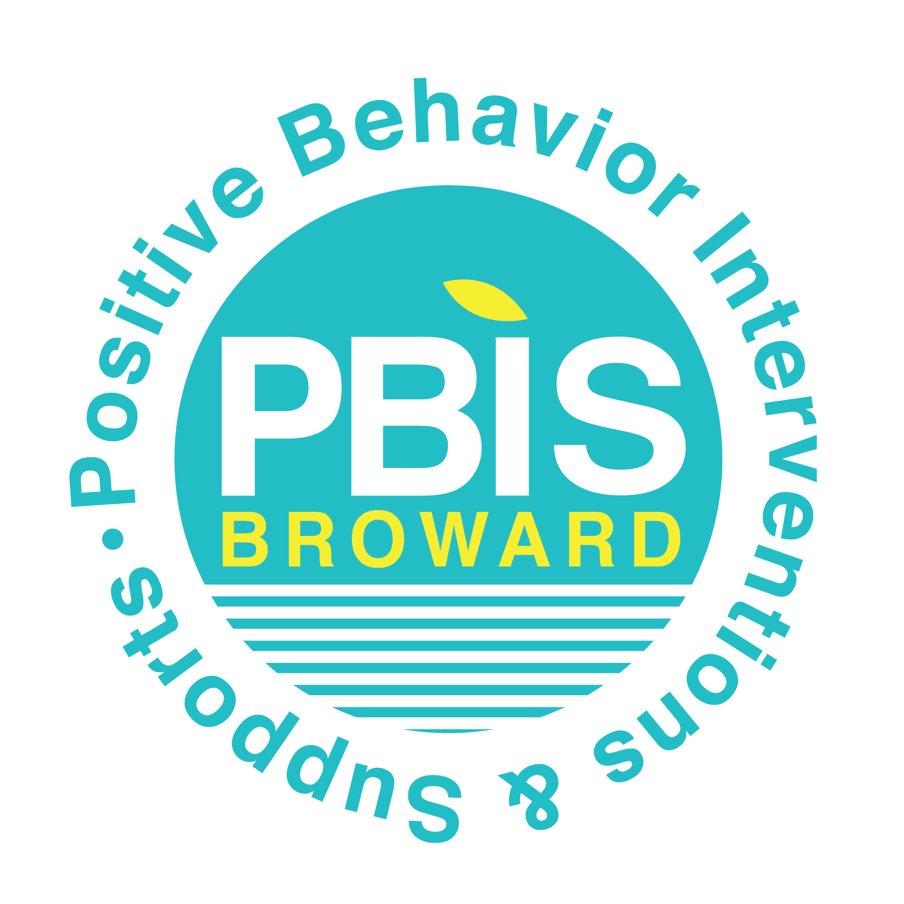
School-Wide Positive Behavior Plan (SPBP)
Voting Ballot
To vote, please check one of the boxes.
Are you in favor of the 2018-19 School-Wide Positive Behavior Plan (SPBP)?

☐ YES ☐NO
If NO, please provide suggestions to revise the School-wide Positive Behavior Plan (SPBP).

