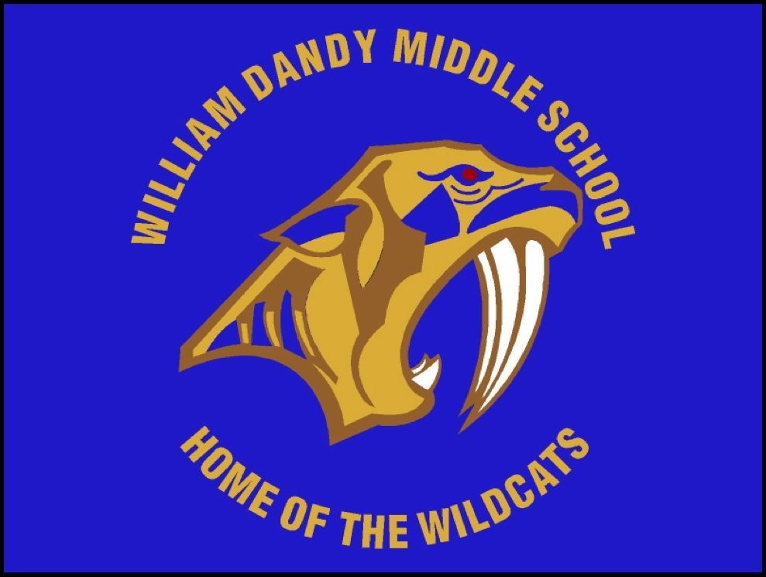
William Dandy Middle School
“Home of the Wildcats”
Felice Winston-Davis, Principal

School Advisory Council (SAC) Meeting Agenda
December 6, 2018
Media Center- 8:00am

- Call to Order
- Welcome
- Principal’s Report
IV. Desired Outcomes:
- SAC Composition
- ESOL Representative
- 2018-2019 SIP
  - Goals and Strategies
V. Guidance Updates
- TITLE 1- Updates
VI. Other Businesses
VII. Adjournment
Upcoming Events and Important Dates:
- Next SAC Meeting: January 10, 2019 (5:00 PM- Media Center)

