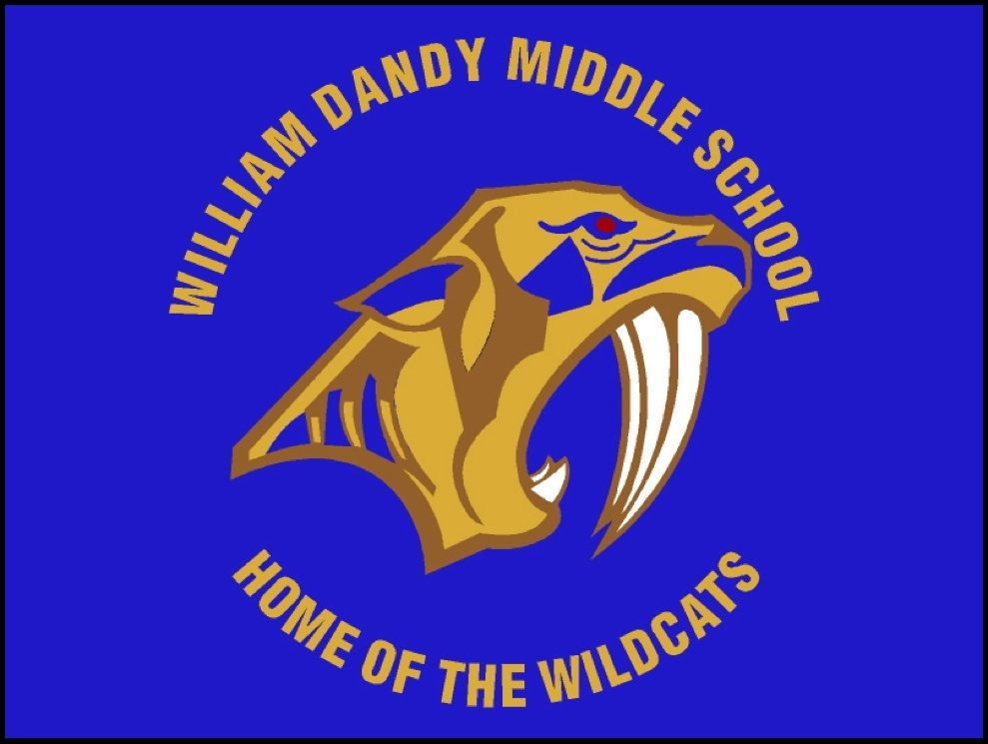
William Dandy Middle School
“Home of the Wildcats”
Felice Winston-Davis, Principal

School Advisory Council (SAC) Meeting Agenda
November 5, 2018
Media Center- 5:00pm

- Call to Order
- Welcome
- Principal’s Report
IV. Desired Outcomes:
- SAC Composition
- ESOL Representative
- Bylaws
- TITLE 1- Updates
VI. Other Businesses
VII. Adjournment
Upcoming Events and Important Dates:
- Next SAC Meeting: December 6, 2018 ( 8:30 AM- Media Center)

