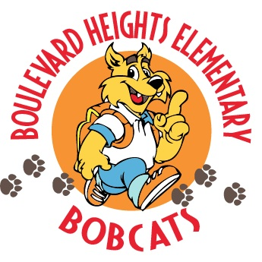

School Advisory Council Meeting Agenda
May 21st. 2019 @ 7:30 a.m.

- Welcome
- Approval of Minutes
- Principal’s Report
    - Sunshine Summer Program
    - New Construction

- New Business
Upcoming dates

- Promotion Awards Ceremony
5/21 - 2nd Grade at 8:30AM
5/13 - 4th Grade
5/14 - 5th Grade
5/15 - 3rd Grade
5/17 - 2nd Grade
5/20 - 1st Grade
6/3 - 5th Grade at 8:30AM

- New SAC Chair voting

- Adjournment
- Next meeting be scheduled TBA

