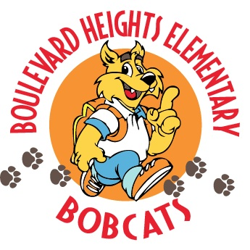

School Advisory Council Meeting Agenda
April 16, 2019 @ 7:30 a.m.

- Welcome
- Principal’s Report
New Business
    - I-ready Diagnostic
    - Upcoming Testing
      - FSA/PRT/BAS Testing
    - Safety Updates
    - Survey

- Questions/Concerns

- Adjournment
- Next Meeting will be held on May 21, 2019 at 7:30 a.m.

School Advisory Council Meeting Minutes
April 16, 2019 @ 7:30 a.m.

Attendance: See sign in.
Call to Order: A meeting of the Boulevard Heights Elementary School Advisory Council was held in the RRC1 on April 16, 2019, Alina Suarez called the meeting to order at 7:30 a.m. Ms. Smith will record minutes for this meeting.

Minutes: Alina Suarez motions to approve the minutes of March 20th .

Approval of March 20, 2019 Minutes:
Mr. Alejo made a motion to approve the minutes. Mrs. Liona seconded it. The minutes are approved.

Principal’s Report (Mr. Alejo):
Mr. Alejo discussed the post I-ready Diagnostic assessment dates and how the data will be used to drive instruction.
.
Mr. Alejo went over the upcoming dates for all assessments taking place on campus in the upcoming weeks.

Mr. Alejo went over recent safety updates and reviewed campus protocols.

Mr. Alejo also informed parents of the upcoming parent survey deadline.

Open Forum
No questions were asked.

Next Meeting
The next meeting will be held on May 21, 2019 at 7:30 a.m.

Meeting Adjournment:
Motion: Mrs. Suarez motioned to adjourn the meeting at _8:10__. Motion carried unanimously.

Submitted by, Ms. Smith
Approval Date: 4/16/2019

