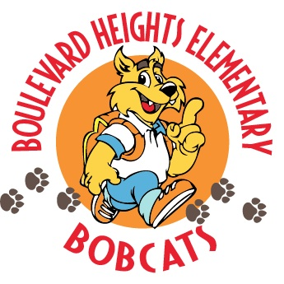

School Advisory Council Meeting Agenda
March 20, 2019 @ 7:30 a.m.

- Welcome
- Principal’s Report
New Business
    - Accountability funds to pay for camps

- Title One Updates
    - 2019-20 SIP: Parent Input & Title One Addendum
    - 2019-20 Title One Plan & Parent and Family Engagement Plan (PFEP)
    - 2019-20 School Parent Compact
    - Title One Survey Results (2018-19)

- Questions/Concerns

- Adjournment
- Next Meeting will be held on April 16, 2019 at 7:30 a.m.

School Advisory Council Meeting Minutes
March 20, 2019 @ 7:30 a.m.

Attendance: See sign in.
Call to Order: A meeting of the Boulevard Heights Elementary School Advisory Council was held in the RRC1 on March 20, 2019, Cindy Cavieres called the meeting to order at 7:30 a.m. Mrs. Suarez will record minutes for this meeting.

Minutes: Cindy Cavieres motions to approve the minutes of February 21st.

Approval of February 21, 2019 Minutes:
Mr. Alejo made a motion to approve the minutes. Mrs. Liona seconded it. The minutes are approved.

Principal’s Report (Mr. Alejo):
Mr. Alejo thanked our Sunshine Business partner. Mr. Alejo request approval for paying for camps. Mrs. Donovan makes a motion to approve the funds. Mrs. Smith seconds the motion.
SAC members approve the use of funds.

Safety and security-Mr. Alejo mentioned the new officer on campus and his responsibilities.

Title One Updates:
Mrs, Smith mentioned how parents were given opportunity to give input on 2019-20 SIP with Title One Plan (Addendum). Parent input was used to develop content and topics for PFEP and Title One Plan and focused on Best Practice Section #4, Scaling Up BEST Practice Goals, Strategies, and Activities. The discussion included scheduling of Family Nights and Parent Trainings.
Fund Allocations for the Parent Involvement activities were discussed, and FSA preparation materials/resources will be set aside for parent trainings next school year. Parents indicated they wanted more information about Paper Based FSA Tests, Primary Reading Test, and resources to prepare students academically. Also, discussed how to better inform parents on interpreting FSA data so they can support students in areas of need. These areas will also be addressed during 2019-20 Parent Nights as well as parent/teacher conferences.
Parents reviewed and approved of school level PFEP for 2019-20 school year. Title One survey results indicated 86% of the parents surveyed had knowledge of the information that was used to determine whether their child moves to the next grade or is retained. Parents indicated that information about standards, testing, and helping their child succeed in school were received by the following methods: 44% Title One Meetings, 22% books, magazines, videos purchased in stores, 73% from teacher conferences, 46% from district websites, 29% from FDOE, 36% from friends, relatives, or other parents, 19% from local television, 27% mailed by the school system, 17% from meeting at district offices, 37% from other meetings at school, 25% from parent center, 20% from parent compact, 52% from school website.
Parents supported proposed 2019-20 PFEP and School Parent Compact. Results of discussions indicated that no changes were necessary to School Parent Compact nor PFEP. Parents reviewed current School-Parent Compact and participated in the development of 2019-20 Parent Compact.

Open Forum
Mrs. Donovan asked about the emergency codes.
She also asked about using the word “kill.”
Mr. Alejo clarifies the difference between yellow and red. He is also discussed the zero tolerance policy for using the word “kill.”

Mrs. Donovan suggest an incentive program for PTA to reward classroom and teacher.

Mr. Beliard suggest isolating a threat to location. Look into it with SIU.

Next Meeting
The next meeting will be held on April 16, 2019 at 7:30 a.m.

Meeting Adjournment:
Motion: motioned to adjourn the meeting at _8:10__. Motion carried unanimously.

Submitted by, Ms. Butler
Approval Date: 3/20/2019

