Colbert Museum Magnet
School Advisory Council/School Advisory Forum
2018/2019 Meeting Dates
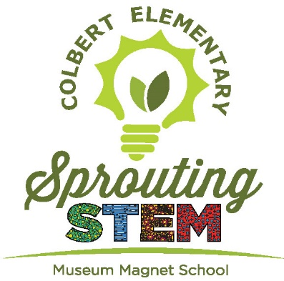

SAC Dates | SAF Dates
September 25th  2:00 PM | Sept. 25th  3:00 PM
October 23rd  3:00 PM | Oct. 23rd  2:00 PM
November 27th  2:00 PM | Nov. 27th  3:00 PM
January 22  2:00 PM | Jan. 22nd  3:00 PM
February 26th  2:00 PM | Feb. 26th  3:00 PM
March 19th  2:00 PM | March 19th  3:00 PM
April 23rd  2:00 PM | April 23rd  3:00 PM
May 14th  2:00 PM | May 14th  3:00 PM
All meetings will be held in the Media Center.

