Colbert Museum Magnet School
SAC Minutes – 9/25/18.

Attendance:
Sharhoda Day
Chentel Neat
Marlene Papa
Lucia Rodriguez
Kelli-Ann Prescott
Marisa Fishlock
Heather Holmes
John Holmes
Dave Gilbert
Dorsett McLeod
Fran Morris
Emmanuel Junard
Alvina Parker
Shallada Restrepo
Lanae Lawford
Ensilen Sierra

Call to Order:
A meeting of the Colbert Museum Magnet School Advisory Council was held in the Media Center on September 25, 2018. Ms. Neat called the meeting to order at 2:09 PM . Ms. Dy will record minutes for this meeting.

New Business: How to Write Meeting Minutes
- What is the School Advisory Council?
  - Ms. Neat reviewed the role of the School Advisory Committee and the State Statue and Guidelines that govern SAC.
- SAC Composition and nominations
  - 51% of composition must not be a BCPS employee
  - SAC Chair- Ms. Neat
  - Pre-K Rep- Ms. Papa
  - Non- Instructional- Mr. Gilbert
  - SAF Chair- Ms. Holmes
  - BTU- Ms. Prescott
  - Roles that still need to be filled: I-Zone, ESOL, ESE, Gifted, Community Rep, additional Teachers representatives.
  - Questions- Can members video chat or phone in when they can’t make meetings? Proposed having a designee for each position
- Meeting dates for 2018-2019 school year
  - Discussed the time that SAC meetings will be held
  - Will vote on time change at the next SAC meeting on Oct. 23rd
  - Voted to keep the October 23rd meeting and move the meeting time to 3:00 PM

Reports:
- Report Name
  - Principal Report/Sharing
    - Mrs. Fishlock reviewed school-wide achievement goals.
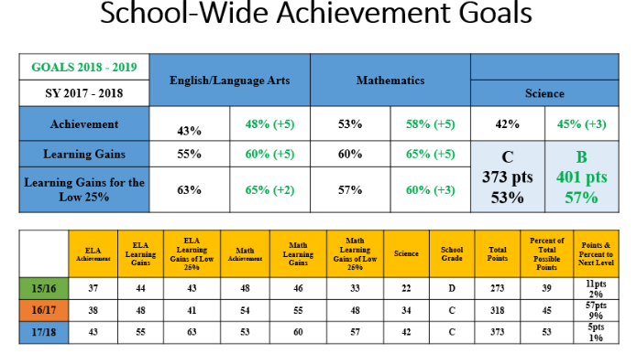

Open Agenda
- Parent Q & A
  - Q- What are our barriers?
    - A- (Mrs. Fishlock) ESOL, below grade level, and mobility rate
  - Q- What is the attraction to Colbert?
    - A- (Mrs. Fishlock) EIE, magnet, specials, clubs, facility, technology, and dedicated staff
  - Q- What are we doing to reach the goals?
    - A- (Mrs. Fishlock)- Data chats, differentiating instruction, guidance support, and i-Ready.
    - A- (Mrs. Prescott)- Educating the whole child, teachers working with support staff, and
  - Q- How do we communicate with parents?
    - A- (Mrs. Prescott)- give parents tools, asking parents to partner with educating their child, communicating expectations to parents.
  - Parent concern- Teachers are not communicating when their child is struggling. Can there be better communication? Can an app be used to communicate progress?

Next Meeting Date & Time:
The next meeting will be held on October 23rd at 3 PM in the Media Center.

Meeting Adjournment:
Motion: Mrs. Fishlock motioned to adjourn the meeting at 3:05 PM. Motion carried unanimously.

Submitted by,
ShaRhoda Day___________

