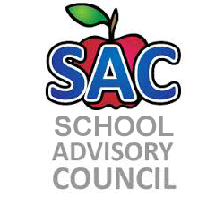  Stranahan SAC  School Advisory Councils (SAC) sets up priorities and student performance standards that serve as guiding principles for schools. A School Advisory Council looks at aspects of their school as suggested by the priorities and develops a written School Improvement Plan as part of the school and District's continuous growth model.  LOCATION: Stranahan High School Media Center 1800 SW 5th Place Ft. Lauderdale, FL 33312  TIME: 5:30 P.M. 2nd Wednesday of each month SAF/PTSA Meeting begins at 6:30 | 2017-2018 SAC Meeting Dates  October 11, 2017  November 8, 2017  December 13, 2017  January 10, 2018  February 21, 2018  March 14, 2018  April 11, 2018  May 9, 2018  All meeting dates are subject to change

