Hollywood Hills Elementary
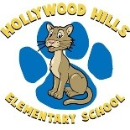
School Advisory Council
11/13/18
Karen Dallas- Chair
Anita O’Sullivan- Co-Chair, Secretary

- School Recognition Funds vote outcome Mrs. Dallas
- Safety information Mrs. Dallas
- Principal’s update Mr. Fossas
- School updates Literacy- Mrs. O’Sullivan BTU- Mrs. Vidal
Specials- Dr. Saef

- Future meeting date- 12/11 Mrs. Dallas

HHE Mission Statement:
We, the Hollywood Hills Elementary School Family, are committed to providing students with a quality education that enables them to reach their maximum potential in a safe and nurturing environment.

