Hollywood Hills Elementary
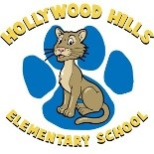
School Advisory Council
10/23/18
Karen Dallas- Chair
Anita O’Sullivan- Co-Chair, Secretary
- Title 1 Volunteers Mrs. Dallas

- School Improvement Plan -input Mrs. Dallas

- Principal’s update Mr. Fossas

- School updates Literacy- Mrs. O’Sullivan BTU- Mrs. Vidal
Specials- Dr. Saef

- Future meeting date- 11/13 Mrs. Dallas

HHE Mission Statement:
We, the Hollywood Hills Elementary School Family, are committed to providing students with a quality education that enables them to reach their maximum potential in a safe and nurturing environment.

