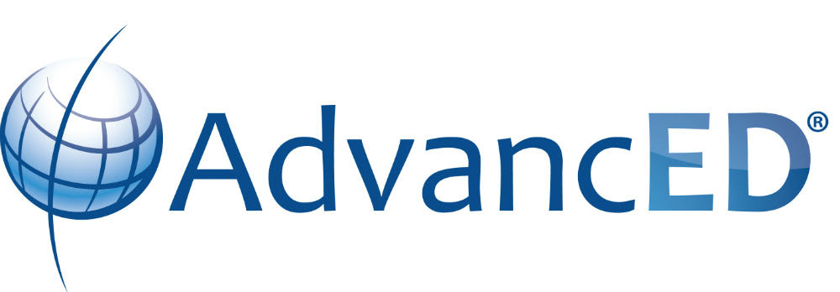

Executive Summary

Cypress Bay High School
Broward County School District

Principal Charles S. Neely
18600 Vista Park Boulevard
Weston, FL 33332

Table of Contents

Introduction ……………………………………………………………………………………….1

Description of School ………………………………………………………………………….2

School’s Purpose ………………………………………………………………………………..3

Notable Achievements and Areas of Improvement …………………………….4

Additional Information ……………………………………………………………………….5

Introduction

Every school has its own story to tell. The context in which teaching and learning takes place influences the processes and procedures by which the school makes decisions around curriculum, instruction, and assessment. The context also impacts the way a school stays faithful to its vision. Many factors contribute to the overall narrative such as an identification of stakeholders, a description of stakeholder engagement, current trends and issues affecting the school, and the kinds of programs and services this school implements to support student learning.

The purpose of this Executive Summary is to provide a school with an opportunity to describe in a narrative form the strengths and challenges it encounters. By doing so the public and members of the school community will have a more complete picture of how the school perceives itself in the process of self-reflection for continuous improvement. This summary is structured for the school to reflect on how it provides teaching and learning on a day to day basis.

1
Description of the School

Describe the school’s size community/communities, location, and changes as it has experience in the last 3 years. Include demographic information about the students, staff, and community at large. What unique features and challenges are associated with the community/communities the school serves?

Cypress Bay High School is a typical public high school in the Broward County Public School system with approximately 4800 students. The school which opened in 2002 is located in the city of Weston, Florida. Our multicultural school is 57% Hispanic with many families from Colombia, Brazil, Argentina, Venezuela, Mexico, and other countries. Weston is a suburban community located in Broward County, Florida that was established in 1996. The city is part of the Miami/Fort Lauderdale/Pompano Beach area and has a population over 70,000 people. Because of the enormous growth of the city in the last 20 years, the schools in Weston are critically overcrowded which is one of the biggest challenges associated with the community. Being the only high school to service the city of Weston, Cypress Bay teachers and administrators have formed a strong partnership with the Weston community and with many other companies in the city including the Rick Case Automotive Group, Office Depot, Publix, Cleveland Clinic, and many others.

2

School’s Purpose

Provide the school’s purpose statement and ancillary content such as mission, vision, values, and/or beliefs. Describe how the school embodies its purpose through its program offerings and expectations for students.

Cypress Bay High School's mission is delivering personalized quality education in a professional, safe, and caring environment. Our stakeholders are committed to developing individuals who are academically proficient, technologically capable, and socially prepared to be productive, conscientious, and responsible citizens. Cypress Bay High School achieves this mission through offering a variety of athletics and clubs with a full portfolio of Honors, AICE, and AP classes. We recently partnered with the FBI to embed an FBI/Cyber Program in which FBI agents work with students to prepare them for this expanding field. Despite our size and capacity issues, we pride ourselves in offering the highest level of excellence through our dedicated teachers, numerous extracurricular activities, and overwhelming support from our community. Our students are engaged and repeatedly place at the highest levels in numerous national competitions, including Debate, Chorus, DECA, Band, The Circuit publication, Skills USA, CBTV, Mu Alpha Theta, and HOSA. We encourage our students to work to their full potential while striving to push themselves and experience new challenges. Our students graduate Cypress Bay High School confident and capable as evidenced by their continued success in in their postsecondary education. Our vision at Cypress Bay High School is to help all students achieve their full potential and graduate from high school being fully college and career ready. Each year we continue to be extremely proud of fulfilling this purpose with our students.

3
Notable Achievements and Areas of Improvement

Describe the school’s notable achievements in areas of improvement in the last three years. Additionally, describe areas for improvement that the school is striving to achieve in the next three years.

Cypress Bay High School has a 99% graduation rate with 98% of students attending college and is accredited as a Top Ranked Public High School in Broward County. Cypress Bay High School offers 32 Advanced Placement courses with a passing rate of 84% and 32 AICE courses with a passing rate of 90%. In the 2017-2018 school year, Cypress Bay administered over 4,000 AP and 3,200 AICE exams. The year also boosted 17 National Merit Finalists among our accolades. Graduates were accepted into seven out of the eight Ivy League schools as well as other prestigious schools such as Cal Tech, Carnegie Mellon University, Emory, Georgia Tech, MIT, Notre Dame, and Vanderbilt. In the past three years, our school has been distinguished on the national, state, and local levels. These Cypress Bay achievements include Debate, Robotics, DECA, UNICEF, and Mu Alpha Theta accomplishments. Debate alone can boast a national champion in Program Oral Interpretation and the team placed in the top ten of all teams in the country both public and private. Our UNICEF Club is rated number one in the country, contributing $55,000 last year and over the past eight years a total of $195,000. In addition, Cypress Bay graduates included fifteen athletic signees from football, tennis, baseball, soccer, and softball. For the last thirteen years, Cypress Bay High School has maintained an “A” rating and is focused on repeating this distinction for years to come. The opportunities that are provided at Cypress Bay are a result of the dedication of all stakeholders and their commitment to our vision.

4

Additional Information

Provide any additional information you would like to share with the public and community that were not prompted in the previous sections.

Cypress Bay High School looks and feels like a college campus. Our media center, The Wave, was been designed to reflect the vibe of the campus with Wi-Fi and state of the art equipment. Students are encouraged to spend time before, during, and after school collaborating and working on their assignments in The Wave. We have an extensive after school program with free tutoring offered in almost every subject as well as Camps. Cypress Bay High School has provided its students with many ways to participate on campus to include over seventy clubs. Through these clubs, we can appeal to the varying interests and cultural diversity of our students. Our school embraces a very active PTSA which hosts activities and informational session for Cypress Bay’s Stakeholder. Additionally, the school was in the top 1% of high schools and designated a Gold Star by U.S. News & World Report. With the ongoing additions such as the FBI/Cyber and Stem Programs, Cypress Bay High School will continue to evolve to meet the changing needs of our students.

5

