Executive Summary Template School Accreditation
The Executive Summary (ES) provides the school an opportunity to describe in narrative form its vision as well as strengths and challenges within the context of continuous improvement. Use this template to complete the responses to the various questions below. The responses should be brief, descriptive, and appropriate for the specific section. Transfer completed narratives into the corresponding sections of the Executive Summary found online in ASSIST.

Description of the School
Describe the school's size, community/communities, location, and changes it has experienced in the last three years. Include demographic information about the students, staff, and community at large. What unique features and challenges are associated with the community/communities the school serves?
Panther Run Elementary School is located at 801 NW 172nd Avenue, in the City of Pembroke Pines, Florida. The population of Pembroke Pines as of the 2014 census was 164,625 people. The school is situated in a predominately middle class community with a median household income of $62,133.00. The education level of the population of Pembroke Pines is as follows: 90.8% high school graduate or higher and 32.5% bachelor’s degree or higher.
Panther Run Elementary has 572 students enrolled, which includes kindergarten through fifth grade. Panther Run’s enrollment is as follows: 76 students in kindergarten, 92 students in first grade, 81 students in second grade, 99 students in third grade, 120 students in fourth grade, and 104 students in fifth grade. Panther Run has an Autism Spectrum Disorder (ASD) Special Program (K-5) that consists of 47 students. Our student/parent demographic population is 70.56% White, 18.47% Black, 6.10% Multi-Racial, 4.36% Asian and .35% Indian, and .17% Pacific. Of the 70.56% White population and the 18.47% Black population, 53.31% identify as Hispanic. The English Language Learner (ELL) population of Panther Run Elementary is 19.4%. This can be a challenge when it comes to communicating with our parents on matters of academics and behavior. Panther Run Elementary has 220 students on Free/Reduced Lunch, which is 38% of our population.
Panther Run employs 77 faculty members, which include 45 instructional staff. The faculty demographic information is 47% White, 17% Black, 35% Hispanic, 1.3% Asian. 4.2% of the teachers at Panther Run Elementary are National Board Certified teachers. 53.2% of the instructional staff have a Masters degree or higher.
A unique feature and challenge associated with our school community is as a result of recent economics, families are staying put in their homes. Therefore, new families are not moving into our community.

School’s Purpose
The vision/mission of Panther Run Elementary School is to work collaboratively with the students, staff, parents, community and business partners to provide a positive, stimulating, nurturing, technology-rich environment that will enable our students to reach their maximum potential in all areas of the curriculum and prepare them to become effective members of society in the future. Students, parents, staff and community – “A Carousel of Commitment!” Panther Run…connecting children to the future by “Changing the World One Child At A Time,” while inspiring a culture of PIF-WIAMAD: “Paying It Forward” & Who I Am Makes A Difference!”
PIF-WIAMAD is a motivational culture used to inspire students, staff, parents and community members. PIF-WIAMAD promotes caring for others, both people and animals. The concepts develop an awareness of helping others and spreading good will. The program consists of two philosophies, “Pay It Forward!” and “Who I Am Makes A Difference!” “Pay It Forward” means repaying the good deeds one has received by doing good things for other unrelated people. “Who I Am Makes A Difference” explains we all make a difference in the lives of others by our actions, words, feelings and the person we become. The concepts taught develop an increased awareness of helping others and spreading good will. Research shows that children need to learn kindness and compassion in order to grow up to be good citizens who are compassionate and caring of not only themselves but to others as well.
PIF-WIAMAD is intricately woven into our mission, vision and educational philosophies thus allowing us to teach and model wonderful values and providing a successful learning experience for all of the students at Panther Run Elementary while helping students and parents utilize these ideas with their peers, families and community at the same time. We also PIF-WIAMAD for the environment by saving energy and recycling. Some of our PIF-WIAMAD programs include the Harvest Drive, Toys for Tots, Book Drive for our sister school, Broward County Humane Society Drive for the Animals, Kicks for Kids Drive, MDA Fundraiser, Dan Marino’s Walk About Autism, our New Years Resolutions, PTA Bike Rodeo & Health Fair, and numerous other activities promoting caring for others.
The PIF-WIAMAD culture affords children the opportunity to see role models exemplifying these traits and allow them to participate in character building humanitarian projects, which helps others. PIF-WIAMAD teaches people to care about each other and make a difference in the world. It produces a culture of kindness and high expectations to do good to all. For this very reason, the PIF-WIAMAD culture is vital because it instills in children a cultural concept that who they are, can and will make a difference in the world by their actions towards others. When children are given the opportunity to Pay It Forward, they are learning the building blocks of what gratitude is and how they can make a small difference in the world in which they live. As students mature, they will become adults who are secure in themselves, as individuals, capable of connecting with the world.

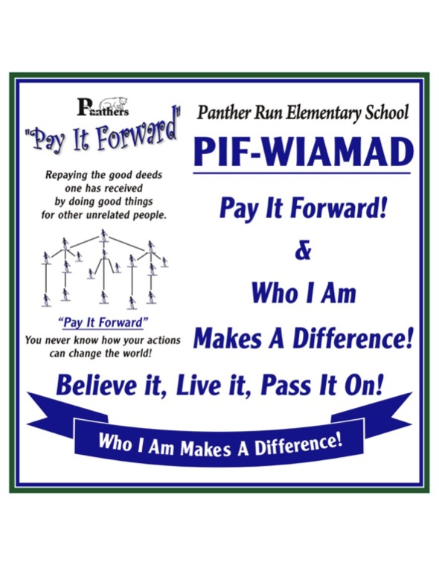

The following are notable achievements within the past three years:
• Panther Run Elementary’s school grade climbed from a B (2013-2014) to an A (2014-2015). Panther Run Elementary has earned an A for the next two school years (2015-2016, 2016-2017) followed by a B (2017-2018).
• Panther Run Elementary was recognized by the National Wildlife Federation as a Certified Wildlife Habitat, providing the four basic habitat elements needed for wildlife to thrive: food, water, cover, & places to raise young.
• The City of Pembroke Pines named Panther Run Elementary as the Kindest School in Pembroke Pines in 2017.
• Golden School Award was given to Panther Run for the school’s outstanding volunteer program in 2015.
• The American Heart Association recognized Panther Run Elementary School with the Fit-Friendly Gold Achievement Award in 2015.
• The Office of Talent Development and the Office of Academics acknowledges that Panther Run Elementary School has successfully completed Level 1: 21st Century Learner Qualification.
• Panther Run Elementary is recognized as a 21st Century School.
• Panther Run Elementary’s Kids in Capes were named a 2017 Finalist at the Youth Impact Awards.
• Panther Run Elementary’s Gifted High Achieving Class came in First Place at the 2016-2017 Stock Market Game in Broward County. They were awarded Second Place in all of South Florida.
Areas of Improvement over the next 3 years we are striving for at PRE:
• Panther Run Elementary’s focus is on best practices. During Professional Learning Communities (PLCs), each grade level team works through the C.A.R.E. (Curriculum, Assessment, Remediation, Enrichment) Cycle. C-Curriculum: Teachers identify through the curriculum what we want all students to know during the cycle and what are some of the best instructional strategies to use in order to maximize student learning. A-Assessment: Teachers identify the assessment to use to determine student mastery, what percent correct defines mastery and how will results be documented. R-Remediation: Teachers decide how to respond to students who do not meet mastery. The team decides what additional time is needed, the frequency and duration of the remediation and how will it be measured? E-Enrichment: Teachers decide how to respond when students meet or exceed mastery, how the enrichment will occur and how it will be measured. Each PLC also works to unwrap the curriculum standards to identify key ideas and details in order to develop the learning goals and targets. These are expressed in student friendly language and posted in the classroom. The assessment is identified or developed based on the learning goal/target and the percent correct is determined for mastery. Those students not meeting mastery level are identified for reteach/remediation. Enrichment activities are determined to go deeper in cognitive complexity and to push students further. Teachers will continue to focus on these B.E.S.T. (Beyond Expected Student Targets) practices and the Response to Intervention (RtI) process. Panther Run Elementary will also focus on looking at the Depth of Knowledge (DOK) levels in writing lesson plans and developing activities. Teachers will also work to perfect how to incorporate rigor and relevance into daily instruction to help students develop the capacity to understand content that is complex, ambiguous, provocative, and personally or emotionally challenging.
• Other focus areas are: Introducing more informational text, implementing project-based learning & S.T.E.M. (Science, Technology, Engineering, Mathematics) programs to create a more rigorous academic environment, a focus on Balanced Literacy for early learners through Daily 5 instruction, incorporating technology into daily instruction and communication, & a focus on cross-curricular instruction through English Language Arts and Math.

Additional Information: Provide any additional information you would like to share with the public and community that were not prompted in the previous sections.

• Panther Run Elementary’s Pay It Forward – Who I Am Makes A Difference (PIF-WIAMAD) Culture was recognized in 2009 as a Best Practice by Broward County Public Schools.
• The Florida Association of School Administrators (FASA) has awarded Panther Run Elementary’s PIF-WIAMAD culture the Little Red School House Award for 2010. The Little Red School House Award program gives recognition to a school with exemplary initiatives, efforts or accomplishments.
• Panther Run Elementary is recognized as a FIVE STAR School from 1998 through 2009. The Five Star School Award was created by the Commissioner’s Community Involvement Council and is presented annually to those schools that have shown evidence of exemplary community involvement. In order to earn Five Star School recognition, Panther Run had to show documentation that it had achieved 100% of the established criteria in the following categories: Business Partnerships, Family Involvement, Volunteerism, Student Community Service, and School Advisory Councils.
• Our Principal, Ms. Saef was named Broward County Public Schools Caliber Award Principal of the Year for the 2017-2018 school year. She has been recognized as a finalist twice for Principal of the Year in the Broward County School District (2010-2011, 2015-2016).
• Ms. Saef was awarded the 2017 Excellence in Leadership Award from the National Alliance of Black School Educators and was honored with the Broward Education Foundation’s 2017 Hall of Fame Education Achievement Award.
• Ms. Saef was recognized as a finalist for Assistant Principal of the Year in the Broward County School District (2010-2011).
• Panther Run students are recognized monthly for good character by the Pembroke Pines Police Department.
• Classroom teachers nominate two students per month to be recognized as a Kid of Character. The Kids of Character program honors students for doing exemplary deeds at home, in school, and the community.
• Our School Resource Officer (SRO), Officer Gibran Cuavas teaches Gang Resistance and Drug Education (G.R.A.D.E.), Be Educated and React to Strangers (BEARS), Eddy Eagle and Halloween Safety to our students.
• Every student at Panther Run Elementary School is instructed using the Child Safety Matters Curriculum by the Guidance Counselor. The program is a comprehensive, research-based primary program designed to educate and empower students, school personnel and adults with information and strategies to prevent bullying, cyber bullying, digital abuse, and all types of child abuse.
• Panther Run Elementary School’s focus is to educate the whole child. In addition to our core curriculum and academic focus, PRE educates the whole child by exposing our students to extra-curricular activities such as:
Community & Family Involvement: Literacy Night & Character Parade, Family Math Night at Super Target, Meet the Scientist-Family Science Night, Book Fair, Cookies & Canvas Family Night, Edu-Quest Family Night Event at the Shops at Pembroke Gardens, McDonald’s McPanther Family Night, Sweet Tomatoes Family Night, Papa John’s Night, Menchies Family Night, Chick-fil-A Family Night, PTA Bike Rodeo & Health Fair.
Extra-Curricular School Events: Seas Program sponsored through the Broward Center for the Performing Arts, Field Day Events, Mini-marathon, S.T.E.M. Olympiad, Mayors’ Chess Challenge Program, Career Day, Junior Achievement Biztown Event, Share-A-Pet Reading Program, Florida Power & Light Solar & Wind Station Site Program, Reflections Awards, All-State Choir Competition, and a School Sustainable Garden Program.

