BELL SCHEDULE

7:40 – 9:10 am Period 1/5

9:18 – 10:48 am Period 2/6

10:48 – 1:02 pm Period 3/7
10:48 – 11:24 am A Lunch
12:26 – 1:02 pm B Lunch

1:10 – 2:40 pm Period 4/8

WHO’s WHO?

Principal Michelle Kefford

Assistant Principals
9th grade Kristine Knapp
10th grade Gina Montagnino-Fiske
11th grade Freddie Jones
12th grade Jay Milmed

Guidance Department
9th grade Guadalupe Prieto
A - F Jennifer DiBenedetto
G - O Dedrian Beason
P - Z Tally Jacobson
Director Jack Reed

BRACE Kimberly Montalvo

PARENT RESOURCES

Pinnacle Internet Viewer

This application allows you to view your child’s grades and attendance in real time. You will be able to see up-to-date assignment lists and grades earned on those assignments.
http://gb.browardschools.com/Pinnacle/Gradebook/
User name-your child’s
school ID number@my.browardschools.com
Password-your child’s birth date Pmm/dd/yyyy

FHS Website

https://www.browardschools1.com/flanagan

Here you will find important happenings, test dates, extracurricular activities, newsletters, the Student Code of Conduct Book, notices and announcements. An important source of information for parents, this site should be visited weekly.

Parent Link Robot Calls
Please make sure that your contact number and email are current on your child’s Emergency Card to receive parent link information.

STAY INFORMED & CONNECTED

ALL PARENTS
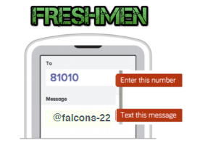

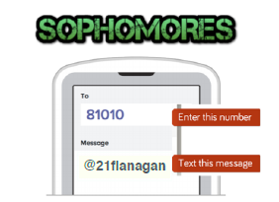

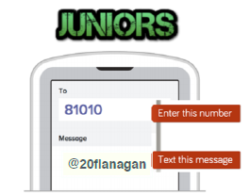

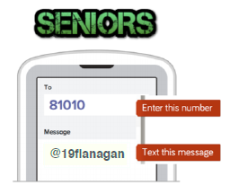

TONIGHT’S CHECKLIST

- Follow your child’s printed schedule to meet all of his/her teachers

- Visit the cafeteria before period 1 to check out athletic teams and clubs

Abby M. Freedman, Chair
Nora Rupert, Vice Chair

Robin Bartleman
Heather P. Brinkworth
Patricia Good
Donna P. Korn
Laurie Rich Levinson
Ann Murray
Dr. Rosalind Osgood

Robert W. Runcie
Superintendent of Schools

The School Board of Broward County, Florida, prohibits any policy or procedure, which results in discrimination on the basis of age, color, disability, gender identity, gender expression, national origin, marital status, race, religion, sex or sexual orientation.
Individuals who wish to file a discrimination and/or harassment complaint may call the Executive Director, Benefits & EEO Compliance at 754-321-2150 or Teletype Machine (TTY) 754-321-2158.

Individuals with disabilities requesting accommodations under the Americans with
Disabilities Act Amendments Act of 2008 (ADAAA) may call Equal Educational Opportunities (EEO) at 754-321-2150 or Teletype Machine (TTY)
754-321-2158.

