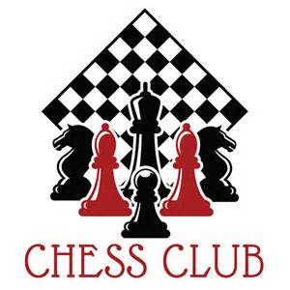Sandpiper Elementary Chess Club 2018-2019:

Misty Alfred Maheras
Zoey Allen Emery
Alana Caraballo Thaler
Muhammad Dagra Edwards
Malik David Godoy
Naveah Di Russo Thaler
Eytan Erez Edwards
Bryan Hodges Maheras
Caden Harrell Thaler
Arsena Jagne Emery
Juliet Janecek Edwards
Madison La Bella Thaler
Gregory LaGrenade Godoy
Hayden Lah Maheras
Caleb Martin Godoy
Aiden Mannarino Hickling
Ethan Mayer Emery
Matteo Mosley Edwards
Christian O’Rourke Maheras
Joaquin Paolo de Jesus Maheras
Angelina Marie Pinzone Maheras
Ashera Smith Godoy
Joseph Woodstock Hickling

Club Sponser: Mrs. Hernandez
Master Chess Teacher: Mr. MO

