PETERS ELEMENTARY SCHOOL School-Level Self-Assessment 2018-19
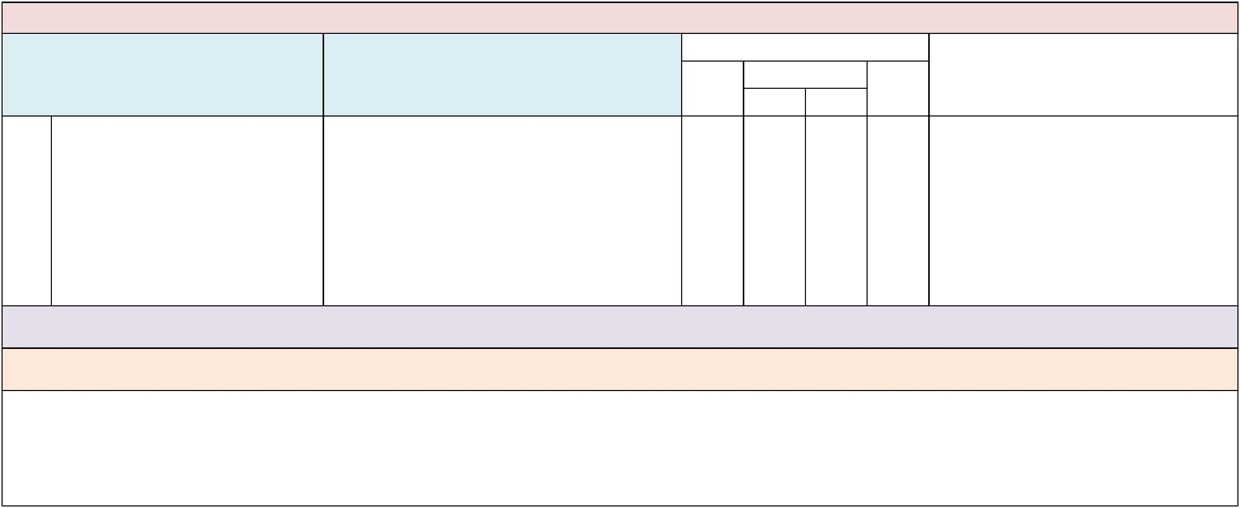

Domain: Leadership and Decision Making

Indicator Examples or Evidence of Practice

 | Implementation Status
Not |  | Partially |  | Fully | Data Sources/Supporting Evidence
yet |  | B | A | Fully

- The school leadership team analyzes data to identify barriers and initiate improvement steps that increase the number of students with low-and high-incidence disabilities, across all grades, in general education and natural contexts.

- School analyzes data of all SWDs to identify current barriers and practices for the provision of educational services in general education classes and natural contexts.
xxXxxX

- School increases the number of SWDs who receive educational services in inclusive classrooms and natural contexts.

- Data are collected, analyzed and shared with all teachers regarding student achievement of SWDs in general education and natural contexts.

- Data chats are conducted with students to create strong accountability and high expectations.

Suggested Measures: Data from state, district and school assessments and alternate assessments, other achievement measures, behavior data, educational environment (percentage of time in general education), graduation rate, postschool outcomes, observations from classroom walk-throughs and progress toward individual educational plan (IEP) goals.

Note: Aligns with District BPIE Indicator #1. Please see the Appendices: Glossary of Terms section for definitions of the terms found above: leadership team, low- and high-incidence disabilities and general education and natural contexts.

Comments:

PETERS ELEMENTARY SCHOOL School-Level Self-Assessment 2018-19


Domain: Leadership and Decision Making

Indicator Examples or Evidence of Practice

 | Implementation Status
Not |  | Partially |  | Fully | Data Sources/Supporting Evidence
yet |  | B | A | Fully

- Short-and long-term efforts to implement and improve inclusive educational practices, as measured by the BPIE, are included in the SIP.

- The school has developed an action plan indicating goals related to inclusive practices, which are included in the SIP.

- The leadership team reviews and shares the language and intent of s. 1003.57 4(F), F.S., with all staff and stakeholders.

- Once every three years, the school completes a BPIE assessment and reports the results of all planned short- and long-term improvement efforts to the district.

- The school leadership team analyzes data quarterly to monitor and evaluate progress toward meeting SIP goals related to inclusive practices in the school.

- All stakeholder groups are represented and involved in a collaborative system of decision making to implement and improve inclusive practices across the school, as noted in the SIP.

- The school provides access to the SIP on the school website and on request in the front office.
- The school handbook or website includes information on the school’s process of shared decision making.

- Family input on inclusive practices is gathered in a variety of ways (surveys, interviews, focus groups, etc.).

Suggested Measures: Copy of SIP, including distribution process (e.g., website, front office request form), data reports, meeting notes and schedule, roster and schedule of school leadership team meetings showing diverse representation.

Note: *It is recommended that the team table and return to this indicator after the entire BPIE assessment has been completed. Please see the Appendices: Glossary of Terms and Resources sections for information about the terms found above: stakeholder groups and s. 1003.57 4(F), F.S. Schools that have specific goals related to the BPIE indicators currently identified in their SIP would rate themselves as Partially implemented. Schools that have not included goals related to the BPIE indicators in their SIP would rate this indicator as Not Yet.

Comments:

PETERS ELEMENTARY SCHOOL School-Level Self-Assessment 2015-16
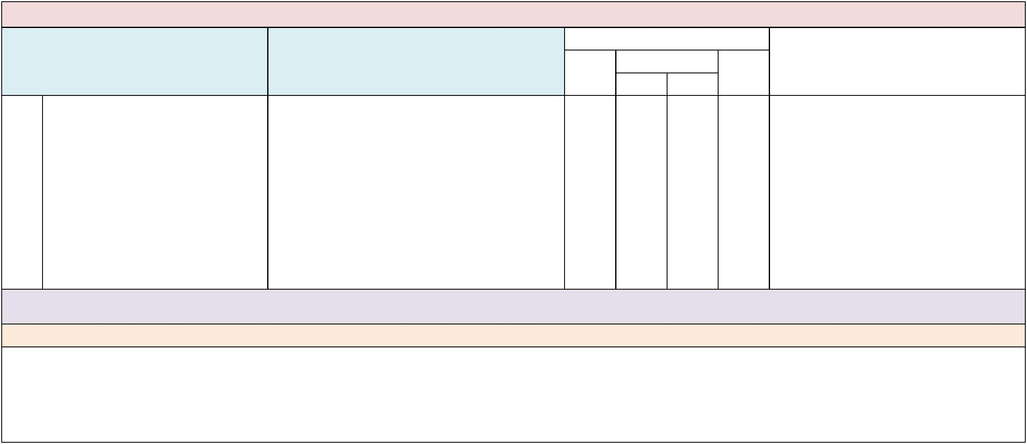

Domain: Leadership and Decision Making

Indicator Examples or Evidence of Practice

 | Implementation Status
Not |  | Partially |  | Fully | Data Sources/Supporting Evidence
yet |  | B | A | Fully

- The school has a key person who oversees, coordinates and monitors the implementation of best practices for inclusive education for all SWDs.

- There are clearly identified roles and responsibilities for the key person (e.g., ongoing communication, data analysis and progress monitoring of BPIE goals).

- The key person is responsible for oversight and coordination of goals and action steps related to inclusive best practices.

- The key person is identified in various school documents, such as:
- -- Staff roster;

- -- Professional Learning Community (PLC) minutes;

- -- Team planning logs;

- -- Staff handbook;

- -- School website; and

- -- Newsletters.

Suggested Measures: Name and job description, including the role and responsibility of key person. Schedule or communication log of activities/meetings of key person. Samples of documents including the name and contact information of the key person who oversees inclusive practices.

Note: Aligns with District BPIE Indicator #6. Progress monitoring toward attainment of BPIE goals will occur after the school’s initial BPIE assessment and development of priority goals/action steps.

Comments:

PETERS ELEMENTARY SCHOOL School-Level Self-Assessment 2018-19
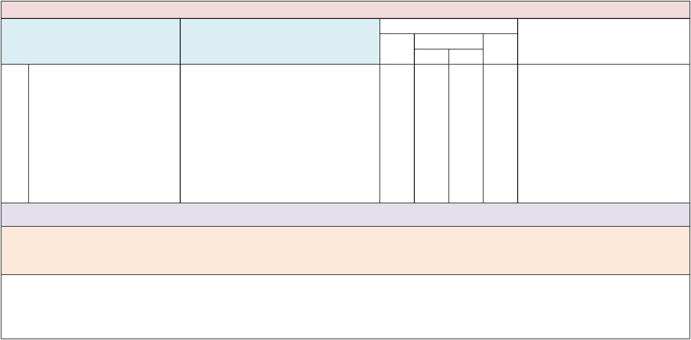

Domain: Leadership and Decision Making

Indicator Examples or Evidence of Practice

 | Implementation Status
Not |  | Partially |  | Fully | Data Sources/Supporting Evidence
yet |  | B | A | Fully

- School administrators advocate for all SWDs to have the same school choice options as students without disabilities to ensure all SWDs receive educational services in their neighborhood school or school of choice.

- The principal contacts the district to obtain information about SWDs who do not attend the school because of the type or severity of their disability or perceived lack of services available at the school.

- The principal requests services and supports to follow SWDs in the school.
- The school has a diverse student population that reflects the full range of students who live in the neighborhood school zone, including those with significant disabilities.

- The school is equipped to provide educational services to all students.
- Families perceive the school as being able to address their child’s needs, regardless of the type or severity of disability.

Suggested Measures: Documentation of school administrator requests for information (e.g., emails, memos) to the district office, roster of SWDs in school’s zone who are not attending the school.

Note: Aligns with District BPIE Indicator #3. This indicator addresses the practice of placing SWDs in schools based primarily on exceptionality, label or services needed, rather than identifying and allocating resources for all SWDs to receive educational services in their neighborhood school or school of choice. Students who are transported to attend other schools are at risk of disenfranchisement from the communities within which they live and lack opportunities to build natural relationships among the students in the assigned school. With the practice of placing SWDs at schools based on their exceptionality, unintended consequences include further isolation of students with significant disabilities and barriers to scheduling SWDs into heterogeneous classrooms that have natural proportions of students with and without disabilities. Please see the Appendices: Glossary of Terms section for definition of the above term natural proportions.

Comments:

PETERS ELEMENTARY SCHOOL School-Level Self-Assessment 2018-19


Domain: Leadership and Decision Making

 | Indicator | Examples or Evidence of Practice
5. | School data reflect that all SWDs, | • All SWDs, including those with significant
 | regardless of the type or severity of | disabilities, are scheduled into general education
 | disability, receive their education and | classes 80% or more of the day.
 | related services in age-and grade- | • All SWDs receive education in a general education
 | appropriate, heterogeneous, general | regular class setting reflecting natural proportions
 | education contexts 80% or more of the | and age-appropriate, heterogeneous groups in core
 | day. | academic and elective or special areas within the
school community, as stated in

s. 1003.574(F), F.S.

• SWDs are not assigned to classrooms based on their

exceptionality or supplementary aids and services

needed.

• SWDs are not assigned to classrooms based on a

perceived lack of resources at the school.

• All teachers ensure that every student feels

welcome and achieves to his or her potential in

general education classes and other natural

contexts.

• All SWDs are involved in before- or after-school

tutoring interventions provided for reading and

math.

• Support services personnel have caseloads that

allow for flexible scheduling of services to SWDs in

general education classes and other settings.

• To the greatest extent possible, related services are

scheduled and provided to SWDs in general

education and natural contexts, rather than in

segregated settings, for example:

- o A speech-language pathologist (SLP) in an

elementary school engages in sma

 | Implementation Status
Not |  | Partially |  | Fully | Data Sources/Supporting Evidence
yet |  | B | A | Fully

All SWDs, including those with significant

disabilities, are scheduled into general

education classes 80% or more of the day.

Suggested Measures: School-level least restrictive environment (LRE) data showing the percentage of time each SWD, disaggregated by exceptionality, spends in age- and grade-appropriate, heterogeneous, general education contexts

Note: Aligns with District BPIE Indicator #12. Please see the Appendices: Glossary of Terms section for definitions of the above terms: related services, Individual educational plan (IEP), age-appropriate heterogeneous groups and supplementary aids and services.

Comments:

PETERS ELEMENTARY SCHOOL School-Level Self-Assessment 2018-19


Domain: Leadership and Decision Making

 | Indicator | Examples or Evidence of Practice
6. | School data reflect that all SWDs, ages | • School administrators collaborate with the district to
 | 3-5, receive special education and | establish programs that include students with and
 | related services in the regular early | without disabilities in the same early childhood and
 | childhood (Pre-K) and kindergarten | kindergarten classes.
 | classes with peers without disabilities. | • The school has targets to increase the number of
 | *Schools with Pre-K programs only | SWDs, ages 3 - 5, who receive special education and
 | *Schools with Pre-K programs only | related services in inclusive classes with peers
 |  | without disabilities.
• General and special education teachers regularly

collaborate to plan and implement weekly lessons

based on Florida standards for Pre-K and

kindergarten.

• Curriculum adaptations, such as changing the

physical or social environment, placing materials in

optimal positions or heights, breaking down steps in

a task, assistive devices, alternate materials, etc.,

are considered as easy-to-implement interventions

• All children receive supports and interventions

necessary to ensure developmentally appropriate

progress prior to referral for special education

services and programs.

• Developmentally appropriate behavior supports are

provided for students.

• The school regularly monitors (e.g., monthly) the

number and progress of SWDs, ages 3–5, who

receive special education and related services in

inclusive settings with peers without disabilities.

 | Implementation Status
Not |  | Partially |  | Fully | Data Sources/Supporting Evidence
yet |  | B | A | Fully

Suggested Measures: Schedules of SWDs, ages 3-5, indicating the location(s) where related services are provided to those students. Data showing the percentage of time each SWD, ages 3–5, spends with same-age peers without disabilities. Teacher lesson plans indicating appropriate curriculum adaptations or interventions for SWDs in the general education, early childhood curriculum.

Note: Aligns with District BPIE Indicator #4. Please see the Appendices: Glossary of Terms for definition of the above term: curriculum adaptations. Partnerships with private providers may be necessary.

Comments:

PETERS ELEMENTARY SCHOOL School-Level Self-Assessment 2019-19
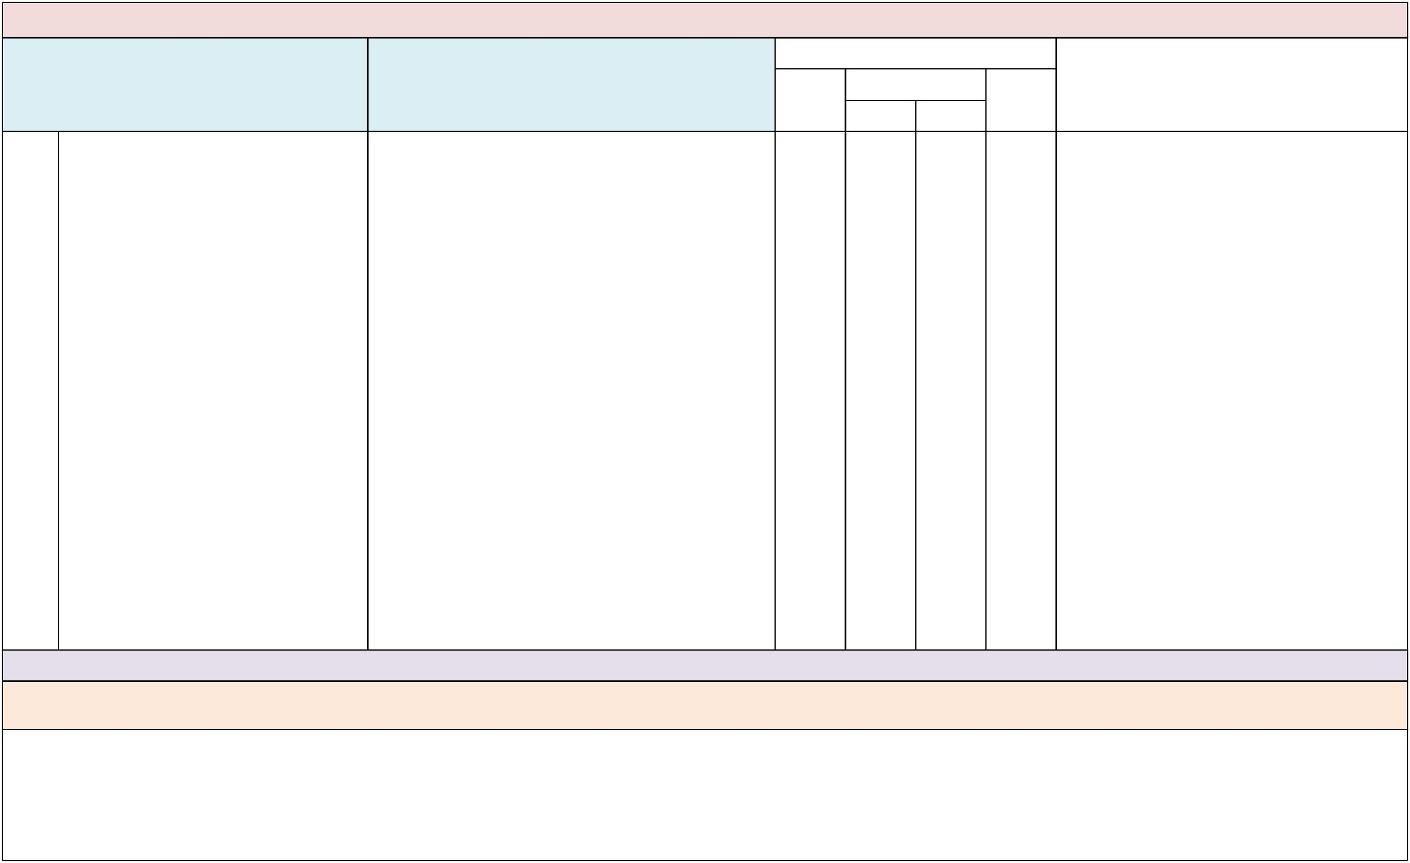

Domain: Leadership and Decision Making

Indicator Examples or Evidence of Practice

 | Implementation Status
Not |  | Partially |  | Fully | Data Sources/Supporting Evidence
yet |  | B | A | Fully

- School administrators communicate expectations for all school personnel to share responsibility for all of the students in their building and consider all SWDs as general education students first.

- Administrators clearly and consistently articulate the following expectations for all school personnel during faculty meetings, School Advisory Committee meetings, PLCs, staff newsletters, etc.:

- -- General and special education teachers are expected to share instructional and behavioral support responsibilities for SWDs in each classroom and other school settings.

- -- SWDs are not the sole responsibility of special education personnel during academic and non-academic school activities.

- -- School personnel refer to special education teachers by name rather than exceptionality of students on their caseload (e.g., Mrs. Smith rather than the Autistic Teacher).

- -- All school personnel are trained and responsible for safety and evacuation procedures for SWDs.
- Administrators provide written rationale and other resources (e.g., research articles, newsletters, websites) with information and strategies on inclusive practices.

- Administrators survey staff to determine beliefs and attitudes about inclusive practices.
- Administrators review staff schedules to ensure all personnel have opportunities to support students with and without disabilities.

- Administrators ensure that all personnel are responsible for and understand the health and safety procedures for all students, especially those who have extensive support needs.

Suggested Measures: Results of surveys, self-assessments, questionnaires, interviews and teacher schedules.

Note: School leaders are critical in setting and maintaining a vision for inclusive education with all personnel and across all school classrooms and settings. Creating a climate of shared responsibility for all students in the school is a cornerstone of inclusive education.

Comments:

PETERS ELEMENTARY SCHOOL School-Level Self-Assessment 2018-19
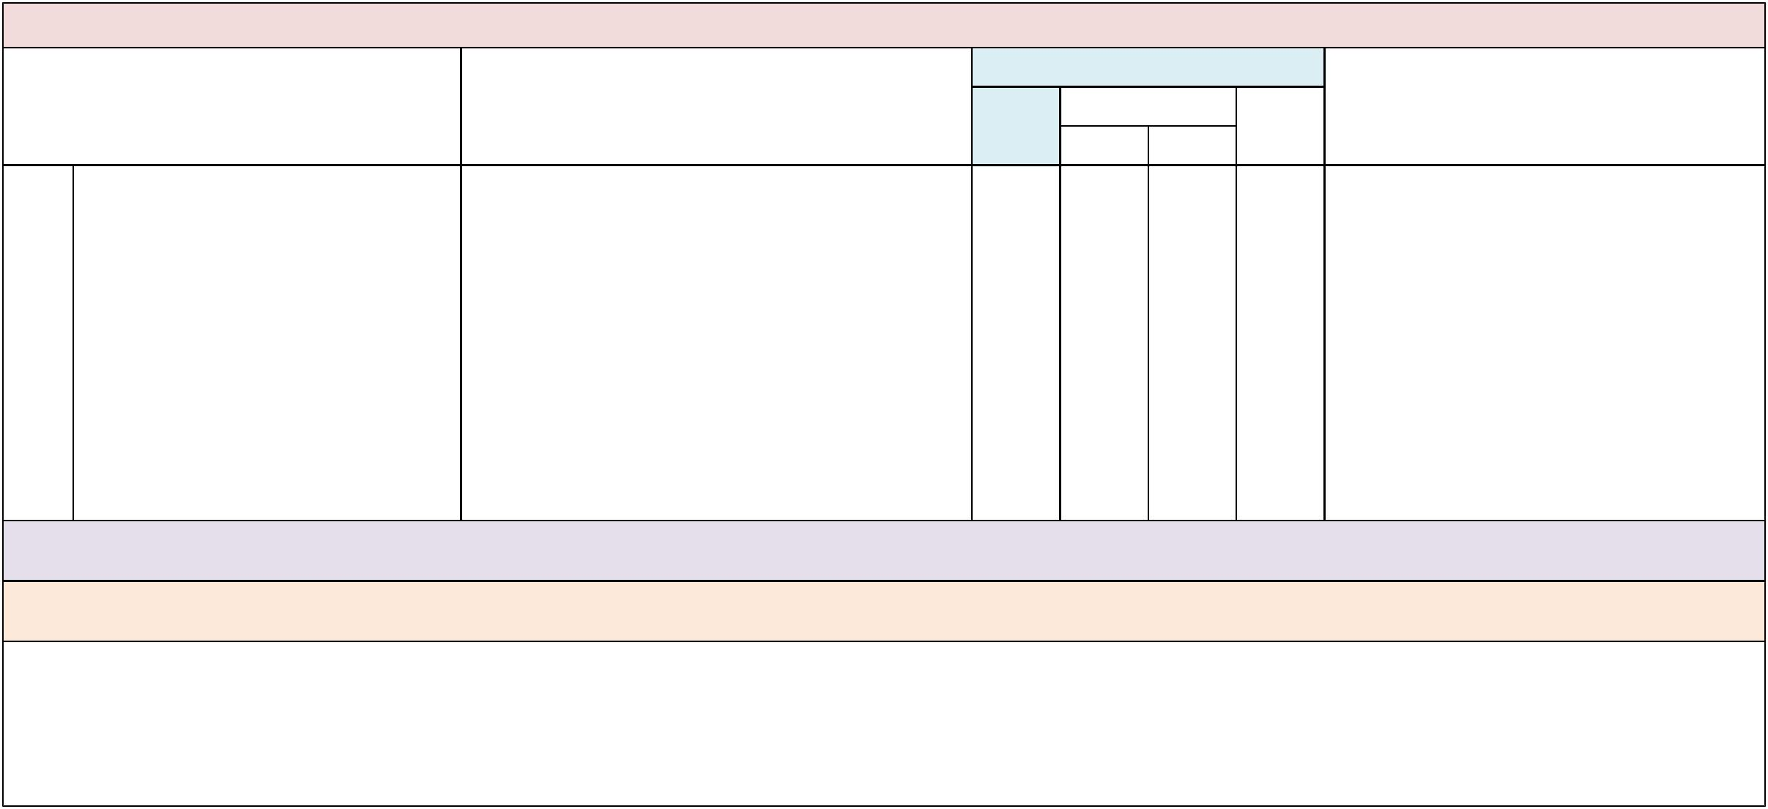

Domain: Leadership and Decision Making

 | Indicator |  | Examples or Evidence of Practice
8. | School administrators facilitate the use of | • | School administrators obtain and allocate resources
 | resources, by school personnel, to |  | (e.g., personnel and materials) to implement
 | implement best practices for inclusive | • | effective inclusive practices.
 | education for all SWDs. | • | School administrators provide and monitor the use
of resources across all school teams, such as:

• -- Supplemental materials for core subject areas

related to all academic standards;

• -- Text sets with differentiated reading levels;

• -- Accessible instructional materials, (e.g., textbook

set for homework and textbooks with alternate

formats: audio/electronic, braille, large print);

• -- Assistive technologies, supports and services;

• -- Time for instructional planning; and

• -- Allocation of personnel aligned with in-class

support needs of students (e.g., reading and math

coaches, paraprofessionals, therapists).

 | Implementation Status
Not |  | Partially |  | Fully | Data Sources/Supporting Evidence
yet |  | B | A | Fully

Suggested Measures: Achievement data for all SWDs. Inventory lists available to all staff indicating supplemental materials available for use with all students across all content areas and grade levels; schedules of teacher planning time; and minutes from planning meetings with support personnel, coaches and/or administrators.

Note: Aligns with District BPIE Indicator #5. Within an MTSS, all educators should have access to a variety of resources that include concepts of universal design so that all students have access to and can make progress in the general education curriculum.

Comments:

PETERS ELEMENTARY SCHOOL School-Level Self-Assessment 2018-19
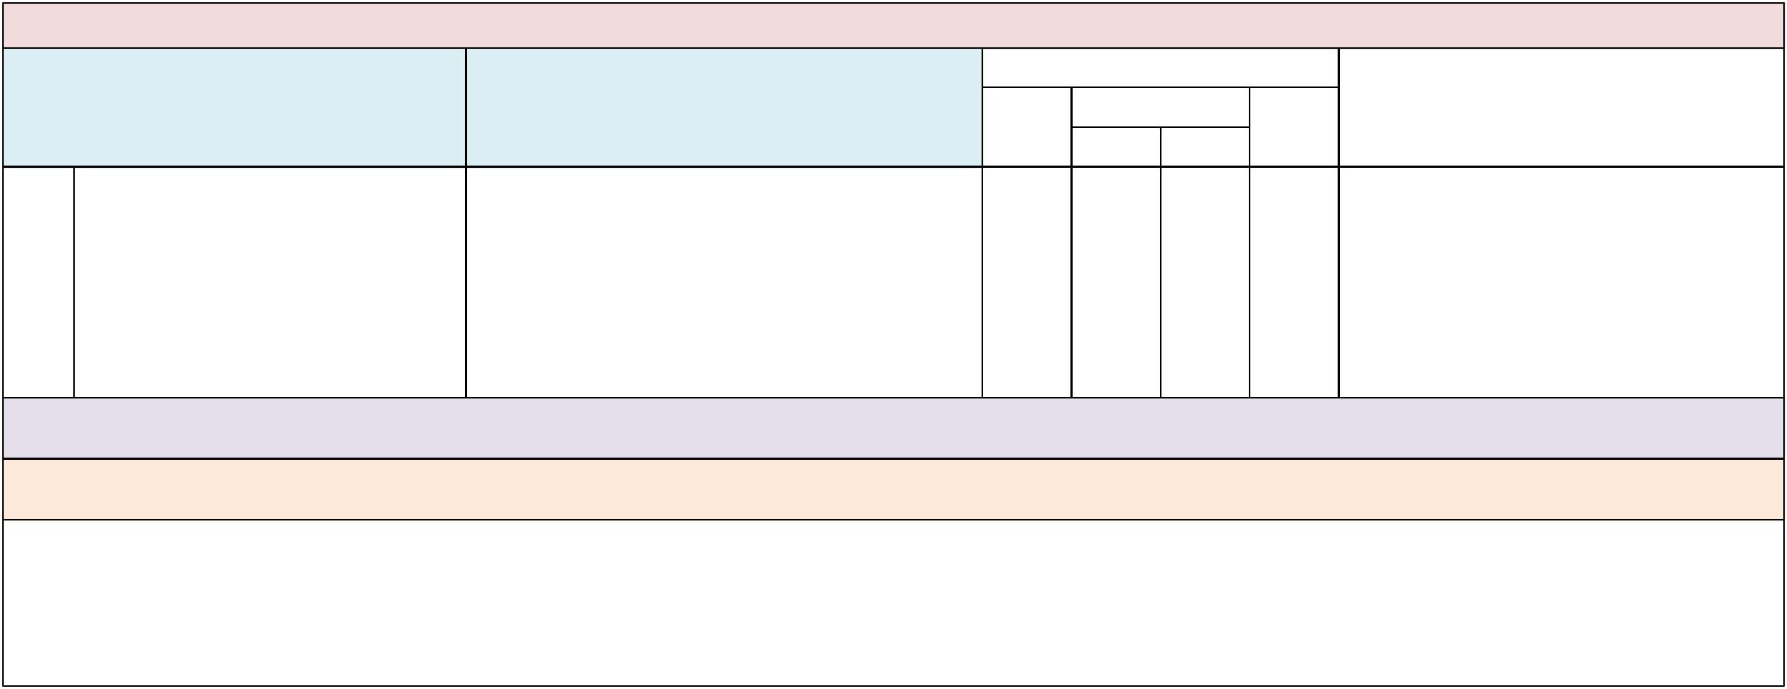

Domain: Leadership and Decision Making

Indicator Examples or Evidence of Practice

 | Implementation Status
Not |  | Partially |  | Fully | Data Sources/Supporting Evidence
yet |  | B | A | Fully

- School administrators communicate expectations for all school personnel to use person first language in all written and verbal communications.

- Administrators provide all school personnel with ongoing information and resources on person first language.

- Administrators provide guidelines on the use of person first language in all written, electronic and verbal communication.

- Administrators provide strategies to eliminate the use of disability-related labels in all written, electronic and verbal communication (e.g., referring to students by name rather than any label).

Suggested Measures: School documents (e.g., SIP, newsletters), family resources, guidelines, written and electronic communication (e.g., staff roster, staff handbook, school website) and job interview questions reflect the use of person first language.

Note: Aligns with District BPIE Indicator #24. See Appendices: Glossary of Terms and Resources/Publications sections for information on supporting and using person first language. Language is a

powerful tool: When we adopt new ways of thinking and talking about people with disabilities, we not only exert a positive influence on their lives, but on our society as a whole.

Comments:

PETERS ELEMENTARY SCHOOL School-Level Self-Assessment 2018-19
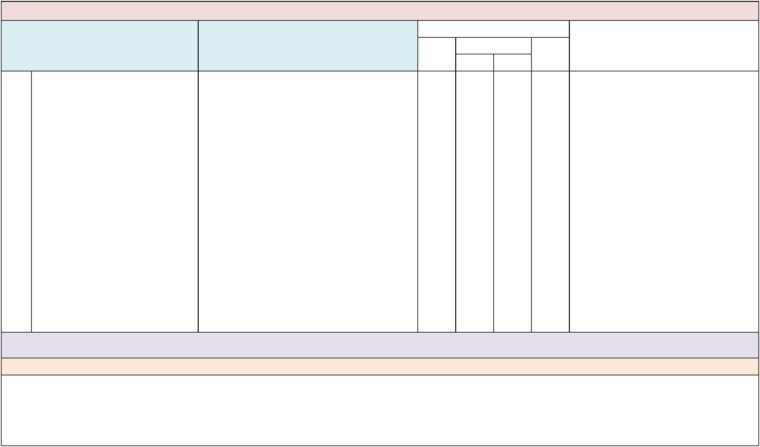

Domain: Leadership and Decision Making

Indicator Examples or Evidence of Practice

 | Implementation Status
Not |  | Partially |  | Fully | Data Sources/Supporting Evidence
yet |  | B | A | Fully

- School administrators use job interview questions to appraise an applicant’s knowledge and beliefs pertaining to diversity and inclusive practices, as applicable to the position.

- School interview team members assess applicant responses to ensure a willingness to implement inclusive educational practices, such as collaborative planning and teaching, differentiating instruction, etc.

- School interview team members include job interview questions for instructional staff that assess knowledge and beliefs of inclusive educational practices, such as:

- -- “Please describe your role in a co-taught classroom.”
- -- “How would you differentiate instruction for students in a mixed-ability classroom, including those on a modified curriculum?”

- -- “Tell me how you would respond if a parent of a student with a significant disability inquires about enrolling their child at this school?”

- School interview team members include job interview questions for non-instructional staff (e.g., paraprofessionals, front office, custodial) that assess knowledge and beliefs of inclusive educational practices, such as:

- -- “Tell me how you would respond if a parent of a student with a significant disability inquires about enrolling their child at this school.”

- -- “Give me an example of a time when you facilitated relationship-building between students with and without disabilities.”

Suggested Measures: Interview questions used for various positions at the school, including front office staff, cafeteria staff, teachers, paraprofessionals, coaches, etc., include questions related to diversity and effective inclusive practice, as applicable to the position.

Note: Aligns with District BPIE Indicator #11.

Comments:

PETERS ELEMENTARY SCHOOL School-Level Self-Assessment 2018-19
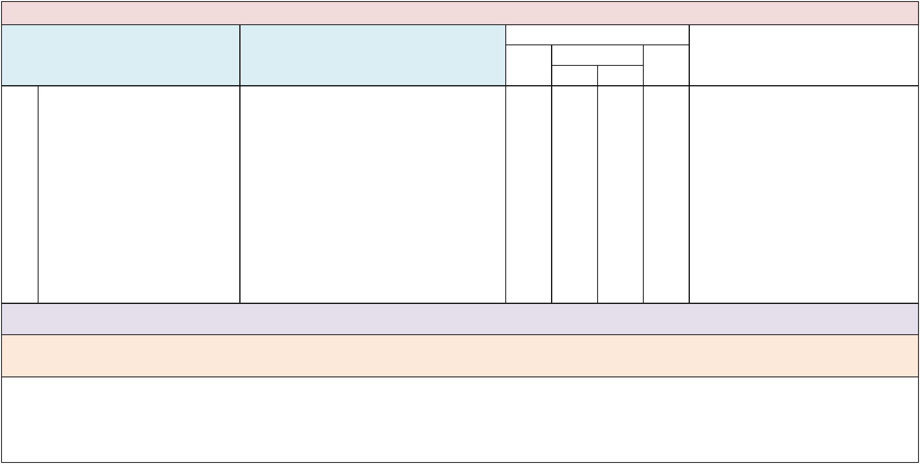

Domain: Leadership and Decision Making

Indicator

- School administrators advocate for all SWDs to be transported to and from school and community-based activities with students without disabilities attending the same school, except for those who have an IEP indicating a shortened school day.

Examples or Evidence of Practice

- Administrators review bus arrival and departure procedures for all buses to ensure the safety of all students and identify potential problem areas (e.g, physical access, health and safety measures, adequate supervision for all bus arrivals and departures)

- All bus arrivals and departures occur at the same time and location for students with and without disabilities.

- There are designated bus monitors in each school who are responsible for overseeing bus procedures and identifying potential problems.

- The principal has made a formal request to the district for bus schedules to be changed.
- Students with and without disabilities attend field trips, community-based career or vocational instruction and school-sponsored trips together.

- SWDs do not arrive late and leave school early based upon the bus schedule.

 | Implementation Status
Not |  | Partially |  | Fully | Data Sources/Supporting Evidence
yet |  | B | A | Fully

Suggested Measures: Bus schedules and rosters, school site map (including bus locations), field trip documentation; documentation of emails or other communication between school leaders and district transportation office requesting changes to bus schedules.

Note: Aligns with District BPIE Indicator #9. Although school leaders may not have full control over district bus schedules, they can advocate for the district to make changes to schedules so that no students lose academic time on task as a result of scheduled bus service. School leaders can also make requests to the district through work orders that include the construction of curb cuts at school bus drop-off and pick-up locations designated for all buses.

Comments:

PETERS ELEMENTARY SCHOOL School-Level Self-Assessment 2018-19


Domain: Leadership and Decision Making

Indicator Examples or Evidence of Practice

 | Implementation Status
Not |  | Partially |  | Fully | Data Sources/Supporting Evidence
yet |  | B | A | Fully

- All SWDs have the same opportunities as students without disabilities to participate in all school-sponsored, non-academic, age-appropriate activities, including electives, sports, dances, clubs, field trips, school plays, community service activities and graduation activities.

- All SWDs have access to all school facilities and non-academic activities.
- Supports, such as adaptive equipment, band instruments and communication devices, are provided so that SWDs can fully participate in the same activities as those students without disabilities.

- Athletic coaches include students with disabilities in the same activities as those without disabilities.
- Club sponsors are chosen because of their commitment to include SWDs in all club activities.
- Case managers monitor the participation of SWDs in non-academic activities.
- All personnel advocate for the inclusion and full participation of SWDs in school-sponsored activities.
- SWDs participate in class field trips with same-age peers without disabilities. Separate, “ESE only” field trips are discouraged.

- School personnel model strategies and create opportunities for students without disabilities to socialize with SWDs in non-academic contexts, (e.g., clubs, common gathering areas, lunch, pep rallies).

- Ability awareness and diversity training is provided to all students in the school.
- Same-age peers provide natural supports to SWDs, as appropriate, to facilitate social interactions during school-sponsored activities.

- SWDs are eligible for and encouraged to run for student government.
- All SWDs are eligible, within the same guidelines as their peers without disabilities, for candidacy for homecoming court, prom court, etc.

- Families of students with significant cognitive disabilities receive information about all school-sponsored, non-academic activities.

Suggested Measures: Student schedules, organizational rosters, list of adaptive equipment; observations of students with and without disabilities in non-academic contexts, e.g., recess, in between class and school social gatherings; surveys, focus groups or interviews of students with and without disabilities

Note: Aligns with District BPIE Indicator #21. For many students with disabilities, especially those with more significant disabilities, learning purposeful skills in the context of meaningful and inclusive activities is critical to practicing, maintaining and generalizing what they learn across a range of natural settings and situations. Educators should consider non-academic activities when identifying opportunities to develop essential skills such as using money, ordering food, reading, speaking and asking for assistance when needed in natural contexts, with non-disabled peers. School-sponsored, non-academic activities also provide opportunities for students with significant disabilities to interact and develop relationships with same-age peers without disabilities.

Comments:
PETERS ELEMENTARY SCHOOL School-Level Self-Assessment 2018-19
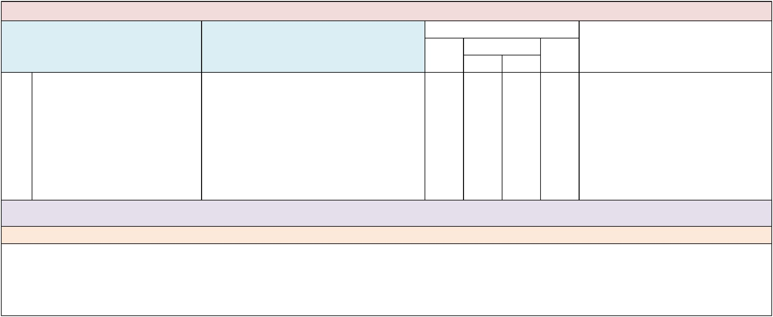

Domain: Leadership and Decision Making

Indicator Examples or Evidence of Practice

 | Implementation Status
Not |  | Partially |  | Fully | Data Sources/Supporting Evidence
yet |  | B | A | Fully

- All students, including SWDs, are given equal consideration for recognition through honors, awards and other designations offered by the school.

- All SWDs, including those who are working on a modified curriculum, are included in honors and awards programs

- (e.g., honor roll, citizenship awards, academic awards, science fair and attendance awards),
- except those honors and awards based solely on the requirements of the standard curriculum
- (e.g., class standing for academic scholarships, honor societies and International Baccalaureate programs).

- All SWDs are recognized for honors and awards in the same manner and at the same time as those without disabilities.

Suggested Measures: Guidelines for participation as noted in information (e.g., school handbook, flyers, newsletters, website) disseminated to teachers, students and families; list of honorees and award recipients; student interview responses.

Note: Aligns with District BPIE Indicator #23.

Comments:

PETERS ELEMENTARY SCHOOL School-Level Self-Assessment 2018-19
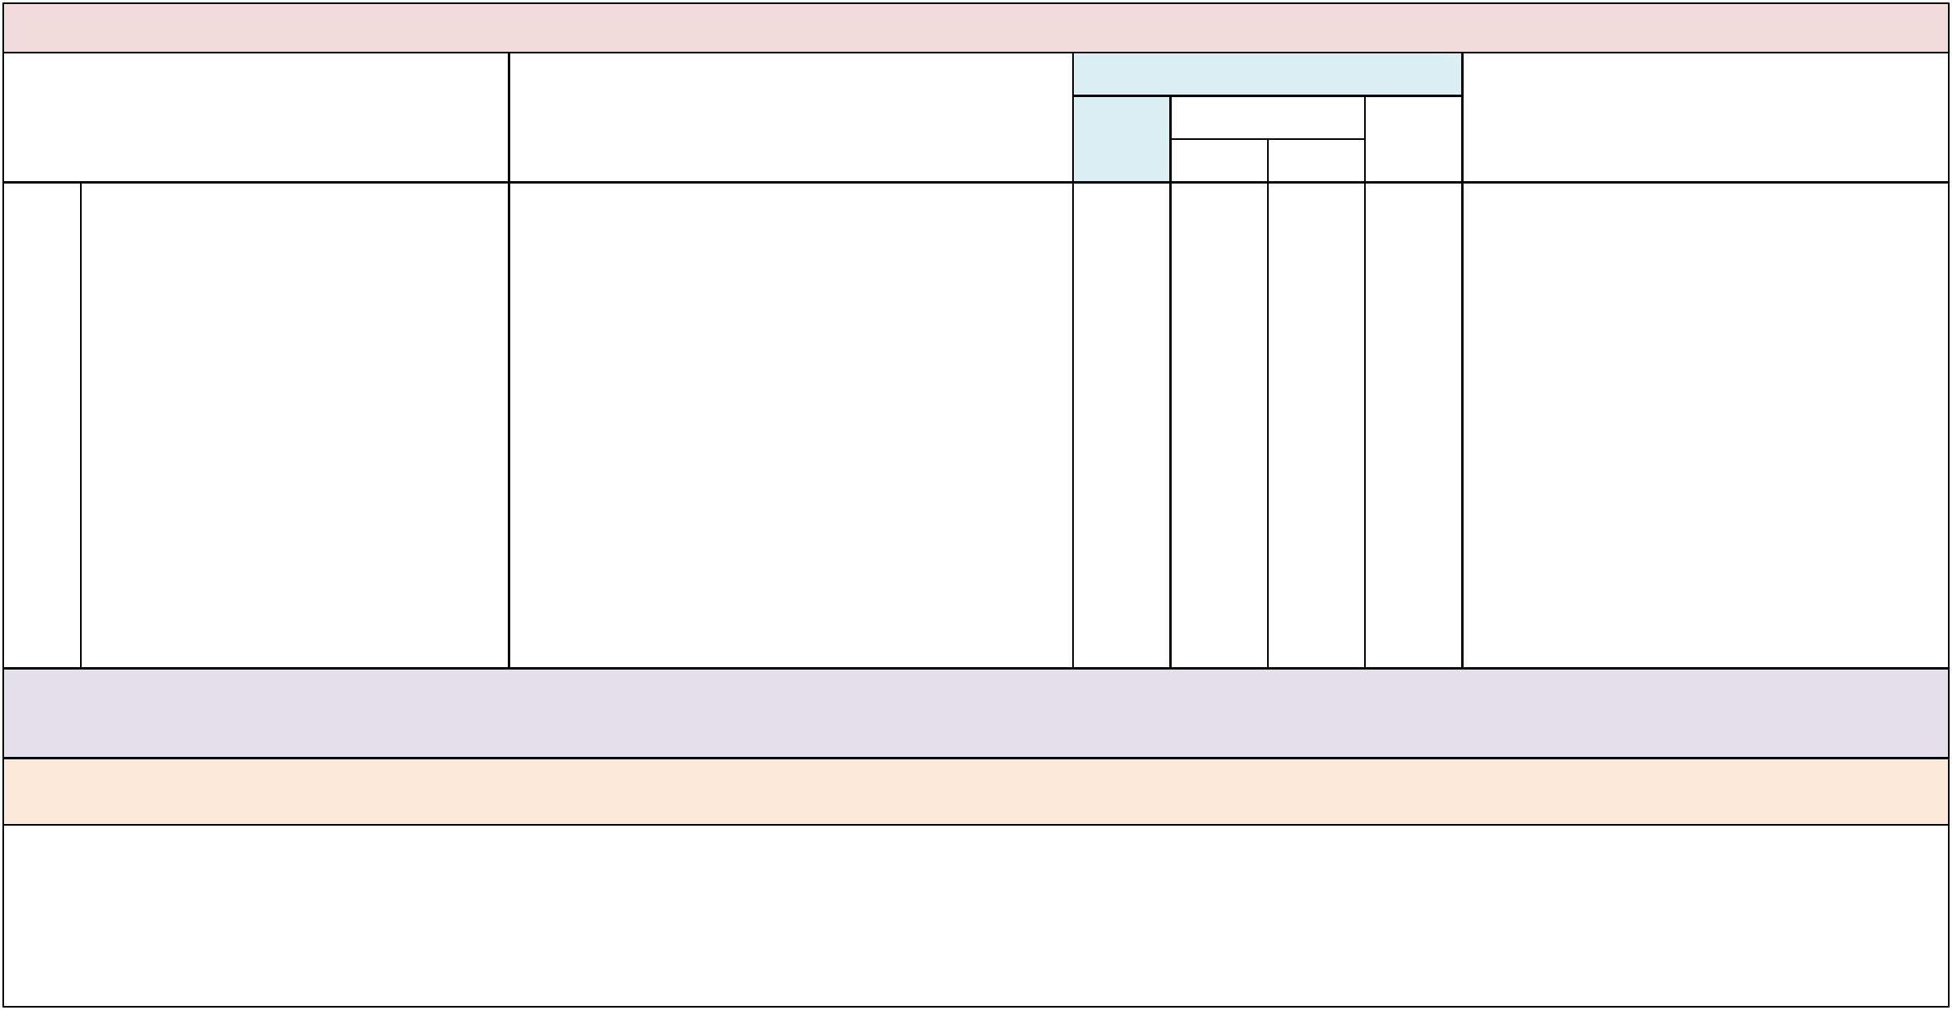

Domain: Leadership and Decision Making

Indicator | Examples or Evidence of Practice
14. School administrators analyze data to | • Administrators analyze student performance data,
identify professional development (PD) | staff and family needs assessments/ surveys.
and technical assistance (TA) needed for | • Administrators analyze data from classroom
school personnel to implement effective | observations.
inclusive practices. | • Administrators obtain input from IEP teams to
 | identify specific PD and TA (e.g., augmentative,
 | alternative communication [AAC], positive behavior
 | supports [PBS]) needed to support individual
 | students.
 | • PD and TA are differentiated for each staff member,
 | as per their assessed needs.
 | • When appropriate, individual staff members include
 | PD and TA goals related to inclusive practices in
 | their individual professional development plan.
 | • Regular review of student learning data is reflected
 | in the SIP in an effort to determine ongoing PD and
 | TA needs.
 | • Regularly scheduled (at least quarterly) data checks/
 | discussions are conducted across school teams to
 | identify ongoing PD and TA needs of teachers.

 | Implementation Status
Not |  | Partially |  | Fully | Data Sources/Supporting Evidence
yet |  | B | A | Fully

Suggested Measures: Needs assessment data from school staff and family members, record of needs assessment and information sessions/PD specifically geared toward family members, the individual professional development plan of each professional staff member, agendas/sign-in sheets from professional development activities/technical assistance activities and record of follow-up activities.

Note: Aligns with District BPIE Indicators #6 and #7. School administrators are encouraged to develop PD and TA that are differentiated based on individual educator and/or team needs and not as a one-size-fits-all approach.

Comments:

PETERS ELEMENTARY SCHOOL School-Level Self-Assessment 2018-19
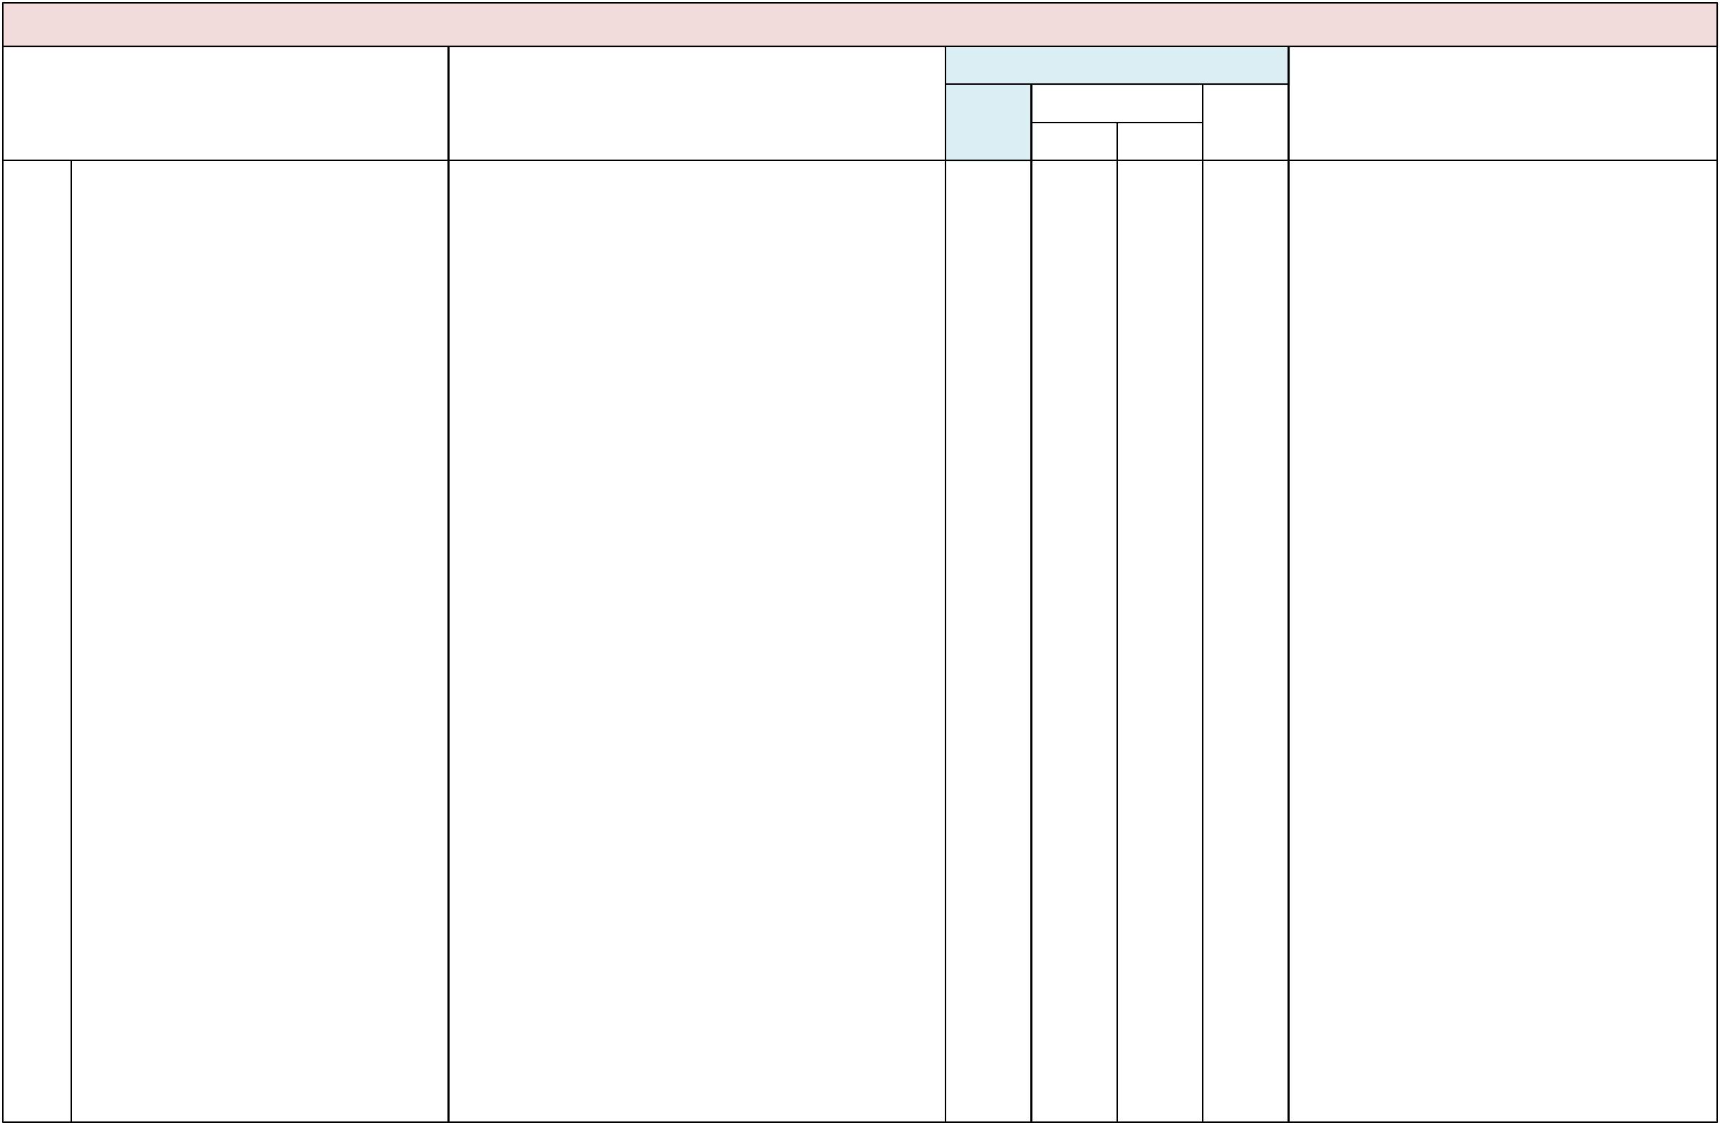

Domain: Leadership and Decision Making

Indicator |  | Examples or Evidence of Practice
15. School leaders provide job-embedded | • | Administrators identify collaborative teams,
professional development for all school- |  | including general and special education staff, to
based personnel, as appropriate for their |  | participate in all PD related to effective inclusive
job role, on best practices for inclusive | • | practices.
education for all SWDs. | • | PD is provided through existing school structures,
 |  | such as PLCs, faculty book studies, collaborative
 |  | team planning, lesson study, peer coaching and
 |  | critical friends groups.
 | • Strategies for effective inclusion are provided and
 |  | modeled in the classroom setting.
 | • PD is provided to collaborative teams, to include the
 |  | following topics.
 | • -- Curricular accommodations and modifications in
 |  | general education classes and non-instructional
 |  | activities
 | • -- Embedding IEP goals into the general education
 |  | instructional activities and natural contexts
 | • -- Access points for math, language arts, science and
 |  | social studies
 | • -- Universal design for learning (UDL)
 | • -- Differentiated instruction (DI)
 | • -- Classroom management strategies
 | • -- Data collection and analysis
 | • -- Accessible instructional materials
 | • | -- Assistive technology
 | • -- Communication supports (AAC)
 | • | -- Visual supports
 | • | -- PBS
 | • -- Alignment of modified curriculum to general
 | • | education standards
 | • | -- Formative assessment
 | • -- Collaborative planning and teaching models
 | • | -- Flexible scheduling
 | • | -- Peer supports
 | • | -- School-family communication/collaboration
 | • School leaders participate in professional
 |  | development activities provided to teachers and
staff on inclusive educational practices.

• School leaders provide electronic learning resources

related to inclusive educational practices (e.g., FIN’s

Building Inclusive Schools) for all SWDs.

• Outside resources, such as webinars, FIN, FDLRS,

and CARD, are procured for the provision of PD.

• School leaders provide a published schedule of PD

opportunities, made available throughout the school

year, for all school personnel.

 | Implementation Status
Not |  | Partially |  | Fully | Data Sources/Supporting Evidence
yet |  | B | A | Fully

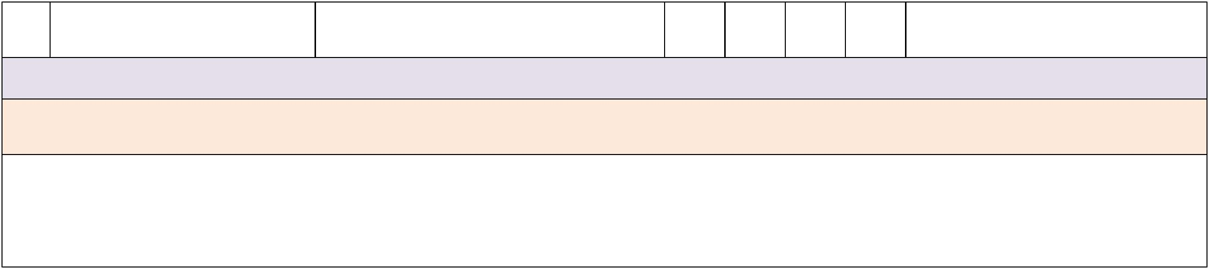
- Administrators provide ongoing support for new personnel who are hired after the beginning of the school year.

Suggested Measures: School’s professional development plan, agendas/sign-in sheets from professional development activities and record of follow-up activities, master schedule (showing collaborative planning time), records of technical assistance activities and follow-up activities for school personnel.

Note: Aligns with District BPIE Indicators #13–#17 and #19. Please see the Appendices: Glossary of Terms for definitions of the above terms: access points, collaborative teams and visual supports. It is recommended that school administrators maintain an active role in the provision of PD activities for their faculty and staff. This includes participation in PD activities and monitoring of progress toward meeting PD goals for individual teachers and/or teams.

Comments:
PETERS ELEMENTARY SCHOOL School-Level Self-Assessment 2018-19


Domain: Leadership and Decision Making

Indicator |  | Examples or Evidence of Practice
16. School leaders facilitate job-embedded, | • | A key person at the school coordinates activities
technical assistance for all school-based |  | related to needs assessments and TA for individual
personnel, as appropriate for their job | • | staff and collaborative teams.
role, on best practices for inclusive | • | School leaders facilitate the provision of technical
education for all SWDs. |  | assistance for individual staff and collaborative
 |  | teams as determined through PD and needs
 |  | assessments, such as:
 | • -- In-class coaching on collaborative teaching
 |  | models;
 | • -- Development of professional learning
 |  | communities;
 | • -- Classroom demonstration of instructional
 |  | strategies;
 | • -- Team problem solving;
 | • | -- Flexible scheduling;
• -- Planning and implementing behavior supports;

• -- Planning and implementing visual supports;

• -- AAC and other instructional technologies;

• -- Planning and application of curricular

accommodations/modifications; and

• -- Planning instruction based on UDL and DI.

• Teacher leader(s) are identified to provide ongoing

follow-up, coaching and feedback to teachers and

teams.

• Outside resources, such as FIN, FDLRS and CARD,

are procured for the provision of TA.

Suggested Measures: Schedule of TA with topics, data from various needs assessment instruments.

 | Implementation Status
Not |  | Partially |  | Fully | Data Sources/Supporting Evidence
yet |  | B | A | Fully

Note: Aligns with District BPIE Indicators #14–#17 and #19. It is recommended that school administrators maintain an active role in the provision of TA activities for their faculty and staff. This includes monitoring of progress toward meeting PD goals for individual teachers and/or teams.

Comments:

PETERS ELEMENTARY SCHOOL School-Level Self-Assessment 2018-19
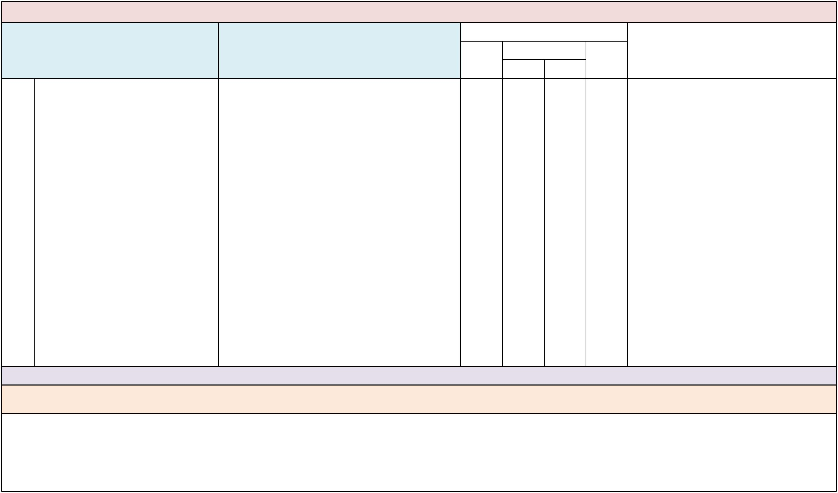

Domain: Leadership and Decision Making

Indicator Examples or Evidence of Practice

 | Implementation Status
Not |  | Partially |  | Fully | Data Sources/Supporting Evidence
yet |  | B | A | Fully

- School administrators ensure that collaborative planning time is used productively and reflected in general and special education staff schedules and instructional plans.

- The school master schedule reflects collaborative planning time for collaborative teaching teams.
- Administrators provide structures for release time for planning (e.g., floating substitute teachers, duty release).

- Administrators ensure that teacher duty assignments are distributed across all staff, allowing time for collaborative teachers to plan.

- The principal schedules time for secondary special education teachers, assigned to different departments (e.g., science, English, history, math) to meet with general education teams to discuss the progress of students they have in common.

- Monthly PD days are designated for teams (including ESE and general education teachers) to plan and discuss grade-level or subject-area concerns related to curriculum and student interventions.

- Agendas and logs from collaborative planning sessions are available for administrators to review.
- There is evidence that lesson plans are developed collaboratively and include shared roles and responsibilities for instruction and assessment.

- There is a schedule and record of PLCs related to the review of student work and instructional planning.
- Meeting logs show evidence that student data are reviewed, discussed and used to guide all instructional decisions made by teams during collaborative planning time.

Suggested Measures: Master schedule, teachers’ lesson plans, agendas and logs from collaborative planning sessions, walk-through notes from teacher planning meetings.

Note: Aligns with District BPIE Indicator #15. School administrators are encouraged to provide support to teams during planning time, such as oversight of and support for team planning agendas and activities, assistance with team problem solving and provision of resources for planning time (e.g., release of regularly scheduled bus duty time for collaborative planning).

Comments:

PETERS ELEMENTARY SCHOOL School-Level Self-Assessment 2018-19
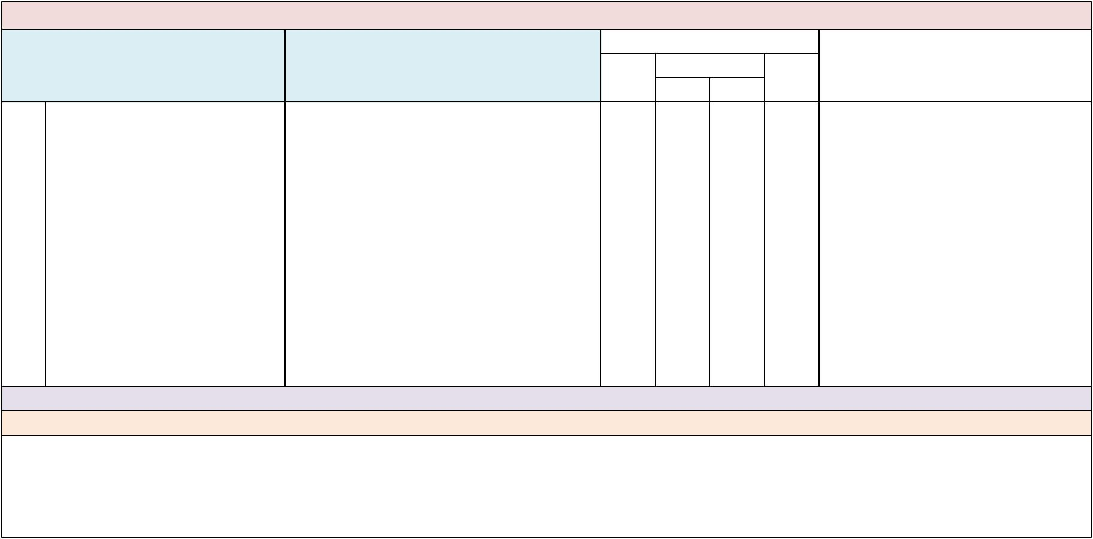

Domain: Instruction and Student Achievement

Indicator Examples or Evidence of Practice

 | Implementation Status
Not |  | Partially |  | Fully | Data Sources/Supporting Evidence
yet |  | B | A | Fully

- Special, electives and career technical education (CTE) teachers have regularly scheduled opportunities to consult with special education teachers and related service providers to implement strategies that support the learning of all SWDs in their classes.

- A music teacher has several SWDs in his classes. A special education teacher is available to observe students during class and discuss accommodations, modifications or other appropriate supports for these students.

- The physical therapist provides consultation to the physical education (P.E.) coach related to adaptive equipment for students who need mobility supports.

- The occupational therapist provides guidance to the business education teacher on the use of assistive devices, such as adaptive keyboards, for a student with fine motor support needs.

- ESE teachers and support services personnel solicit feedback from specials, electives or CTE teachers to determine the effectiveness of instructional accommodations or modifications.

- The ESE teachers provide monthly updates with specific student information, instructional strategies and/or useful articles to teachers.

- The LATS team provides guidance and training on the use of assistive technology devices.

Suggested Measures: Teacher schedules, teachers’ lesson plans, agendas and notes from collaborative teaching sessions.

Note: -

Comments:

PETERS ELEMENTARY SCHOOL School-Level Self-Assessment 2018-19
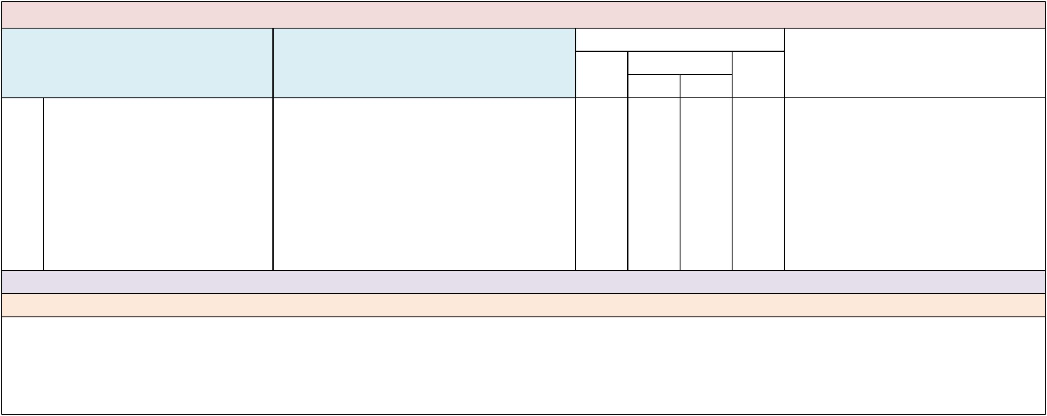

Domain: Instruction and Student Achievement

Indicator Examples or Evidence of Practice

 | Implementation Status
Not |  | Partially |  | Fully | Data Sources/Supporting Evidence
yet |  | B | A | Fully

- General and special education teachers use the Florida Standards as the foundation for instruction of all SWDs, including those with a significant cognitive disability.

- IEP goals and objectives for all SWDs are aligned to the general education standards.
- General and special education teachers can articulate what all students need to know, understand and be able to do in relation to the Florida Standards.

- The instructional goals and learning targets of students with a significant cognitive disability are based on access points.

- Teachers modify learning goals and instruction for students with a significant cognitive disability using the same, or similar, age-appropriate materials as those used by students without disabilities.

Suggested Measures: Lesson or unit plans, curriculum maps, walk-through data, ongoing progress-monitoring data.

Note: For all SWDs, including those who are taking alternate assessment, educators should develop learning goals and assess progress toward meeting those goals based on the Florida Standards.

Comments:

PETERS ELEMENTARY SCHOOL School-Level Self-Assessment 2018-19


Domain: Instruction and Student Achievement

Indicator Examples or Evidence of Practice

 | Implementation Status
Not |  | Partially |  | Fully | Data Sources/Supporting Evidence
yet |  | B | A | Fully

- An MTSS and problem-solving process is consistently used by school personnel to ensure progress in the general education curriculum, across all grades and settings, for all students with and without disabilities.

- School personnel use a problem-solving process to identify appropriate instructional and behavioral interventions.

- There is a schoolwide plan to provide school personnel with ongoing PD and TA on the implementation of an MTSS framework.

- Members of the school MTSS team are assigned to provide support to specific grade-level or subject-area teams.

- PD and TA activities for implementing MTSS are documented in the SIP, including evaluation criteria to measure desired outcomes.

- PD and TA activities are provided with the goal of matching tiered supports with the instructional support needs of individual SWDs in general education classrooms and natural contexts.

- Families are provided information and opportunities to understand the MTSS process as it relates to tiered interventions for their child.

- Administrators allocate resources to support schoolwide MTSS, functional behavior assessments (FBA) and PBS plans.

- An FBA process is used to identify triggers and replacement behaviors for any student who needs additional behavioral support.

- School rules are translated into specific applications for classrooms, hallways and other school areas as part of a schoolwide PBS plan.

Suggested Measures: SIP, PD/TA schedule and sign-in sheets, minutes of MTSS meetings, schoolwide PBS plans, FBA documents.

Note: For more information and resources on the MTSS and problem-solving process, please refer to the Appendices: Glossary and Resources/Publications sections.

Comments:

PETERS ELEMENTARY SCHOOL School-Level Self-Assessment 2018-19
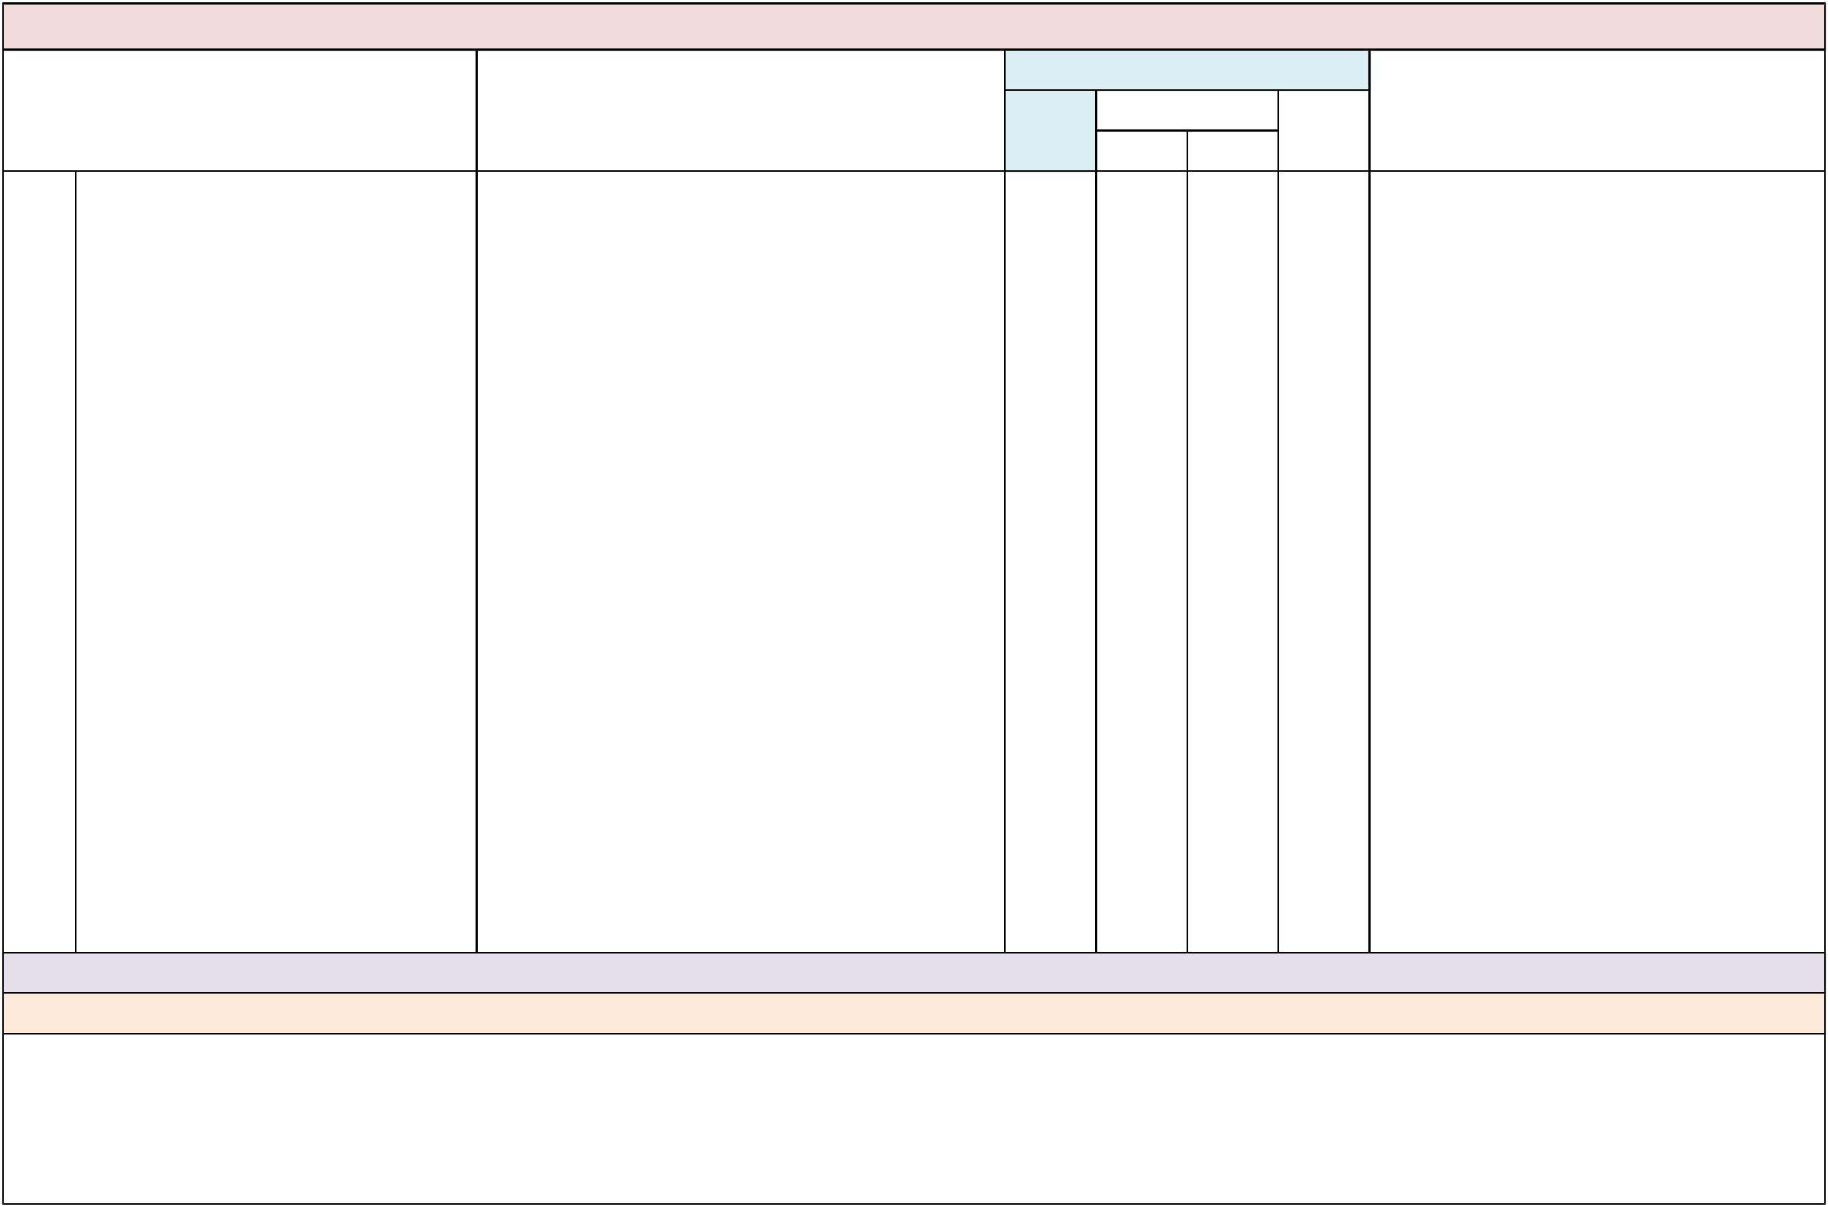

Domain: Instruction and Student Achievement

Indicator |  | Examples or Evidence of Practice
21. All instructional and related services | • | General education teachers collaborate with special
personnel use formative assessment |  | education teachers, and other related services
processes and tools to gather, analyze |  | personnel, to use a variety of data collection tools
and evaluate data about effective |  | and processes to continuously assess progress of
instruction and behavior interventions for |  | SWDs in general education classrooms and natural
all students with and without disabilities | • | conte
in general education and natural | • | to use a variety of data collection tools and
contexts. |  | processes to continuously assess progress of SWDs
 |  | in general education classrooms and natural
 | • | contexts, such as:
 | • | -- Checklists
 | • | -- Profiles
 | • | -- FBA tools;
 | • | -- Ecological inventories;
 | • | -- Task analysis;
 | • | -- Portfolios;
 | • | -- Performance assessments;
 | • -- Reading assessment tools; and
 | • | -- Scoring criteria/rubrics.
• All teachers use formative assessment data to

adjust instruction, revise behavior plans and

determine individual student responses to

interventions in general education and natural

contexts.

• Instructional personnel consider SWDs as general

education students first and use data-driven

decision making to identify supports needed for

SWDs to make progress in general education and

natural contexts.

• The school has designated personnel with expertise

in gathering and analyzing student data who provide

ongoing support in the use of formative assessment

processes.

• All SWDs have access to the same multi-tiered

interventions as those without disabilities.

 | Implementation Status
Not |  | Partially |  | Fully | Data Sources/Supporting Evidence
yet |  | B | A | Fully

Suggested Measures: Sample assessments, MTSS meeting minutes, classroom data, documentation showing adjustments in instruction or behavior plans.

Note: -

Comments:

PETERS ELEMENTARY SCHOOL School-Level Self-Assessment 2018-19
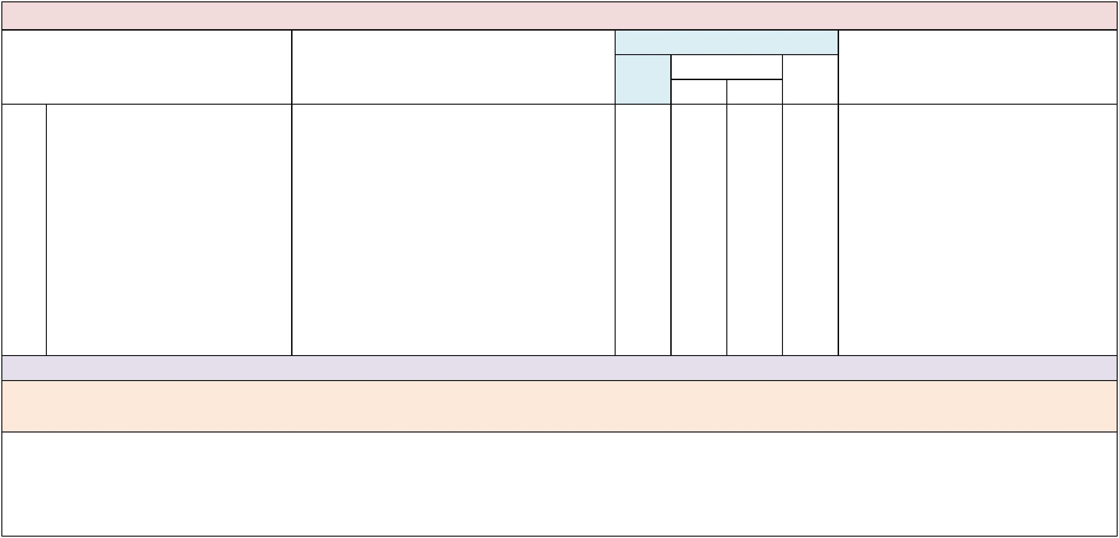

Domain: Instruction and Student Achievement

Indicator | Examples or Evidence of Practice
22. Teachers of SWDs who spend less than | • Special education teachers use formative
80% of their day in general education | assessment to identify student needs, adjust
classes use formative assessment data to | instruction, revise behavior plans and identify
identify effective instructional and | opportunities for learning in general education and
behavioral interventions that, when | natural contexts.
implemented in general education and | • Teachers of students in self-contained classrooms
natural contexts, allow SWDs to make | use formative assessment data to increase time
progress toward meeting IEP and learning | SWDs receive instruction in general education
goals. | classes, such as observational data to identify
 | effective behavior supports for learning in the
 | general -
 | • education classes, such as observational data to
 | identify effective behavior supports for learning in
 | the general education classroom.
 | • Teachers of students in self-contained classrooms
 | use formative assessment data to increase time
 | SWDs receive instruction in natural contexts, such
 | as lunchroom, media center and school store.

 | Implementation Status
Not |  | Partially |  | Fully | Data Sources/Supporting Evidence
yet |  | B | A | Fully

Suggested Measures: Sample assessments, MTSS meeting minutes, classroom data, documentation showing adjustments in instruction or behavior plans.

Note: This indicator refers to the use of formative assessment data to ensure SWDs served in self-contained and resource settings have opportunities to receive educational services in general education classes. Assessment data are used to determine interventions and supports that follow the student into general education classes, rather than providing educational supports and services in a pull-out model.

Comments:

PETERS ELEMENTARY SCHOOL School-Level Self-Assessment 2018-19
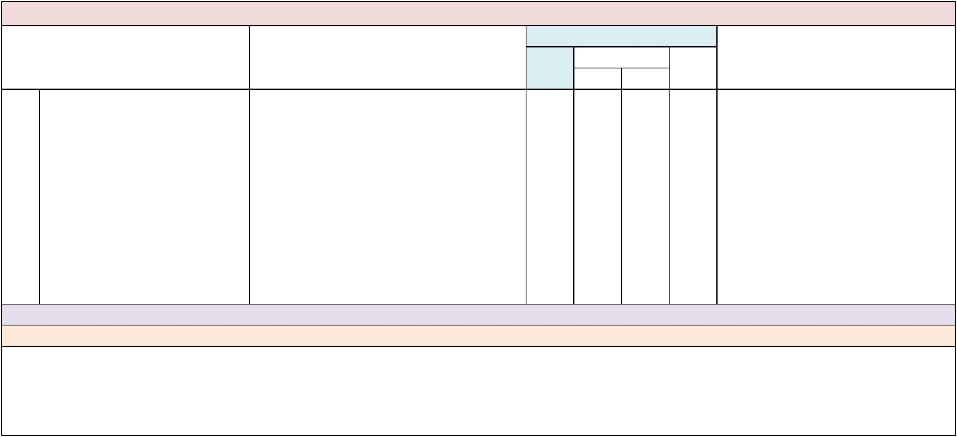

Domain: Instruction and Student Achievement

Indicator |  | Examples or Evidence of Practice
23. There is a schoolwide approach to | • | The school has one or more schoolwide programs in
facilitate positive, interdependent | • | place that address the following:
relationships and social responsibility | • | -- Formal, academic and social peer support
among all students with and without | • | -- Social and community inclusion
disabilities across all general education | • | -- Anti-bullying
and natural contexts. | • | -- Conflict mediation
 | • -- Student problem solving
 | • | -- Character education
• -- Self-determination and self-advocacy

• -- Community service projects

• -- Global cultural and diversity awareness

• Teachers include team-building and class-building

structures to create and support positive

interactions among students with and without

disabilities.

• School guidance counselor(s) are involved in

identifying and coordinating schoolwide programs

for anti-bullying, peer supports, etc.

 | Implementation Status
Not |  | Partially |  | Fully | Data Sources/Supporting Evidence
yet |  | B | A | Fully

Suggested Measures: Peer support roster, roster and syllabus of anti-bullying and character education programs, list of community service projects. Note: Aligns with District BPIE Indicator #22. These programs can be formal or informal, but should involve the entire school. Comments:

PETERS ELEMENTARY SCHOOL School-Level Self-Assessment 2018-19
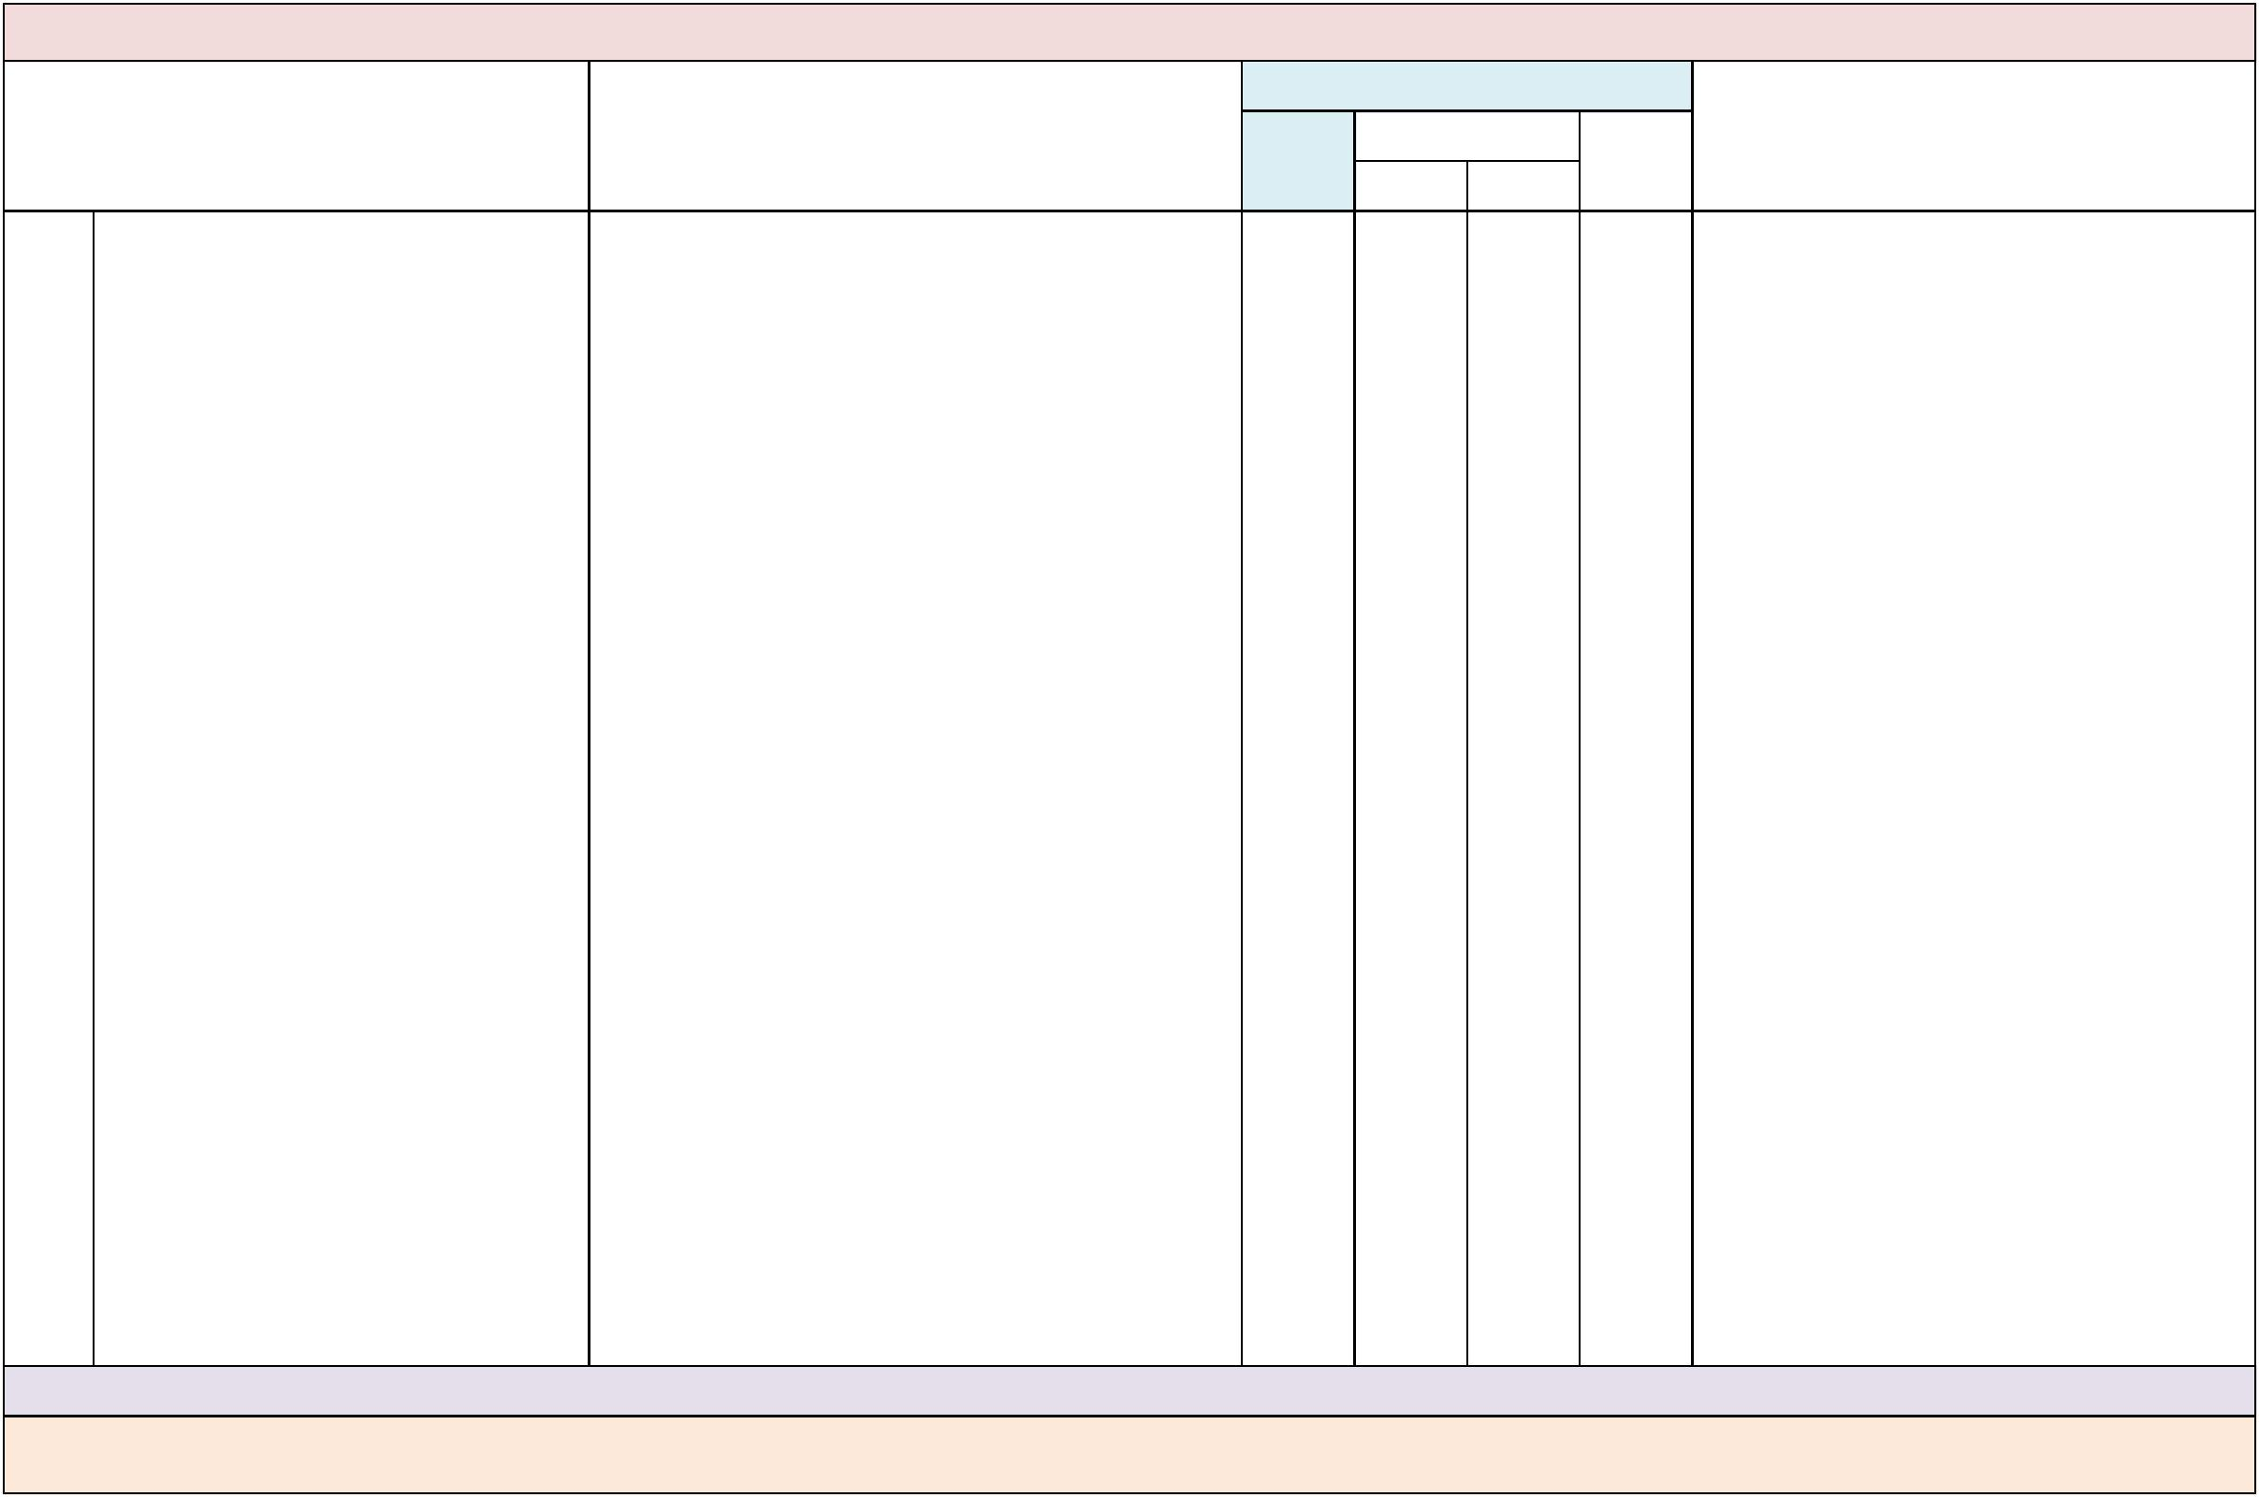

Domain: Instruction and Student Achievement

Indicator |  | Examples or Evidence of Practice
24. There is a schoolwide approach for | • | Teachers differentiate instruction to allow multiple
planning and implementing UDL across |  | means of representation, expression and
all instructional and non-instructional | • | engagement.
school contexts. | • | Lessons are presented in visual and oral formats.
 | • The student responds using eye gaze, choices cards
 |  | and/or gestures.
 | • Appropriate response time is given for SWDs to
 |  | participate.
 | • Instructional technology, matched to the needs of
 |  | individual students, is effectively used for instruction
 |  | in all classrooms.
 | • Teachers and support personnel use assistive
 |  | technology for students who need it, including low-
 |  | tech strategies and high-tech communication
 |  | systems and software, such as:
 | • -- Book pages equipped with foam tabs for Pre-K
 |  | students to easily turn pages;
 | • -- A visual schedule that includes items with Velcro
 |  | for ease of manipulation on the schedule board;
 | • -- Wide classroom aisles to accommodate students
 |  | with limited mobility;
 | • -- Table heights adjusted to accommodate a
 |  | wheelchair, a stander or students of short stature;
 | • -- Choice boards or software programs for visual
 | • | schedules and assignments;
 | • | -- Pencil grips;
 | • -- Wood blocks to raise the desk level;
 | • -- Specialized computer software, digital text,
 |  | iPads™, Alpha-Smarts™ or FM systems to ensure
 |  | meaningful participation in instructional activities;
 | • -- A student with scoliosis is provided with a lab stool
 |  | with a back so that he can participate fully in
 |  | instructional activities; and
 | • -- An FM system is provided in class for a student
 |  | who needs auditory support.
 | • Teachers allow students to respond orally on
 | • | assessments.
 | • | Teachers tier assignments/assessments.
 | • Teachers involve students with disabilities by
 |  | regularly using instructional strategies that support
more complex thinking rather than watering down

the curriculum.

 | Implementation Status
Not |  | Partially |  | Fully | Data Sources/Supporting Evidence
yet |  | B | A | Fully

Suggested Measures: Classroom observation, lesson plans reflect use of technology/DI and the principles of UDL.

Note: Creating learning environments using the principals of UDL does not mean teachers water down the curriculum for SWDs. Students with IEPs are expected to know and understand the same concepts as those without disabilities (with varying levels of complexity), through multiple means of representation, action and expression and engagement.

Comments:
PETERS ELEMENTARY SCHOOL School-Level Self-Assessment 2018-19


Domain: Instruction and Student Achievement

Indicator Examples or Evidence of Practice

 | Implementation Status
Not |  | Partially |  | Fully | Data Sources/Supporting Evidence
yet |  | B | A | Fully

- There are a variety of service delivery models in place, across all grade levels, to provide instruction and related services to SWDs in general education classes and natural contexts.

- Administrators and teachers can articulate different ways to deliver special education services in general education settings.

- Related services are provided, as appropriate, in general education classes and natural contexts: language therapy is provided to SWDs during reading instruction,

- physical therapy is provided during P.E. or recess and occupational therapy is provided during writing activities.

- When developing the school’s master schedule, SWDs are scheduled first.
- The school master schedule reflects a variety of service delivery models used across the school, including co-teaching, support facilitation and consultation.

- When providing in-class supports, teachers select and use various approaches, such as station teaching, parallel teaching and alternative teaching, based on the needs of the students and the intended outcome(s) of instruction and assessment.

- Collaborative teachers can explain why they selected a structure for a particular lesson.
- Collaborative teachers share accountability for co-planning and co-delivering instruction and co-assessing all students.

- Administrators note and provide feedback on collaborative teaching structures as part of the teacher evaluation system.

Suggested Measures: School master schedule, student schedules, IEPs, classroom observations, teacher interviews, administrative feedback.

Note: Service delivery models used to serve students in inclusive classes include consultation, support facilitation and co-teaching. For more information, please see the Resources/Publications

section: Course Code Directory and Instructional Personnel Assignments.

Comments:

PETERS ELEMENTARY SCHOOL School-Level Self-Assessment 2018-19


Domain: Instruction and Student Achievement

Indicator

- All paraprofessionals have received PD that includes clear descriptions of their work responsibilities and strategies for providing support to SWDs in general education classrooms and natural contexts.

Examples or Evidence of Practice

- Paraprofessionals receive ongoing training on topics relative to their work responsibilities
- (e.g., the nature of specific disabilities and impact on learning; providing communication, physical, social and academic supports; health, safety and hygiene needs; and confidentiality).

- Outside resources, such as FIN, FDLRS, and CARD, are procured for the provision of training to paraprofessionals.

- The roles and responsibilities of paraprofessionals are clearly outlined and communicated by administrators and teachers.

- The principal ensures dedicated time for paraprofessionals to consult with teachers and be involved in student IEP meetings.

- Teachers and paraprofessionals discuss strategies and methods to provide individual supports to SWDs in general education classrooms and natural contexts.

- Administrators and teachers monitor the activities of paraprofessionals to evaluate the effectiveness of supports provided to SWDs.

- Paraprofessionals can clearly articulate the learning, communication and behavioral support needs of the SWDs they serve.

 | Implementation Status
Not |  | Partially |  | Fully | Data Sources/Supporting Evidence
yet |  | B | A | Fully

Suggested Measures: Professional development logs, pre- and post-assessments, checklists, paraprofessional interviews, job descriptions, paraprofessional schedules.

Note: It is important that paraprofessionals understand how to support learning while using the least intrusive interventions for SWDs. Paraprofessionals should be included in professional learning opportunities and technical assistance relative to their assigned students and job responsibilities. Paraprofessionals’ input on student learning (academic, behavioral and social) is critical to planning and implementing appropriate supports as part of the IEP and curriculum team planning processes.

Comments:

PETERS ELEMENTARY SCHOOL School-Level Self-Assessment 2018-19
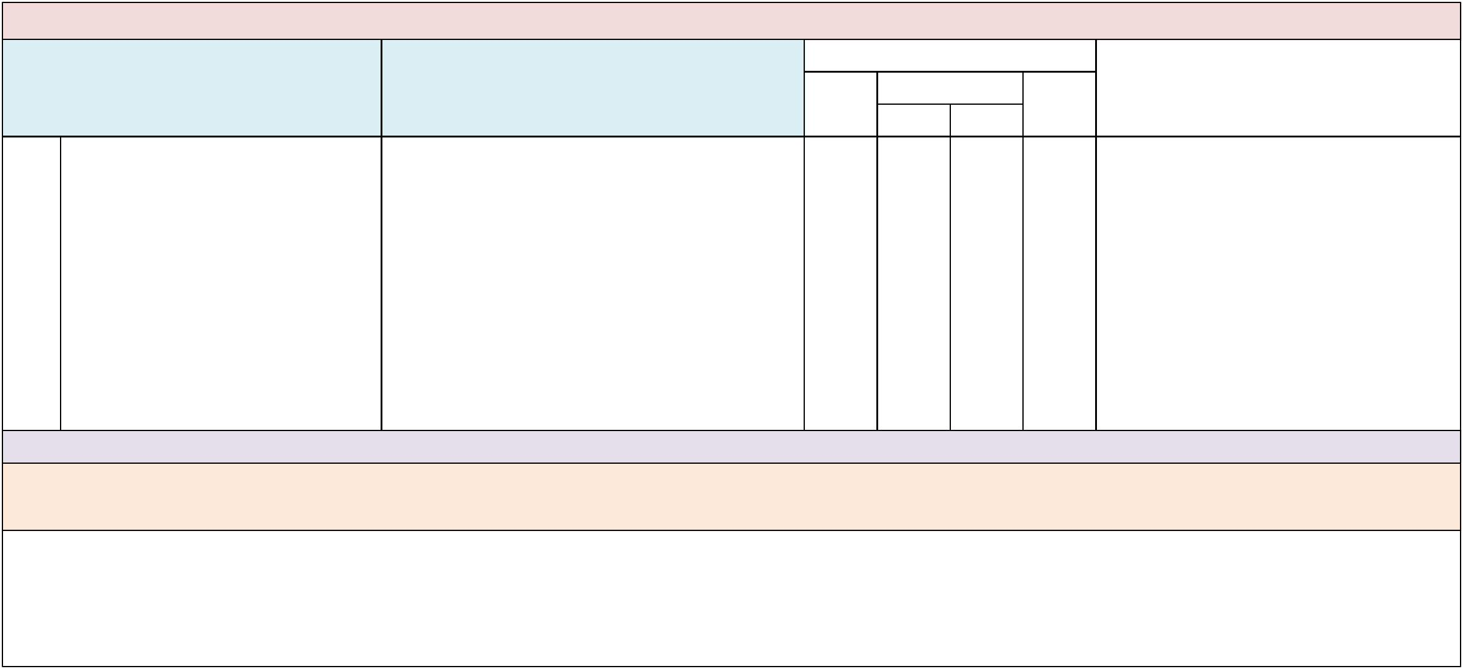

Domain: Communication and Collaboration

Indicator

- All special education teachers are full, collaborative members of a general education curriculum team.

Examples or Evidence of Practice

- A secondary school special education teacher is an active member of the social studies department.
- An elementary school special education teacher is an active member of the third grade team.
- Special education teachers collaborate with general education teachers to share and implement instructional decisions made by the team.

- Special and general education teachers meet regularly to share information on curriculum and individual student support needs.

- All team members receive minutes of team meetings and have input into decisions when not available to attend in person.

- Special education teachers are not pulled from regularly scheduled classroom schedules to attend other meetings (e.g., IEP or parent conferences).

 | Implementation Status
Not |  | Partially |  | Fully | Data Sources/Supporting Evidence
yet |  | B | A | Fully

Suggested Measures: Curriculum team rosters, curriculum team meeting schedules and notes.

Note: Although all special education teachers may not be available to meet with each curriculum team during every scheduled team meeting, they should flex their schedules to have opportunities to meet with each team throughout each grading period. For example, Mrs. Smith may meet with the third grade team during pre-school planning time on Monday, and the fifth grade team during pre-school planning the following Monday.

Comments:

PETERS ELEMENTARY SCHOOL School-Level Self-Assessment 2018-19
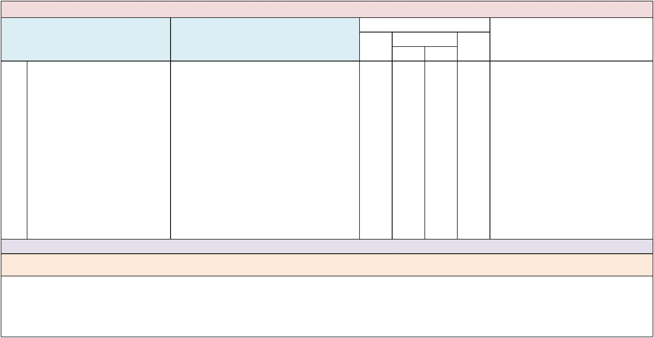

Domain: Communication and Collaboration

Indicator Examples or Evidence of Practice

 | Implementation Status
Not |  | Partially |  | Fully | Data Sources/Supporting Evidence
yet |  | B | A | Fully

- General and special education teachers use regularly scheduled collaborative planning time to clarify their roles and responsibilities while planning effective instruction and assessment for all students.

- Teachers identify and discuss their various roles (e.g., collaborative teaching structures) during the lesson-planning process.

- When planning, teachers consider the application of UDL and DI as part of every lesson.
- Teachers determine appropriate accommodations and other supports (e.g., behavior, visual and communication) for individual students.

- Teachers have consensus on grading procedures, especially when accommodations or modifications are provided for individual students.

- Teachers share roles and responsibilities such that distinctions between special education and the content- or grade-level teacher are not obvious.

- Teachers have parity in their roles so that one teacher does not have more responsibility for instruction and assessment than the other.

- Teachers reflect on and assess their effectiveness as collaborative teachers.
- Administrators provide ongoing support to assist collaborative teachers in identifying, clarifying and developing their roles and responsibilities.

Suggested Measures: Master schedule, teacher lesson plans, classroom observation or walk-throughs, teacher interviews, coaching logs.

Note: Please see the Resources Section: DOE Course Code Directory; Please see the Appendices: Glossary of Terms section for definitions of the above terms: Collaborative models of support—consultation, support facilitation and co-teaching.

Comments:

PETERS ELEMENTARY SCHOOL School-Level Self-Assessment 2018-19
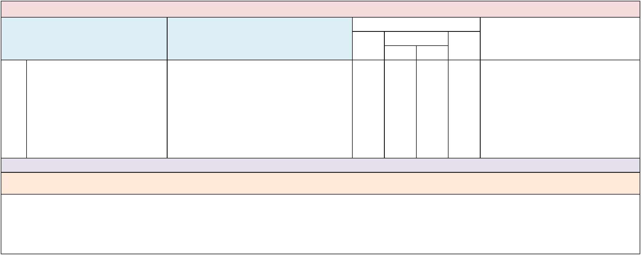

Domain: Communication and Collaboration

Indicator Examples or Evidence of Practice

 | Implementation Status
Not |  | Partially |  | Fully | Data Sources/Supporting Evidence
yet |  | B | A | Fully

- Family members of SWDs are contributing members of school decision-making groups.

- School administrators actively recruit family members of SWDs to participate in school decision-making groups, including the School Advisory Council.

- Family members of SWDs are active members of groups such as the Parent-Teacher Association (PTA) and school sub-committees (e.g., Fall Festival, Band Boosters).

- Family members of SWDs participate in school decision-making based upon annual measurable outcome data for students with and without disabilities.

Suggested Measures: Decision-making group rosters, meeting notes.

Note: In addition to the School Advisory Council, family members of students with disabilities should be included in all decision-making groups that include family members of students without disabilities, such as the PTA and school sub-committees.

Comments:

PETERS ELEMENTARY SCHOOL School-Level Self-Assessment 2018-19
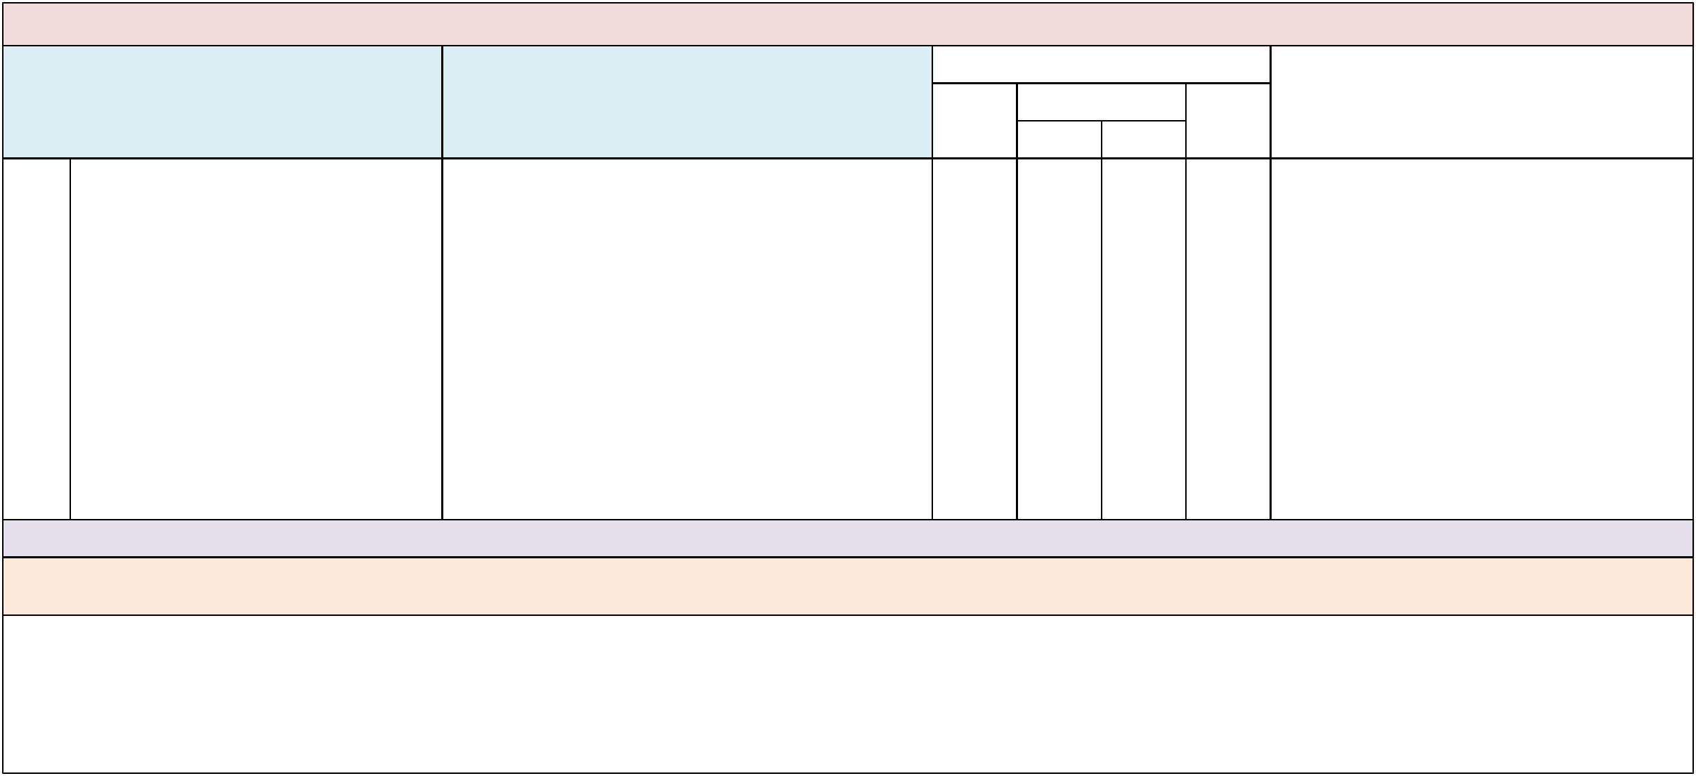

Domain: Communication and Collaboration

Indicator Examples or Evidence of Practice

 | Implementation Status
Not |  | Partially |  | Fully | Data Sources/Supporting Evidence
yet |  | B | A | Fully

- Learning opportunities and resources are provided to families of SWDs as a result of needs assessments and student data.

- Data are gathered from families via surveys, interviews, focus groups, suggestion box, etc.
- Learning opportunities and resources are identified and provided to families based on family surveys or interviews, school climate surveys, IEP goals and student data.

- Information and strategies are provided on topics such as helping with homework, test preparation, understanding LRE and inclusion, developing meaningful IEP goals and postsecondary school opportunities.

- Schedule of ongoing learning opportunities is provided to all families via newsletter, website, emails, etc.

- Family learning opportunities include content and activities that are translated for families whose first language is not English.

Suggested Measures: List of resources/learning opportunities available to families, survey samples and results, samples of information in languages other than English.

Note: Family members play an important role in facilitating their child’s success in school when they are given complete and accurate information. It is important for families to understand ways to support their child’s learning goals and objectives at home and in community settings.

Comments:

PETERS ELEMENTARY SCHOOL School-Level Self-Assessment 2018-19
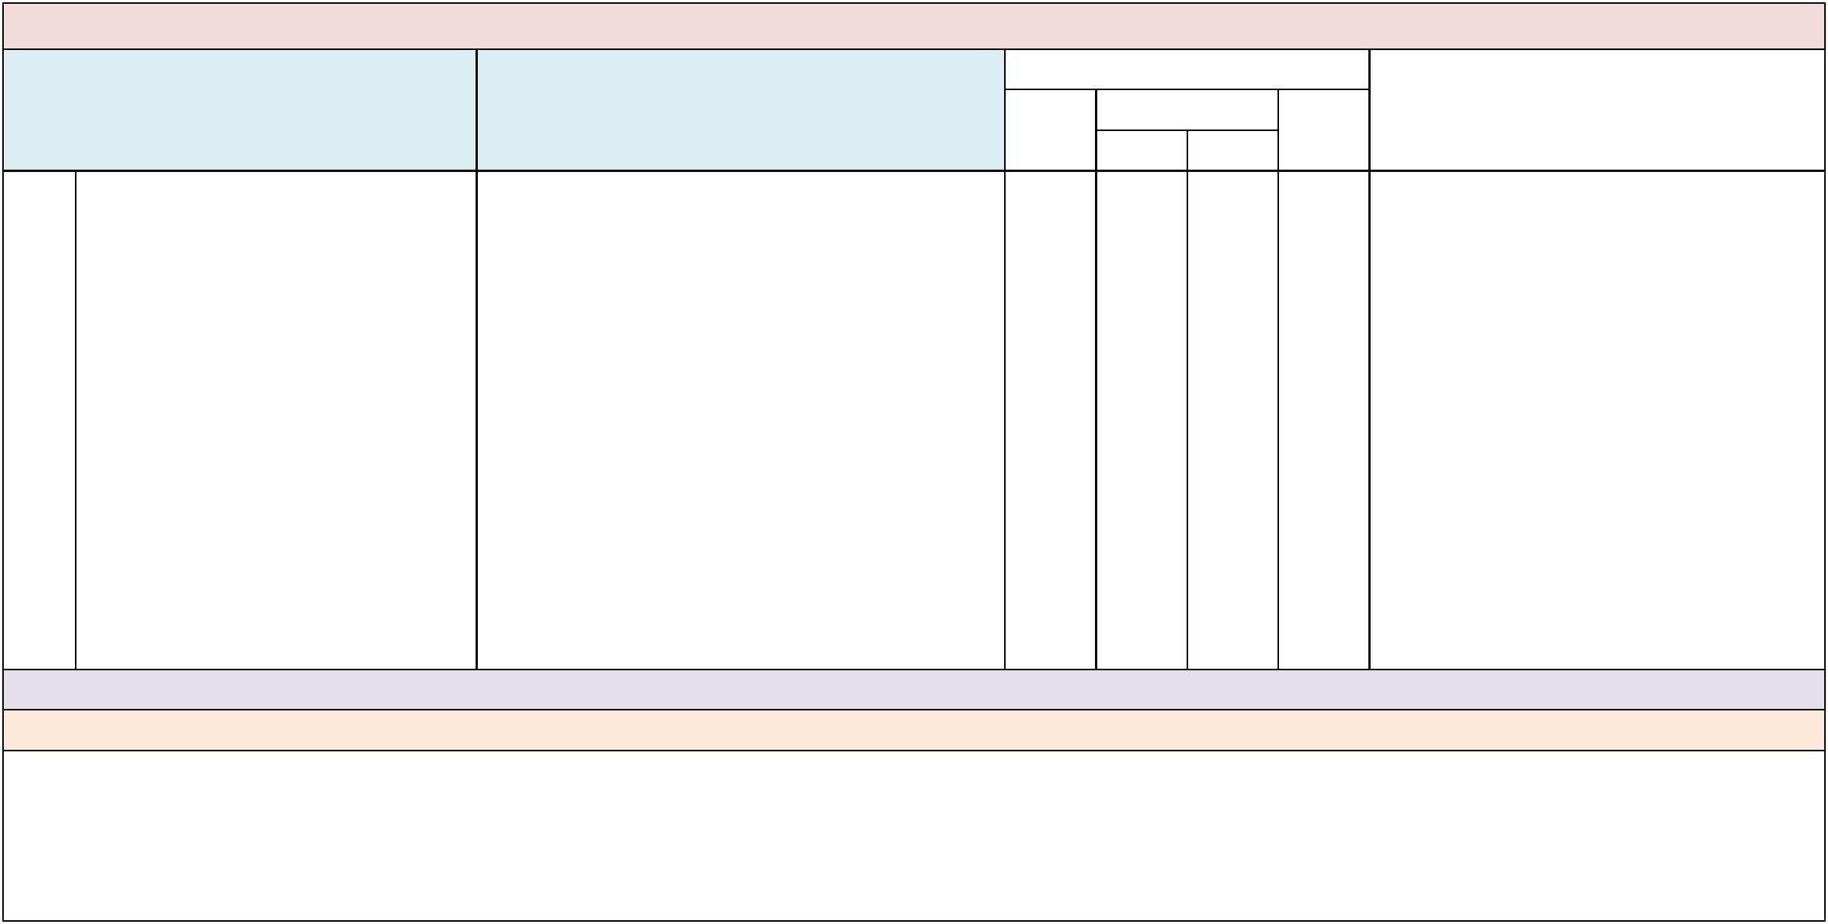

Domain: Communication and Collaboration

Indicator Examples or Evidence of Practice

 | Implementation Status
Not |  | Partially |  | Fully | Data Sources/Supporting Evidence
yet |  | B | A | Fully

- When communicating with families of SWDs, all personnel consider family members as a resource and obtain their input in planning and problem solving.

- A fifth grade co-teaching team sends a letter home during the first week of school that gives a broad outline of what the students will learn, homework and grading procedures, ideas for how parents can support good study skills and homework habits, etc.

- Team/department meeting notes reflect family input on developing educational, behavioral and/or social strategies for their children, such as an individual PBS plan and FBA.

- Families receive support and resources, such as checklists or point systems, to implement behavior support plans at home and in the community.

- Teachers maintain ongoing communication with families to ensure support plans are consistent from school to home and community.

- Teachers obtain family input on creating a student profile for a student with significant behavioral support needs (e.g., interventions that have worked at home or in other settings).

- Structures are in place for educators and families to share ongoing information about access, equity and progress of SWDs.

Suggested Measures: Sample correspondence, meeting notes, phone logs, planning documents.

Note: Family members are experts about their child. Their input is invaluable in identifying and providing appropriate supports for success.

Comments:

PETERS ELEMENTARY SCHOOL School-Level Self-Assessment 2018-19
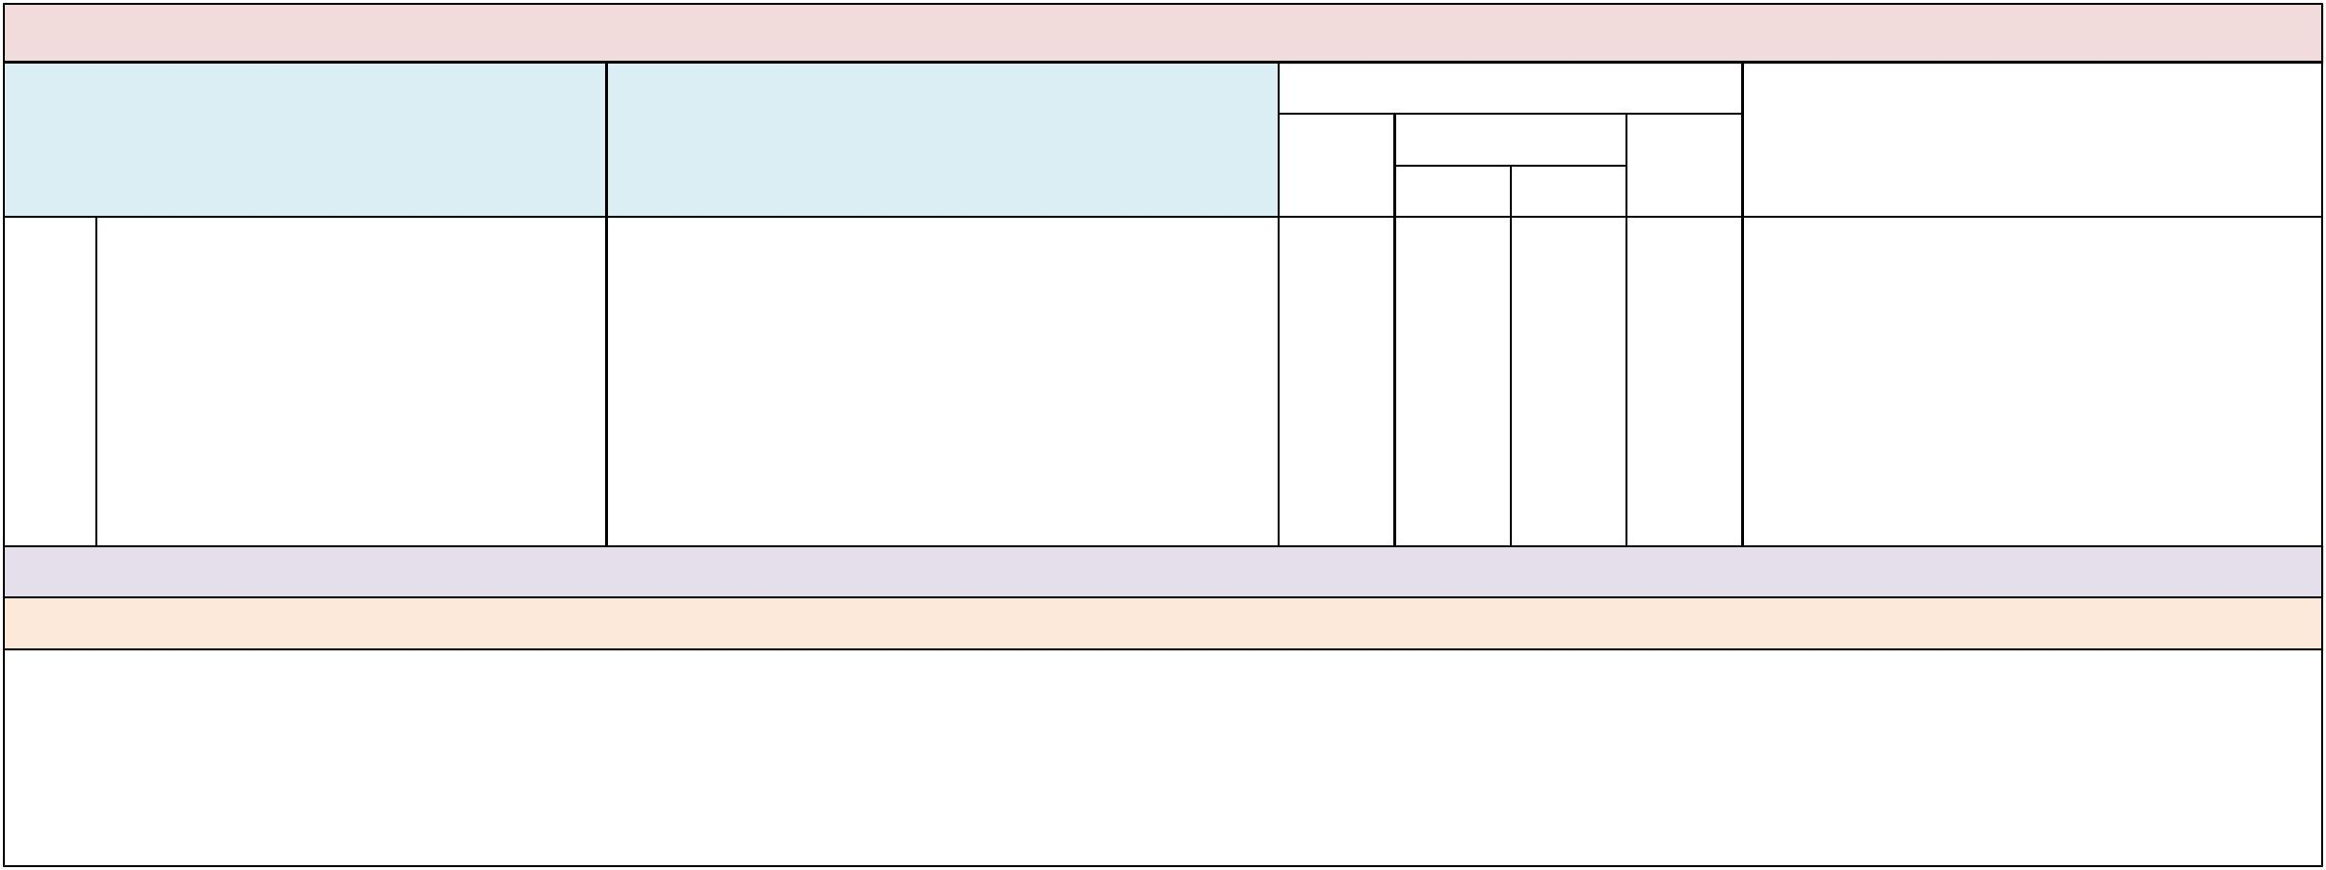

Domain: Communication and Collaboration

Indicator Examples or Evidence of Practice

 | Implementation Status
Not |  | Partially |  | Fully | Data Sources/Supporting Evidence
yet |  | B | A | Fully

- The SIP and subsequent reports of progress toward implementing inclusive practices are disseminated to families, school district personnel and community members annually.

- At the end of the school year, the school provides a report to the district that includes progress toward implementing and improving inclusive practices as described in the SIP.

- The school administrator provides a report to families as part of school open house activities.
- The school administrator provides a report to all school personnel as part of pre-school activities and throughout the year.

- The school administrator provides a report to other school administrators during district meetings.

Suggested Measures: SIP; annual summary report of BPIE priority indicators and resulting improvement efforts and outcomes. Note: See indicator #2; BPIE results should be embedded as goals in the SIP. Comments:

PETERS ELEMENTARY SCHOOL School-Level Self-Assessment 2018-19
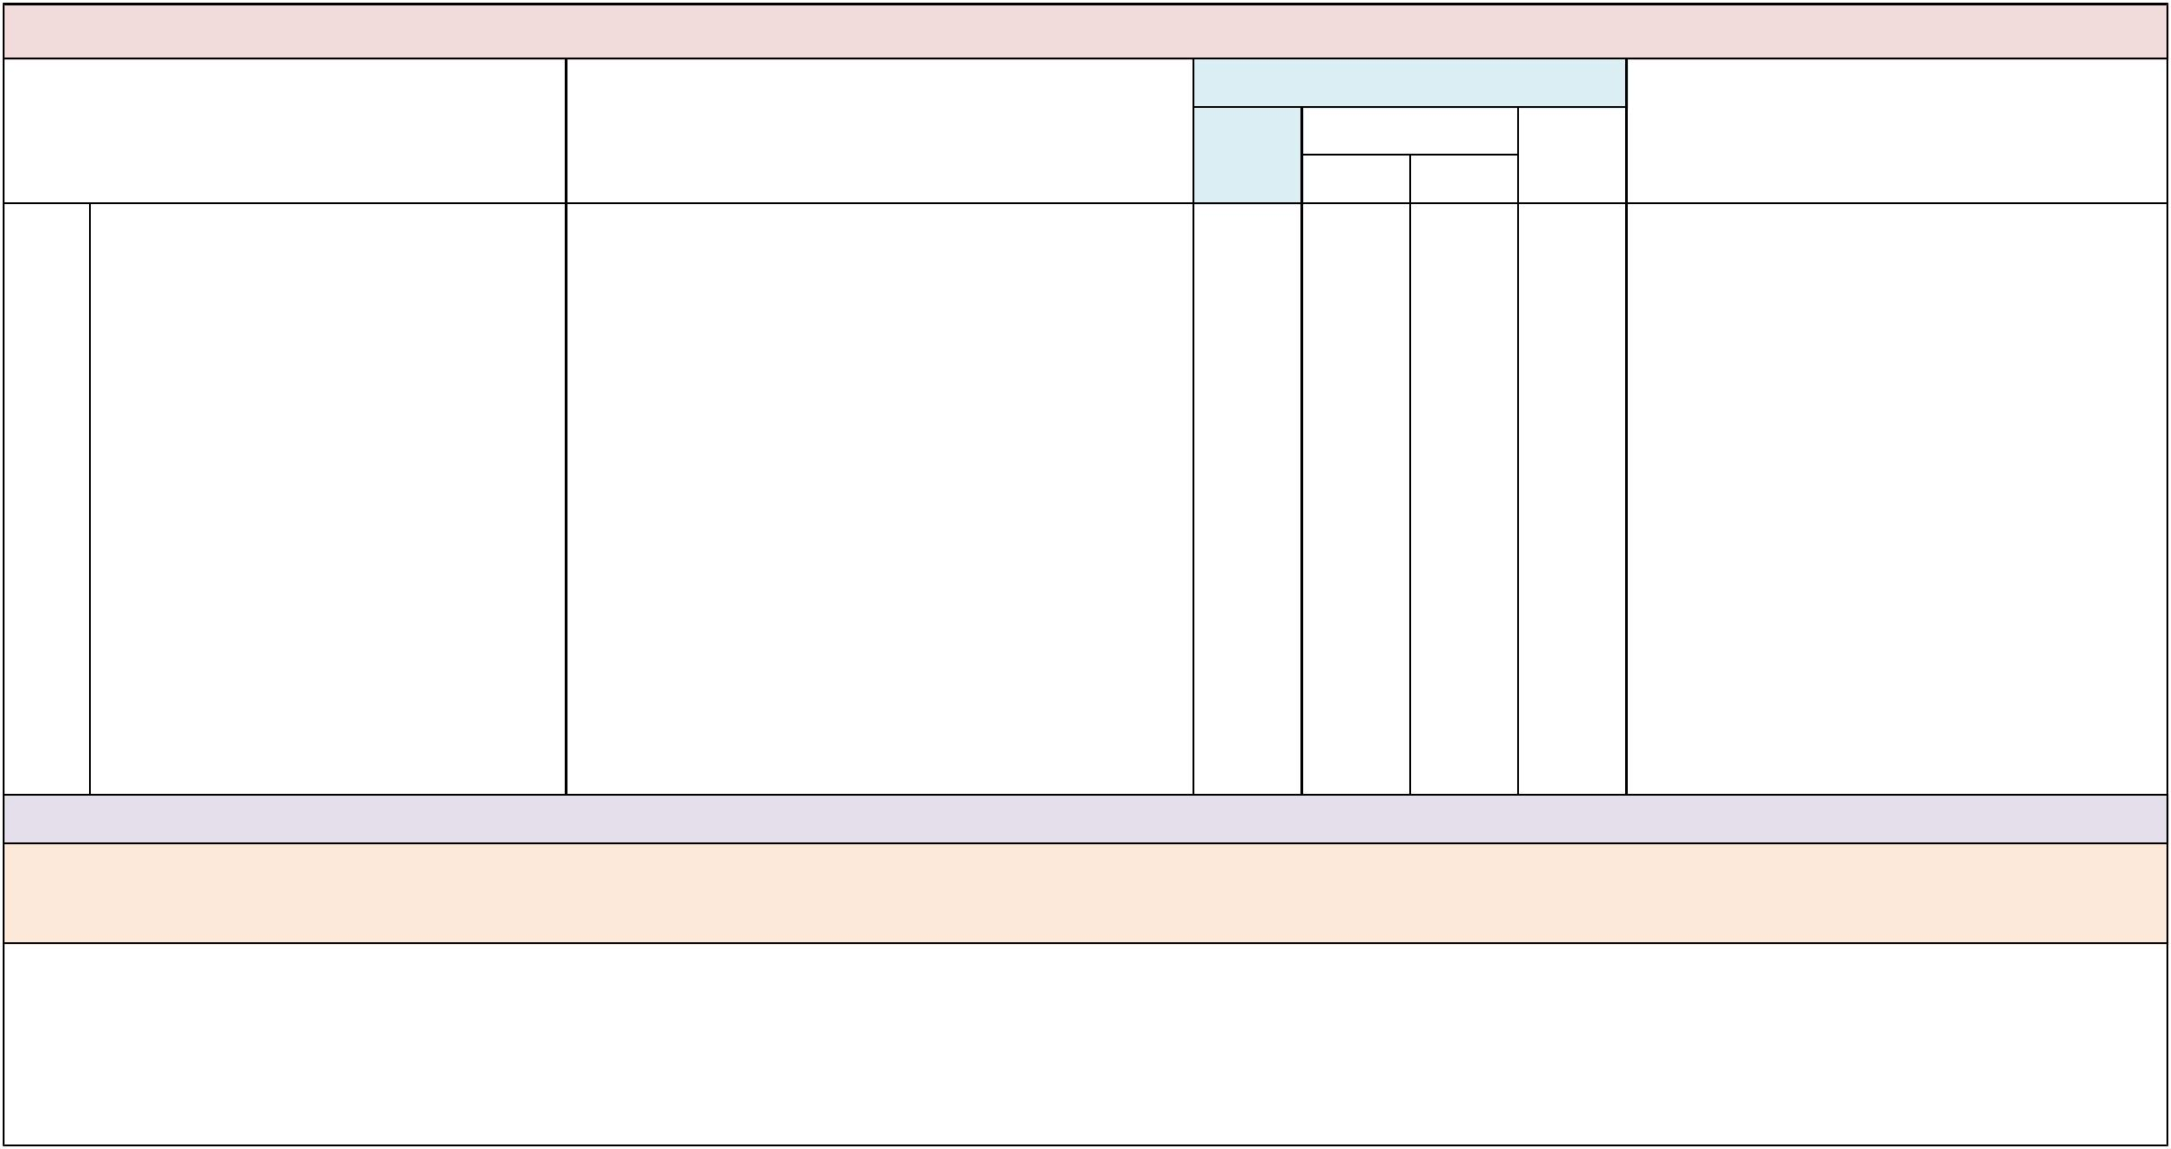

Domain: Communication and Collaboration

Indicator | Examples or Evidence of Practice
33. The school uses a person-centered | • There is an established protocol for facilitating a
planning process for SWDs. | smooth transition for SWDs from grade to grade and
 | school to school.
- Personnel use the Circles of Friends activity to identify natural learning and social/friendship supports for SWDs in general education contexts.

- Person-centered planning is used for SWDs to plan for independent living, postsecondary education and careers.

- SWDs have opportunities to learn and practice skills associated with self-determination.
- Personnel use the Students Transitioning to Adult Roles (STAR) process for SWDs transitioning from school to postsecondary education.

- Personnel use the Planning Alternative Tomorrows with Hope (PATH) or McGill Action Planning System (MAPS) to determine person-centered planning goals for the future in general education and community contexts.

- The school involves adult and community agencies and postsecondary education institutions in person-centered planning.

 | Implementation Status
Not |  | Partially |  | Fully | Data Sources/Supporting Evidence
yet |  | B | A | Fully

Suggested Measures: Policies and procedures for transition, STAR, PATH, MAPS, and Circles of Friends graphics and participant rosters, IEP goals, postschool outcomes data.

Note: The input of all stakeholders, including family members and peers, should be considered in determining the supports needed for SWDs to achieve the most desirable outcome. Please see the

Appendices: Glossary of Terms for definitions of the terms person centered planning and self-determination. For more information on STAR, PATH, MAPS and Circles of Friends, please refer to the

Appendices: Resource/Publications section.

Comments:

PETERS ELEMENTARY SCHOOL School-Level Self-Assessment 2018-19


Domain: Communication and Collaboration

Indicator Examples or Evidence of Practice

 | Implementation Status
Not |  | Partially |  | Fully | Data Sources/Supporting Evidence
yet |  | B | A | Fully

- School uses a team decision-making process to ensure SWDs transition from grade to grade, school to school and district to district to ensure placement in the LRE.

- Supports are in place and are passed seamlessly between sending and receiving parties.
- Vertical planning between teachers from school to school includes sharing information and effective instructional or behavioral supports for individual students.

- Administrators proactively ensure that supports follow all SWDs as they transition from grade to grade, school to school and district to district.

- Structures are in place for the educational and transition teams to communicate and plan postschool opportunities for SWDs.

- Schools identify and share individual needs of SWDs, through the flexible scheduling process, as they transition from grade to grade.

- In the spring, the school coordinates an orientation for students moving from elementary to middle school or middle to high school,

- including giving a tour of the building, reviewing important information in the student handbook and orienting students to school procedures.

- The school provides opportunities and transportation for a student with autism spectrum disorder, transitioning from one school to another,

- to spend time in the receiving school’s classrooms for a week, with appropriate support (e.g., paraprofessional, visual schedule, social supports).

Suggested Measures: Teacher, family and administrator interviews, district and school articulation plans, procedures and policies.

Note: Aligns with District BPIE Indicator #10.

Comments:

PETERS ELEMENTARY SCHOOL School-Level Self-Assessment 2018-19
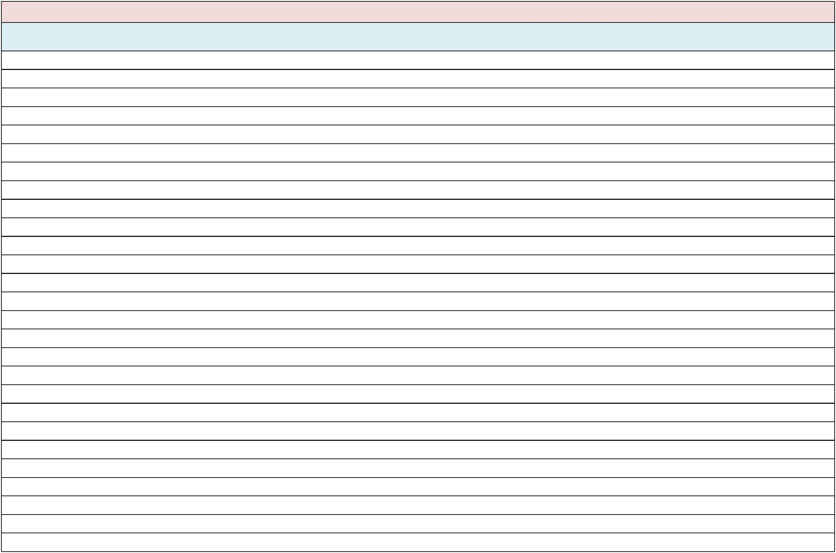

School Priority Indicators

- Based on your team’s final indicator ratings, please specify your school’s priority indicators by selecting them on the list below. When you have selected your priority indicators, please click on the “Save” button in the toolbar above and email your completed BPIE to your ESE administrator.

  - School analyzes data to identify barriers and initiate improvement steps that increase the number of students in gen. ed.

  - Short and long term improvement efforts are included in the SIP.

  - School has a key person who coordinates and monitors the implementation of inclusive education.

  - School administrators advocate for all SWDs to have the same school choice options as typical peers.

  - School data reflect that all SWDs are educated in gen. ed. contexts 80% or more of the day.

  - School data reflect that all SWDs, ages 3-5, receive special education and related services in regular Pre-K and kindergarten classes.

  - Administrators communicate expectations for all personnel to share responsibility for all students.

  - Administrators facilitate the use of resources to implement best practices for inclusive education.

  - Administrators communicate expectations for all personnel to use person first language.

  - Administrators use job interview questions to appraise an applicant’s knowledge and beliefs pertaining to inclusive practices.

  - Administrators advocate for all SWDs to be transported to and from school with typical peers attending the same school.

  - All SWDs have the same opportunities as typical peers to participate in all school-sponsored, non-academic, age-appropriate activities.

  - All SWDs are given equal consideration for recognition through honors, awards, etc.

  - Administrators analyze data to identify staff professional development and technical assistance needs related to inclusion.

  - Administrators facilitate job-embedded professional development on inclusive practices for all school personnel.

  - Administrators facilitate job-embedded, technical assistance on inclusive practices for all school personnel.

  - Administrators ensure collaborative planning time is reflected in general and special educator schedules and instructional plans.

  - Specials, electives, and technical education teachers have regular opportunities to consult with special education teachers.

  - General and special education teachers use the Florida Standards as the foundation for instruction of all SWDs, including those with a significant cognitive disability.

  - A multi-tiered system of student supports and problem-solving process is used for all students with and without disabilities.

  - Instructional and related services personnel use formative assessment to analyze and evaluate data about effective instruction and behavior interventions for SWDs.

  - Teachers of SWDs who spend less than 80% of their day in general education classes use formative assessment data to identify effective instructional and behavioral interventions.

  - There is a school wide approach to facilitate positive, interdependent relationships and social responsibility among all students.

  - There is a school wide approach for planning and implementing Universal Design for Learning.

  - There are a variety of service delivery models in place, across all grade levels, to provide instruction and related services for SWDs in gen. ed.

  - All paraprofessionals receive professional development on ways to support SWDs in gen. ed.

  - All special education teachers are collaborative members of a gen. ed. curriculum team.
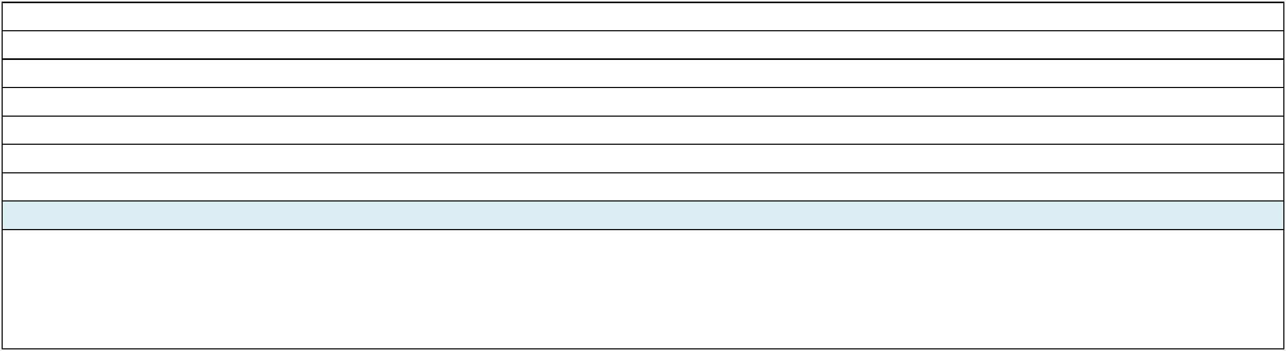
- General and special education teachers regularly plan instruction together.

- Family members of SWDs are contributing members of school decision-making groups.

- Learning opportunities and resources are provided to families of SWD.

- All personnel consider family members as a resource and obtain their input in planning and problem-solving.

- Reports of progress toward implementing inclusion are disseminated to families, district personnel, and community members annually.

- School uses a person-centered planning process for SWDs.

- School uses a team decision-making process to ensure SWDs transition to and maintain placement in the least restrictive environment.

Name and Title of team members completing this BPIE Self Assessment

