School Name: Northeast High School
School Number: 1241 School Zone: Northeast District Name: Broward
District Coordinator: Kelly Justice
Thank you for your completion of the Self-Assessment of MTSS Implementation (SAM). Your completion of the SAM will provide us with important information as we continue to develop and refine this instrument.
The purpose of this report is to provide your team with visual representations (graphs) about the extent to which your school is implementing components of a multi-tiered system of support (MTSS).

Following the graphs summarizing your data, there are Guiding Questions to help you make decisions about how to use this data as you prepare an action plan for improving MTSS implementation. The report concludes with a sample Action Planning template for your school leadership team to use if desired.
Recommended steps for reviewing this report:
1. Review the “Overview” graph and identify any patterns (high or low scores).
2. Review the SAM instrument and “SAM Domain” graphs to identify any patterns across
domains or items.
3. Use the Guiding Questions to help you decide which MTSS components and/or actions
to address.
4. Complete the Action Planning form to document what next steps will be taken to improve implementation of MTSS in your school.
If you have questions about this report, please contact the district coordinator noted above.
Thank you again for your completion of the SAM. We hope that you found the process valuable

Graphs
Overview
The data presented in this graph are intended to provide an overview of your team’s ratings across the six SAM domains. Items were scored on a 4-point scale ranging from 0 - 3 (0 = Not Started; 1 = Emerging/Developing; 2 = Operationalizing; 3 = Optimizing). Each bar represents the average score based on ratings of the items within each of the six domains. It is important to note the number of items in each domain varies making them more or less susceptible to the presence of any particularly high or low scores. The six domains are listed along the
horizontal axis and possible ratings are listed along the vertical axis.

SCHOOL & DISTRICT DOMAIN AVERAGES

3
2.6
2.6
2.4
2.3
2.2
2.2
2.3
2.3
2.2
2.2
2.0
1.7
1.5
1.5

2
AVERAGE SCORE

1

0
OVERALL (ALL ITEMS)

LEADERSHIP CAPACITY/ INFRASTRUCTURE

COMMUNICATION/ COLLABORATION

DBPS 3-TIER MODEL DATA/EVALUATION

SCHOOL DOMAIN AVERAGE DISTRICT DOMAIN AVERAGE

6 SAM Domains
The data presented on the following pages are graphs of your team’s ratings of each of each of the items within the six SAM domains. It is important that you have a copy of the SAM available when reviewing these graphs, so that you can refer to the complete item as the graphs only include the item number and few descriptive words. Each of the items within a domain are listed along the horizontal axis and possible ratings (ranging from 0 – 3) are listed along the vertical axis.

1) Leadership
Leadership is key to successful implementation of any large-scale innovation. The building principal, assitant principal(s), and school leadership team are critical to implementing MTSS at the school level. They engage staff in ongoing professional development for implementing MTSS, plan strategically for MTSS implementation, and model a data-based problem-solving process for school improvement. The school principal also supports the implementation of MTSS by communicating a vision and mission to school staff, providing resources for planning and implementing instruction and intervention, and ensuring that staff have the data needed
for data-based problem-solving.

3
3
3
3
2.5
2.7
2.4
2.4
2
2.1
2

2

1

0
- PRINCIPAL
INVOLVED

- LEADERSHIP
TEAM

- TEAM SUPPORTS PD

- IMPLEMENTATION
PLAN

- FACILITATE
IMPLEMENTATION

SCHOOL ITEM SCORE DISTRICT ITEM AVERAGES

2) Building the Capacity/Infrastructure for Implementation
School-wide capacity and infrastructre are required in order to implement and sustain MTSS. This capacity and infrastructure usually includes ongoing professional development and coahing with an emphasis on data-based problem-solving and multi-tiered instruction and intervention; scheduling that allows staff to plan and implement instruction and intervention; and processes and procedures for engaging in data-based problem-solving.

3
3
3
2
2.1
2.3
2.1
2
2.1
2
2.2
2
2.2

2

1

0
- CRITICAL ELEMENTS 7. PD AND COACHING 8. DATA-BASED PROB PD 9. MULTI-TIERED PD 10. IMPLEM. COACHING 11. TIME FOR
TRAINING/COACHING

3
2.2
2.2
2.3
2.2
2.2
1
1
1
1
1

2

1

0
  - TIME TO ADMIN. ASSESSMENTS

  - TIME FOR MULTIPLE TIERS 14.TIME FOR DBPS 15. RULES FOR DBPS 16. MTSS RESOURCES

SCHOOL ITEM SCORE DISTRICT ITEM AVERAGES

3) Communication and Collaboration
Ongoing communication and collaboration are essential for successful implementation of MTSS. Many innovations fail due to a lack of consensus, to a lack of feedback to implementers to support continuous improvement, and to not involving stakeholders in planning. In addition to including stakeholders in planning and providing continuous feedback, it is also important to build the infrastructure to communicate and work with families and other community partners. These practices increase the likelihood that innovative practices will be implemented and sustained.

3
2
2.3
2.1
2
2.3
2.3
1
1

2

1

0
    - STAFF
CONSENSUS

    - FIDELITY AND STUDENT DATA

    - FAMILY /
COMMUNITY ENGAGED

    - EDUCATORS
ENGAGE FAMILIES

SCHOOL ITEM SCORE DISTRICT ITEM AVERAGES

3)Three-Tiered Instructional/Intervention Model

4)Data-Evaluation
4) Data-Based Problem Solving
The use of data-based problem-solving to make educational decisions is a critical element of MTSS implementation. This includes the use of data-based problem-solving for student outcomes across content areas, grade levels, and tiers, as well as the use of problem-solving to address barriers to school-wide implementation of MTSS. While several models for data- based problem-solving exist, the four-step problem-solving approach evaluated in this instrument includes: 1) defining the goals and objectives to be attained, 2) identifying possible reasons why the desired goals are not being attained, 3) developing a plan for and implementing evidence-based strategies to attain the goals, and 4) evaluating the
effectiveness of the plan.

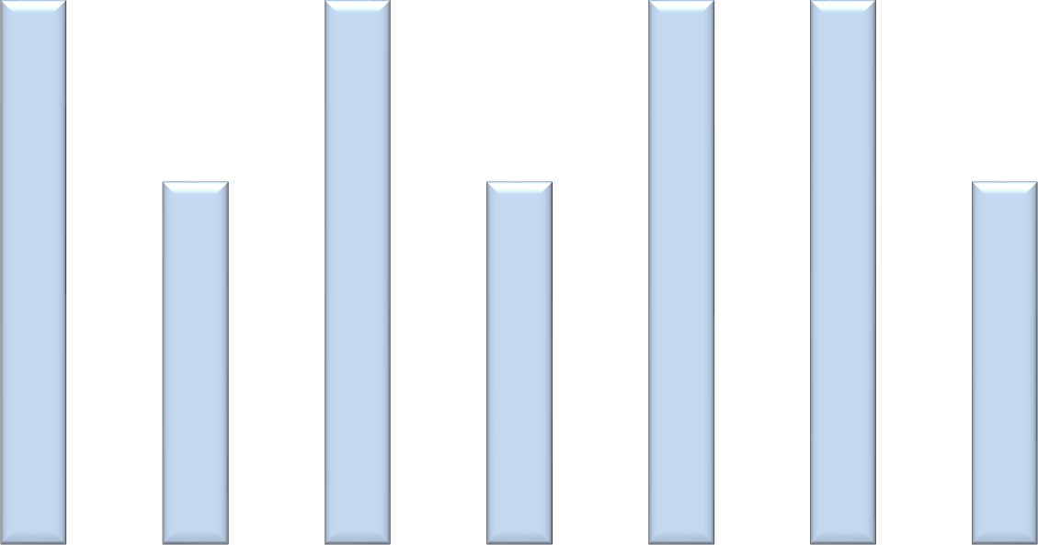
3
2
3
3
3
3
1
2.2
2.4
2.5
2.4
2.4
2
2
2.1
2 2.2
0
21. DBPS CONTENT 22. DATA USED TO 23. WHY
LEVELS TIERS IDENTIFY “GAP” EXPECTATIONS
NOT MET
24. PLANS
EXPECTATIONS NOT MET
25. STUDENT
PROGRESS MONITORED
26.DBPS INFORMS
ACROSS GROUPS
27. RESOURCES
ADDRESSED BY DBPS
SCHOOL ITEM SCORE
DISTRICT ITEM AVERAGES

5) Three-Tiered Instructional/Intervention Model
The three-tiered instructional/intervention model is another critical element of MTSS implementation. In a typical system, Tier 1 includes the instruction delivered to all students; Tier 2 includes supplemental instruction or intervention provided to students not meeting benchmarks; and Tier 3 includes intensive, small-group or individual interventions for students facing significant barriers to learning the skills required for school success. It is important to consider academic, behavior, and social-emotional instruction and interventions when examining this domain.

3
3
2.6
2
2
2.4
2
2.4
2.2
2 2.2
2
2.1

2

1

0
      - T1 ACADEMIC STANDARDS

      - T1 BEHAVIOR EXPECTATIONS

      - T2 ACADEMIC LINKED TO TIER 1

      - T2 BEHAVIOR LINKED TO TIER 1

      - T3 ACADEMIC ALIGNED TIER 1+2

      - T3 BEHAVIOR ALIGNED TIER 1+2

SCHOOL ITEM SCORE DISTRICT ITEM AVERAGES

6) Data-Evaluation
Given the importance of data-based problem-solving within an MTSS model, the need for a data and evaluation system is clear. In order to do data-based problem-solving, school staff need to understand and have access to data sources that align with the purposes of assessment. Procedures and protocols for administering assessments and data use allow school staff to use student data to make educational decisions. In addition to student data, data on the fidelity of MTSS implementation allow school leadership to examine the current
practices and make changes to increase implementation.

3
2
2.1
2
2.3
2 2.0
2
2.1
2.3
2.2
1
0

2

1

0
      - STAFF HAVE ACCESS TO DATA

      - POLICIES FOR DECISION-MAKING

      - DATA TOOLS ARE USED BY STAFF

      - DATA USED TO EVALUATE FIDELITY

      - RESOURCES
EFFECTIVELY USED

      - DATA SOURCES QUALITY ASSURED

SCHOOL ITEM SCORE DISTRICT ITEM AVERAGES

Guiding Questions

In which domains are the greatest gaps in current and optimal MTSS implementation?

Data Based Problem Solving

Three Tiered Instruction/Intervention Model

        - Which specific items represent the greatest gaps in current and optimal MTSS implementation?
Data use to identify gap and plan expectation not met

3. Which specific MTSS implementation actions or activities will your team focus on
improving within your school?
- Which are most immediately actionable?
Teachers utilizing and entering TIER interventions in Basis are most actionable. Guidance meetings with below credit and GPA students, as well as students that are having attendance issues. The social worker is addressing attendance issues as well as counseling students with social/emotional difficulties.
- Which would be most impactful?
The guidance meetings may be most impactful because they will address where the student is now with where they should be and provide supports/strategies to help progress to where they should be in accomplishments towards graduation.
- Which would be most foundational (aligned with where you want to be)?
Having teachers utilize and enter TIER interventions in Basis is most foundational. Teachers consistently using TIER 1 interventions in the classroom helps deter the need for higher interventions and if they are the documented interventions assist in identifying academic and behavioral strategies that have already been utilized.

Action Planning
You may choose to use your own action planning form or the one provided below.
Action: Guidance counselors will meet with below credit and below GPA students quarterly and provide support to bring students to where they should be with credit and GPA. It will be started in October following first quarter it will be done by May 2018 and it will be evaluated at the end of every quarter.

Action: All teachers will enter TIER interventions in Basis. We have contacted the district to determine how we can pull data reports on teacher interventions from Basis.This will be monitored year long.

Action: Student attendance issues are being researched and addressed by the school social worker through RTi referrals generated by TERMS and teacher attendance referrals. This is ongoing all school year. Data will be reviewed quarterly.

