RtI Case Managers
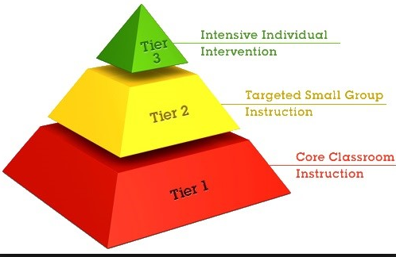
K-Gutierrez
1-Millar
2- Danier
3- Liberatore
4- Frankovitz
5- Frankovitz

Roles and Responsibilities:
- Classroom walkthroughs at least twice a week during designated intervention times to ensure intervention fidelity.
- Meet with teachers to review RtI folder completion including all items on the RtI checklist.
- Assist teachers with preparing for meetings.
- Review RtI database weekly and meet with teachers as needed if items are not completed on database.
- Support teachers by answering any questions they may have. If the question relates to the specific intervention being used, refer questions to Mrs. Liberatore.

Important Things to Remember:
- The goal of RtI is to provide the correct interventions to students in hopes that students can be successful with Tier 1 instruction. The goal is not to have students evaluated unless absolutely necessary.
- Interventions need to directly correlate to a student’s specific weakness. Teachers need to provide data and evidence to support their decision for determining the weakness.
- Interventions will only be successful when done with FIDELITY.
- When deciding if a student needs to be on tier 2 or tier 3, it is essential to make sure that the tier 1 instruction is not the cause for low performance.

