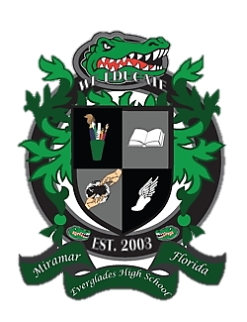
Everglades High School
School Advisory Council Agenda
May 16, 2017……Media Center……3:00pm

- Desired Outcomes
- Welcome
- Waiver Results
- SIP Monitoring
- SAM Data
- Nomination and Open Voting for 2017-2018 Officers
- Subcommittee updates
- PTSA Updates
- New Issues/Concerns

- Welcome
- Ms. Lisa Alonso, SAC Co-Chair
- Mrs. Maureen Eves, SAC Co-Chair
- Mr. Delano Fields, SAC Secretary

- Waiver Results

- SIP Monitoring

- SAM DATA

- Nominations/Open Voting for 2017-2018 Officers

- Subcommittee Updates
  - Parent Involvement
  - Student Concerns
  - Discipline
  - Reading and Writing
  - Math
  - Science
  - Social Studies
  - Technology

- PTSA Update

- New Issues / Concerns

