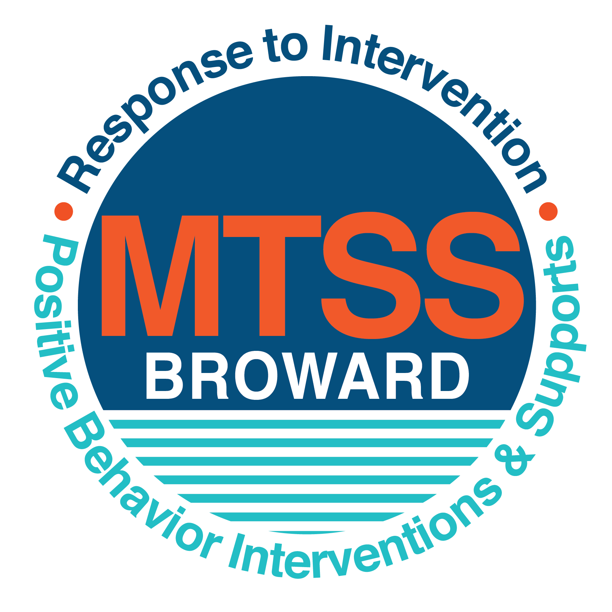
School-wide Positive Behavior Plan (SPBP)
Broward County Public Schools
To be implemented in SY 2018/19

Elements have changed in the SPBP.
Before completing, go to http://www.browardprevention.org/mtssrti/rtib/ → School-wide Positive Behavior Plan for:

- A NEW Brainshark for Principals. ACTION: Log in with your p # and watch the Brainshark before Jan 30th.
- A NEW Overview Brainshark for Teams. ACTION: Log in with school name and watch the Brainshark.
- A NEW mini Brainshark Series for teams. These Brainsharks are divided into the 10 Critical Elements of PBIS. They will
show you “how to” write a comprehensive SPBP (and receive a high score!)
- A Rating Rubric to ensure teams will correctly complete the SPBP and develop a meaningful plan.

To provide consistency across the District, only plans entered on the current district template will be accepted.
ACTION: Download, complete and upload the SPBP into your School Improvement Plan before May 1, 2018:

School Name: | Sunset Lakes Elementary School
School Number: | 3661
SPBP Contact Name: | Cynthia Slater
Direct Phone Number: | 754-323-7650

CRITICAL ELEMENT # 1: Active Team with Administrative Participation

1A. List your current (SY 2017/18) team members (6 - 10 team members). Must include an instructional representative from EACH grade/content area. Each name on this list verifies attendance in ongoing team meetings and participation in developing this SPBP. Each member is responsible for representing major stakeholders and sharing the SPBP content and updates with their respective group.
Full Name | Position | Who or what grade level does this member represent?
Cynthia Slater | Assistant Principal | Administration
Jessica Hudson | Equity Liaison | 3rd Grade Teacher
Francine Friedman | Team Leader | Kindergarten Teacher
Nicole Callow | Team Leader | 1st Grade Teacher
Ana Mundy and Natalie Moyer | Team Leaders | 2nd Grade Teachers
Mayte Garcia | SAC Chair | 3rd Grade Teacher
Patricia Smith | Team Leader | 4th Grade Teacher
Rosemary Hartenhoff | Team Leader | 5th Grade Teacher
Cecilia DelCristo | Math Coach | All Grade Levels; RtI Contact
Aileen Soto | Literacy Coach | All Grade Levels; RtI Contact
Julie Padron | SPBP Point of Contact | SPBP Point of Contact; RtI Contact

1B. Schedule and document your quarterly team meeting dates for next 2018/19 school year:
Meeting Date | Meeting Time | Name & title of person responsible to facilitate meeting | Content of meetings:
9/18/2018 | 2:00-3:00 p.m. | Cynthia Slater, Assistant Principal | 1. Disseminate  Expectations and Rules lesson  plans (#3 and #4)  2. Review progress of  Implementation Action Plan (#9)  3. Collect & analyze implementation  data (#10A)  4. Collect & analyze student  outcome data (#10B)
11/15/2018 | 2:00-3:00 p.m. | Cynthia Slater, Assistant Principal
1/17/2019 | 2:00-3:00 p.m. | Cynthia Slater, Assistant Principal
4/16/2019 | 2:00-3:00 p.m. | Cynthia Slater, Assistant Principal

CRITICAL ELEMENT # 2: Faculty & Stakeholder Commitment:

2A. Action Steps completed this year (SY 2017/18) that increased faculty and stakeholder understanding and knowledge of your new (2018/19) SPBP:
Action Steps: | Date  (Between Jan 15 –  April 30, 2018) | Details  (retain attendance sheets at school) | Person responsible to collect and retain attendance sheets:
Presented the new SPBP (for SY 2018/19) to staff | 4/3/2018 | # of participants = 74 | Mayte Garcia
Held a faculty vote on the new SPBP  (for SY 2018/19) | 4/24/2018 | % approved =100% | Mayte Garcia
Presented the new SPBP (for SY 2018/19) to stakeholders (parents and community) | 4/26/2018 | # of participants = 12 | Mayte Garcia

2B. Action Steps to be completed next year (SY 2018/19) to increase faculty and stakeholder understanding and knowledge of your SPBP:
Action Steps: | Date(s)  (NEXT YEAR) | Content  (retain attendance sheets at school) | Person responsible to collect and retain attendance sheets:
Provide a professional development on the 2018/19 SPBP for all staff | August 9, 2018 | The team will present the updates in the SPBP for the 18/19 school year. All stakeholders will be provided with access to the SPBP. Feedback will be collected for future team meetings. | Cynthia Slater/  Mayte Garcia
Present the 2018/19 SPBP to stakeholders (parents and community) | September 25, 2018 |  | Cynthia Slater/  Mayte Garcia
Present behavior data to staff  Quarterly: minimum of 4 each year | 1. September 19, 2018 | The team will present the implementation data in 10A. Include:  • the “marketing” (teaching and posting) of expectations and rules  • lesson plan implementation  • discipline procedures  • reward system implementation  The team will present the student outcome data in 10B. Include:  • top 3 event locations  • type of behavior incidents  • core effectiveness data  • classroom referral data, as well as analysis of this data. | Cynthia Slater/  Mayte Garcia
 | 2. November 15, 2018 |  | Cynthia Slater/  Mayte Garcia
 | 3. January 17, 2019 |  | Cynthia Slater/  Mayte Garcia
 | 4. April 16, 2019 |  | Cynthia Slater/  Mayte Garcia

CRITICAL ELEMENT # 3: School-wide Expectations

3A. List the top 10 behavior incidents data YTD from BASIS 3.0 Behavior Dashboard:
Top 10 Behavior Incidents
(put N/A in any blank spaces)
1.Unruly/Disruptive | 6.Insulting/Profane/Obscene Language
2.Disobedient/Insubordinate | 7.Disruption on Campus
3.Defiance of Authority | 8.Battery
4.Disruption on Campus | 9.N/A
5.Inappropriate Usage of Technology | 10.N/A

3B. Based on the behavior incidents in 3A, develop 3 – 5 positive characteristics (not behaviors) that would counteract the demonstration of these misbehaviors. These positive characteristics become your school-wide expectations.
School-wide Expectations
1.Be Respectful To Others
2.Be Responsible
3.Be Kind to Yourself and To Others
4.N/A
5.N/A

3C. Research indicates that discipline referrals increase after long holidays and during testing times. Plan to teach your expectations at least 3 times throughout the year (and anytime the expected behaviors are not being demonstrated).
ACTION: Create at least one lesson plan for each school-wide expectation above and distribute to teachers during pre-planning 2018-19. Develop additional lesson plans you will use throughout the year to re-teach and reinforce your school-wide expectations. You do not need to submit your lesson plans with the SPBP. Retain all behavior lesson plans at the school; make sure these lesson plans are available for guests and stakeholders.
When will school-wide expectations lesson plans be taught?
 | Date(s) | Time:
August | August 13, 2018 | 9:30 a.m.
January | January 8, 2019 | 2:15 p.m.
4th Quarter | May 9, 2019 (Early Release) | 1:00 p.m.
Who will be responsible for teaching the lesson plans? |  |  | Cynthia Slater/Mayte Garcia
Where will the lesson plan instruction occur? |  |  | Media Center
Who is responsible for retaining, organizing and distributing all lesson plans? |  |  | Mayte Garcia

CRITICAL ELEMENT #4: Location-based Rules

4A. List the top 3 locations for behavior Events YTD from BASIS 3.0 Behavior Dashboard. Do not use “classroom”
Top 3 Locations
School Location | # Incidents
1.Cafeteria | 4
2.Hallway | 1
3.Playground | 1

4B. Create an Expectations/Rules Matrix from your 3-5 school-wide expectations and your top 3 event locations. Develop a positively stated, observable, and measurable rule that correlates with every expectation to create a maximum of 5 rules under each location.
Expectations and Rules Matrix
School-wide EXPECTATIONS | Copy and paste expectations from 3C. | IDENTIFIED LOCATIONS  Copy and paste locations from 4A.
School-wide EXPECTATIONS | Copy and paste expectations from 3C. | CAFETERIA | HALLWAY | PLAYGROUND
School-wide EXPECTATIONS | Copy and paste expectations from 3C. | Rules | Rules | Rules
School-wide EXPECTATIONS | Be Respectful to Others | Raise hand for assistance Ask permission to leave your assigned table | Use quiet voices  Listen to instructions and directions | Wait your turn  Listen to adults  Follow rules  Play fairly
School-wide EXPECTATIONS | Be Responsible | Say please and thank you  Wait patiently in line  Use a quiet voice  Remove trash from floor and table areas | Say please and thank you  Use a quiet voice  Keep traffic flowing  Walk on right side of hallway | Line up on time  Wait your turn  Say please and thank you
School-wide EXPECTATIONS | Be Kind to Yourself and Others | Line up quietly when your teacher arrives  Remain in a straight line | Keep hands and feet to yourself  Walk in single file line | Say please and thank you  Stay in designated area  Wait your turn
School-wide EXPECTATIONS | N/A | N/A | N/A | N/A
School-wide EXPECTATIONS | N/A | N/A | N/A | N/A

4C. Research indicates that discipline referrals increase after long holidays and during testing times. Plan to teach your location-specific rules at least 3 times throughout the year (and anytime the expected behaviors are not being demonstrated).
ACTION: Create at least one lesson plan for each location above and distribute to teachers during pre-planning 2018-19. Develop additional lesson plans you will use throughout the year to re-teach and reinforce your location-specific rules.
You do not need to submit your lesson plans with the SPBP. Retain all behavior lesson plans at the school; make sure these lesson plans are available for guests and stakeholders.
When will location-specific rules lesson plans be taught?
 | Date(s) | Time:
August | August 13, 2018 | 9:30 a.m.
January | January 8, 2019 | 2:15 p.m.
4th Quarter | May 9, 2019 (Early Release) | 1:00 p.m.
Who will be responsible for teaching the lesson plans? |  |  | Cynthia Slater/Mayte Garcia
Where will the lesson plan instruction occur? |  |  | Media Center
Who is responsible for retaining, organizing and distributing all lesson plans? |  |  | Mayte Garcia

CRITICAL ELEMENT # 5: Reward and Recognition Programs

Although you will post, teach, review, practice and reinforce all school-wide expectations and location-specific rules, choose 1 expectation OR 1 event location you will target for a specific reward program for students. Based on the data that led to this expectation or location, create a reward plan using the 4 Step Problem Solving Process:

Expectation or Location: CAFETERIA

4 Step Problem Solving Process | Plan
1. Problem Identification: Use your behavior data to identify a school-wide problem.  What problem did you identify? (use numerical data) | Data used: Basis 3.0 (Behavior/Discipline Dashboards)  Problem Identification: 4 BEHAVIORAL INCIDENTS OCCURRED IN THE CAFETERIA DRUING THE LUNCH PERIOD. THIS LOCATION WAS THE 2ND HIGHEST REPORTED INCIDENTS DURING THE 2017-18 SCHOOL YEAR.
2. Problem Analysis: Why do you think this problem is occurring?  What is your goal? (use a SMART goal statement with numerical data) | Hypothesis: The problem is occurring due to the large number of students eating lunch during a scheduled timeframe, and students are not reminded of rules and expectations.  Goal Statement: By June 2019, students will be reminded of cafeteria, rules, procedures and expectations, more adult supervision will be in place, cafeteria rewards and incentives will be added. Doing so will result in 30% fewer incidents occurring during the lunch period.
3. Intervention Design: Describe how you will implement a positive reward program to decrease this problem. | Type of System: TOKEN ECONOMY SYSTEM  Description of System: A token economy system will be implemented using EAGLE cash. All supervising adults will issue EAGLE currency to students to reinforce positive student behavior during the lunch period. Students will be issued currency when it is observed the rules and procedures have been followed such as using quiet voices, remain seated, discarding food items, and walking in a straight line.  School wide incentive will require teacher/student input.
4. Evaluation:  A. Implementation fidelity | - How do you monitor the fidelity (consistency and effectiveness) of the staff’s implementation of the reward program? The EAGLE currency communicates that when students follow EAGLE expectations, their behavior will be positively acknowledged.  - Schoolwide incentives will be monitored monthly by administration, teachers, and guidance counselor
B. Student outcome monitoring | - How will you know if the reward program is positively impacting students? What measurable data will you use to determine “success”?  Reviewing and analyzing quarterly behavior data; fewer incidents in the cafeteria and surrounding school areas.  Students are diligently working effectively to participate in the reward system.  More positive school climate among staff and students.

CRITICAL ELEMENT #6 Effective Discipline Procedures

6A. Staff Managed Misbehaviors: List the top 6 most common school-wide misbehaviors staff are expected to manage.
Write a short, objective, and measurable definition for each.
Staff Managed Misbehaviors
Misbehavior | “Looks Like” - provide a description with example(s)
1.Talks Out | Student speaking out of turn; talking loudly; not using a quiet voice
2.Off Task | Not passing attention to instruction or teacher directives
3.Inappropriate Language | Verbal messages that include swearing, name calling, profanity
4.Note Passing | Passing of notes during class time; interruption in the lesson or activity
5.Failure to Follow Directions | Refusal to Follow Adult Directions, Talking Back
6.Keeping Hands to Themselves | Pushing Another Student while in Line or the Playground

6B. Staff Managed Consequences: Create a consequence menu OR a consequence hierarchy for staff to use when students exhibit the above misbehaviors. Provide a minimum of 5 consequences.
Is this a menu or hierarchy system? | ☐ Menu ☐XXHierarchy
Differential reinforcement of alternative behavior
Student conference/problem solving
Nonverbal reminders
Verbal reminders
Provide a safe spot for de-escalation

6C. Administration Managed Misbehaviors:
(a) Define the first 3 behaviors by providing examples that clearly identify the point at which the misbehavior warrants an Office Discipline Referral (ODR).
(b) List two additional common school-wide misbehaviors that will result in an ODR. Provide concrete examples.
(c) Determine staff tolerance level for repetitive misbehaviors (the point at which the number of staff-managed misbehaviors becomes an ODR).
Office Discipline Referrals (ODRs)
Behavior | “Looks Like” - provide a description with example(s)
1. Disobedience/Insubordination | After being told to follow directions, student replies with profanity Refuses to follow directions
2. Disruptive/Unruly Play | Unruly play that interferes or disrupts the learning environment; such as playing in the classroom, pushing another student
3. Disruption on campus (minor) | An act or event that occurs on campus causing the disruption of a classroom or another localized area of the school without substantially disrupting the entire campus. Ex: Pushing another student in classroom
4. Insulting/Profane/Obscene Language | Use of insulting, abusive, profane, obscene, or vulgar language in any form (verbal, written, or gestures). This includes, racially or sexually offensive conduct. Ex. Using profanity towards a staff member or student
5. Defiance of Authority | The deliberate refusal to physically attend the In-School-Suspension Program as assigned, or failure to comply with the In-School Suspension Program rules and requirements resulting in dismissal Ex. Consistently fails to adhere to staff directions; consistently exhibits negative behavior
6. Repetitive staff managed  misbehaviors | More than misbehaviors in warrants an office referral.  3  one  hour  e.g., 3 half hour  2 one period

6D. School-wide Discipline Flow Chart:
(a) Review the sample discipline flow charts in “Additional Items” located on browardprevention.org
(b) Copy or customize a flow chart to graphically represent the discipline process at your school.
(c) Paste the flow chart here OR complete the flow chart below.

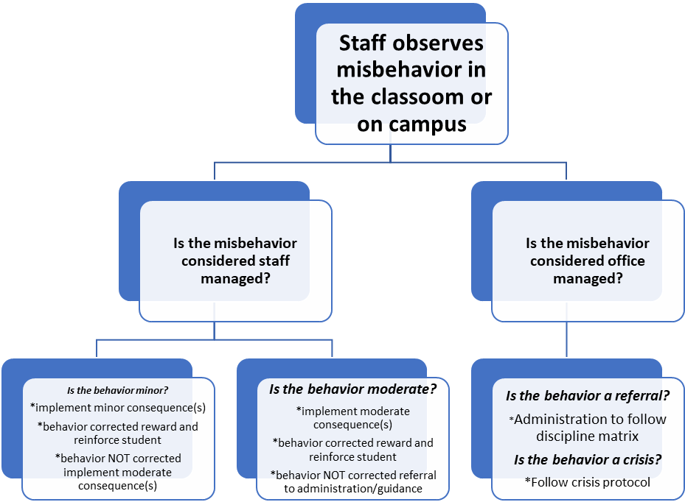

List Staff Managed  Misbehaviors from 6A | List Office Managed  Misbehaviors from 6C
 | 1.Disobedient/Insubordination  2.Disruptive/Unruly Play  3.Disruption on campus (minor)  4.Insulting/Profane/Obscene Language  5.Defiance of Authority
  1.Talks Out
  2.Off Task
  3.Inappropriate Language
  4.Note Passing
  5.Failure to Follow Directions
  6.Keeping Hands to Themselves

CRITICAL ELEMENT # 7 : Classroom Management Systems

7A. ALL teachers implement an effective Tier 1 classroom management system:
Which evidence-based classroom management system is supported by your school’s administration and is expected to be implemented school-wide?  PBIS Classroom Management is supported and will be implemented schoolwide for the 2018-19 school year. | ☐ CHAMPs*  ☒ PBIS Classroom Management  ☐ Administration does not expect an evidence-based classroom management system to be implemented by teachers this year  (your school will need to adopt one next year)  ☒ Other (complete below)
If other, name the evidence-based classroom management system:  In addition, Evidence Based Practices in Classroom is also utilized | Evidence Based Practices in Classroom Management (Simonsen, Fairbanks, Briech, 2008)
*CHAMPs is the district-supported, evidence-based universal classroom management system for all teachers. Would your Principal like to be contacted to learn about CHAMPs professional development? | ☒ Yes ☐ No

7B. Fidelity of staff implementation of school-wide classroom management systems
What data collection tool does your school leadership team use to monitor and evaluate your teacher’s classroom management skills? (Measure staff skills, not student outcomes)
X☐ CHAMPs 7 Up Checklist
☐ CHAMPs Classroom Check Up (CCU)
X☐ PBIS Classroom Assistance Tool (CAT)
☐ PBIS Walkthrough
☒ Marzano’s Domain 1, Design Questions 5, 6, 7, 8, 9
☐ Fidelity of staff classroom management implementation is not monitored to determine training needs this year (you will need to adopt a tool and plan next year)
☐ Other (specify):
Explain how this data is collected and analyzed by your school leadership team as a universal screening across teachers to determine the need for classroom management training: Assistant principal retrieves data from various district sources including Basis 3.0, i-Observations, and Data Warehouse. Quarterly, the behavioral data is analyzed with the discipline committee (grade level) members, support staff, and leadership team. Data is shared and discussed with classroom teachers. Supports and interventions are employed to address classroom management strategies. In addition, Professional Development meetings are held with classroom teachers monthly to review and analyze data.
Fidelity of Implementation Plan: (3-4 sentences)
During pre-planning, teachers will be given a self-assessment to address classroom management skills.
Behavior supports will be employed to achieve social and academic gains while diminishing the problem behavior for all students. Behavioral and academic data (Basis, iObservations, referrals) will be monitored and analyzed on a quarterly basis. Administration and guidance will conduct discussions and share data with support staff, classroom teachers, and paraprofessionals. Expectations and rules are to be reviewed by teachers on a monthly basis.

7C. Percentage of Classroom Referrals:
(a) Review your classroom data YTD (“Events by Location”) in BASIS 3.0 Behavior Dashboard.
(b) Complete the yellow highlighted cells first.
(c) Auto-calculate the % of referrals in the classroom by clicking on “!Zero Divide” in the next cell and pressing “Fn + F9” together.
Total number of discipline referrals from classrooms: | 14
Total number of school-wide discipline referrals: | 25
% of referrals in the classroom: | 55%
Do more than 40% of your referrals come from the classroom? | XX☐ Yes ☐ No
If >40% of discipline referrals come from the classroom, it suggests Tier 1 classroom management implementation may need to be strengthened school-wide.

CRITICAL ELEMENT # 8: Data Collection and Analysis

8A. Determine your School-wide Core Effectiveness YTD from the BASIS Behavior Dashboard in the “Referrals per Student” chart.
(a) Complete the yellow highlighted cells first.
(b) Auto-calculate the “% of Total Population” by clicking on each “!Zero Divide” in the cells and pressing “Fn + F9”.
(c) Determine if the core is effective in all three areas
TOTAL Population: | 934
# Referrals |  | % of Total Population | Core Effectiveness
0 - 1 referral |  | !Zero Divide | Are your 0 – 1 referrals > 80%? | X☐Yes ☐No
2 - 5 referrals  (at risk students) | 6 | 1% | Are your 2 - 5 referrals <15%? | X☐Yes ☐No
> 5 referrals  (high risk students) | 2 | 0% | Are your >5 referrals <5%? | X☐Yes ☐No

8B. Core Effectiveness Plan:
If all 3 are “Yes”, your core is effective. Is your core behavior curriculum effective? | XX☐Yes ☐No
Answer either (a) or (b):
(a) If you answered “Yes”, although your core is effective, what plan does your school leadership team implement for early identification of at risk and high risk students?
(b) If you answered “NO”, indicate the supports and interventions your school leadership team will implement at the beginning of the next school year to improve core strength:
Core Effectiveness Plan:
All students will be exposed to a core social skills behavior curriculum (SPBP and PBIS) to prevent the development of problem behavior and to identify behaviors that are not responding to the behavior core. Individualized and intensive behavior support will be developed to reduce severe behaviors. Positive reinforcements, employing a token economy system, and Rtl creates a blended integration that assist with a positive learning environment.

8C. Disproportionality: Determine if there are any issues within subgroups from BASIS 3.0 Behavior Dashboard in the “Referrals by Demographics” chart.
(a) Complete the yellow highlighted cells first.
(b) Auto-calculate the difference by clicking on each “0” in the next cell and pressing “Fn + F9”.
Subgroups | (PctPop - Green)  % of students | (PctRef - Blue)  % of referrals | Difference in referral composition | Positive value suggests disproportionality  (Is the value positive?)
Black | 43 | 38 | -5 | ☐Yes X☐No
Hispanic/Latin | 35 | 37 | 2 | X☐Yes ☐No
White | 17 | 22 | 5 | X☐Yes ☐No

8D. Disproportionality Plan: If any values are positive, the percentage of referrals contributed to that subgroup is higher than expected, given that subgroups’ percentage in the student population.
If all 3 are “No”, disproportionality is not indicated. Are all 3 “No”? | ☐Yes X ☐No
Answer either (a) or (b):
(a) If you answered “Yes”, although your data indicates equity, what plan does your school leadership team implement for early identification of any disproportionality issues
(b) If you answered “No”, indicate the support plan and interventions your school leadership team will implement at the beginning of next year to improve sub group disproportionality
Disproportionality Plan: The leadership team will identify strengths and address improvements in the operation of our school through the continuous use of behavioral data as an effort to bring equality to all subgroups. More attention will be placed on implementing positive, proactive behavior support practices that will be taught and retaught, employing student incentives and rewards. In alignment to the district’s equity policy, professional development opportunities will be provided to staff related to culturally responsive behavior support practices to reduce the number of overall referrals.

Critical Elements # 9: SPBP Implementation Planning

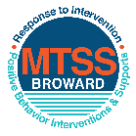
This form provides a timeline to complete best practices and required actions. This timeline should drive team actions and accountability. As you implement your SPBP NEXT year, check off completed items and indicate the accountable person. (Complete only the yellow highlighted area at this time). Next year, you will upload this completed plan within your SPBP.

Required actions for all schools in Broward County
Best Practices for all schools in Broward County
Resources
SPBP Team Implementation Action Plan 2018 - 2019
Month | Action Step  ☒ check when Action completed | Completed:  Person Responsible  Name & Title
Current | ☐X This Action Plan has been saved to use next year during quarterly meetings | Cynthia Slater  Asst. Principal
Current | ☐X Create a SPBP binder or portfolio to retain (for 2 years) hard copies of: your SPBPs, Action Plans, staff PBIS professional development attendance, stakeholder training attendance, quarterly meeting agendas, quarterly staff behavior presentations, voting attendance and outcome, Expectation lesson plans and Rules lesson plans | Cynthia Slater  Asst. Principal
Pre Planning  2018 | ☐ Print up your SPBP Review and school score from OSPA  ☐ Provide SPBP presentation to all staff during Pre Planning  ☐ Disseminate the current SPBP (hard copy or electronically) to all staff and stakeholders  ☐ Market and post school-wide Expectations and location-specific Rules (posters, PSAs, etc.)  ☐ Identify your RtI Instructional Facilitator provided by the district  (Contact tyyne.hogan@browardschools.com for more information, if you are unsure)  ☐ Confirm 1st team meeting date and time | Click here to enter NAME & title.
August  1st meeting | ☐ Ensure schedule of quarterly meeting dates for entire year as indicated in the SPBP  ☐ Determine any needed team training, such as the 4 Step PSP Brainshark Series, 10 Critical  Elements Brainsharks, Data Collection, Effective CPST Teams, PBIS 101, etc.  Trainings available at: http://www.browardprevention.org/mtssrti/training-modules/  ☐ Review previous year’s behavior data. (Use ‘Agenda’ and ‘Data Collection Template’)  Forms available at: http://www.browardprevention.org/mtssrti/rtib in Tier 1, Teaming  ☐ Present implementation data, behavior data, team activities and progress to entire staff  ☐ Utilize the 4 Step Problem Solving Process to develop initial interventions  ☐ Review previous year’s SPBP and feedback form  ☐ Verify and implement teaching schedule for SPBP Expectations and Rules behavior lesson plans | Click here to enter NAME & title
September | ☐ Provide stakeholder presentation on SPBP prior to October 1  ☐ Check for staff and teacher understanding of PBIS - provide “PBIS 101” Brainshark as a resource  Brainshark available at: http://www.brainshark.com/browardschools/PBIS101 | Click here to enter NAME & title.
October  2nd meeting | ☐ Ensure instructional staff know how to (and are, as needed) enter Tier 1 Supplemental Strategies  for behavior in BASIS  ☐ Present implementation data, behavior data, team activities and progress to entire staff | Click here to enter NAME & title.
November | ☐ Staff to re-teach Expectations and Rules first day back from break.  ☐ Team to develop new and/or improved lesson plans as indicated by behavior data. | Click here to enter NAME & title
January  2019  3rd meeting  Prepare for 2019/20 SPBP | ☐ Staff to re-teach Expectations and Rules first day back from break  ☐ Ensure the Principal signs in and watches the new SPBP Brainshark: Due January 30th  ☐ Present implementation data, behavior data, team activities and progress to entire staff  ☐ Choose team members and dates to work on, complete, and submit the new SPBP  ☐ Teams watch the new SPBP Brainsharks and refers to new “Additional items”  Brainsharks and Additional items posted at: http://www.browardprevention.org/mtssrti/rtib | Click here to enter NAME & title.
February | ☐ Ensure progress towards completion of SPBP  ☐ Check on recently hired staff for PBIS understanding - provide “PBIS 101” Brainshark resource  ☐ Provide the SPBP Surveymonkey link to all staff (optional). Email Tyyne.hogan@browardschools.com to request analysis. | Click here to enter NAME & title
March  4th meeting | ☐ Ensure progress towards completion of SPBP  ☐ Provide staff presentation and vote on new SPBP for next year  ☐ Provide stakeholders/parent presentation on new SPBP for next year  ☐ Present implementation data, behavior data, team activities and progress to entire staff | Click here to enter NAME & title
April | ☐ Submit your SPBP in OSPA by April 30th every year | Click here to enter NAME & title

CRITICAL ELEMENT # 10: Monitoring Plans

10A. How will you determine the success of staff implementation of the School-wide Positive Behavior Plan?
“Are staff implementing the SPBP with fidelity? How do you know?”
Fidelity of Implementation Monitoring Plan
Action Step | Create an observable and measureable SMART goal to determine “successful”  staff implementation of action step | When will data be collected, analyzed & presented? | Person responsible to collect and analyze data
School-wide expectations and location-specific rules are posted across campus | By September 2018, schoolwide rules and expectations will be posted on classroom bulletin boards, and throughout the school in high frequency areas such as hallways, cafeteria, and media center. 100 percent of teachers will post the schoolwide rules and expectations as observed in classroom walkthroughs and visits. Asst. Principal will post the rules in intricate locations of the school. | Refer to quarterly presentation dates in 2B.  This is the data the team will be sharing during presentations. | Mayte Garcia  Cynthia Slater
Behavior lesson plans are being taught as written and when indicated | 100 percent of teachers will include lesson plans in their plan book and also submit the plan books quarterly to be viewed by administration. 100 percent of teachers will implement schoolwide discipline plan strategies as observed in classroom walkthroughs and visits. Each classroom will utilize a behavior system of rewards and consequences as indicated in their weekly plans. |  | Cynthia Slater  Assistant Principal
Discipline consequences and flow chart are being used by all staff as written | By September 2018, assistant principal will provide a copy of the behavior flow chart and consequences to each teacher. Follow up and monitoring of the flow chart will be referred to and discussed on a quarterly basis with all staff through grade level, faculty, and discipline committee meetings. |  | Cynthia Slater  Assistant Principal
A reward system is being implemented for all students | 100 percent of teachers will implement a classroom reward system. System will be monitored and discussed at quarterly discipline committee meeting where discipline data and RtI behavioral data will be analyzed. |  | Julie Padron  Guidance Counselor  All Classroom Teachers

10B. How will you determine whether the SPBP is successful in positively impacting students?
“If staff are implementing the SPBP consistently and effectively, did it positively impact the students? How do you know?”
Student Outcome Monitoring Plan
Student Outcome Data | Create an observable and measureable SMART goal to determine “successful”  student outcomes | When will data be collected, analyzed & presented? | Person responsible to collect and analyze data
See critical element 3A  • Type of behavior incidents data | By May 2019, the number of student referrals will decrease by 50%; from 24 to 12 referrals | Refer to quarterly presentation dates in 2B.  This is the data the team will be sharing during presentations. | Cynthia Slater
See critical element 4A  • Top 3 event locations data | By June 2019, during academic instruction, students will increase on task behaviors by a rate of 40% as observed and monitored weekly. |  | Cynthia Slater  Julie Padron
See critical element 8  • Core effectiveness data | By June 2019, faculty and staff will participate in professional development trainings to become familiar with behavioral prevention addressing the interaction patterns of culturally diverse students. After participating in the trainings, African American discipline referral data will decrease by 30%. |  | Cynthia Slater  Nicole Callow
See critical element 7A  • Grade Level/Classroom referrals data | By March 2019, effectively using the PBIS classroom management system, student referrals will significantly decrease by 30%. |  | Cynthia Slater

