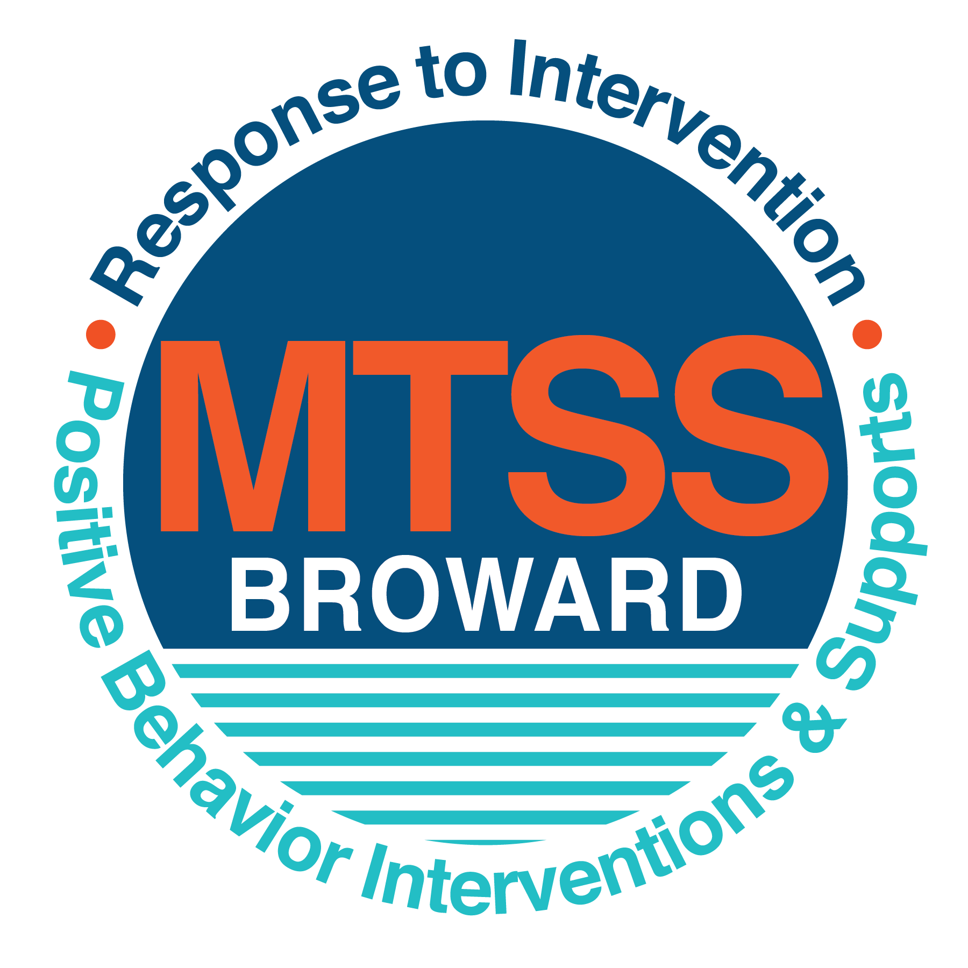
School-wide Positive Behavior Plan (SPBP)
Broward County Public Schools
To be implemented in SY 2019/20

School Name: | Sunset Lakes Elementary School
School Number: | 3661
SPBP Contact Name: | Cynthia Slater
Direct Phone Number: | 754-323-7650

CRITICAL ELEMENT # 1: Active Team with Administrative Participation

1A. Current (SY 2018/19) SPBP team members:
Full Name | Position
Marc Charpentier | 1. Administration
Susan Squire | 2. BTU Representative
Cynthia Slater | 3. SPBP Point of Contact; Asst. Principal
Stephanie Wilson | 4. Parent/Community Representation
Julie Padron | 5. Guidance Counselor; Rtl Contact
Cecilia DelCristo | 6. Math Coach (K-5); Rtl Contact
Aileen Soto | 7. Literacy Coach (K-5); Rtl Contact
Jessica Hudson | 8. Equity Liaison; SAC Chair; 3rd Gr. Teacher
Taylor Henry | 9. Autism Coach
Annie Proffitt | 10. ESE Specialist; Rtl Contact

1B. Schedule of quarterly SPBP Team Meeting dates for next 2019/20 school year:
Meeting Date | Meeting Time | Content of meetings:
08/12/2019 | 10:00-11:00 a.m. | 1. Progress of Action Steps indicated in Implementation Plan in #9  2. Collect & analyze fidelity of staff implementation data in #10A  3. Collect & analyze student outcome data in #10B
10/18/2019 | 2:00-3:00 p.m.
1/14/2020 | 2:00-3:00 p.m.
4/21/2020 | 2:00-3:00 p.m.

CRITICAL ELEMENT # 2: Faculty & Stakeholder Commitment:

2A. Action Steps completed this year (SY 2018/19) that increased faculty and stakeholder knowledge of the new SPBP:

Action Steps: | Date  (Between Jan 15 and  April 30, 2019) | Details  (Sign-in sheets in SPBP Binder)
Presented the new SPBP (for SY 2019/20) to staff | 4/9/2019 | # of participants = 74
Held a faculty vote on the new SPBP  (for SY 2019/20) | 4/23/2019 | # of participants = 81  % approved = 100%
Presented the new SPBP (for SY 2019/20) to stakeholders (parents and community) | 4/24/2019 | # of participants = 9

2B. Action Steps to be completed next year (SY 2019/20) to increase faculty and stakeholder knowledge of the new SPBP:

Action Steps: | Date  (SY 2019-20) | Content  (Sign-in sheets in SPBP Binder)
Provide professional development on the 2019/20 SPBP for all staff | 8/12/2019 | The team will present the updates in the SPBP for the 19/20 school year. All stakeholders will be provided with access to the SPBP. Feedback will be collected for future team meetings.
Present the 2019/20 SPBP to stakeholders  (parents and community) | 9/24/2019
Present the behavior data to all staff quarterly | 1.October 22, 2019 | The team will present:  - the team’s progress in the Implementation Plan in # 9.  - the fidelity of staff implementation data in #10A.  - the student outcome data in #10B.
Present the behavior data to all staff quarterly | 2. January 7, 2020
Present the behavior data to all staff quarterly | 3.March 17, 2020
Present the behavior data to all staff quarterly | 4. May 19, 2020

CRITICAL ELEMENT # 3: School-wide Expectations

3A. Top five behavior incidents data YTD as listed in BASIS 3.0
Top 5 Behavior Incidents
1.Unruly Disruptive
2. Disobedience/Insubordination
3.Defiance of Authority
4.Fight Minor
5.Disruption on Campus

3B. School-wide expectations are 3 – 5 positive characteristics (not behaviors) that counteract the demonstration of the top school-wide misbehaviors above. ALL people on campus model these expectations.
School-wide Expectations
1.Be Respectful To Others
2.Be Responsible
3.Be Kind To Yourself and To Others
4.N/A
5.N/A

3C. At least one lesson plan for each school-wide expectation above is distributed to teachers during pre-planning SY 2019/20 and maintained in the SPBP Binder.
Dates the school-wide expectations lesson plans are taught:
 | Date(s) | Time: | Location(s):
August | August 12, 2019 | 9:30 a.m.-10:30 a.m. | Media Center (in service faculty and staff)
January | January 6, 2020 | 8:30 a.m.-9:30 a.m. | Media Center (review plans with faculty and staff)
After Spring Break | April 9, 2020 | 1:00 p.m. -2:00 p.m. | Media Center (review plans with faculty and staff)

CRITICAL ELEMENT #4: Location-based Rules

4A. Top three school-wide locations for Behavior Events YTD.
Top 3 Locations, not including Classroom:
School Location | # Incidents
1. Playground | 4
2. Cafeteria | 3
3. Main Office | 1

4B. Expectations and Rules Chart for common areas of school campus: (next page)

Schoolwide Positive Behavior Expectations

Playground Expectations
- Be Safe at Recess
- Follow Playground Procedures
- Always Remain on School Grounds
- Wait your Turn
- Inform Adult of Unsafe Behaviors

Cafeteria Expectations
- Raise Hand for Assistance
- Ask Permission to Leave Area
- Say Please and Thank You
- Wait Patiently
- Use a Quiet Voice

Hallway Expectations
- Use Quiet Voices
- Listen to Instructions
- Keep Traffic Flowing
- Walk to The Right Side
- Keep Hands and Feet to Yourself

Front Office Expectations
- Use Quiet Voices
- Listen to Instructions and Directions
- Wait Patiently
- Say Please and Thank You

TEACHERS AND STAFF WILL IMPLEMENT I-HUM STRATEGIES:

- I – Interact with Students
- HU – Heads up, always looking around at students
- M – Moving constantly in and around students



Expectations and Rules Chart |  |  |  | To be completed by classroom teachers
School-wide EXPECTATIONS | Cafeteria Rules | Hallway Rules | Playground Rules | Classroom Rules
BE RESPECTFUL  TO OTHERS | - Raise hand for assistance  - Ask permission to leave area  - Or your assigned table  - Eat your own food | - Use quiet voices  - Listen to instructions and directions  - Look straight ahead | - Wait your turn  - Listen to adults  - Follow rules  - Play fairly
BE RESPONSIBLE | - Say please and thank you  - Wait patiently in line  - Use a quiet voice  - Remove trash from table and floor areas | - Say please and thank you  - Use a quiet voice  - Keep traffic flowing  - Walk on the right side of the hallway | - Line up on time  - Wait your turn  - Say please and thank you  - Inform adult of unsafe behaviors
BE KIND TO YOURSELF and  TO OTHERS | - Line up quietly when your teacher arrives  - Remain in a straight line | - Keep hands and feet to yourself  - Walk in a single file line | - Say please and thank you  - Stay in designated area  - Wait your turn  - Use good sportsmanship
N/A | N/A | N/A | N/A
N/A | N/A | N/A | N/A

4C. At least one Rules lesson plan for each specific location is distributed to teachers during pre-planning SY 2019/20 and maintained in the SPBP Binder.

Dates the Locations’ Rules lesson plans are taught
 | Date(s) | Time: | Location(s):
August | August 12, 2019 | 9:30-10:30 a.m. | Media Center
January | January 6, 2020 | 8:30-9:30 a.m. | Media Center
After Spring Break | April 9, 2020 | 1:00-2:00 p.m. | Media Center

CRITICAL ELEMENT # 5: Reward and Recognition Programs

5. The reward system is focused on one School-wide Expectation OR specific location at a time.
Expectation or Location: PLAYGROUND

4 Step Problem Solving Process | Plan Details
1. Problem Identification: Use your behavior data to identify one school-wide problem.  What problem did you identify? (use numerical data) | Data used: BASIS 3.0 (Behavioral/Discipline Dashboard)  Problem Identification Statement: 4 BEHAVIORAL INCIDENTS OCCURRED ON THE PLAYGROUND DURING RECESS. THIS LOCATION WAS THE 2ND HIGHEST REPORTED INCIDENTS DURING THE 2018-19 SCHOOL YEAR.
2. Problem Analysis: Why do you think this problem is occurring?  What is your goal? (use a SMART goal statement with numerical data) | Hypothesis: The problem is occurring due to the number of students utilizing the playground; students are not reminded of the rules and expectations.  Goal Statement: By May 2020, students will be reminded of playground rules, procedures, and expectations. A recess schedule will be created to assign times for each classroom; rewards and incentives will be added. Doing so will result in fewer incidents occurring on the playground.
3. Intervention Design: Describe how you will implement a positive reward program to decrease this problem. | Type of System: TOKEN ECONOMY SYSTEM  Description of System: A token economy system will be implemented using EAGLE coins. Eagle coins will be rewarded to students that follow rules, and procedures during recess, lunch, and while transitioning in the hallway. School wide token system will require teacher/staff input.
4. Evaluation:  A. Implementation fidelity | - How will you monitor the fidelity (consistency and effectiveness) of the staff’s implementation of the reward program? EAGLE coins will communicate to staff that students are following rules and expectations.  Incentives will be monitored monthly by administration, teachers, and guidance counselor. Additional discussions and to analyze data (results) will be held with grade level representatives at quarterly discipline committee meetings.
B. Student outcome monitoring | - How will you know if the reward program is positively impacting students? What measurable data will you use to determine “success”? Reviewing and analyzing quarterly behavior data; fewer reported incidents and referrals being documented. Students are diligently working effectively to participate and earn EAGLE coins.

CRITICAL ELEMENT #6: Effective Discipline Procedures

Student Behavior Discipline Flow Chart

Staff Observes Misbehavior in the Classroom or on Campus
Intervene and Redirect
Office Managed Misbehaviors
Staff Managed Misbehaviors
Is the Behavior Considered Staff Managed?
YES or NO
Is the Behavior Considered Office Managed?
YES or NO
Implement an initial consequence
Behavior corrected reward and reinforce
Behavior not corrected
Implement moderate consequences(s)

Call to notify office of a
crisis/safety issue
Administrator to follow discipline matrix

Specific Examples of  6 Staff Managed  Misbehaviors: | Specific Examples of  6 Office Managed  Misbehaviors:
- Talks Out  - Off Task  - Inappropriate Language  - Note Passing  - Failure to Follow Directions  - Keeping Hands to Themselves | - Disobedient/Insubordination  - Disruptive/Unruly Play  - Disruption on Campus  - Insulting/Profane/Language  - Defiance of Authority  - Property Damage/Theft

CRITICAL ELEMENT # 7: Classroom Management Systems

7A. In SY 2019/20, ALL teachers implement an evidence-based Tier 1 classroom management system:
Evidence-based system: | Evidence of training:
☐ CHAMPS | 2 % of teachers currently holding valid CHAMPS certificate.
X☐ PBIS Classroom Management  http://www.fl-pda.org/independent/ | 1 % of teachers currently holding completion certificate.
☐X Other: Evidence Based Practices in the Classroom. | Training evidence: Training held in September 2019. Power point and sign in sheets available  95% of teachers currently trained.

7B. The administration reviews and analyzes the fidelity of staff implementation of Tier 1 classroom management systems across teachers using:
☐ CHAMPs 7 Up Checklist
☐ Basic FIVE (Classroom Management Screening)
X☐ PBIS Classroom Assistance Tool (CAT)
☐ Other (specify):I-Observations Marzano Tool
☐ Classroom management screening is not conducted across teachers to determine appropriate professional
development. (Next year, assessment of classroom management implementation fidelity will be scored).

7C. School year 2018/19 percentage of classroom referrals:
Total number of discipline referrals from classrooms: | 16
Total number of other school-wide discipline referrals: | 37
% of referrals in the classroom: | 30%
Do more than 40% of your referrals come from the classroom? | ☐ Yes X☐ No
If >40% of discipline referrals come from the classroom, it suggests Tier 1 classroom management implementation may need to be strengthened school-wide.
If “Yes”, school-wide classroom management professional development will be conducted in 2019-20:
Click here to choose: If “Other”, indicated system here: Click here to enter text.

CRITICAL ELEMENT # 8: Data Collection and Analysis

8A. Core Effectiveness:
TOTAL Population: | 902 | % of Total Population | Core Effectiveness
# Referrals: | # of Students: | % of Total Population
0 - 1 referrals | 12 | 99% | Are your 0 – 1 referrals > 80%? | X☐Yes ☐No
2 - 5 referrals  (at risk students) | 4 | 0% | Are your 2 - 5 referrals <15%? | X☐Yes ☐No
> 5 referrals  (high risk students) | 1 | 0% | Are your >5 referrals <5%? | X☐Yes ☐No

8B. Core Effectiveness Action Steps:
If all 3 are “Yes”, your core is effective. Is your core behavior curriculum effective? | X☐Yes ☐No
Answer either (a) or (b):
(a) If you answered “Yes”, although your core is effective, what steps does your school leadership team take for early identification of at risk and high-risk students?
(b) If you answered “NO”, indicate the supports and interventions your school leadership team will implement at the beginning of the next school year to improve core strength:
Core Effectiveness Action Steps:
1.All students will be introduced to a core skills behavior curriculum (SPBP and PBIS) to prevent the development of problem behavior and to identify behaviors that are not responding to the core.
2.Individualized and intensive behavior support will be implemented to reduce severe behaviors.
3.Positive reinforcements, employing a token economy system for all students.
4.RtI process will create a blended integration that assist with a positive learning environment.

8C. Disproportionality within racial subgroups:
Subgroups | (PctPop - Green)  % of students | (PctRef - Blue)  % of referrals | Difference in referral composition | Positive value suggests disproportionality  (Is the value positive?)
Black | 19 | 6 | -13 | ☐Yes X ☐No
Hispanic/Latin | 48 | 80 | 32 | X☐Yes ☐No
White | 15 | 8 | -7 | ☐Yes X☐No

8D. Disproportionality Action Steps:
If all three are “No”, disproportionality is not indicated. Are all 3 “No”? | ☐Yes X☐No
Answer either (a) or (b):
(a) If you answered “Yes”, although your data indicates equity, what plan does your school leadership team implement for early identification of any disproportionality issues
(b) If you answered “No”, indicate the support plan and interventions your school leadership team will implement at the beginning of next year to improve sub group disproportionality
Disproportionality Action Steps: (3-4 steps)
1.Leadership team will identify strengths and address improvements in the operation of our school through continuous use of behavioral data as an effort to bring equality to all subgroups.
2.Attention to be placed on implementing positive, proactive support practices that will be reinforced.
3.In alignment to the district’s equity policy, PD opportunities for staff related to culturally responsive behavior support practices to reduce the number of overall referrals.

Critical Elements # 9: SPBP Implementation Planning
RED Font = Action Steps for all schools in Broward County
GREY Font = Best Practices for all schools in Broward County
TEAL Font = Resources available at https://browardcountyschools.sharepoint.com/sites/DPI6Strands/strand6/SitePages/SPBP.aspx
SPBP Team Implementation Action Plan 2019 - 2020
Month | Action Steps  ☒ check off Action Step when completed
Current | X☐ Create a SPBP binder or portfolio to retain (for 2 years) hard copies of: your SPBPs, Action Plans, staff PBIS  professional development attendance, stakeholder training attendance, quarterly meeting agendas, quarterly staff  behavior presentations, voting attendance and outcome, Expectations lesson plans and Rules lesson plans
Pre-Planning  2019 | ☐ Print up your SPBP Review and school score from OSPA  ☐ Provide SPBP presentation to all staff during Pre-Planning  ☐ Disseminate the current SPBP (hard copy or electronically) to all staff and stakeholders  ☐ Market and post school-wide Expectations and location-specific Rules  ☐ Identify your district RtI Instructional Facilitator  (Contact tyyne.hogan@browardschools.com for more information, if you are unsure)  ☐ Confirm 1st team meeting date and time
August  1st meeting | ☐ Ensure schedule of quarterly meeting dates for entire year as indicated in the SPBP  ☐ Review Implementation plan; check off completed Action Steps  ☐ Determine any needed team training, such as these Brainsharks: 4 Step Problem Solving Process series, PBIS 10  Critical Elements, Data Collection, Big 5 Data, PBIS 101, etc. (All found in Sharepoint site)  ☐ Review previous year’s behavior data. (Use ‘Agenda’ Form and ‘Data Collection Template’ in Sharepoint site)  ☐ Utilize the 4 Step Problem Solving Process to initiate a Reward System for all students  ☐ Review previous year’s SPBP and feedback form; make necessary modifications  ☐ Verify and implement teaching schedule for Expectations and Rules behavior lesson plans  ☐ Present implementation data, behavior data, team activities and SPBP progress to entire staff
September | ☐ Provide SPBP stakeholder presentation prior to October 1  ☐ Check for staff and teacher understanding of PBIS - provide “PBIS 101” Brainshark as a resource  Brainshark available at: http://www.brainshark.com/browardschools/PBIS101  ☐ Ensure the Discipline Flow Chart is distributed to all staff and is being used as written
October  2nd meeting | ☐ Review Implementation plan; check off completed Action Steps  ☐ Ensure instructional staff know how to (and are, as needed) enter Tier 1 Supplemental Strategies  for behavior in BASIS  ☐ Review previous quarter’s behavior data. (Use ‘Agenda’ and ‘Data Collection Template’ in Sharepoint site)  ☐ Present implementation data, behavior data, team activities, and SPBP progress to entire staff  ☐ Ensure all teachers are using an evidence-based classroom management plan, such as CHAMPS  ☐ Ensure Core Effectiveness Action Steps are being implemented as written
November | ☐ Team to develop new and/or improved lesson plans as indicated by behavior data.  ☐ Ensure that the Disproportionality Action Steps are being implemented as written
January  2020  3rd meeting  Prepare for SY 2020/21 SPBP | ☐ Review Implementation plan; check off completed Action Steps  ☐ Staff to re-teach Expectations and Rules after winter break  ☐ Principal signs in and watches the new “SPBP for Principals” Brainshark: Due January 30th  ☐ Present implementation data, behavior data, team activities, and SPBP progress to entire staff  ☐ Choose team members and dates to work on, complete, and submit the new SPBP  ☐ Teams watch the new “SPBP Team Overview” Brainshark and refers to district resources and supports  (Brainsharks and Additional items in Sharepoint site. Webinars and in-person lab information in Team Brainshark)
February | ☐ Ensure progress towards completion of SPBP  ☐ Check on recently hired staff for PBIS understanding - provide “PBIS 101” Brainshark resource  ☐ Provide the SPBP Surveymonkey link to all staff (optional)
March  4th meeting | ☐ Ensure progress towards completion and submission of SPBP  ☐ Review Implementation plan; check off completed Action Steps  ☐ Staff to re-teach Expectations and Rules after from spring break  ☐ Provide stakeholders/parent presentation on new SPBP for next year  ☐ Provide staff presentation and faculty vote on new SPBP for next year  ☐ Present implementation data, behavior data, team activities, and SPBP progress to entire staff
April | ☐ Submit your SPBP in OSPA by April 30th every year. Use this new SPBP in the next school year  ☐ Continue implementing your current SPBP through the end of the current school year

CRITICAL ELEMENT # 10: Evaluation

10A. Staff implement the School-wide Positive Behavior Plan effectively:
“Are staff implementing the SPBP with fidelity? How do you know?”
STAFF Implementation Monitoring
Action Step | Create an observable and measurable SMART goal to determine “successful”  staff implementation of action step
School-wide expectations and location-specific rules are posted across campus | By September 2019, schoolwide rules and expectations will be reprinted and reposted on classroom bulletin boards and throughout the school in high frequency areas such as hallways, cafeteria, media center, art, and music rooms. 100 percent of teachers will post the rules and expectations as observed in classroom walkthroughs and visits. Assistant Principal will be responsible for placing rules in intricate locations.
Expectations and Rules lesson plans are being taught as written and when indicated | 100 percent of teachers will include expectations and rules’ lesson plans in their plan book and submit the plan books quarterly to be reviewed by administration. 100 percent of teachers will implement schoolwide discipline plan strategies as observed in classroom walkthroughs and visits. Each classroom will utilize a behavior system as indicated in their weekly plans.
The Discipline flow chart is being used by all staff as written | By September 2019, Assistant Principal will provide a copy of the behavior flow chart and consequences to each teacher. Follow up and monitoring of the flow chart will be referred to and discussed on a quarterly basis with all staff through faculty, grade level planning, and discipline committee meetings.
A reward system is being implemented for all students | 100 percent of teachers will implement a classroom reward system. System will be monitored and discussed at quarterly discipline committee meetings where data and RtI behavioral data will be analyzed.

10B. The SPBP is successful in positively impacting students:
“If staff are implementing the SPBP consistently and effectively, did it positively impact the students? How do you know?”
STUDENT Outcome Monitoring
Student Outcome Data | Create an observable and measurable SMART goal to determine  “successful” student outcomes
Behavior Incident data  (See critical element #3A) | By May 2020, the number of student referrals will decrease by 20 percent. From 37 to 29 referrals.
Top 3 event locations data  (See critical element #4A) | By June 2020, during academic instruction, students will increase on task behaviors by a rate of 25 percent as observed and monitored weekly.
Core effectiveness data  (See critical element #8A) | By May 2020, faculty and staff will participate in professional development trainings to become familiar with behavioral prevention addressing the interaction patterns of culturally diverse students. After participating in the trainings, Hispanic discipline referral data will decrease by 10 percent.
Classroom referrals data  (See critical element #7C) | By March 2020, effectively using the PBIS classroom management system, student referrals will significantly decrease by 20 percent.

