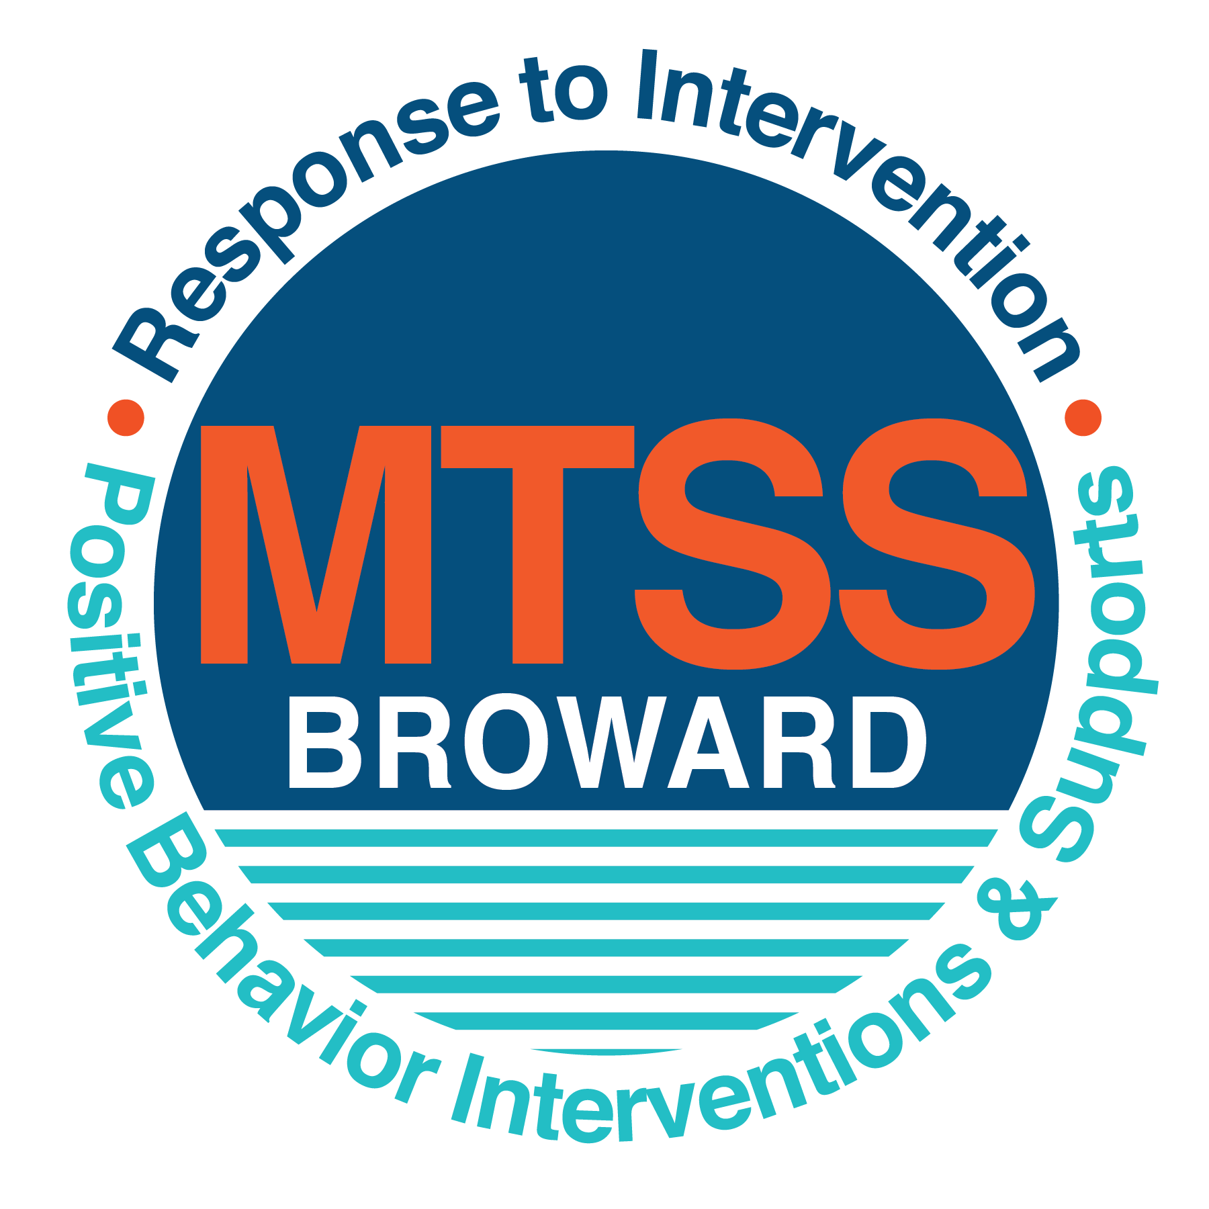
School-wide Positive Behavior Plan (SPBP)
Broward County Public Schools
To be implemented in SY 2018/19

Elements have changed in the SPBP.
Before completing, go to http://www.browardprevention.org/mtssrti/rtib/ → School-wide Positive Behavior Plan for:

- A NEW Brainshark for Principals. ACTION: Log in with your p # and watch the Brainshark before Jan 30th.
- A NEW Overview Brainshark for Teams. ACTION: Log in with school name and watch the Brainshark.
- A NEW mini Brainshark Series for teams. These Brainsharks are divided into the 10 Critical Elements of PBIS. They will
show you “how to” write a comprehensive SPBP (and receive a high score!)
- A Rating Rubric to ensure teams will correctly complete the SPBP and develop a meaningful plan.

To provide consistency across the District, only plans entered on the current district template will be accepted.
ACTION: Download, complete and upload the SPBP into your School Improvement Plan before May 1, 2018:

School Name: | Falcon Cove Middle
School Number: | 754-323-3200
SPBP Contact Name: | David Malca
Direct Phone Number: | 754-323-3236

CRITICAL ELEMENT # 1: Active Team with Administrative Participation

1A. List your current (SY 2017/18) team members (6 - 10 team members). Must include an instructional representative from EACH grade/content area. Each name on this list verifies attendance in ongoing team meetings and participation in developing this SPBP. Each member is responsible for representing major stakeholders and sharing the SPBP content and updates with their respective group.
Full Name | Position | Who or what grade level does this member represent?
Dr. Mark Kaplan | Principal | Administration
David Roca | SPBP Point of Contact | Guidance Director
Deputy Mathew Brandt | Parent/Community Representation | Community
Jarrod Hedrick | BTU Representative | BTU/8th grade teacher
Cheryl Rubin | Seventh Grade Admin | Administration
Laurie Reichow | Literacy Coach | Staff Member
Debra Zalman | Guidance | 6th grade guidance
Jeffrey Showers | Guidance | 7th grade guidance
David Malca | Teacher/SAC Chair | 8th grade teacher

1B. Schedule and document your quarterly team meeting dates for next 2018/19 school year:
Meeting Date | Meeting Time | Name & title of person responsible to facilitate meeting | Content of meetings:
9/18/2018 | 2:00 PM | Cheryl Rubin 7th Grade Administrator | 1. Create and disseminate updated  Expectations and Rules lesson  plans (#3 and #4)  2. Review progress of  Implementation Action Plan (#9)  3. Collect & analyze implementation  data (#10A)  4. Collect & analyze student  outcome data (#10B)
12/11/2018 | 2:00 PM | Cheryl Rubin 7th Grade Administrator
3/12/2019 | 2:00 PM | Cheryl Rubin 7th Grade Administrator
4/23/2019 | 2:00 PM | Cheryl Rubin 7th Grade Administrator

CRITICAL ELEMENT # 2: Faculty & Stakeholder Commitment:

2A. Action Steps completed this year (SY 2017/18) that increased faculty and stakeholder understanding and knowledge of your new (2018/19) SPBP:
Action Steps: | Date  (Between Jan 15 –  April 30, 2018) | Details  (retain attendance sheets at school) | Person responsible to collect and retain attendance sheets:
Presented the new SPBP (for SY 2018/19) to staff | 3/2/2018 | # of participants = 85 | David Malca
Held a faculty vote on the new SPBP  (for SY 2018/19) | 3/7/2018 | % approved =96% | David Malca
Presented the new SPBP (for SY 2018/19) to stakeholders (parents and community) | 3/14/2018 | # of participants = | David Malca

2B. Action Steps to be completed next year (SY 2018/19) to increase faculty and stakeholder understanding and knowledge of your SPBP:
Action Steps: | Date(s)  (NEXT YEAR) | Content  (retain attendance sheets at school) | Person responsible to collect and retain attendance sheets:
Provide a professional development on the 2018/19 SPBP for all staff | Prior to students’ 1st day:  8/8/2018 | The team will present the updates in the SPBP for the 18/19 school year. All stakeholders will be provided with access to the SPBP. Feedback will be collected for future team meetings. | David Malca
Present the 2018/19 SPBP to stakeholders (parents and community) | Prior to Oct 1st, 2018  9/12/2018 |  | David Malca
Present behavior data to staff  Quarterly: minimum of 4 each year | 1. 10/5/2018 | The team will present the implementation data in 10A. Include:  • the “marketing” (teaching and posting) of expectations and rules  • lesson plan implementation  • discipline procedures  • reward system implementation  The team will present the student outcome data in 10B. Include:  • top 3 event locations  • type of behavior incidents  • core effectiveness data  • classroom referral data, as well as analysis of this data. | David Malca
 | 2. 12/7/2018 |  | David Malca
 | 3. 2/2/2018 |  | David Malca
 | 4. 4/6/2018 |  | David Malca

CRITICAL ELEMENT # 3: School-wide Expectations

3A. List the top 10 behavior incidents data YTD from BASIS 3.0 Behavior Dashboard:
Top 10 Behavior Incidents
(put N/A in any blank spaces)
1. SB: UNRULY/DISRUPTIVE BEHAVIOR | 6. ZI:FIGHT-MINOR/ALTERCATION/CONF
2. 01:DISOBEDIANCE/INSUBORDINATION | 7. ZP Unserved Detentions
3. TU:TOBACCO USE | 8. T5 Petty Theft
4. UP: DISRUPTIVE/UNRULY PLAY | 9. ZM Tardiness Habitual
5. ZL:CLASS CUT (SKIPPING) | 10. Z3 Technology Inappropriate Use

3B. Based on the behavior incidents in 3A, develop 3 – 5 positive characteristics (not behaviors) that would counteract the demonstration of these misbehaviors. These positive characteristics become your school-wide expectations.
School-wide Expectations
1. Be Accountable
2. Be positive with your thoughts and actions
3. Be proud to be at Falcon Cove

3C. Research indicates that discipline referrals increase after long holidays and during testing times. Plan to teach your expectations at least 3 times throughout the year (and anytime the expected behaviors are not being demonstrated).
ACTION: Create at least one lesson plan for each school-wide expectation above and distribute to teachers during pre-planning 2018-19. Develop additional lesson plans you will use throughout the year to re-teach and reinforce your school-wide expectations. You do not need to submit your lesson plans with the SPBP. Retain all behavior lesson plans at the school; make sure these lesson plans are available for guests and stakeholders.
When will school-wide expectations lesson plans be taught?
 | Date(s) | Time:
August | August 31st 2018 | All Day
January | January 25th 2019 | All Day
4th Quarter | April 26th 2019 | All Day
Who will be responsible for teaching the lesson plans? |  |  | Social Teachers
Where will the lesson plan instruction occur? |  |  | Classroom
Who is responsible for retaining, organizing and distributing all lesson plans? |  |  | David Malca

CRITICAL ELEMENT #4: Location-based Rules

4A. List the top 3 locations for behavior Events YTD from BASIS 3.0 Behavior Dashboard. Do not use “classroom”
Top 3 Locations
School Location | # Incidents
- Hallway | 11
- Cafeteria | 8
- Bus | 5

4B. Create an Expectations/Rules Matrix from your 3-5 school-wide expectations and your top 3 event locations. Develop a positively stated, observable, and measurable rule that correlates with every expectation to create a maximum of 5 rules under each location.
Expectations and Rules Matrix
School-wide EXPECTATIONS | Copy and paste expectations from 3C. | IDENTIFIED LOCATIONS  Copy and paste locations from 4A.
School-wide EXPECTATIONS | Copy and paste expectations from 3C. | Hallway #1 | Cafeteria #2 | Bus #3
School-wide EXPECTATIONS | Copy and paste expectations from 3C. | Rules | Rules | Rules
School-wide EXPECTATIONS | Be Accountable Expectation #1 | Keep the hallway clear and walk to class in a timely fashion. | Follow proper cafeteria etiquette | Students will enter and exit the bus in an orderly and timely fashion.
School-wide EXPECTATIONS | Be positive with your thoughts and actions  Expectation #2 | Students will express their ideas and opinions in a respectful manner to peers and staff members. Students will avoid using insulting and profane language Students will remain quiet in hallways during class time. | Students will be respectful to their classmates and cafeteria staff | Students will be respectful to their classmates and their bus driver.
School-wide EXPECTATIONS | Be proud to be at Falcon Cove  Expectation #3 | Speak in pleasant tone/voice level 1-2 | Students will keep their designated areas clean. | Students will keep their designated areas clean.

4C. Research indicates that discipline referrals increase after long holidays and during testing times. Plan to teach your location-specific rules at least 3 times throughout the year (and anytime the expected behaviors are not being demonstrated).
ACTION: Create at least one lesson plan for each location above and distribute to teachers during pre-planning 2018-19. Develop additional lesson plans you will use throughout the year to re-teach and reinforce your location-specific rules.
You do not need to submit your lesson plans with the SPBP. Retain all behavior lesson plans at the school; make sure these lesson plans are available for guests and stakeholders.
When will location-specific rules lesson plans be taught?
 | Date(s) | Time:
August | August 24th 2109 | 2:00 pm
January | January 18th 2019 | 2:00 pm
4th Quarter | April 19th 2019 | 2:00 pm
Who will be responsible for teaching the lesson plans? |  |  | Science Teachers
Where will the lesson plan instruction occur? |  |  | Classroom
Who is responsible for retaining, organizing and distributing all lesson plans? |  |  | David Malca

CRITICAL ELEMENT # 5: Reward and Recognition Programs

Although you will post, teach, review, practice and reinforce all school-wide expectations and location-specific rules, choose 1 expectation OR 1 event location you will target for a specific reward program for students. Based on the data that led to this expectation or location, create a reward plan using the 4 Step Problem Solving Process:

Location: Cafeteria

4 Step Problem Solving Process | Plan
1. Problem Identification: Use your behavior data to identify a school-wide problem.  What problem did you identify? (use numerical data) | Data used: Basis, behavior dashboard.  Problem Identification: Poor cafeteria behavior.
2. Problem Analysis: Why do you think this problem is occurring?  What is your goal? (use a SMART goal statement with numerical data) | Goal Statement: Using the reward system we aim to decrease behavior referrals by 15 %
3. Intervention Design: Describe how you will implement a positive reward program to decrease this problem. | Type of System: Reward  Description of System: Students will need to have zero tardies throughout the month and no discipline on their record. In the cafeteria they will need to have a clean lunch table all week and their reward will be Falcon feather tickets to spend on ice cream and gifts donated by PTA
4. Evaluation:  A. Implementation fidelity | Data will be collected based on receipts of falcon feather ticket distribution and there will be a monthly reward for students that have received a large amount of tickets as well as students that were nominated for Kids of Character.
B. Student outcome monitoring | Reduction of infractions. We will use behavior data from Basis.

CRITICAL ELEMENT #6 Effective Discipline Procedures

6A. Staff Managed Misbehaviors: List the top 6 most common school-wide misbehaviors staff are expected to manage.
Write a short, objective, and measurable definition for each.
Staff Managed Misbehaviors
Misbehavior | “Looks Like” - provide a description with example(s)
1. Tardiness | Arriving to class after the bell
2. Inappropriate language | Using offensive language
3.Tobacco Use | Students using vaping devices on campus and on school busses
4. Cell Phone Violation | Cell phone is being used during instructional time.
5. Untidy Lunch Table | Students leave a mess in their designated seats during breakfast and lunch.
6. Disrupting Hallway Flow | Students take too long in the hallway and group up causing a bottleneck In high volume areas.

6B. Staff Managed Consequences: Create a consequence menu OR a consequence hierarchy for staff to use when students exhibit the above misbehaviors. Provide a minimum of 5 consequences.
Is this a menu or hierarchy system? | X Menu ☐Hierarchy
Call home
Parent Conference
Pre Referral
Send to another teacher
Referral

6C. Administration Managed Misbehaviors:
(a) Define the first 3 behaviors by providing examples that clearly identify the point at which the misbehavior warrants an Office Discipline Referral (ODR).
(b) List two additional common school-wide misbehaviors that will result in an ODR. Provide concrete examples.
(c) Determine staff tolerance level for repetitive misbehaviors (the point at which the number of staff-managed misbehaviors becomes an ODR).
Office Discipline Referrals (ODRs)
Behavior | “Looks Like” - provide a description with example(s)
1. Disobedience/Insubordination | Defiant of authority. Ex. Not listening to staff instructions.
2. Disruptive/Unruly Play | Behaviors that hamper the ability of instructors to teach or students to learn. Ex. Throwing paper in class.
3. Defiance of authority | Not following the rules in the cafeteria during morning supervision.
4. Tobacco Use | Students using vaping devices on campus and on school busses
5.Inappropriate School Bus Behavior | Failure to follow bus driver’s instructions. Eating on the school bus.
6. Repetitive staff managed  misbehaviors | More than misbehaviors in warrants an office referral.  3  One  period  e.g., 3 half hour  2 one period

6D. School-wide Discipline Flow Chart:
(a) Review the sample discipline flow charts in “Additional Items” located on browardprevention.org
(b) Copy or customize a flow chart to graphically represent the discipline process at your school.
(c) Paste the flow chart here OR complete the flow chart below.

Student Behavior Discipline Flow Chart
Observe Problem Behavior

Office Managed Misbehaviors
Teacher/ Staff Managed Misbehaviors
Is behavior Teacher/Staff Managed or Office Managed
Intervention 1: Write office referral / Call to notify office of infraction.

Intervention 1: Re-direct student
Intervention 3: Parent Contact
Intervention 2: Reteach appropriate behavior.
Intervention 2: Student Conference with administration.

Intervention 3: Administration determines consequence based on discipline matrix

Intervention 4: Administration has conference with parent and student.

List Staff Managed  Misbehaviors from 6A | List Office Managed  Misbehaviors from 6C
Tardiness  Physical Contact  Disrespect  Defiance  Disruptive  Dress code violation | Abusive language  Fighting  Leaving school grounds w/out permission  Vandalism  weapons
Intervention 4: Referral

CRITICAL ELEMENT # 7 : Classroom Management Systems

7A. ALL teachers implement an effective Tier 1 classroom management system:
Which evidence-based classroom management system is supported by your school’s administration and is expected to be implemented school-wide?  (Class Dojo, LEAPs, HERO, Cloud 9, etc. are tools, not classroom systems) | X PBIS Classroom Management
If other, name the evidence-based classroom management system: | NA
*CHAMPs is the district-supported, evidence-based universal classroom management system for all teachers. Would your Principal like to be contacted to learn about CHAMPs professional development? | ☐ Yes X No

7B. Fidelity of staff implementation of school-wide classroom management systems
What data collection tool does your school leadership team use to monitor and evaluate your teacher’s classroom management skills? (Measure staff skills, not student outcomes)
☐ CHAMPs 7 Up Checklist
☐ CHAMPs Classroom Check Up (CCU)
☐ PBIS Classroom Assistance Tool (CAT)
X PBIS Walkthrough
☐ Marzano’s Domain 1, Design Questions 5, 6, 7, 8, 9
☐ Fidelity of staff classroom management implementation is not monitored to determine training needs this year (you will need to adopt a tool and plan next year)
☐ Other (specify):
Explain how this data is collected and analyzed by your school leadership team as a universal screening across teachers to determine the need for classroom management training:
Fidelity of Implementation Plan: (3-4 sentences)

7C. Percentage of Classroom Referrals:
(a) Review your classroom data YTD (“Events by Location”) in BASIS 3.0 Behavior Dashboard.
(b) Complete the yellow highlighted cells first.
(c) Auto-calculate the % of referrals in the classroom by clicking on “!Zero Divide” in the next cell and pressing “Fn + F9” together.
Total number of discipline referrals from classrooms: | 86
Total number of school-wide discipline referrals: | 148
% of referrals in the classroom: | 37%
Do more than 40% of your referrals come from the classroom? | No
If >40% of discipline referrals come from the classroom, it suggests Tier 1 classroom management implementation may need to be strengthened school-wide.

CRITICAL ELEMENT # 8: Data Collection and Analysis

8A. Determine your School-wide Core Effectiveness YTD from the BASIS Behavior Dashboard in the “Referrals per Student” chart.
(a) Complete the yellow highlighted cells first.
(b) Auto-calculate the “% of Total Population” by clicking on each “!Zero Divide” in the cells and pressing “Fn + F9”.
(c) Determine if the core is effective in all three areas
TOTAL Population: | 2291
# Referrals | 144 | % of Total Population | Core Effectiveness
0 - 1 referral | 72 | 99% | Are your 0 – 1 referrals > 80%? | Yes
2 - 5 referrals  (at risk students) | 20 | 1% | Are your 2 - 5 referrals <15%? | Yes
> 5 referrals  (high risk students) | 3 | 0% | Are your >5 referrals <5%? | Yes

8B. Core Effectiveness Plan:
If all 3 are “Yes”, your core is effective. Is your core behavior curriculum effective? | Yes
Answer either (a) or (b):
(a) If you answered “Yes”, although your core is effective, what plan does your school leadership team implement for early identification of at risk and high risk students?
(b) If you answered “NO”, indicate the supports and interventions your school leadership team will implement at the beginning of the next school year to improve core strength:
Core Effectiveness Plan: (3-4 sentences)

8C. Disproportionality: Determine if there are any issues within subgroups from BASIS 3.0 Behavior Dashboard in the “Referrals by Demographics” chart.
(a) Complete the yellow highlighted cells first.
(b) Auto-calculate the difference by clicking on each “0” in the next cell and pressing “Fn + F9”.
Subgroups | (PctPop - Green)  % of students | (PctRef - Blue)  % of referrals | Difference in referral composition | Positive value suggests disproportionality  (Is the value positive?)
Black | 4 | 5 | 1 | Yes
Hispanic/Latin | 65 | 69 | 4 | Yes
White | 22 | 23 | 1 | Yes

8D. Disproportionality Plan: If any values are positive, the percentage of referrals contributed to that subgroup is higher than expected, given that subgroups’ percentage in the student population.
If all 3 are “No”, disproportionality is not indicated. Are all 3 “No”? | No all values are positive.
Answer either (a) or (b):
(a) If you answered “Yes”, although your data indicates equity, what plan does your school leadership team implement for early identification of any disproportionality issues
(b) If you answered “No”, indicate the support plan and interventions your school leadership team will implement at the beginning of next year to improve sub group disproportionality
Disproportionality Plan: (3-4 sentences)

Critical Elements # 9: SPBP Implementation Planning

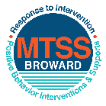
This form provides a timeline to complete best practices and required actions. This timeline should drive team actions and accountability. As you implement your SPBP NEXT year, check off completed items and indicate the accountable person. (Complete only the yellow highlighted area at this time). Next year, you will upload this completed plan within your SPBP.

Required actions for all schools in Broward County
Best Practices for all schools in Broward County
Resources
SPBP Team Implementation Action Plan 2018 - 2019
Month | Action Step  ☒ check when Action completed | Completed:  Person Responsible  Name & Title
Current | ☐ This Action Plan has been saved to use next year during quarterly meetings | David Malca SAC Chair.
Current | ☐ Create a SPBP binder or portfolio to retain (for 2 years) hard copies of: your SPBPs, Action Plans, staff PBIS professional development attendance, stakeholder training attendance, quarterly meeting agendas, quarterly staff behavior presentations, voting attendance and outcome, Expectation lesson plans and Rules lesson plans | David Malca.
Pre Planning  2018 | ☐ Print up your SPBP Review and school score from OSPA  ☐ Provide SPBP presentation to all staff during Pre Planning  ☐ Disseminate the current SPBP (hard copy or electronically) to all staff and stakeholders  ☐ Market and post school-wide Expectations and location-specific Rules (posters, PSAs, etc.)  ☐ Identify your RtI Instructional Facilitator provided by the district  (Contact tyyne.hogan@browardschools.com for more information, if you are unsure)  ☐ Confirm 1st team meeting date and time | Click here to enter NAME & title.
August  1st meeting | ☐ Ensure schedule of quarterly meeting dates for entire year as indicated in the SPBP  ☐ Determine any needed team training, such as the 4 Step PSP Brainshark Series, 10 Critical  Elements Brainsharks, Data Collection, Effective CPST Teams, PBIS 101, etc.  Trainings available at: http://www.browardprevention.org/mtssrti/training-modules/  ☐ Review previous year’s behavior data. (Use ‘Agenda’ and ‘Data Collection Template’)  Forms available at: http://www.browardprevention.org/mtssrti/rtib in Tier 1, Teaming  ☐ Present implementation data, behavior data, team activities and progress to entire staff  ☐ Utilize the 4 Step Problem Solving Process to develop initial interventions  ☐ Review previous year’s SPBP and feedback form  ☐ Verify and implement teaching schedule for SPBP Expectations and Rules behavior lesson plans | Click here to enter NAME & title
September | ☐ Provide stakeholder presentation on SPBP prior to October 1  ☐ Check for staff and teacher understanding of PBIS - provide “PBIS 101” Brainshark as a resource  Brainshark available at: http://www.brainshark.com/browardschools/PBIS101 | Click here to enter NAME & title.
October  2nd meeting | ☐ Ensure instructional staff know how to (and are, as needed) enter Tier 1 Supplemental Strategies  for behavior in BASIS  ☐ Present implementation data, behavior data, team activities and progress to entire staff | Click here to enter NAME & title.
November | ☐ Staff to re-teach Expectations and Rules first day back from break.  ☐ Team to develop new and/or improved lesson plans as indicated by behavior data. | Click here to enter NAME & title
January  2019  3rd meeting  Prepare for 2019/20 SPBP | ☐ Staff to re-teach Expectations and Rules first day back from break  ☐ Ensure the Principal signs in and watches the new SPBP Brainshark: Due January 30th  ☐ Present implementation data, behavior data, team activities and progress to entire staff  ☐ Choose team members and dates to work on, complete, and submit the new SPBP  ☐ Teams watch the new SPBP Brainsharks and refers to new “Additional items”  Brainsharks and Additional items posted at: http://www.browardprevention.org/mtssrti/rtib | Click here to enter NAME & title.
February | ☐ Ensure progress towards completion of SPBP  ☐ Check on recently hired staff for PBIS understanding - provide “PBIS 101” Brainshark resource  ☐ Provide the SPBP Surveymonkey link to all staff (optional). Email Tyyne.hogan@browardschools.com to request analysis. | Click here to enter NAME & title
March  4th meeting | ☐ Ensure progress towards completion of SPBP  ☐ Provide staff presentation and vote on new SPBP for next year  ☐ Provide stakeholders/parent presentation on new SPBP for next year  ☐ Present implementation data, behavior data, team activities and progress to entire staff | Click here to enter NAME & title
April | ☐ Submit your SPBP in OSPA by April 30th every year | Click here to enter NAME & title

CRITICAL ELEMENT # 10: Monitoring Plans

10A. How will you determine the success of staff implementation of the School-wide Positive Behavior Plan?
“Are staff implementing the SPBP with fidelity? How do you know?”
Fidelity of Implementation Monitoring Plan
Action Step | Create an observable and measureable SMART goal to determine “successful”  staff implementation of action step | When will data be collected, analyzed & presented? | Person responsible to collect and analyze data
School-wide expectations and location-specific rules are posted across campus | 85% of students exemplify expectations | 9/18/2018  12/11/2018  3/12/2019  4/23/2109 | Behavior Team
Behavior lesson plans are being taught as written and when indicated | 100% of teachers will be provided with access to SPBP lessons/videos | 9/18/2018  12/11/2018  3/12/2019  4/23/2109 | Behavior Team
Discipline consequences and flow chart are being used by all staff as written | 100% of staff will be trained on how to implement the SPBP flow chart and reinforce positive behavior | 9/18/2018  12/11/2018  3/12/2019  4/23/2109 | Behavior Team
A reward system is being implemented for all students | 100% of staff will be informed on how to implement the rewards system. By January 2019 100% of teachers will be utilizing the reward system. | 9/18/2018  12/11/2018  3/12/2019  4/23/2109 | Behavior Team

10B. How will you determine whether the SPBP is successful in positively impacting students?
“If staff are implementing the SPBP consistently and effectively, did it positively impact the students? How do you know?”
Student Outcome Monitoring Plan
Student Outcome Data | Create an observable and measureable SMART goal to determine “successful”  student outcomes | When will data be collected, analyzed & presented? | Person responsible to collect and analyze data
See critical element 3A  • Type of behavior incidents data | -Overall 10% decrease in # referrals written for skipping.  -Overall, 5% decrease in # referrals written for disruptive behavior. | 9/18/2018  12/11/2018  3/12/2019  4/23/2109 | Behavior Team
See critical element 4A  • Top 3 event locations data | 5% reduction in events reported in location based on 2017-2018 baseline data. | 9/18/2018  12/11/2018  3/12/2019  4/23/2109 | Behavior Team
See critical element 8  • Core effectiveness data | Decrease the number of students gaining 5 or more referrals by 30 % Decrease the number of students with 2-5 referrals by 20% | 9/18/2018  12/11/2018  3/12/2019  4/23/2109 | Behavior Team
See critical element 7A  • Grade Level/Classroom referrals data | By April 2019 FCMS will decrease classroom referrals by 15% | 9/18/2018  12/11/2018  3/12/2019  4/23/2109 | Behavior Team

