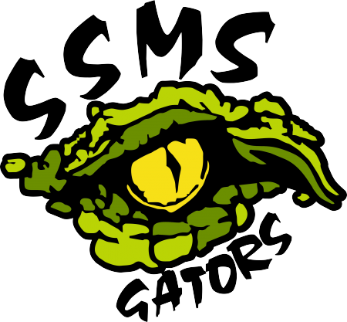

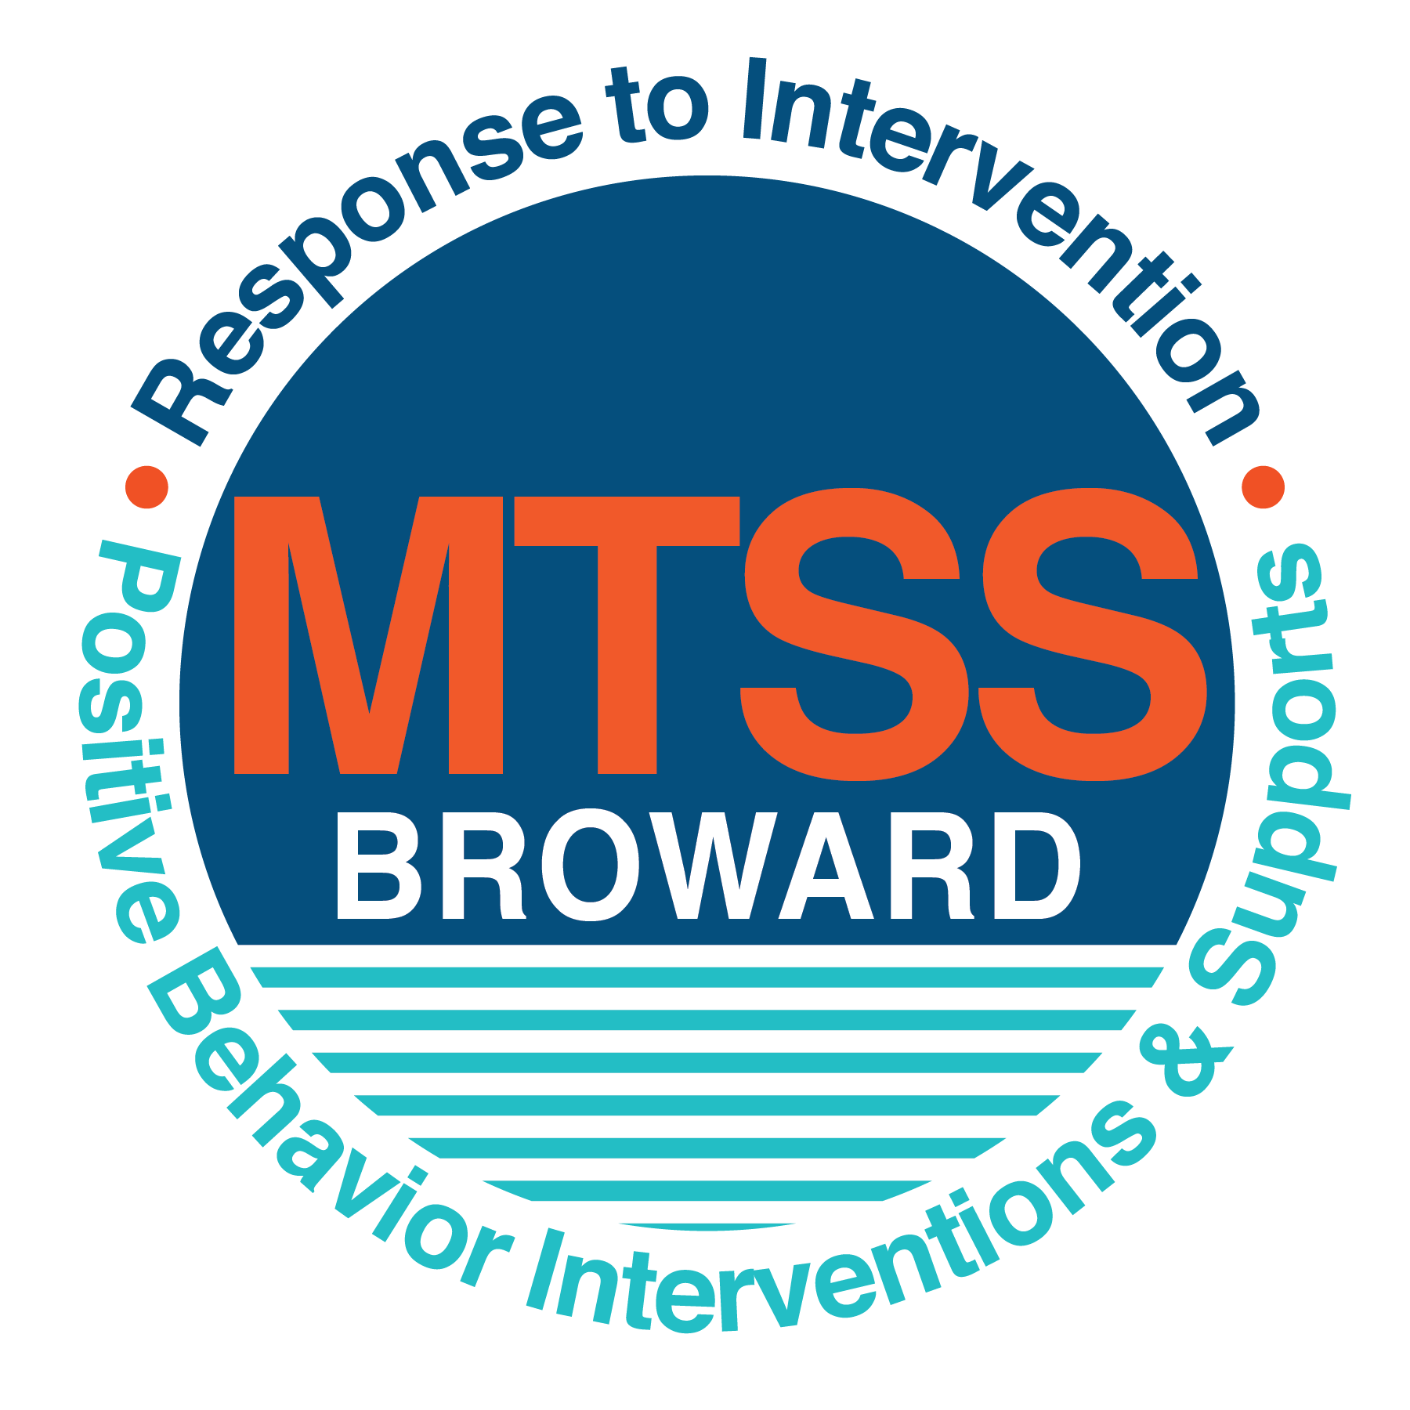
School-wide Positive Behavior Plan (SPBP)
Broward County Public Schools
To be implemented in SY 2019/20

School Name: | Sawgrass Springs Middle School
School Number: | 3431
SPBP Contact Name: | Lorry Bruce Greenberg
Direct Phone Number: | 754 322-4507

CRITICAL ELEMENT # 1: Active Team with Administrative Participation

1A. Current (SY 2018/19) SPBP team members:
Full Name | Position
James Cecil | 1. Administration (Principal)
Meryl Tabatchnick | 2. BTU Representative
Lorry Bruce Greenberg | 3. SPBP Point of Contact (Intern Principal)
Donna Schwartz | 4. Parent/Community Representation
Dariel Haggerty | 5. ESE Support Facilitator
Michelle Gausman | 6. 6th Grade Teacher
Kamiah Hodges | 7. 7th Grade Teacher
Mary-Ellen Hirsch | 8. 8th Grade Teacher
Donna Cambron | 9. Clerical
 | 10.

1B. Schedule of quarterly SPBP Team Meeting dates for next 2019/20 school year:
Meeting Date | Meeting Time | Content of meetings:
8/9/2019 | 9:00 am | 1. Progress of Action Steps indicated in Implementation Plan in #9  2. Collect & analyze fidelity of staff implementation data in #10A  3. Collect & analyze student outcome data in #10B  Mr. Greenberg will conduct all four of these meetings
10/18/2019 | 9:00 am
1/6/2020 | 9:00 am
3/20/2020 | 9:00 am

CRITICAL ELEMENT # 2: Faculty & Stakeholder Commitment:

2A. Action Steps completed this year (SY 2018/19) that increased faculty and stakeholder knowledge of the new SPBP:

Action Steps: | Date  (Between Jan 15 and  April 30, 2019) | Details  (Sign-in sheets in SPBP Binder)
Presented the new SPBP (for SY 2019/20) to staff | 3/22/2020 | # of participants = 92  Gausman & Hirsch (Responsible)
Held a faculty vote on the new SPBP  (for SY 2019/20) | 4/17/2020 | # of participants = 66 (6 did not vote)  % approved =77%  Tabatchnick & Haggerty (Responsible)
Presented the new SPBP (for SY 2019/20) to stakeholders (parents and community) | 4/3/2020 | # of participants = 24  Greenberg (Responsible)

2B. Action Steps to be completed next year (SY 2019/20) to increase faculty and stakeholder knowledge of the new SPBP:

Action Steps: | Date  (SY 2019-20) | Content  (Sign-in sheets in SPBP Binder)
Provide professional development on the 2019/20 SPBP for all staff | Prior to students’ 1st day:  8/13/2019 | The team will present the updates in the SPBP for the 19/20 school year. All stakeholders will be provided with access to the SPBP. Feedback will be collected for future team meetings.  Tabatchnick, Haggerty, Gausman, & Hirsch will present to staff  Greenberg will present to stakeholders
Present the 2019/20 SPBP to stakeholders  (parents and community) | Prior to Oct 1st, 2019  SAC Meeting
Present the behavior data to all staff quarterly | 1. 8/13/2019 | The team will present:  - the team’s progress in the Implementation Plan in # 9.  - the fidelity of staff implementation data in #10A.  - the student outcome data in #10B.  Greenberg will report out at all the dates listed.
 | 2. 10/18/2019
 | 3. 1/6/2020
 | 4. 3/20/2020

CRITICAL ELEMENT # 3: School-wide Expectations

3A. Top five behavior incidents data YTD as listed in BASIS 3.0

Top 5 Behavior Incidents
(as of 2/15/2019)
- SB- Unruly/Disruptive Behaviors (65)
- ZI -Fight-Minor Altercation (51)
- 01-Disobedience/Insubordination (51)
- ZM-Tardiness Habitual (27)
- ZL-Class Cut -Skipping (23)

3B. School-wide expectations are 3 – 5 positive characteristics (not behaviors) that counteract the demonstration of the top school-wide misbehaviors above. ALL people on campus model these expectations.

School-wide Expectations
- Be Cooperative
- Exercise Respect
- Show Self -Control
- Time Management Awareness

3C. At least one lesson plan for each school-wide expectation above is distributed to teachers during pre-planning SY 2019/20 and maintained in the SPBP Binder.

Dates the school-wide expectations lesson plans are taught:
 | Date(s) | Time: | Location(s):
August | August 15, 2019 | 9:25 am to 10:10 am | - Classroom  - Administration will monitor
January | January 7, 2020 | 9:25 am to 10:10 am | - Classroom  - Administration will monitor
After Spring Break | April 9, 2020 | 9:25 am to 10:10 am | - Classroom  - Administration will monitor

CRITICAL ELEMENT #4: Location-based Rules

4A. Top three school-wide locations for Behavior Events YTD.
Top 3 Locations, not including Classroom:
(as of 2/15/19)
School Location | # Incidents
- Cafeteria | 37
- Hallways | 23
- Gym | 21

4B. Expectations and Rules Chart for common areas of school campus: (next page)

Expectations and Rules Chart |  |  |  | To be completed by classroom teachers
School-wide EXPECTATIONS | Cafeteria Rules | Hallway Rules | Gym/Locker Rooms | Classroom Rules
Be Cooperative | Sit at designated tables  and wait to be called to  go into the lunch line  Pick up after yourself | Walk on the right side of the hallway  Use quiet voices not to disrupt classes taking place. | Sit in your designated seat on the bench in the gym or locker room.
Exercise Respect | Obtain your food tray in a timely manner so that the lunch line moves quickly | Follow the traffic patterns while walking | Be mindful of other student’s belongings. Keep your belongings secured in your assigned locker/area.
Show Self-Control | Use appropriate language while having discussions at your tables | Keep hands, body and objects to self. | Provide personal space when changing into PE uniforms  Use appropriate language when communicating
Time Management Awareness | Obtain your food tray in a timely manner so that the lunch line moves quickly and have money ready. | Report to your next class on time and use shortest distance to next class | Be in the appropriate PE uniform and in your seat by the designated time

4C. At least one Rules lesson plan for each specific location is distributed to teachers during pre-planning SY 2019/20 and maintained in the SPBP Binder.

Dates the Locations’ Rules lesson plans are taught
 | Date(s) | Time: | Location(s):
August | 15th | 9:30 AM | First period classes
January | ^{7th} | 10:20 AM | Second period classes
After Spring Break | April 9th | 9:30 AM | First period classes

CRITICAL ELEMENT # 5: Reward and Recognition Programs

5. The reward system is focused on one School-wide Expectation OR specific location at a time.
Expectation or Location: Cafeteria

4 Step Problem Solving Process | Plan Details
1. Problem Identification: Use your behavior data to identify one school-wide problem.  What problem did you identify? (use numerical data) | Data used: 3% (37 out of 1200 students) of all students received office discipline referral in the cafeteria as of 2/15/2019  Problem Identification Statement: During the 2017-18 school year, we had a total of 36 office discipline referrals from the cafeteria. As of 2/15/2019, our school is above that amount for office discipline referrals.  We want to decrease the number of students receiving referrals in the cafeteria by 1% (12 students) for the school year.
2. Problem Analysis: Why do you think this problem is occurring?  What is your goal? (use a SMART goal statement with numerical data) | Hypothesis: Students need more structure during lunch time in the cafeteria with additional supervision to reduce decrease the amount of horse playing.  Goal Statement: By the end of the current school year (6/2/2020), the amount of office discipline referrals will be reduced from 37 referrals (as of 2/15/2019) to 10 referrals for the remaining of school year. That would be a 27% decrease.
3. Intervention Design: Describe how you will implement a positive reward program to decrease this problem. | Type of System: Point system  Description of System: (≥ 5 sentences) Classrooms will assign points for good behavior and reward accordingly.  - Students will sit with their class and will be called to lunch lines  - Students will follow a pattern to enter/exit lunch lines without their backpacks  - Students will dispose their own trash from the table and place in garbage.  - Grade levels will be rewarded for following the outline above with open seating and/or outdoor seating every Friday.  - Every week the reward will reset.
4. Evaluation:  A. Implementation fidelity | - How will you monitor the fidelity (consistency and effectiveness) of the staff’s implementation of the reward program? (2-3 sentences)  - Students will be informed through grade level assemblies and re-addressed every Monday over the PA by the grade level administrator or support counselor.  - Cafeteria rules will be posted. Mr. Greenberg will monitor to ensure they are posted once a month  - Grade level administrator or support counselor will monitor daily and notify students every Friday when entering the cafeteria if they met the reward criteria.
B. Student outcome monitoring | - How will you know if the reward program is positively impacting students? What measurable data will you use to determine “success”? (2-3 sentences)  Twice a quarter (interim and end), administration will use BASIS Behavior Dashboard to determine the number of referrals generated in the cafeteria. We want to decrease the amount of cafeteria referrals by 1% for the 2019-2020 school year.

CRITICAL ELEMENT #6: Effective Discipline Procedures

Student Behavior Discipline Flow Chart
Observe problem behavior behaviorBehavior
Intervene and redirect
Office Managed Misbehaviors
Staff Managed Misbehaviors
Call to notify office of a
crisis/safety issue
No
Yes

Implement an initial consequence
Is behavior Office Managed?
(if unsure, check below)

Specific Examples of  6 Staff Managed  Misbehaviors: | Specific Examples of  6 Office Managed  Misbehaviors:
Inappropriate Language  Physical Contact  Defiance  Unruly/disruptive behavior  Cutting/Skipping Class  Excessive Talking | Disobedience/Insubordination  Disruptive/Unruly play  Defiance of Authority  Profanity to Staff  Minor Fight  Repetitive staff managed behaviors

CRITICAL ELEMENT # 7: Classroom Management Systems

7A. In SY 2019/20, ALL teachers implement an evidence-based Tier 1 classroom management system:

Evidence-based system: | Evidence of training:
☒ CHAMPS | 0% of teachers currently holding valid CHAMPS certificate:
☐ PBIS Classroom Management  http://www.fl-pda.org/independent/ | % of teachers currently holding completion certificate:
☐ Other: Click here to enter name of system. | Training evidence: Click here to enter evidence  % of teachers currently trained:

7B. The administration reviews and analyzes the fidelity of staff implementation of Tier 1 classroom management systems across teachers using:

☐ CHAMPs 7 Up Checklist
☐ Basic FIVE (Classroom Management Screening)
☐ PBIS Classroom Assistance Tool (CAT)
☐ Other (specify):
☒ Classroom management screening is not conducted across teachers to determine appropriate professional
development. (Next year, assessment of classroom management implementation fidelity will be scored).

7C. School year 2018/19 percentage of classroom referrals: Data obtained from the Behavior Dashboard 3/14/19

Total number of discipline referrals from classrooms: | 246
Total number of other school-wide discipline referrals: | 152
% of referrals in the classroom: | 62%
Do more than 40% of your referrals come from the classroom? | ☒ Yes ☐ No
If >40% of discipline referrals come from the classroom, it suggests Tier 1 classroom management implementation may need to be strengthened school-wide.
If “Yes”, school-wide classroom management professional development will be conducted in 2019-20:
Click here to choose: If “Other”, indicated system here: Click here to enter text.

CRITICAL ELEMENT # 8: Data Collection and Analysis

8A. Core Effectiveness: Data from the BASIS Behavior Dashboard 2-15-2019

TOTAL Population: | 1200 | % of Total Population | Core Effectiveness
# Referrals: 360 | # of Students:1200
0 - 1 referrals | 1089 | 95% | Are your 0 – 1 referrals > 80%? | ☒Yes ☐No
2 - 5 referrals  (at risk students) | 50 | 4% | Are your 2 - 5 referrals <15%? | ☒Yes ☐No
> 5 referrals  (high risk students) | 10 | 1% | Are your >5 referrals <5%? | ☒Yes ☐No

8B. Core Effectiveness Action Steps:
If all 3 are “Yes”, your core is effective. Is your core behavior curriculum effective? | ☒Yes ☐No
Answer either (a) or (b):
(a) If you answered “Yes”, although your core is effective, what steps does your school leadership team take for early identification of at risk and high-risk students?
(b) If you answered “NO”, indicate the supports and interventions your school leadership team will implement at the beginning of the next school year to improve core strength:
Core Effectiveness Action Steps: (3-4 steps)
1. Quarterly the SPBP Team reviews data from BASIS Behavior Dashboard and reports out to staff and Leadership Team
2. Students with 2-5 referrals will be referred to our RtI Team (Tier 2 strategies are implemented)
3. School Counselors will meet with these students to provide intervention services.
4. Students successful will receive rewards, unsuccessful students will move to RtI Tier 3 interventions.

8C. Disproportionality within racial subgroups: Data from the BASIS Behavior Dashboard 2-15-2019

Subgroups | (PctPop - Green)  % of students | (PctRef - Blue)  % of referrals | Difference in referral composition | Positive value suggests disproportionality  (Is the value positive?)
Black | 28 | 48 | 20 | ☒Yes ☐No
Hispanic/Latin | 32 | 29 | -3 | ☐Yes ☒No
White | 32 | 20 | -12 | ☐Yes ☒No

8D. Disproportionality Action Steps:
If all three are “No”, disproportionality is not indicated. Are all 3 “No”? | ☐Yes ☒No
Answer either (a) or (b):
(a) If you answered “Yes”, although your data indicates equity, what plan does your school leadership team implement for early identification of any disproportionality issues
(b) If you answered “No”, indicate the support plan and interventions your school leadership team will implement at the beginning of next year to improve sub group disproportionality
Disproportionality Action Steps: (3-4 steps
1. Schedule a consultation with DPI experts to assist determine specific needs for black subgroup.
2. Based on the above information, plan staff development to address this sub group.
3. SPBP Team will explore the BCPS resources to determine what resources will fit at our school
4. Multicultural events through the school year.

Critical Elements # 9: SPBP Implementation Planning
RED Font = Action Steps for all schools in Broward County
GREY Font = Best Practices for all schools in Broward County
TEAL Font = Resources available at https://browardcountyschools.sharepoint.com/sites/DPI6Strands/strand6/SitePages/SPBP.aspx
SPBP Team Implementation Action Plan 2019 - 2020
Month | Action Steps  ☒ check off Action Step when completed
Current | ☒ Create a SPBP binder or portfolio to retain (for 2 years) hard copies of: your SPBPs, Action Plans, staff PBIS  professional development attendance, stakeholder training attendance, quarterly meeting agendas, quarterly staff  behavior presentations, voting attendance and outcome, Expectations lesson plans and Rules lesson plans
Pre-Planning  2019 | ☒ Print up your SPBP Review and school score from OSPA  ☐ Provide SPBP presentation to all staff during Pre-Planning  ☐ Disseminate the current SPBP (hard copy or electronically) to all staff and stakeholders  ☐ Market and post school-wide Expectations and location-specific Rules  ☐ Identify your district RtI Instructional Facilitator  (Contact tyyne.hogan@browardschools.com for more information, if you are unsure)  ☐ Confirm 1st team meeting date and time
August  1st meeting | ☐ Ensure schedule of quarterly meeting dates for entire year as indicated in the SPBP  ☐ Review Implementation plan; check off completed Action Steps  ☐ Determine any needed team training, such as these Brainsharks: 4 Step Problem Solving Process series, PBIS 10  Critical Elements, Data Collection, Big 5 Data, PBIS 101, etc. (All found in Sharepoint site)  ☐ Review previous year’s behavior data. (Use ‘Agenda’ Form and ‘Data Collection Template’ in Sharepoint site)  ☐ Utilize the 4 Step Problem Solving Process to initiate a Reward System for all students  ☐ Review previous year’s SPBP and feedback form; make necessary modifications  ☐ Verify and implement teaching schedule for Expectations and Rules behavior lesson plans  ☐ Present implementation data, behavior data, team activities and SPBP progress to entire staff
September | ☐ Provide SPBP stakeholder presentation prior to October 1  ☐ Check for staff and teacher understanding of PBIS - provide “PBIS 101” Brainshark as a resource  Brainshark available at: http://www.brainshark.com/browardschools/PBIS101  ☐ Ensure the Discipline Flow Chart is distributed to all staff and is being used as written
October  2nd meeting | ☐ Review Implementation plan; check off completed Action Steps  ☐ Ensure instructional staff know how to (and are, as needed) enter Tier 1 Supplemental Strategies  for behavior in BASIS  ☐ Review previous quarter’s behavior data. (Use ‘Agenda’ and ‘Data Collection Template’ in Sharepoint site)  ☐ Present implementation data, behavior data, team activities, and SPBP progress to entire staff  ☐ Ensure all teachers are using an evidence-based classroom management plan, such as CHAMPS  ☐ Ensure Core Effectiveness Action Steps are being implemented as written
November | ☐ Team to develop new and/or improved lesson plans as indicated by behavior data.  ☐ Ensure that the Disproportionality Action Steps are being implemented as written
January  2020  3rd meeting  Prepare for SY 2020/21 SPBP | ☐ Review Implementation plan; check off completed Action Steps  ☐ Staff to re-teach Expectations and Rules after winter break  ☐ Principal signs in and watches the new “SPBP for Principals” Brainshark: Due January 30th  ☐ Present implementation data, behavior data, team activities, and SPBP progress to entire staff  ☐ Choose team members and dates to work on, complete, and submit the new SPBP  ☐ Teams watch the new “SPBP Team Overview” Brainshark and refers to district resources and supports  (Brainsharks and Additional items in Sharepoint site. Webinars and in-person lab information in Team Brainshark)
February | ☐ Ensure progress towards completion of SPBP  ☐ Check on recently hired staff for PBIS understanding - provide “PBIS 101” Brainshark resource  ☐ Provide the SPBP Surveymonkey link to all staff (optional)
March  4th meeting | ☐ Ensure progress towards completion and submission of SPBP  ☐ Review Implementation plan; check off completed Action Steps  ☐ Staff to re-teach Expectations and Rules after from spring break  ☐ Provide stakeholders/parent presentation on new SPBP for next year  ☐ Provide staff presentation and faculty vote on new SPBP for next year  ☐ Present implementation data, behavior data, team activities, and SPBP progress to entire staff
April | ☐ Submit your SPBP in OSPA by April 30th every year. Use this new SPBP in the next school year  ☐ Continue implementing your current SPBP through the end of the current school year

CRITICAL ELEMENT # 10: Evaluation

10A. Staff implement the School-wide Positive Behavior Plan effectively:
“Are staff implementing the SPBP with fidelity? How do you know?”

STAFF Implementation Monitoring
Action Step | Create an observable and measurable SMART goal to determine “successful”  staff implementation of action step
School-wide expectations and location-specific rules are posted across campus | By September 2019, 100% of the school-wide rules and expectations will be posted in the hallways, gym/locker rooms, classrooms and cafeteria.  Mr. Greenberg will monitor to ensure compliance each quarter.
Expectations and Rules lesson plans are being taught as written and when indicated | By September 1, 2019, all students will be taught the behavior lesson plans according to section 3c. Teacher will send to their grade level administrator a class roster of students that participated in the lesson. Guidance will go over lesson plans of students that were not in attendance.  Quarterly review of lesson plans to ensure fidelity. We expect 100% of the staff will comply with this directive  Guidance Department (Mrs. Barrangan, Mr. Kashdin & Ms. De Los Angles) will be responsible for implementation
The Discipline flow chart is being used by all staff as written | During pre-planning and first week of school, administration will walk the school to ensure that 100% of the classrooms display the flow chart and behavior expectations in classrooms, hallways and cafeteria.  Quarterly, review of behavior referrals will indicate that 95% of teachers are utilizing the flow charts to assist in classroom management.  Grade Level Administration (Mr. Greenberg, Mrs. Hamm & Mrs. Laurel) will monitor to ensure compliance.
A reward system is being implemented for all students | 100% of all students will be invited to attend the free Gator Growl Dance on Early Release Days for not receiving a referral.  Mr. Greenberg along with PTA will be responsible for implementation of the dance.

Quarterly Presentations in section 2B for sections 10A & 10 B
1. 8/13/2019
2. 10/18/2019
3. 1/6/2020
4. 3/20/2020

10B. The SPBP is successful in positively impacting students:
“If staff are implementing the SPBP consistently and effectively, did it positively impact the students? How do you know?”
STUDENT Outcome Monitoring
Student Outcome Data | Create an observable and measurable SMART goal to determine  “successful” student outcomes
Behavior Incident data  (See critical element #3A) | Quarterly review of the data in BASIS 3.0 will indicate a decrease of top 5 incidents referrals in section 3a by 5% from the previous school year.  Grade Level Administrators (Mr. Greenberg, Mrs. Hamm & Mrs. Laurel) will collect and analyze data.
Top 3 event locations data  (See critical element #4A) | Quarterly review of the data in BASIS 3.0 will indicate a decrease of incidents referrals in certain locations in section 4a by 5% from the previous school year.  Grade Level Administrators (Mr. Greenberg, Mrs. Hamm & Mrs. Laurel) will collect and analyze data.
Core effectiveness data  (See critical element #8A) | By the end of first semester (1/7/20) the student receiving 2 to 5 referrals will decrease by at least 1%  Grade Level Administrators (Mr. Greenberg, Mrs. Hamm & Mrs. Laurel) will collect and analyze data.
Classroom referrals data  (See critical element #7C) | School-wide classroom management professional development will be conducted in 2019-20 school year, staff will be trained on CHAMPS to decrease the amount of classroom referrals by 5%.  In addition, we will determine which students have more than 2 referrals and submit their names to the RtI team.  Grade Level Administrators (Mr. Greenberg, Mrs. Hamm & Mrs. Laurel) will collect and analyze data.

