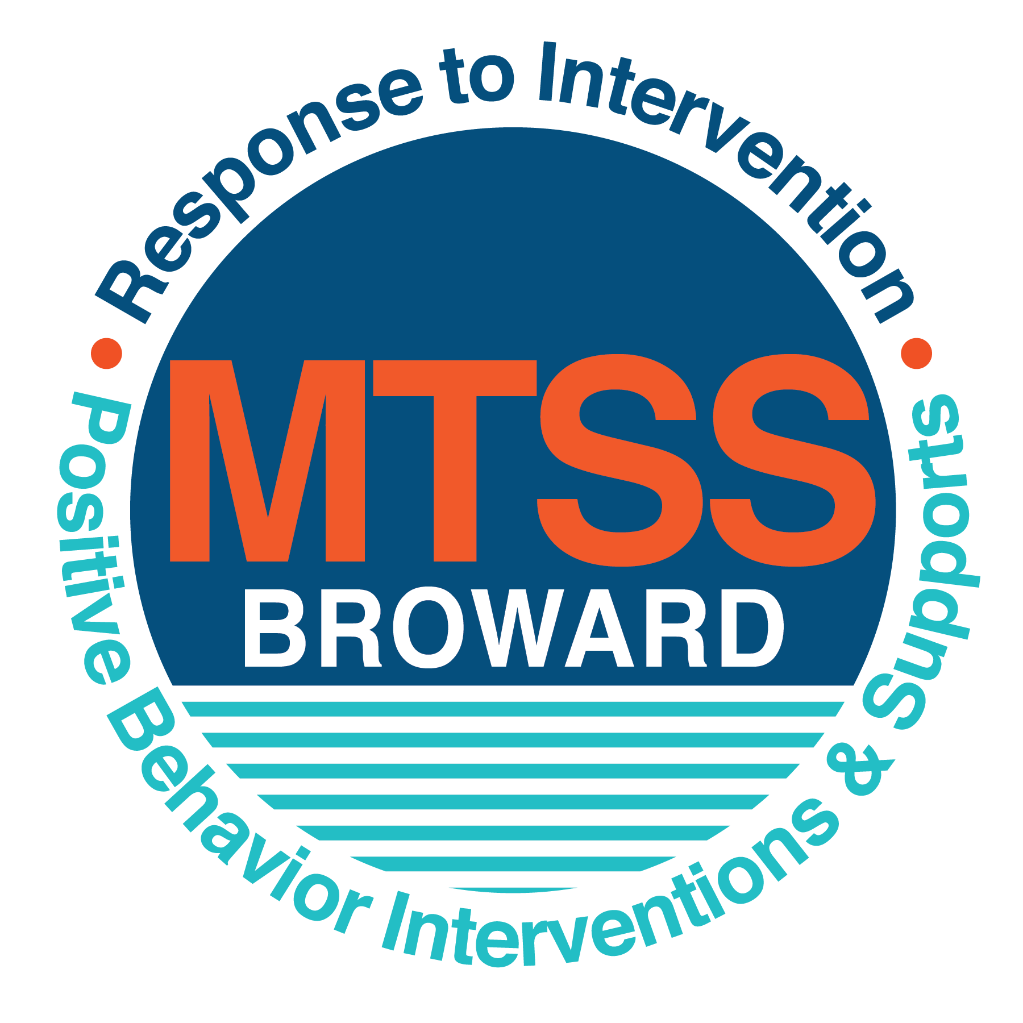
School-wide Positive Behavior Plan (SPBP)
Broward County Public Schools
To be implemented in SY 2019/20

School Name: | Charles W. Flanagan High School
School Number: | 3391
SPBP Contact Name: | Kristine Knapp
Direct Phone Number: | 754-323-0658

CRITICAL ELEMENT # 1: Active Team with Administrative Participation

1A. Current (SY 2018/19) SPBP team members:
Full Name | Position
Michelle Kefford | 1. Administration
Tracy Chandler | 2. BTU Representative
Kristine Knapp | 3. SPBP Point of Contact
Tim Arnwine | 4. Parent/Community Representation
Anna Koltunova | 5. Mathematics Department Head/SAC Chair
Robert Johnson | 6. Social Studies/SAC Secretary
Rhonda Ben Ezra | 7. English Department Head
Jennell Lozin | 8. Reading Department Head/Literacy Coach
Andrew Witcher | 9. Science Department Head
Matias Arellano | 10. Social Studies Department Head

1B. Schedule of quarterly SPBP Team Meeting dates for next 2019/20 school year:
Meeting Date | Meeting Time | Content of meetings:
9/16/2019 | 3:00 | 1. Progress of Action Steps indicated in Implementation Plan in #9  2. Collect & analyze fidelity of staff implementation data in #10A  3. Collect & analyze student outcome data in #10B
11/18/2019 | 3:00
1/13/2020 | 3:00
4/20/2020 | 3:00

CRITICAL ELEMENT # 2: Faculty & Stakeholder Commitment:

2A. Action Steps completed this year (SY 2018/19) that increased faculty and stakeholder knowledge of the new SPBP:

Action Steps: | Date  (Between Jan 15 and  April 30, 2019) | Details  (Sign-in sheets in SPBP Binder)
Presented the new SPBP (for SY 2019/20) to staff | Click here to enter a date. | # of participants =
Held a faculty vote on the new SPBP  (for SY 2019/20) | Click here to enter a date. | # of participants =  % approved =
Presented the new SPBP (for SY 2019/20) to stakeholders (parents and community) | 2/25/2019 | # of participants = 11

2B. Action Steps to be completed next year (SY 2019/20) to increase faculty and stakeholder knowledge of the new SPBP:

Action Steps: | Date  (SY 2019-20) | Content  (Sign-in sheets in SPBP Binder)
Provide professional development on the 2019/20 SPBP for all staff | Prior to students’ 1st day:  8/13/2019 | The team will present the updates in the SPBP for the 19/20 school year. All stakeholders will be provided with access to the SPBP. Feedback will be collected for future team meetings.
Present the 2019/20 SPBP to stakeholders  (parents and community) | Prior to Oct 1st, 2019  9/16/2019
Present the behavior data to all staff quarterly | - 9/16/2019 | The team will present:  - the team’s progress in the Implementation Plan in # 9.  - the fidelity of staff implementation data in #10A.  - the student outcome data in #10B.
 | - 11/18/2019
 | - 1/13/2020
 | - 4/20/2020

CRITICAL ELEMENT # 3: School-wide Expectations

3A. Top five behavior incidents data YTD as listed in BASIS 3.0
Top 5 Behavior Incidents
- Class Cut
- Technology – Illegal Use of Computers
- Unruly/Disruptive Behavior
- Disobedience/Insubordination
- Disruptive/Unruly Play

3B. School-wide expectations are 3 – 5 positive characteristics (not behaviors) that counteract the demonstration of the top school-wide misbehaviors above. ALL people on campus model these expectations.
School-wide Expectations
- Considerate
- Respectful
- Engaged
- Responsible
- Agreeable

3C. At least one lesson plan for each school-wide expectation above is distributed to teachers during pre-planning SY 2019/20 and maintained in the SPBP Binder.
Dates the school-wide expectations lesson plans are taught:
 | Date(s) | Time: | Location(s):
August | August 13, 2019 | 1:00 | Media Center/Auditorium
January | January 9, 2020 | 1:00 | Media Center/Auditorium
After Spring Break | April 9, 2020 | 1:00 | Media Center/Auditorium

CRITICAL ELEMENT #4: Location-based Rules

4A. Top three school-wide locations for Behavior Events YTD.
Top 3 Locations, not including Classroom:
School Location | # Incidents
1. Hallway | 52
2. School Grounds | 25
3. Rest Room | 17

4B. Expectations and Rules Chart for common areas of school campus: (next page)

Expectations and Rules Chart |  |  |  | To be completed by classroom teachers
School-wide EXPECTATIONS | Cafeteria Rules | Hallway Rules | School Ground Rules | Classroom Rules
Be considerate to your peers and adults in the area | Join the food line at the end of the line and wait your turn. | Move in the direction of on-going student traffic. | Immediately report any misconduct to the closest adult. | Follow the ‘Golden Rule’: Treat others the way you would like to be treated.
Show agreeable actions in and out of class | Move in the direction of the on-going student traffic. | Display school issued identification in a proper manner. | Begin to walk to you next class at the sound of the bell. | Follow basic classroom rules (i.e. raise your hand if you wish to speak).
Be respectful of the people, objects, and ideas in the area | Throw your trash away into the closest receptacle. | Use kind language when addressing peers and staff members. | Be considerate of all school and personal property. | Use appropriate language and be considerate of others viewpoints.

4C. At least one Rules lesson plan for each specific location is distributed to teachers during pre-planning SY 2019/20 and maintained in the SPBP Binder.

Dates the Locations’ Rules lesson plans are taught
 | Date(s) | Time: | Location(s):
August | August 13, 2019 | 1:00 | Media Center/Auditorium
January | January 9, 2020 | 1:00 | Media Center/Auditorium
After Spring Break | April 9, 2020 | 1:00 | Media Center/Auditorium

CRITICAL ELEMENT # 5: Reward and Recognition Programs

5. The reward system is focused on one School-wide Expectation OR specific location at a time.
Expectation or Location: Show agreeable action in and out of class.

4 Step Problem Solving Process | Plan Details
1. Problem Identification: Use your behavior data to identify one school-wide problem.  What problem did you identify? (use numerical data) | Data used: 52 occurrences of students receiving referrals for disobedience and dress code violations  Problem Identification Statement: School policy states that all students must have school identification on and visible at all times.
2. Problem Analysis: Why do you think this problem is occurring?  What is your goal? (use a SMART goal statement with numerical data) | Hypothesis: Students have become complacent and put their ID’s in their bags instead of wearing them at all times.  Goal Statement: The expectation of students will be that 100% of students will display their ids on a daily basis to eliminate referrals for this infraction.
3. Intervention Design: Describe how you will implement a positive reward program to decrease this problem. | Type of System: Token system  Description of System: (>5 sentences) School leaders will randomly provide treats to students during lunch who are properly wearing and displaying their school IDs. Administrators, teachers, and security have lunch duty on a daily basis and frequently use this time to remind students that their IDs need to be worn at all times. The goal of this system will be to reward students who are following school policy and extrinsically motivate students to follow suit. By randomly selecting the lunch period and school official who will be handing out rewards on a daily basis, students will not know what days they will be eligible for a reward. This will be done so students pre-emptively wear their IDs in the hopes that they will receive a treat for wearing their ID.
4. Evaluation:  A. Implementation fidelity | - How will you monitor the fidelity (consistency and effectiveness) of the staff’s implementation of the reward program? (2-3 sentences)  School officials who participate overseeing lunch periods will meet at the beginning of each lunch period to decide who will hand out the treats. At the end of each lunch period, Mrs. Knapp will meet with the school official who received the treats to ensure that they were given to students who were properly displaying IDs.
B. Student outcome monitoring | - How will you know if the reward program is positively impacting students? What measurable data will you use to determine “success”? (2-3 sentences)  Just as one school official will receive treats to give out for each lunch period, another random school official, who will be selected at the beginning of each period, will document how many times they had to remind students to properly display their IDs throughout the lunch period. Mrs. Knapp will also meet with this school official to document data that can be analyzed at monthly leadership meetings. Based upon the findings the plan can be adjusted as needed.

CRITICAL ELEMENT #6: Effective Discipline Procedures

Student Behavior Discipline Flow Chart
Observe problem behavior behaviorBehavior
Intervene and redirect
Office Managed Misbehaviors
Staff Managed Misbehaviors
Call to notify office of a
crisis/safety issue
No
Yes

Implement an initial consequence
Is behavior Office Managed?
(if unsure, check below)

Specific Examples of  6 Staff Managed  Misbehaviors: | Specific Examples of  6 Office Managed  Misbehaviors:
1. Talking during instructional time  2. Excessive use of the bathroom pass  3. Tardiness  4. Interrupting other students when speaking  5. Using a cell phone during instructional time  6. Using insulting/rude language | 1. Skipping Class  2. Disobedience/ insubordination  3. Disruptive/ Unruly Play  4. Defiance of Authority  5. Illegal Use of Technology  6. Unserved Detention

CRITICAL ELEMENT # 7: Classroom Management Systems

7A. In SY 2019/20, ALL teachers implement an evidence-based Tier 1 classroom management system:
Evidence-based system: | Evidence of training:
☒ CHAMPS | % of teachers currently holding valid CHAMPS certificate: N/A, but CHAMPS training will be offered to staff in the 19-20 school year.
☐ PBIS Classroom Management  http://www.fl-pda.org/independent/ | % of teachers currently holding completion certificate:
☐ Other | Training evidence: Click here to enter evidence  % of teachers currently trained:

7B. The administration reviews and analyzes the fidelity of staff implementation of Tier 1 classroom management systems across teachers using:
☐ CHAMPs 7 Up Checklist
☐ Basic FIVE (Classroom Management Screening)
☐ PBIS Classroom Assistance Tool (CAT)
☐ Other (specify):
☒ Classroom management screening is not conducted across teachers to determine appropriate professional
development. (Next year, assessment of classroom management implementation fidelity will be scored).

7C. School year 2018/19 percentage of classroom referrals:
Total number of discipline referrals from classrooms: | 219
Total number of other school-wide discipline referrals: | 422
% of referrals in the classroom: | 51.8%
Do more than 40% of your referrals come from the classroom? | ☒ Yes ☐ No
If >40% of discipline referrals come from the classroom, it suggests Tier 1 classroom management implementation may need to be strengthened school-wide.
If “Yes”, school-wide classroom management professional development will be conducted in 2019-20:
CHAMPS Training - District offered If “Other”, indicated system here: Click here to enter text.

CRITICAL ELEMENT # 8: Data Collection and Analysis

8A. Core Effectiveness:
TOTAL Population: | 2525 | % of Total Population | Core Effectiveness
# Referrals: 433 | # of Students: 241
0 - 1 referrals | 154 | 97% | Are your 0 – 1 referrals > 80%? | ☒Yes ☐No
2 - 5 referrals  (at risk students) | 78 | 3% | Are your 2 - 5 referrals <15%? | ☒Yes ☐No
> 5 referrals  (high risk students) | 9 | 0% | Are your >5 referrals <5%? | ☒Yes ☐No

8B. Core Effectiveness Action Steps:
If all 3 are “Yes”, your core is effective. Is your core behavior curriculum effective? | ☒Yes ☐No
Answer either (a) or (b):
(a) If you answered “Yes”, although your core is effective, what steps does your school leadership team take for early identification of at risk and high-risk students?
(b) If you answered “NO”, indicate the supports and interventions your school leadership team will implement at the beginning of the next school year to improve core strength:
Core Effectiveness Action Steps: (3-4 steps)
1. Analyze previous years data to identify students that need additional mentoring and place them in mentoring groups.
2. Provide social and emotional intelligence programs that help students cope with difficult situations.
3. Monitor and analyze student data on a monthly basis at discipline team meetings.

8C. Disproportionality within racial subgroups:
Subgroups | (PctPop - Green)  % of students | (PctRef - Blue)  % of referrals | Difference in referral composition | Positive value suggests disproportionality  (Is the value positive?)
Black | 34 | 55 | 21 | ☒Yes ☐No
Hispanic/Latin | 47 | 36 | -11 | ☐Yes ☒No
White | 12 | 5 | -7 | ☐Yes ☒No

8D. Disproportionality Action Steps:
If all three are “No”, disproportionality is not indicated. Are all 3 “No”? | ☐Yes ☒No
Answer either (a) or (b):
(a) If you answered “Yes”, although your data indicates equity, what plan does your school leadership team implement for early identification of any disproportionality issues
(b) If you answered “No”, indicate the support plan and interventions your school leadership team will implement at the beginning of next year to improve sub group disproportionality
Disproportionality Action Steps: (3-4 steps)
1. The school has created mentoring groups that reach out to different segments of the school population that are supported by different members of the school’s faculty.
2. School will provide proactive social emotional intelligence programs for subgroups with a disproportionate number of referrals.
3. Schedule guest speakers from the local community that reflect the subgroups culture to provide positive leadership that students can relate to.

Critical Elements # 9: SPBP Implementation Planning
RED Font = Action Steps for all schools in Broward County
GREY Font = Best Practices for all schools in Broward County
TEAL Font = Resources available at https://browardcountyschools.sharepoint.com/sites/DPI6Strands/strand6/SitePages/SPBP.aspx
SPBP Team Implementation Action Plan 2019 - 2020
Month | Action Steps  ☒ check off Action Step when completed
Current | ☐ Create a SPBP binder or portfolio to retain (for 2 years) hard copies of: your SPBPs, Action Plans, staff PBIS  professional development attendance, stakeholder training attendance, quarterly meeting agendas, quarterly staff  behavior presentations, voting attendance and outcome, Expectations lesson plans and Rules lesson plans
Pre-Planning  2019 | ☐ Print up your SPBP Review and school score from OSPA  ☐ Provide SPBP presentation to all staff during Pre-Planning  ☐ Disseminate the current SPBP (hard copy or electronically) to all staff and stakeholders  ☐ Market and post school-wide Expectations and location-specific Rules  ☐ Identify your district RtI Instructional Facilitator  (Contact tyyne.hogan@browardschools.com for more information, if you are unsure)  ☐ Confirm 1st team meeting date and time
August  1st meeting | ☐ Ensure schedule of quarterly meeting dates for entire year as indicated in the SPBP  ☐ Review Implementation plan; check off completed Action Steps  ☐ Determine any needed team training, such as these Brainsharks: 4 Step Problem Solving Process series, PBIS 10  Critical Elements, Data Collection, Big 5 Data, PBIS 101, etc. (All found in Sharepoint site)  ☐ Review previous year’s behavior data. (Use ‘Agenda’ Form and ‘Data Collection Template’ in Sharepoint site)  ☐ Utilize the 4 Step Problem Solving Process to initiate a Reward System for all students  ☐ Review previous year’s SPBP and feedback form; make necessary modifications  ☐ Verify and implement teaching schedule for Expectations and Rules behavior lesson plans  ☐ Present implementation data, behavior data, team activities and SPBP progress to entire staff
September | ☐ Provide SPBP stakeholder presentation prior to October 1  ☐ Check for staff and teacher understanding of PBIS - provide “PBIS 101” Brainshark as a resource  Brainshark available at: http://www.brainshark.com/browardschools/PBIS101  ☐ Ensure the Discipline Flow Chart is distributed to all staff and is being used as written
October  2nd meeting | ☐ Review Implementation plan; check off completed Action Steps  ☐ Ensure instructional staff know how to (and are, as needed) enter Tier 1 Supplemental Strategies  for behavior in BASIS  ☐ Review previous quarter’s behavior data. (Use ‘Agenda’ and ‘Data Collection Template’ in Sharepoint site)  ☐ Present implementation data, behavior data, team activities, and SPBP progress to entire staff  ☐ Ensure all teachers are using an evidence-based classroom management plan, such as CHAMPS  ☐ Ensure Core Effectiveness Action Steps are being implemented as written
November | ☐ Team to develop new and/or improved lesson plans as indicated by behavior data.  ☐ Ensure that the Disproportionality Action Steps are being implemented as written
January  2020  3rd meeting  Prepare for SY 2020/21 SPBP | ☐ Review Implementation plan; check off completed Action Steps  ☐ Staff to re-teach Expectations and Rules after winter break  ☐ Principal signs in and watches the new “SPBP for Principals” Brainshark: Due January 30th  ☐ Present implementation data, behavior data, team activities, and SPBP progress to entire staff  ☐ Choose team members and dates to work on, complete, and submit the new SPBP  ☐ Teams watch the new “SPBP Team Overview” Brainshark and refers to district resources and supports  (Brainsharks and Additional items in Sharepoint site. Webinars and in-person lab information in Team Brainshark)
February | ☐ Ensure progress towards completion of SPBP  ☐ Check on recently hired staff for PBIS understanding - provide “PBIS 101” Brainshark resource  ☐ Provide the SPBP Surveymonkey link to all staff (optional)
March  4th meeting | ☐ Ensure progress towards completion and submission of SPBP  ☐ Review Implementation plan; check off completed Action Steps  ☐ Staff to re-teach Expectations and Rules after from spring break  ☐ Provide stakeholders/parent presentation on new SPBP for next year  ☐ Provide staff presentation and faculty vote on new SPBP for next year  ☐ Present implementation data, behavior data, team activities, and SPBP progress to entire staff
April | ☐ Submit your SPBP in OSPA by April 30th every year. Use this new SPBP in the next school year  ☐ Continue implementing your current SPBP through the end of the current school year

CRITICAL ELEMENT # 10: Evaluation

10A. Staff implement the School-wide Positive Behavior Plan effectively:
“Are staff implementing the SPBP with fidelity? How do you know?”
STAFF Implementation Monitoring
Action Step | Create an observable and measurable SMART goal to determine “successful”  staff implementation of action step
School-wide expectations and location-specific rules are posted across campus | 100% of the teachers will have a Falcons CARE poster in their classroom.
Expectations and Rules lesson plans are being taught as written and when indicated | 90% of teachers will attend their department meetings and participate in the lesson activities through the year.
The Discipline flow chart is being used by all staff as written | The issuance of referrals will decrease by 10%
A reward system is being implemented for all students | School leadership will be utilizing positive reinforcement when students are observed following the Falcons CARE expectation.

10B. The SPBP is successful in positively impacting students:
“If staff are implementing the SPBP consistently and effectively, did it positively impact the students? How do you know?”
STUDENT Outcome Monitoring
Student Outcome Data | Create an observable and measurable SMART goal to determine  “successful” student outcomes
Behavior Incident data  (See critical element #3A) | Class cut incidences will be reduced by 10%.
Top 3 event locations data  (See critical element #4A) | Hallway behavior will improve while seeing a reduction of incidences in this area by 15%.
Core effectiveness data  (See critical element #8A) | Less than 5 students will have greater than 5 ODRs and considered high-risk.
Classroom referrals data  (See critical element #7C) | 100% of the staff will be trained in CHAMPS and will implement with fidelity for all grade levels leading to a 10% reduction in referrals.

