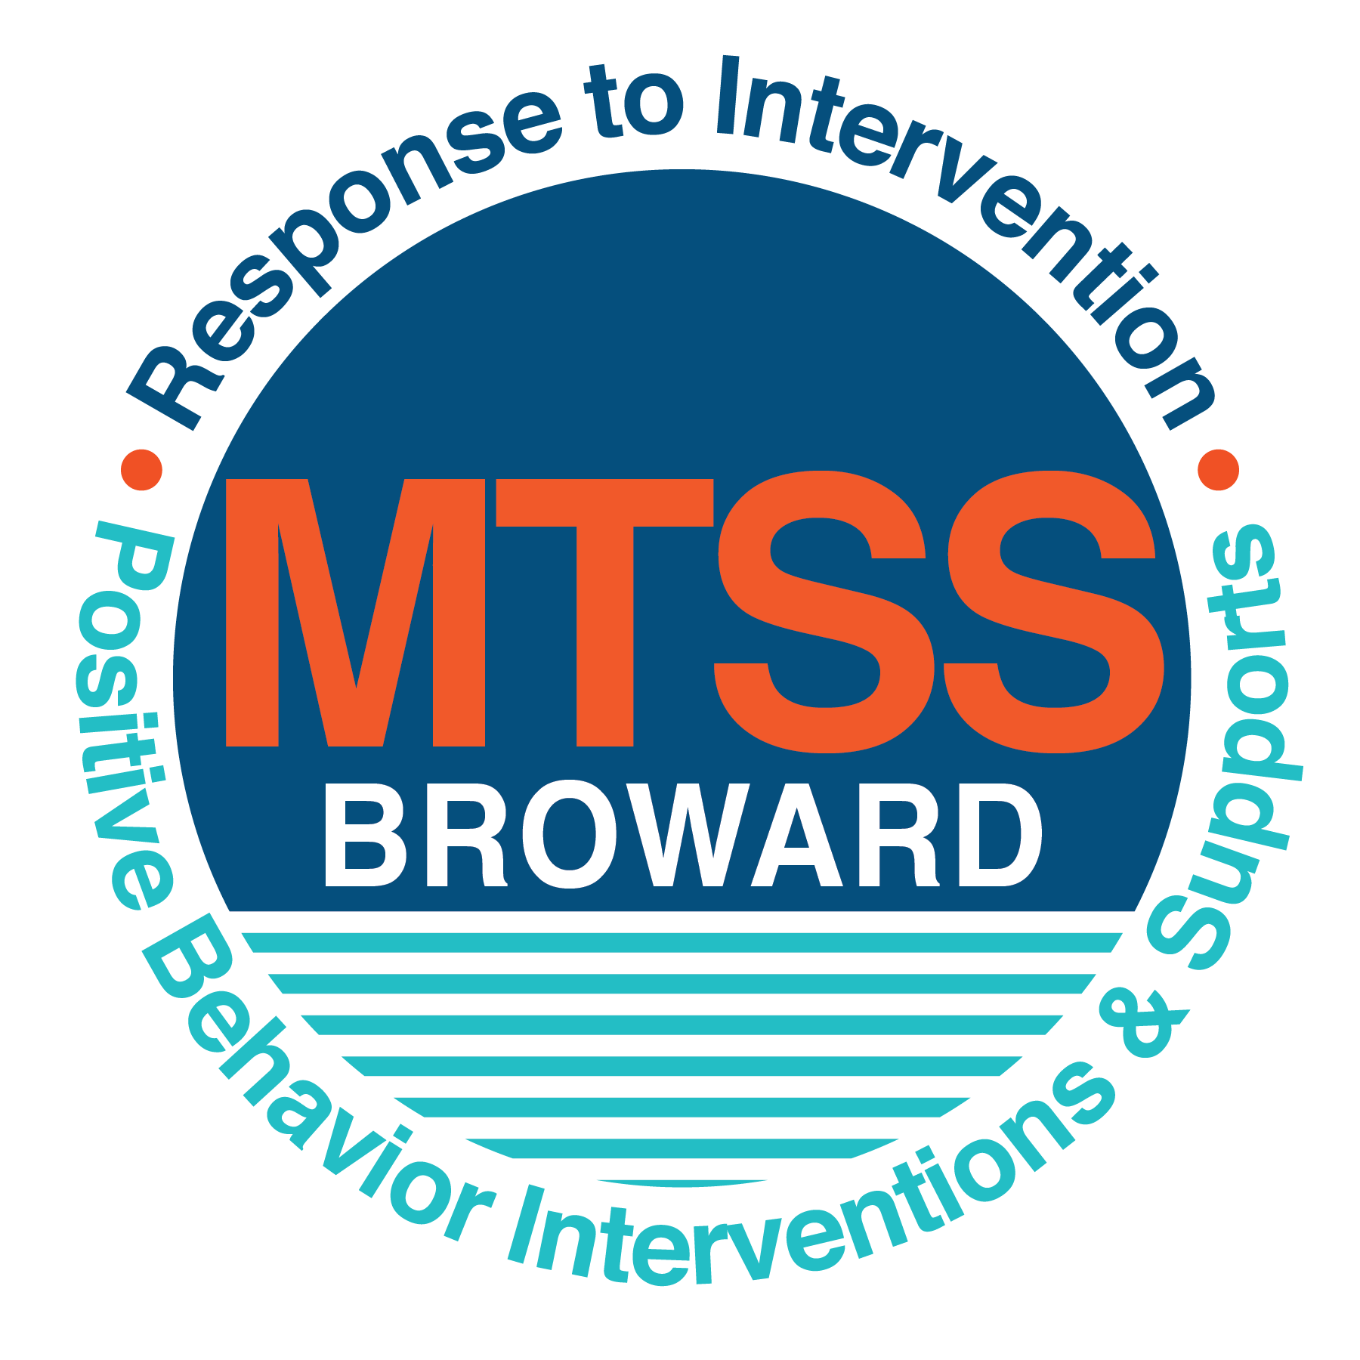
School-wide Positive Behavior Plan (SPBP)
Broward County Public Schools
To be implemented in SY 2019/20

School Name: | Silver Trail Middle School
School Number: | 3331
SPBP Contact Name: | Suhay Nunez
Direct Phone Number: | (754) 323-4300

CRITICAL ELEMENT # 1: Active Team with Administrative Participation

1A. Current (SY 2018/19) SPBP team members:
Full Name | Position
Claudia Ruiz | 1. Administration
Michele Bonsanti | 2. BTU Representative
Suhay Nunez | 3. SPBP Point of Contact
June-Marie Rahim | 4. Parent/Community Representation
Najdah McCoy | 5. Science Department Chair
Jodi Gorfinkel | 6. Math Department Chair
Shira Greenberg | 7. Social Studies Department Chair
Mary Batchelor | 8. Language Arts Department Chair
Kristi Saunig | 9. Academic Electives Department Chair

1B. Schedule of quarterly SPBP Team Meeting dates for next 2019/20 school year:
Meeting Date | Meeting Time | Content of meetings:
10/16/2019 | 8:15 a.m. | 1. Progress of Action Steps indicated in Implementation Plan in #9  2. Collect & analyze fidelity of staff implementation data in #10A  3. Collect & analyze student outcome data in #10B
12/18/2019 | 8:15 a.m.
2/19/2020 | 8:15 a.m.
4/15/2020 | 8:15 a.m.

CRITICAL ELEMENT # 2: Faculty & Stakeholder Commitment:

2A. Action Steps completed this year (SY 2018/19) that increased faculty and stakeholder knowledge of the new SPBP:

Action Steps: | Date  (Between Jan 15 and  April 30, 2019) | Details  (Sign-in sheets in SPBP Binder)
Presented the new SPBP (for SY 2019/20) to staff | 4/15/2019 | # of participants = 109
Held a faculty vote on the new SPBP  (for SY 2019/20) | 4/17/2019 | # of participants = 109  % approved = 70
Presented the new SPBP (for SY 2019/20) to stakeholders (parents and community) | 4/24/2019 | # of participants = 23

2B. Action Steps to be completed next year (SY 2019/20) to increase faculty and stakeholder knowledge of the new SPBP:

Action Steps: | Date  (SY 2019-20) | Content  (Sign-in sheets in SPBP Binder)
Provide professional development on the 2019/20 SPBP for all staff | Prior to students’ 1st day:  8/12/2019 | The team will present the updates in the SPBP for the 19/20 school year. All stakeholders will be provided with access to the SPBP. Feedback will be collected for future team meetings.
Present the 2019/20 SPBP to stakeholders  (parents and community) | Prior to Oct 1st, 2019  8/28/2019
Present the behavior data to all staff quarterly | 1. 10/16/2019 | The team will present:  - the team’s progress in the Implementation Plan in # 9.  - the fidelity of staff implementation data in #10A.  - the student outcome data in #10B.
 | 2. 12/18/2019
 | 3. 2/19/2020
 | 4. 4/15/2020

CRITICAL ELEMENT # 3: School-wide Expectations

3A. Top five behavior incidents data YTD as listed in BASIS 3.0
Top 5 Behavior Incidents
- Disobedience/Insubordination
- Unruly/Disruptive Behavior
- Disruptive/Unruly Play
- Class Cut (Skipping)
- Out of Assigned Area

3B. School-wide expectations are 3 – 5 positive characteristics (not behaviors) that counteract the demonstration of the top school-wide misbehaviors above. ALL people on campus model these expectations.
School-wide Expectations
1. Follow directions and respect authority figures.
2. Be respectful to others and yourself.
3. Keep your hands, body, and objects to yourself.
4. Attend all classes at the assigned time.
5. Remain in your assigned area within the classroom and the building.

3C. At least one lesson plan for each school-wide expectation above is distributed to teachers during pre-planning SY 2019/20 and maintained in the SPBP Binder.
Dates the school-wide expectations lesson plans are taught:
 | Date(s) | Time: | Location(s):
August | 08/14/2019-08/16/2019 | 9:10 a.m. – 9:30 a.m. | Classroom – All classroom teachers will teach the assigned lesson plans the first 20 minutes of each class period.
January | 01/07/2021 | First 20 minutes of each class period for one day. 9:10 a.m. – 3:40 p.m. | Classroom- Teachers will answer a survey in December to rank the most problematic areas of adherence to the Stride Pride discipline plan. The top 5 areas will be retaught and the remaining will be reviewed.
After Spring Break | 03/30/2021 | First 20 minutes of each class period for one day. 9:10 a.m. – 3:40 p.m. | Classroom- Teachers will answer a survey in February to rank the most problematic areas of adherence to the Stride Pride discipline plan. The top 5 areas will be retaught and the remaining will be reviewed.

CRITICAL ELEMENT #4: Location-based Rules

4A. Top three school-wide locations for Behavior Events YTD.
Top 3 Locations, not including Classroom:
School Location | # Incidents
1. Hallway | 22
2. Cafeteria | 55
3. Bus | 20

4B. Expectations and Rules Chart for common areas of school campus: (next page)

Expectations and Rules Chart |  |  |  | To be completed by classroom teachers
School-wide EXPECTATIONS | Cafeteria Rules | Hallway Rules | Bus Rules | Classroom Rules
Follow directions and respect authority figures. | When giving the “hands up” sign, students will stop all conversation, make eye contact, and direct their attention to the adult that is speaking. | When addressed, students will provide their ID and respond appropriately with respect. | Upon entering the bus, students should report to their assigned seats. Students must follow all directions the first time their given by the bus operator. Students will refrain from using profanity towards bus driver and others. | Follow classroom procedures willingly and respectfully.  Be in your seat and prepared with required materials when the bell rings.  Follow directions the first time they are given.  Raise your hand and wait to be called on.
Be respectful to others and yourself | Upon entering the cafeteria, remain seated in assigned area, raise your hand for assistance, wait for your lunch table to be called if buying lunch, and keep the cafeteria clean. | Students will act appropriately in the hallways by walking to the right, “walk and talk” quickly, have appropriate passes during class, and adhere to 10/10 rule. | Students will board the bus in a safe and orderly manner. They will enter without pushing, respect other designated spaces, and remain seated for the duration of the ride. While riding on the bus, students will respect the bus operator. | Respect yourself, adults, peers, and other school property by using kinds words and a professional attitude.
Keep your hands, body, and objects to yourself (H.B.O.) | Move in an orderly fashion, raise your hand for permission to get out of your seat, enter in a single orderly and silent fashion, respond to universal signal, stay on designated route and lunch table, keep your area clean and pick up after yourself. | Walk to the right in a single orderly silent fashion, walk and talk to class, and your hands to yourself. | Students will refrain from sticking their hands/head out of the bus, and from throwing objects on or off the bus. | Refrain from touching others and/or their belongings.  Do not throw objects in the classroom.

4C. At least one Rules lesson plan for each specific location is distributed to teachers during pre-planning SY 2019/20 and maintained in the SPBP Binder.

Dates the Locations’ Rules lesson plans are taught
 | Date(s) | Time: | Location(s):
August | 08/07/2019 | First 20 minutes of each class period for one day. 9:10 a.m. – 3:40 p.m. | Classroom – All classroom teachers will teach the assigned lesson plans the first 20 minutes of each class period.
January | 01/07/2020 | First 20 minutes of each class period for one day. 9:10 a.m. – 3:40 p.m. | Classroom – All classroom teachers will teach the assigned lesson plans the first 20 minutes of each class period.
After Spring Break | 03/30/2020 | First 20 minutes of each class period for one day. 9:10 a.m. – 3:40 p.m. | Classroom – All classroom teachers will teach the assigned lesson plans the first 20 minutes of each class period.

CRITICAL ELEMENT # 5: Reward and Recognition Programs

5. The reward system is focused on one School-wide Expectation OR specific location at a time.
Expectation or Location: Bus

4 Step Problem Solving Process | Plan Details
1. Problem Identification: Use your behavior data to identify one school-wide problem.  What problem did you identify? (use numerical data) | Data used:  # of Office Discipline Referrals (ODRs) from the Cafeteria  Problem Identification Statement:  The number of ODRs between the first and second quarter of 2018 is 14% higher than last year (6%).
2. Problem Analysis: Why do you think this problem is occurring?  What is your goal? (use a SMART goal statement with numerical data) | Hypothesis:  Students are horse-playing and need more structure in the cafeteria.  Goal Statement:  By the end of the second quarter, ODRs from the cafeteria will decrease from 55 to less than 25 (45% reduction).
3. Intervention Design: Describe how you will implement a positive reward program to decrease this problem. | Type of System: Point system  Description of System: Students will be placed into teams by class/teacher. Students will earn points for doing the right thing and setting examples of good behavior. Teams will compete for a prize of either cookies, ice cream, etc. The reward will be provided every Friday. The competition starts over every Monday.
4. Evaluation:  A. Implementation fidelity | - How will you monitor the fidelity (consistency and effectiveness) of the staff’s implementation of the reward program? (2-3 sentences)  The number of cafeteria referrals will be collected every Friday by adding up the points for each team, to ensure the system is positively impacting ODRs and no interim modifications needs to be made. The total number of ODRs for the second quarter will be collected on December 13, 2019 by the grade level administrators. The team will meet again on December 20, 2019 will determine we met our goal if the number of ODRs was less than our goal.
B. Student outcome monitoring | - How will you know if the reward program is positively impacting students? What measurable data will you use to determine “success”? (2-3 sentences)  Every quarter, the number of students ODRs in the cafeteria will decrease by 7% as measured by the BASIS Behavior Dashboard

CRITICAL ELEMENT #6: Effective Discipline Procedures
Student Behavior Discipline Flow Chart
Observe problem behavior behaviorBehavior
Intervene and redirect
Office Managed Misbehaviors
Staff Managed Misbehaviors
Call to notify office of a
crisis/safety issue
No
Yes

Implement an initial consequence
Is behavior Office Managed?

Specific Examples of  6 Staff Managed  Misbehaviors: | Specific Examples of  6 Office Managed  Misbehaviors:
- Not listening to a teacher’s request.  - Not following instructions.  - Copying other students work.  - Making inappropriate comments.  - Touching another student’s property.  - Noncompliance with in-school directives. | - Repetitive minor misbehaviors.  - Talking back to a teacher.  - Copying other students work during a test.  - Throwing objects at another individual in the classroom or hallway.  - Horseplaying.  - Cursing.
**Please see below

Staff observes misbehavior in the classroom or on campus
Office Managed
Is the behavior a crisis?
Per discipline matrix, Administration determines consequences and contacts parents
Administrations holds student conference
Administration follows up with teacher/staff member
Referring Teacher/Staff Member completes discipline referral and contacts parent
Is the behavior a referral?
- Verbal Warning
- Re-teach Expectation
Behavior is corrected
Reinforce/
reward student
Complete Team Detention Form & Contact Parent
Complete Discipline Referral
Parent Contact; Teacher & guidance counselor work with student to re-teach behavior and propose strategies for success
Moderate Behavior
Staff Managed
Follow crisis protocol
CRITICAL ELEMENT # 7: Classroom Management Systems

7A. In SY 2019/20, ALL teachers implement an evidence-based Tier 1 classroom management system:
Evidence-based system: | Evidence of training:
☐ CHAMPS | % of teachers currently holding valid CHAMPS certificate:
☐ PBIS Classroom Management  http://www.fl-pda.org/independent/ | % of teachers currently holding completion certificate:
☒ Other: STRIDE PRIDE | Training evidence: Sign-in sheet(s)  % of teachers currently trained: 109

7B. The administration reviews and analyzes the fidelity of staff implementation of Tier 1 classroom management systems across teachers using:
☐ CHAMPs 7 Up Checklist
☐ Basic FIVE (Classroom Management Screening)
☐ PBIS Classroom Assistance Tool (CAT)
☒ Other (STRIDE PRIDE):
☐ Classroom management screening is not conducted across teachers to determine appropriate professional
development. (Next year, assessment of classroom management implementation fidelity will be scored).

7C. School year 2018/19 percentage of classroom referrals:
Total number of discipline referrals from classrooms: | 282
Total number of other school-wide discipline referrals: | 521
% of referrals in the classroom: | 54%
Do more than 40% of your referrals come from the classroom? | ☒ Yes ☐ No
If >40% of discipline referrals come from the classroom, it suggests Tier 1 classroom management implementation may need to be strengthened school-wide.
If “Yes”, school-wide classroom management professional development will be conducted in 2019-20:
Other: If “Other”, indicated system here: Revision of STRIDE PRIDE

CRITICAL ELEMENT # 8: Data Collection and Analysis

8A. Core Effectiveness:
TOTAL Population: | 1,475 | % of Total Population | Core Effectiveness
# Referrals: | # of Students:
0 - 1 referrals | 113 | 93% | Are your 0 – 1 referrals > 80%? | ☒Yes ☐No
2 - 5 referrals  (at risk students) | 84 | 6% | Are your 2 - 5 referrals <15%? | ☒Yes ☐No
> 5 referrals  (high risk students) | 17 | 1% | Are your >5 referrals <5%? | ☒Yes ☐No

8B. Core Effectiveness Action Steps:
If all 3 are “Yes”, your core is effective. Is your core behavior curriculum effective? | ☒Yes ☐No
Answer either (a) or (b):
(a) If you answered “Yes”, although your core is effective, what steps does your school leadership team take for early identification of at risk and high-risk students?
(b) If you answered “NO”, indicate the supports and interventions your school leadership team will implement at the beginning of the next school year to improve core strength:
Core Effectiveness Action Steps: (3-4 steps)
1.At the beginning of the 2019/20 school year, the grade level APs will collect data on new and articulating students to see identify at-risk and high-risk students by providing support and connecting those students to our school.
2. Students who have a history of Working collaboratively with our stakeholders, we can provide resources and maximize instruction.
3. We will begin by changing classroom instruction and having additional support staff assisting in the classrooms; connecting families to our school by encouraging family involvement in our schoolwide events and provide community resources.

8C. Disproportionality within racial subgroups:
Subgroups | (PctPop - Green)  % of students | (PctRef - Blue)  % of referrals | Difference in referral composition | Positive value suggests disproportionality  (Is the value positive?)
Black | 12% | 20% | 8 | ☒Yes ☐No
Hispanic/Latin | 52% | 47% | 5 | ☐Yes ☒No
White | 29% | 27% | 2 | ☐Yes ☒No

8D. Disproportionality Action Steps:
If all three are “No”, disproportionality is not indicated. Are all 3 “No”? | ☐Yes ☒No
Answer either (a) or (b):
(a) If you answered “Yes”, although your data indicates equity, what plan does your school leadership team implement for early identification of any disproportionality issues
(b) If you answered “No”, indicate the support plan and interventions your school leadership team will implement at the beginning of next year to improve sub group disproportionality
Disproportionality Action Steps: (3-4 steps)
Our data indicates we have a disproportionality in the black subgroup domain. To address this, we will contact Keisha Starks in the diversity department to conduct culturally responsive training. This will allow staff to be aware and sensitive to various cultures. Training will also be provided in Courageous Conversations, Character Education, Peer Counseling, and classroom management systems. Data will be monitored weekly by classroom teachers.

Critical Elements # 9: SPBP Implementation Planning
RED Font = Action Steps for all schools in Broward County
GREY Font = Best Practices for all schools in Broward County
TEAL Font = Resources available at https://browardcountyschools.sharepoint.com/sites/DPI6Strands/strand6/SitePages/SPBP.aspx
SPBP Team Implementation Action Plan 2019 - 2020
Month | Action Steps  ☒ check off Action Step when completed
Current | ☒ Create a SPBP binder or portfolio to retain (for 2 years) hard copies of: your SPBPs, Action Plans, staff PBIS  professional development attendance, stakeholder training attendance, quarterly meeting agendas, quarterly staff  behavior presentations, voting attendance and outcome, Expectations lesson plans and Rules lesson plans
Pre-Planning  2019 | ☐ Print up your SPBP Review and school score from OSPA  ☐ Provide SPBP presentation to all staff during Pre-Planning  ☐ Disseminate the current SPBP (hard copy or electronically) to all staff and stakeholders  ☐ Market and post school-wide Expectations and location-specific Rules  ☐ Identify your district RtI Instructional Facilitator  (Contact tyyne.hogan@browardschools.com for more information, if you are unsure)  ☐ Confirm 1st team meeting date and time
August  1st meeting | ☐ Ensure schedule of quarterly meeting dates for entire year as indicated in the SPBP  ☐ Review Implementation plan; check off completed Action Steps  ☐ Determine any needed team training, such as these Brainsharks: 4 Step Problem Solving Process series, PBIS 10  Critical Elements, Data Collection, Big 5 Data, PBIS 101, etc. (All found in Sharepoint site)  ☐ Review previous year’s behavior data. (Use ‘Agenda’ Form and ‘Data Collection Template’ in Sharepoint site)  ☐ Utilize the 4 Step Problem Solving Process to initiate a Reward System for all students  ☐ Review previous year’s SPBP and feedback form; make necessary modifications  ☐ Verify and implement teaching schedule for Expectations and Rules behavior lesson plans  ☐ Present implementation data, behavior data, team activities and SPBP progress to entire staff
September | ☐ Provide SPBP stakeholder presentation prior to October 1  ☐ Check for staff and teacher understanding of PBIS - provide “PBIS 101” Brainshark as a resource  Brainshark available at: http://www.brainshark.com/browardschools/PBIS101  ☐ Ensure the Discipline Flow Chart is distributed to all staff and is being used as written
October  2nd meeting | ☐ Review Implementation plan; check off completed Action Steps  ☐ Ensure instructional staff know how to (and are, as needed) enter Tier 1 Supplemental Strategies  for behavior in BASIS  ☐ Review previous quarter’s behavior data. (Use ‘Agenda’ and ‘Data Collection Template’ in Sharepoint site)  ☐ Present implementation data, behavior data, team activities, and SPBP progress to entire staff  ☐ Ensure all teachers are using an evidence-based classroom management plan, such as CHAMPS  ☐ Ensure Core Effectiveness Action Steps are being implemented as written
November | ☐ Team to develop new and/or improved lesson plans as indicated by behavior data.  ☐ Ensure that the Disproportionality Action Steps are being implemented as written
January  2020  3rd meeting  Prepare for SY 2020/21 SPBP | ☐ Review Implementation plan; check off completed Action Steps  ☐ Staff to re-teach Expectations and Rules after winter break  ☐ Principal signs in and watches the new “SPBP for Principals” Brainshark: Due January 30th  ☐ Present implementation data, behavior data, team activities, and SPBP progress to entire staff  ☐ Choose team members and dates to work on, complete, and submit the new SPBP  ☐ Teams watch the new “SPBP Team Overview” Brainshark and refers to district resources and supports  (Brainsharks and Additional items in Sharepoint site. Webinars and in-person lab information in Team Brainshark)
February | ☐ Ensure progress towards completion of SPBP  ☐ Check on recently hired staff for PBIS understanding - provide “PBIS 101” Brainshark resource  ☐ Provide the SPBP Surveymonkey link to all staff (optional)
March  4th meeting | ☐ Ensure progress towards completion and submission of SPBP  ☐ Review Implementation plan; check off completed Action Steps  ☐ Staff to re-teach Expectations and Rules after from spring break  ☐ Provide stakeholders/parent presentation on new SPBP for next year  ☐ Provide staff presentation and faculty vote on new SPBP for next year  ☐ Present implementation data, behavior data, team activities, and SPBP progress to entire staff
April | ☐ Submit your SPBP in OSPA by April 30th every year. Use this new SPBP in the next school year  ☐ Continue implementing your current SPBP through the end of the current school year

CRITICAL ELEMENT # 10: Evaluation

10A. Staff implement the School-wide Positive Behavior Plan effectively:
“Are staff implementing the SPBP with fidelity? How do you know?”
STAFF Implementation Monitoring
Action Step | Create an observable and measurable SMART goal to determine “successful”  staff implementation of action step
School-wide expectations and location-specific rules are posted across campus | By the end of each month, 100% of hallways, cafeteria, and all classrooms will have all STRIDE PRIDE expectations poster and 2 rules posters as measured through monthly observation by all grade level (6th, 7th, and 8th) administrators.
Expectations and Rules lesson plans are being taught as written and when indicated | 100% of teachers will have a STRIDE PRIDE binder with lesson plans, and all classrooms will have STRIDE PRIDE posters posted and visible. Rules are also present in the cafeteria, hallway, and bus exits.
The Discipline flow chart is being used by all staff as written | 100% of our schoolwide discipline plan is implemented by all stakeholders with uniformity and fidelity to the discipline flow chart.
A reward system is being implemented for all students | By June 4, 2019, schoolwide student Office Discipline Referrals will reduce 7% each quarter, as measured by BASIS behavior Dashboard.

10B. The SPBP is successful in positively impacting students:
“If staff are implementing the SPBP consistently and effectively, did it positively impact the students? How do you know?”
STUDENT Outcome Monitoring
Student Outcome Data | Create an observable and measurable SMART goal to determine  “successful” student outcomes
Behavior Incident data  (See critical element #3A) | By the end of every quarter, there will be 10% fewer referrals from the cafeteria as measured by monthly ODR data collection by all grade level administrators.
Top 3 event locations data  (See critical element #4A) | Every quarter, there will be a 7% decrease in the number of Office Discipline Referrals that contain previously identified staff-managed misbehaviors in the Hallway, Cafeteria, and Bus, as measured by a referral review by the PBIS team.
Core effectiveness data  (See critical element #8A) | By the end of the second quarter, the classroom ODRs from all grade levels will decrease by 7% as measured by the BASIS Behavior Dashboard.
Classroom referrals data  (See critical element #7C) | By the end of the second quarter, the classroom ODRs from all grade levels will decrease by 10% as measured by the BASIS Behavior Dashboard.

